用户登录测试

#1.用户登录并获取token
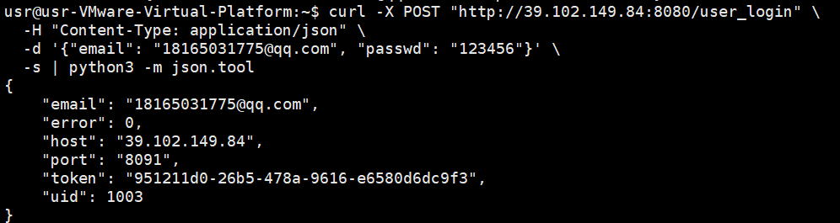
登录成功，获取token: 951211d0-26b5-478a-9616-e6580d6dc9f3
记录下：
TOKEN="951211d0-26b5-478a-9616-e6580d6dc9f3"
UID=1003
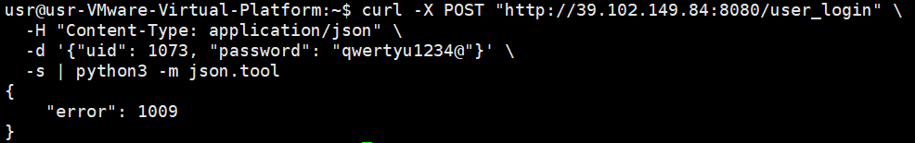
密码错误返回错误码

贴吧管理接口测试

# 1. 获取论坛列表
curl "http://39.102.149.84:8080/forums?page=1&limit=10" \
-s | python3 -m json.tool
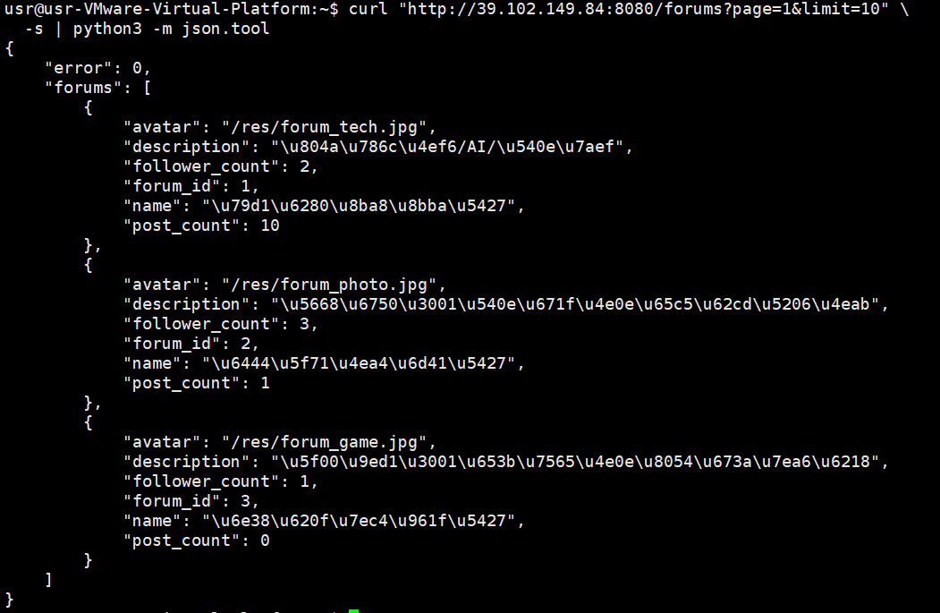

# 2. 获取论坛详情
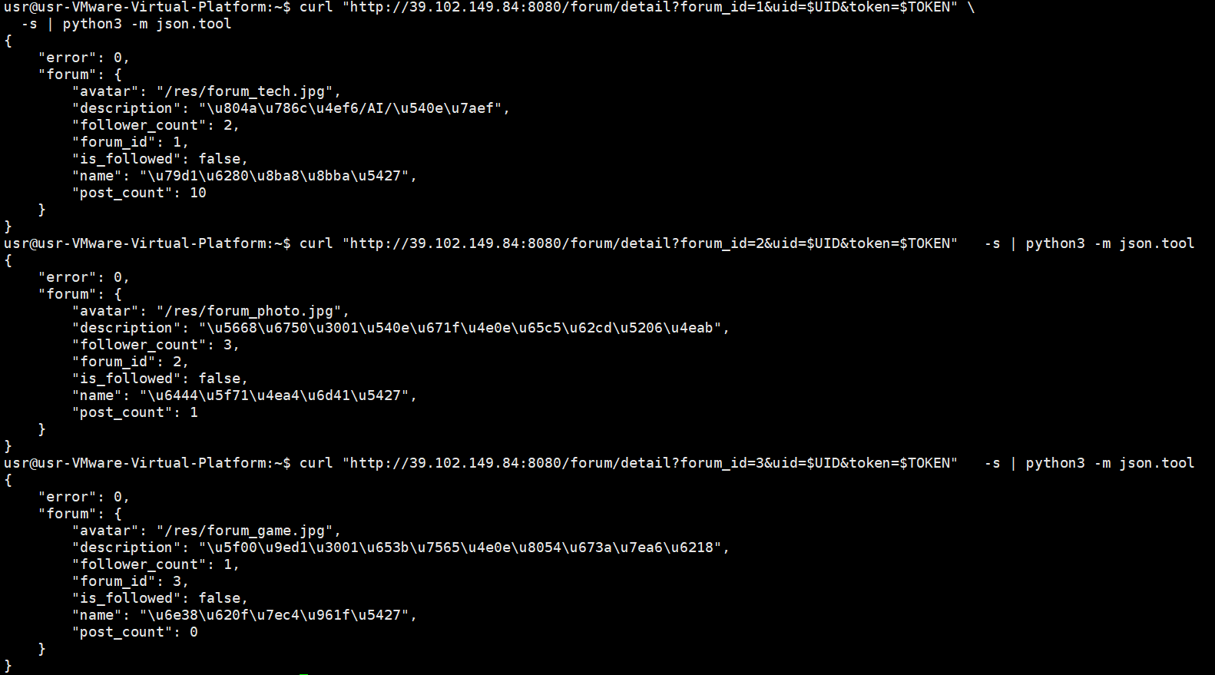
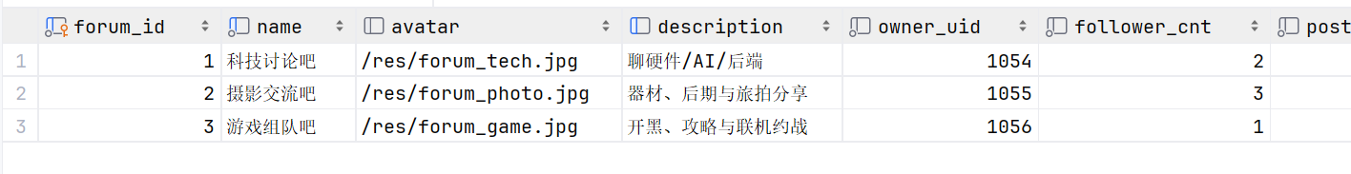

# 3. 关注贴吧
curl -X POST "http://39.102.149.84:8080/follow_forum" \
-H "Content-Type: application/json" \
-d "{\"uid\": 1003, \"token\": \"951211d0-26b5-478a-9616-e6580d6dc9f3\", \"forum_id\": 1}" \
-s | python3 -m json.tool
校验失败
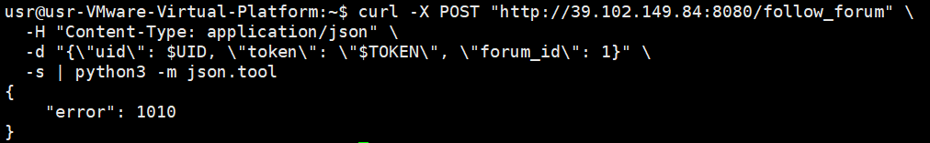
校验成功
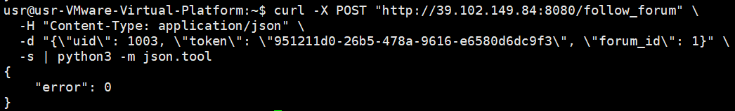
发现数据库中关注人数加1

# 4. 取消关注贴吧
curl -X POST "http://39.102.149.84:8080/unfollow_forum" \
-H "Content-Type: application/json" \
-d "{\"uid\": 1003, \"token\": \"951211d0-26b5-478a-9616-e6580d6dc9f3\", \"forum_id\": 1}" \
-s | python3 -m json.tool
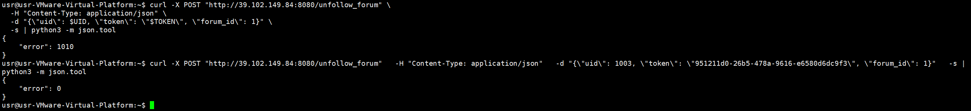
同理验证取消关注，数据库中关注量减一

# 5. 获取已关注的贴吧列表
curl "http://39.102.149.84:8080/followed_forums?uid=1003&token=951211d0-26b5-478a-9616-e6580d6dc9f3&page=1&limit=10" \
-s | python3 -m json.tool
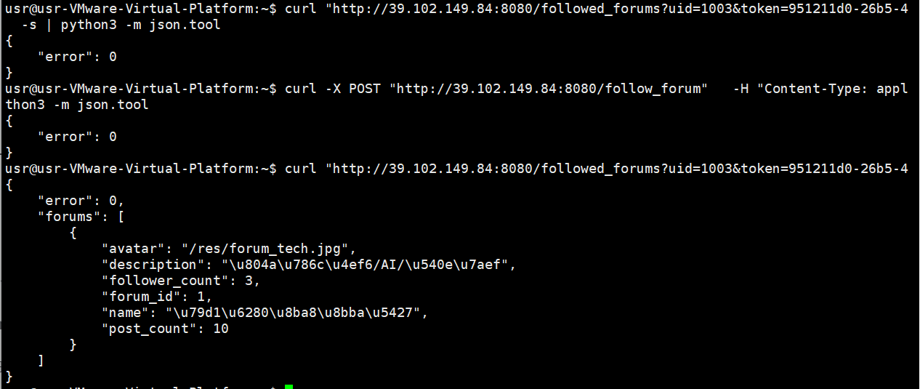
分别在有关注和没关注的情况下查询关注列表

帖子管理接口测试

# 1. 获取帖子列表（可按不同方式排序）
# 按时间排序
curl "http://39.102.149.84:8080/posts?forum_id=1&page=1&limit=10&sort=time" \
-s | python3 -m json.tool
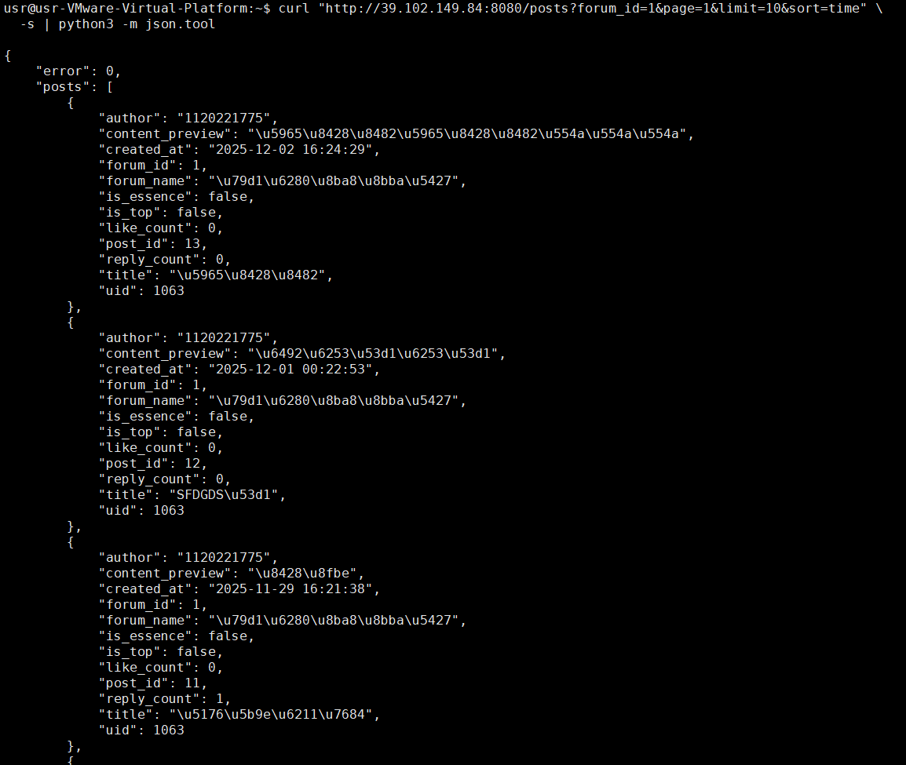

# 按热度排序
curl "http://39.102.149.84:8080/posts?forum_id=1&page=1&limit=10&sort=hot" \
-s | python3 -m json.tool
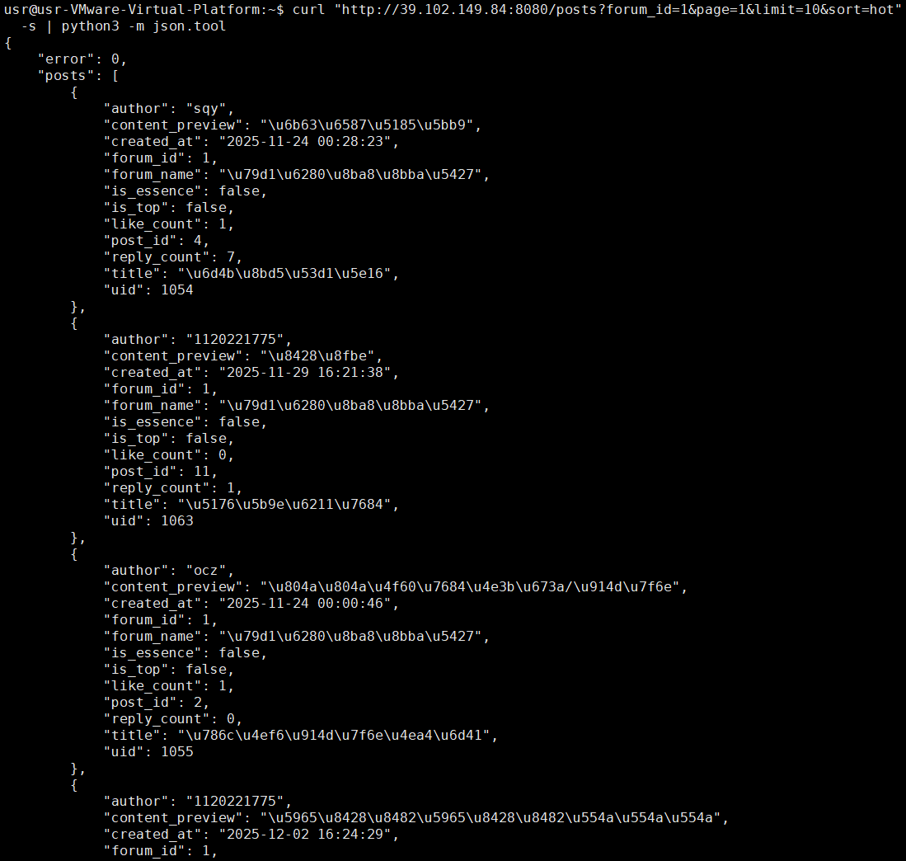

# 2. 创建帖子
curl -X POST "http://39.102.149.84:8080/post/create" \
-H "Content-Type: application/json" \
-d "{\"uid\": 1003, \"token\": \"951211d0-26b5-478a-9616-e6580d6dc9f3\", \"forum_id\": 1, \"title\": \"接口测试用帖 \", \"content\": \"阿马特拉斯\"}" \
-s | python3 -m json.tool
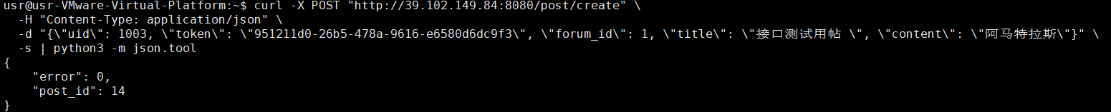
Post_id=14

# 3. 获取帖子详情
curl "http://39.102.149.84:8080/post/detail?post_id=1&uid=1003&token=951211d0-26b5-478a-9616-e6580d6dc9f3" \
-s | python3 -m json.tool
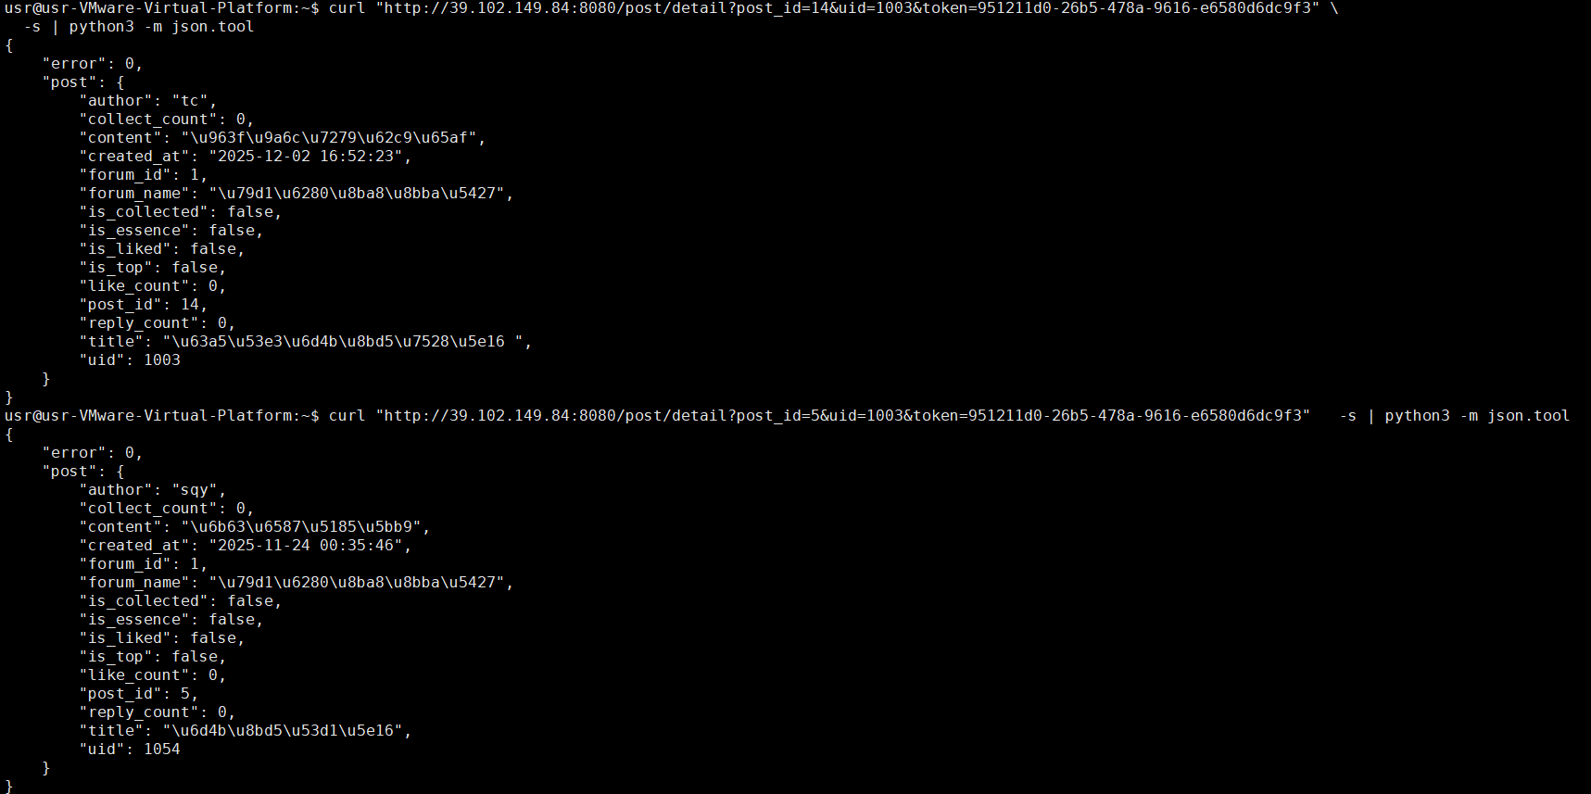
分别测试自己的和他人的帖子

# 4. 更新帖子
curl -X POST "http://39.102.149.84:8080/post/update" \
-H "Content-Type: application/json" \
-d "{\"uid\": 1003, \"token\": \"951211d0-26b5-478a-9616-e6580d6dc9f3\", \"post_id\": $POST_ID, \"title\": \"更新后的标题\", \"content\": \"更新后的内容\"}" \
-s | python3 -m json.tool
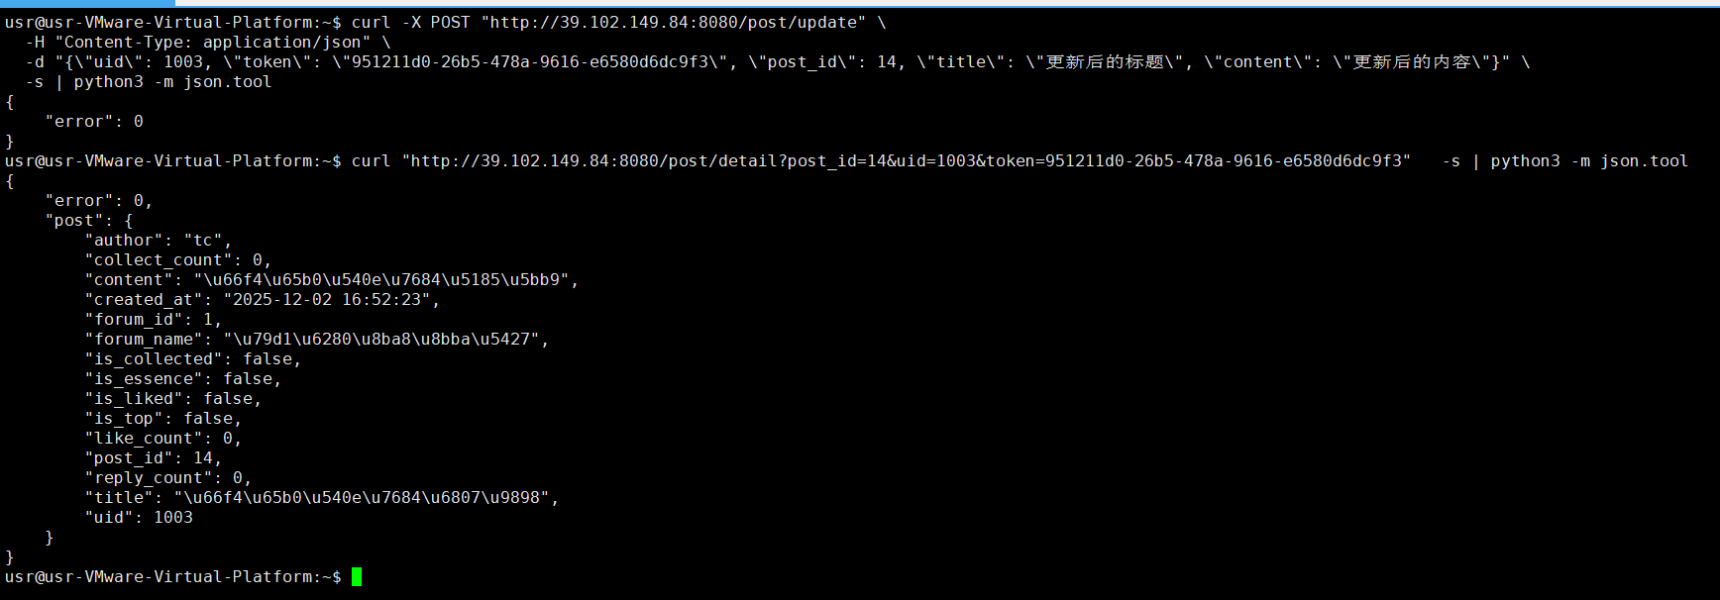

# 5. 删除帖子（软删除）
curl -X POST "http://39.102.149.84:8080/post/delete" \
-H "Content-Type: application/json" \
-d "{\"uid\": 1003, \"token\": \"951211d0-26b5-478a-9616-e6580d6dc9f3\", \"post_id\": $POST_ID}" \
-s | python3 -m json.tool
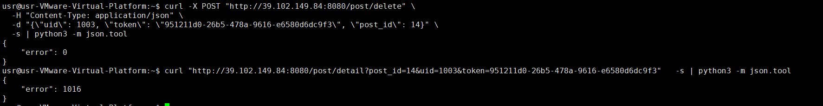
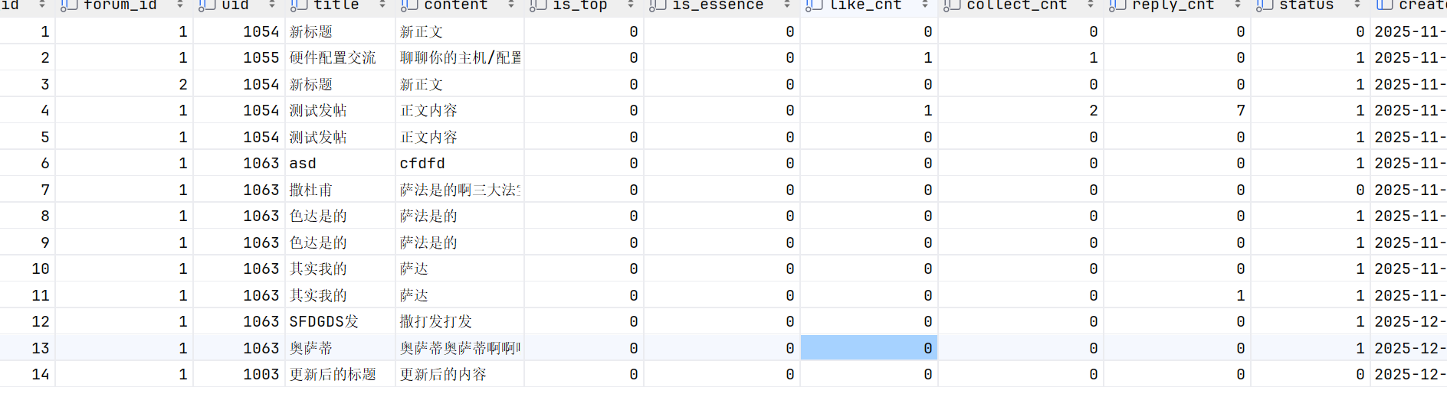

# 6. 点赞/取消点赞帖子
curl -X POST "http://39.102.149.84:8080/like_post" \
-H "Content-Type: application/json" \
-d "{\"uid\": 1003, \"token\": \"951211d0-26b5-478a-9616-e6580d6dc9f3\", \"post_id\": 15}" \
-s | python3 -m json.tool
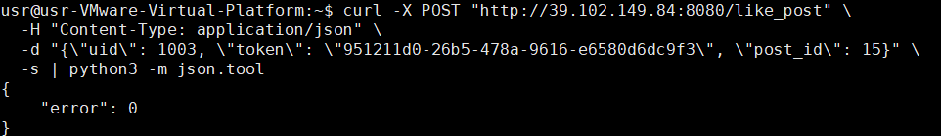
curl -X POST "http://39.102.149.84:8080/unlike_post" \
-H "Content-Type: application/json" \
-d "{\"uid\": 1003, \"token\": \"951211d0-26b5-478a-9616-e6580d6dc9f3\", \"post_id\": 15}" \
-s | python3 -m json.tool
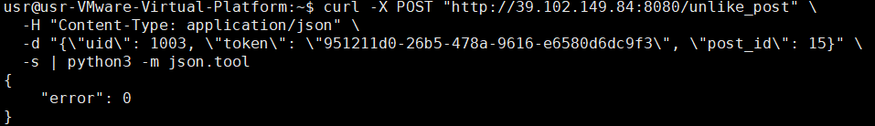

# 7. 收藏/取消收藏帖子
curl -X POST "http://39.102.149.84:8080/collect_post" \
-H "Content-Type: application/json" \
-d "{\"uid\": 1003, \"token\": \"951211d0-26b5-478a-9616-e6580d6dc9f3\", \"post_id\": 15}" \
-s | python3 -m json.tool
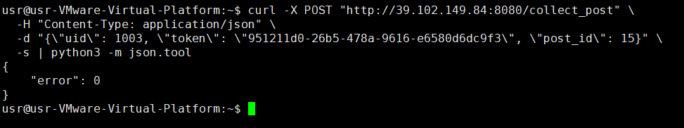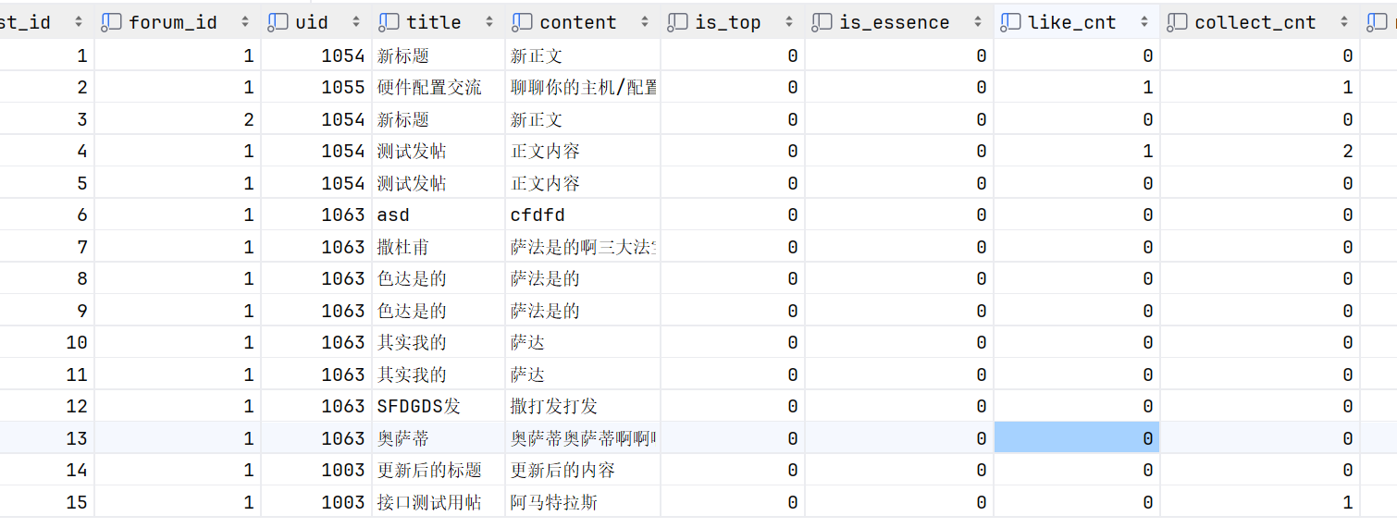
curl -X POST "http://39.102.149.84:8080/uncollect_post" \
-H "Content-Type: application/json" \
-d "{\"uid\": 1003, \"token\": \"951211d0-26b5-478a-9616-e6580d6dc9f3\", \"post_id\": 15}" \
-s | python3 -m json.tool
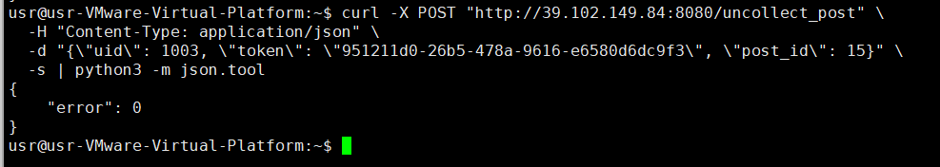

# 8. 置顶/取消置顶帖子
（需要贴吧owner权限）//此后的token改为d6b4c8fd-e36b-401c-91e4-b6e27b37253e
换号，UID=1054，TOKEN= 3a800ff1-0be2-4258-9443-14b3f9e9d1da
curl -X POST "http://39.102.149.84:8080/set_top_post" \
-H "Content-Type: application/json" \
-d "{\"uid\": 1054, \"token\": \"3a800ff1-0be2-4258-9443-14b3f9e9d1da\", \"post_id\": 16, \"is_top\": true}" \
-s | python3 -m json.tool

# 9. 加精/取消加精帖子
（需要贴吧owner权限）
curl -X POST "http://39.102.149.84:8080/set_essence_post" \
-H "Content-Type: application/json" \
-d "{\"uid\": 1054, \"token\": \"3a800ff1-0be2-4258-9443-14b3f9e9d1da\", \"post_id\": 16, \"is_essence\": true}" \
-s | python3 -m json.tool
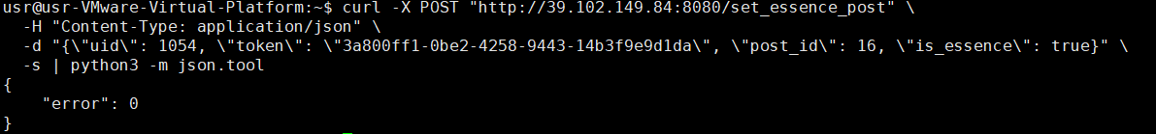
结果如下：
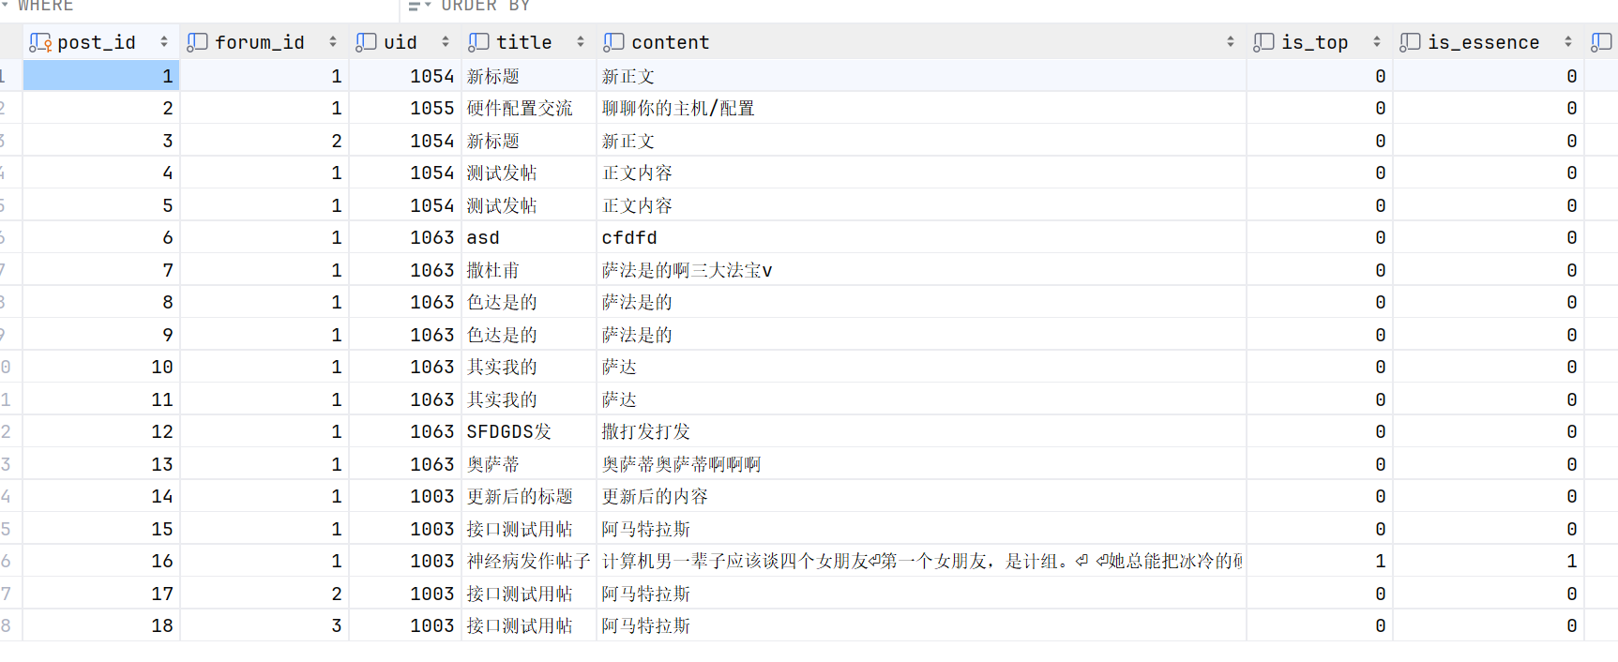

回复管理接口测试

# 1. 获取帖子回复列表
curl "http://39.102.149.84:8080/post/replies?post_id=4&page=1&limit=10&sort=time&uid=1003&token=d6b4c8fd-e36b-401c-91e4-b6e27b37253e" \
-s | python3 -m json.tool
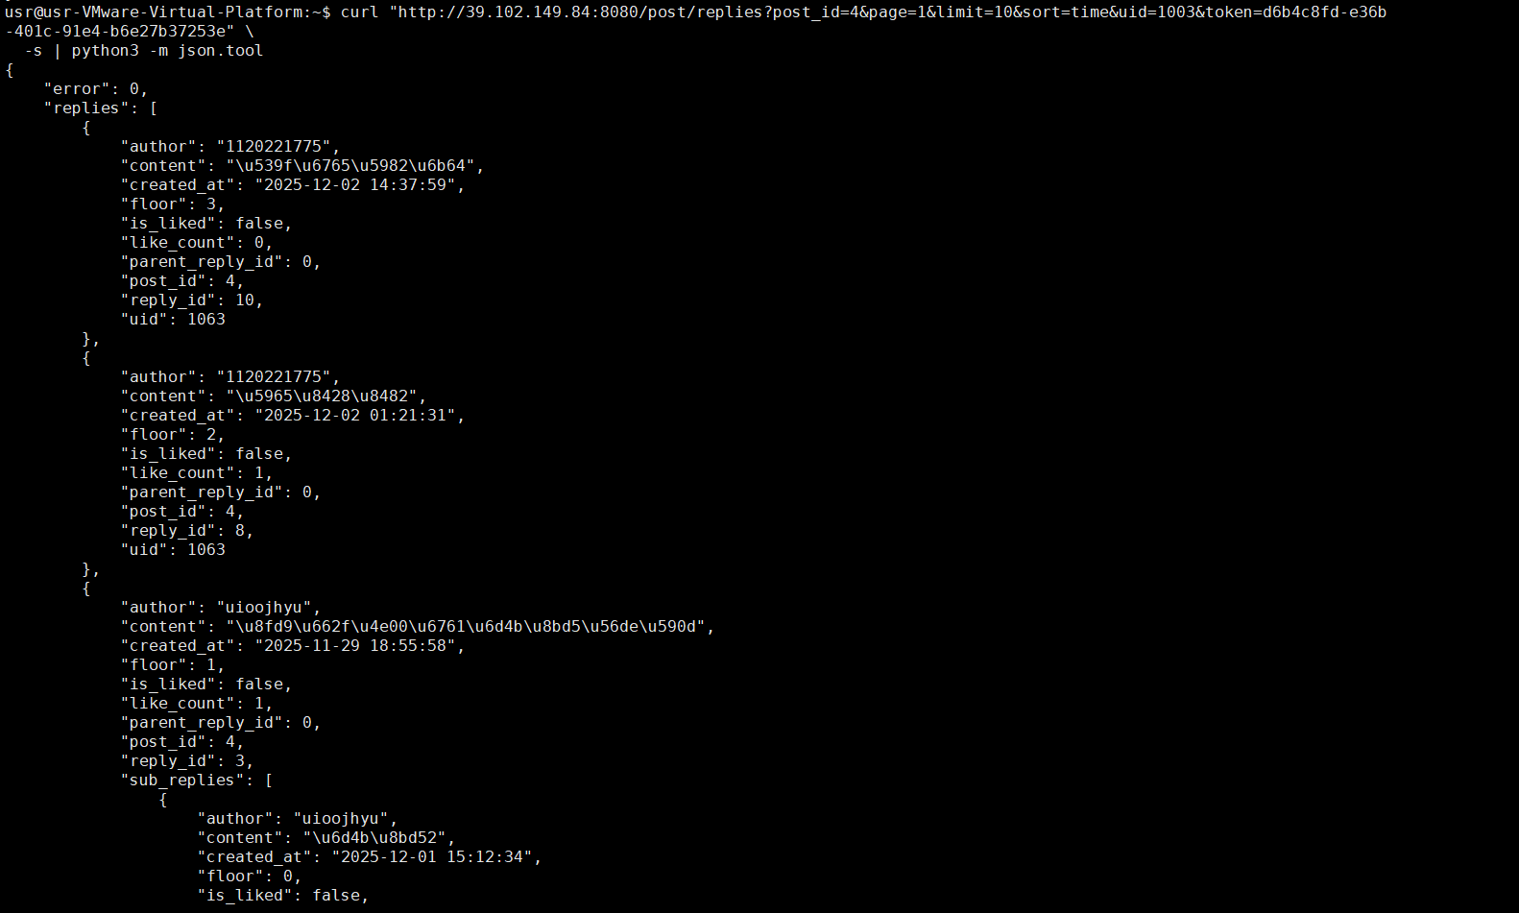

# 2. 创建回复（主回复，parent_reply_id=0）
curl -X POST "http://39.102.149.84:8080/reply" \
-H "Content-Type: application/json" \
-d "{\"uid\": 1003, \"token\": \"d6b4c8fd-e36b-401c-91e4-b6e27b37253e\", \"post_id\": 15, \"content\": \"ciallo~\", \"parent_reply_id\": 0}" \
-s | python3 -m json.tool
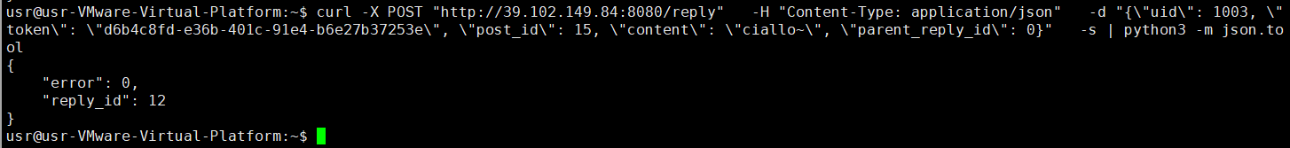
# 记录返回的reply_id
REPLY_ID=12

回复得奇葩一点也没问题
curl -X POST "http://39.102.149.84:8080/reply" \
-H "Content-Type: application/json" \
-d "{\"uid\": 1003, \"token\": \"d6b4c8fd-e36b-401c-91e4-b6e27b37253e\", \"post_id\": 15, \"content\": \" Ciallo～(∠・ω< )⌒☆\", \"parent_reply_id\": 0}" \
-s | python3 -m json.tool
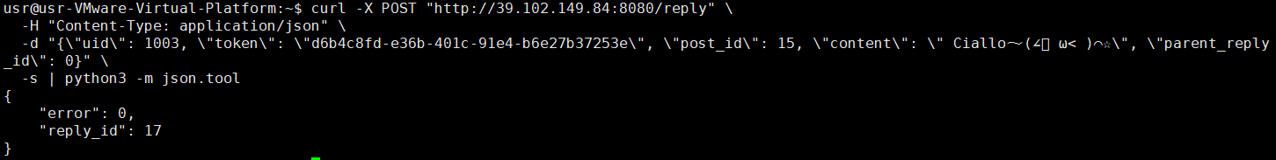

# 3. 创建楼中楼回复（回复某个回复）
curl -X POST "http://39.102.149.84:8080/reply" \
-H "Content-Type: application/json" \
-d "{\"uid\": 1003, \"token\": \"d6b4c8fd-e36b-401c-91e4-b6e27b37253e\", \"post_id\": 15, \"content\": \"sixsixsixhaiyouqianlianwanhua\", \"parent_reply_id\": 12}" \
-s | python3 -m json.tool
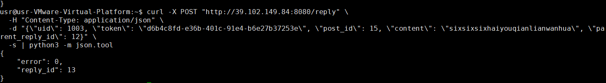

# 4. 删除回复
curl -X POST "http://39.102.149.84:8080/reply/delete" \
-H "Content-Type: application/json" \
-d "{\"uid\": 1003, \"token\": \"d6b4c8fd-e36b-401c-91e4-b6e27b37253e\", \"reply_id\": 12}" \
-s | python3 -m json.tool
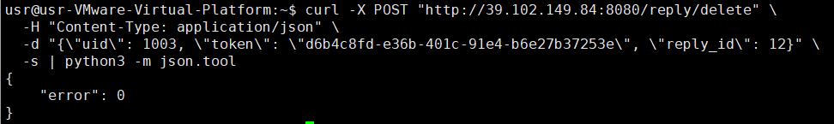

# 5. 点赞/取消点赞回复
curl -X POST "http://39.102.149.84:8080/like_reply" \
-H "Content-Type: application/json" \
-d "{\"uid\": 1003, \"token\": \"d6b4c8fd-e36b-401c-91e4-b6e27b37253e\", \"reply_id\": 17}" \
-s | python3 -m json.tool
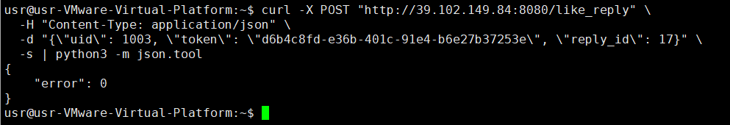
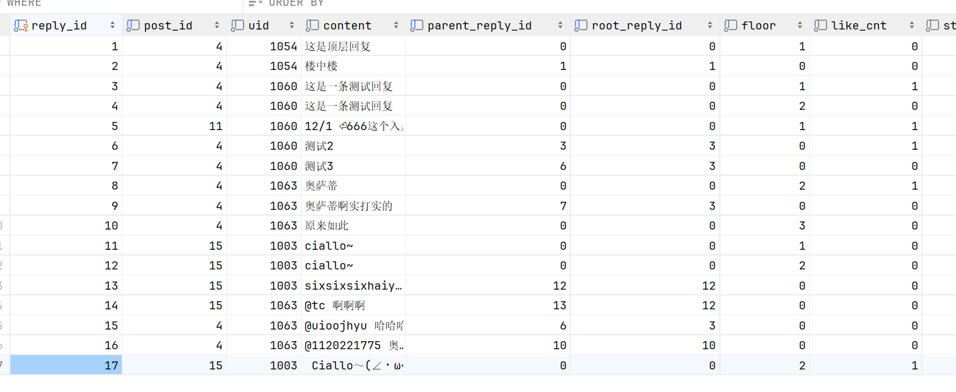
curl -X POST "http://39.102.149.84:8080/unlike_reply" \
-H "Content-Type: application/json" \
-d "{\"uid\": 1003, \"token\": \"d6b4c8fd-e36b-401c-91e4-b6e27b37253e\", \"reply_id\": 17}" \
-s | python3 -m json.tool
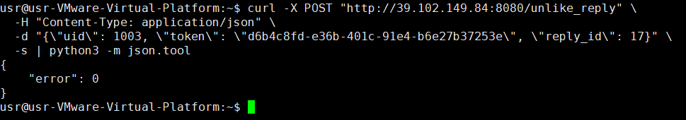

搜索功能接口测试

# 1. 搜索帖子
curl "http://39.102.149.84:8080/search?keyword=接口测试用帖&type=post&page=1&limit=10" \
-s | python3 -m json.tool
提前在三个吧里都设置了同样标题的帖子
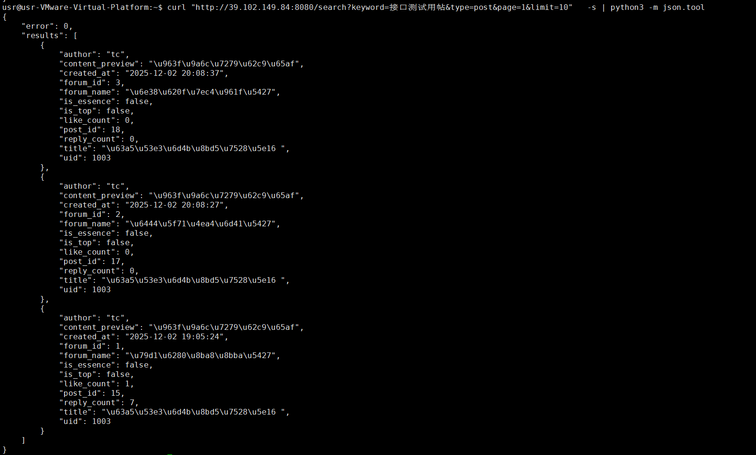
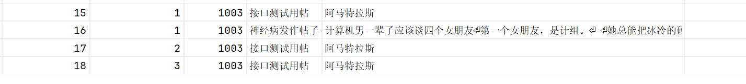

也可以只有关键词匹配
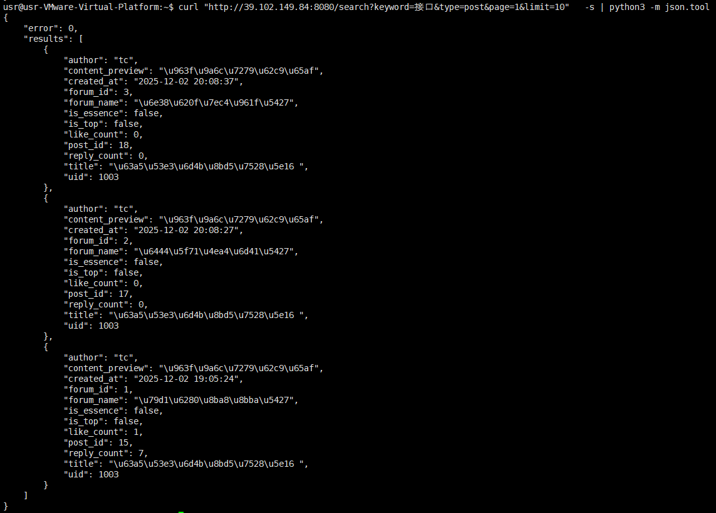

# 2. 在指定贴吧内搜索帖子
curl "http://39.102.149.84:8080/search?keyword=接口测试用帖&type=post&forum_id=1&page=1&limit=10" \
-s | python3 -m json.tool
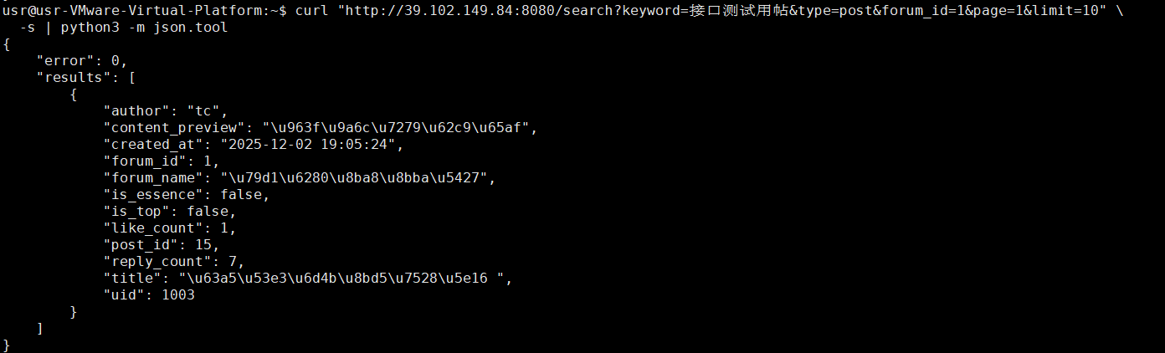
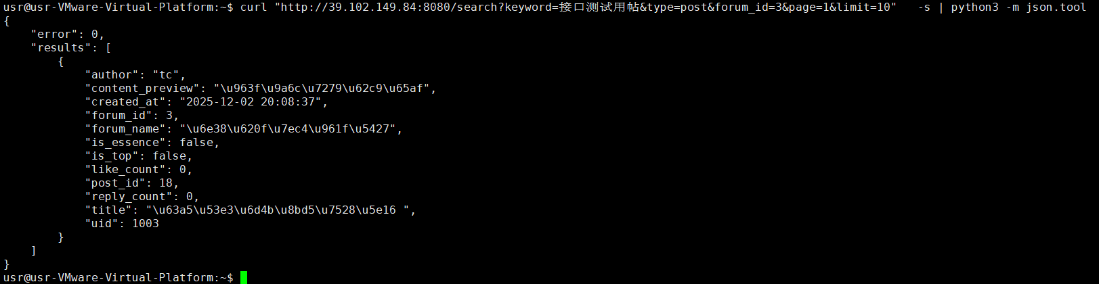

# 3. 搜索贴吧
curl "http://39.102.149.84:8080/search?keyword=游戏组队吧&type=forum&page=1&limit=10" \
-s | python3 -m json.tool
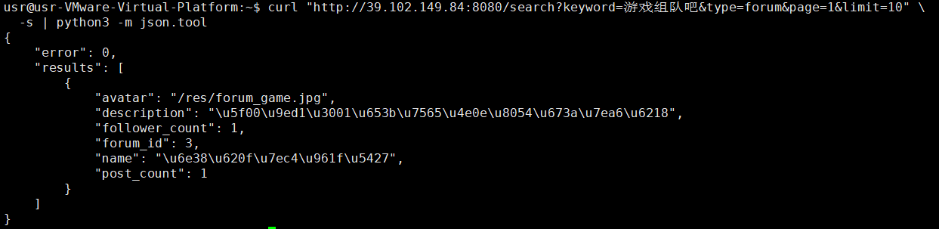

# 4. 搜索用户
curl "http://39.102.149.84:8080/search?keyword=1120221775&type=user&page=1&limit=10" \
-s | python3 -m json.tool
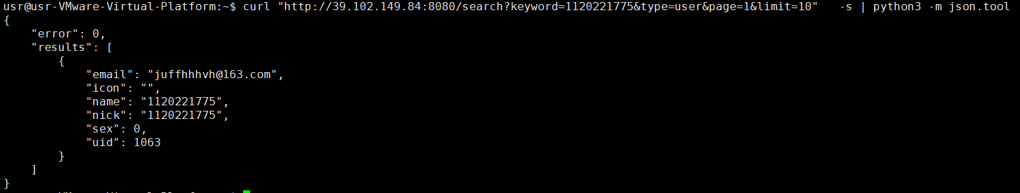

# 5. 空关键词测试
curl "http://39.102.149.84:8080/search?keyword=&type=post&page=1&limit=10" \
-s | python3 -m json.tool
产生空json错误码

用户内容管理接口测试s

# 1. 获取用户发布的帖子
curl "http://39.102.149.84:8080/my/posts?uid=1003&token=d6b4c8fd-e36b-401c-91e4-b6e27b37253e&page=1&limit=10" \
-s | python3 -m json.tool
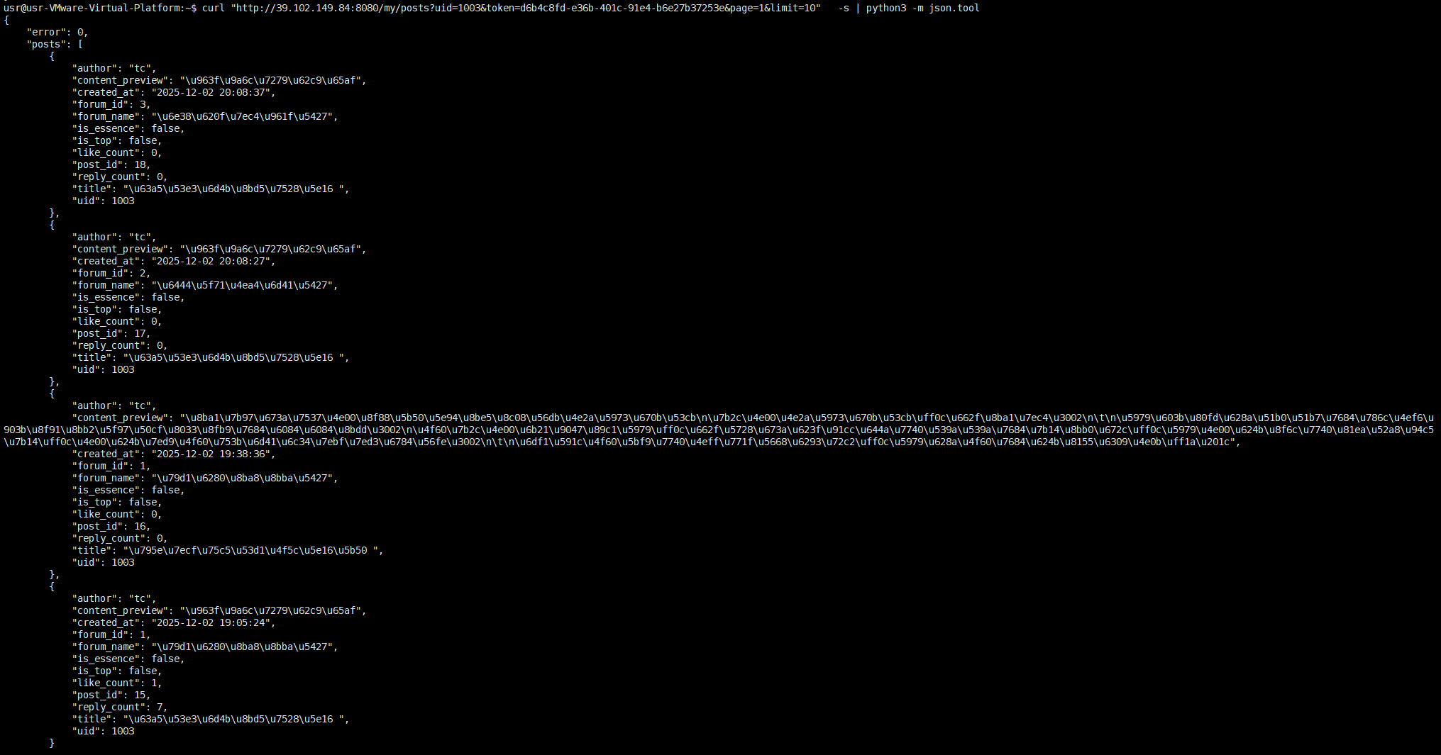

# 2. 获取用户发布的回复
curl "http://39.102.149.84:8080/my/replies?uid=1003&token=d6b4c8fd-e36b-401c-91e4-b6e27b37253e&page=1&limit=10" \
-s | python3 -m json.tool
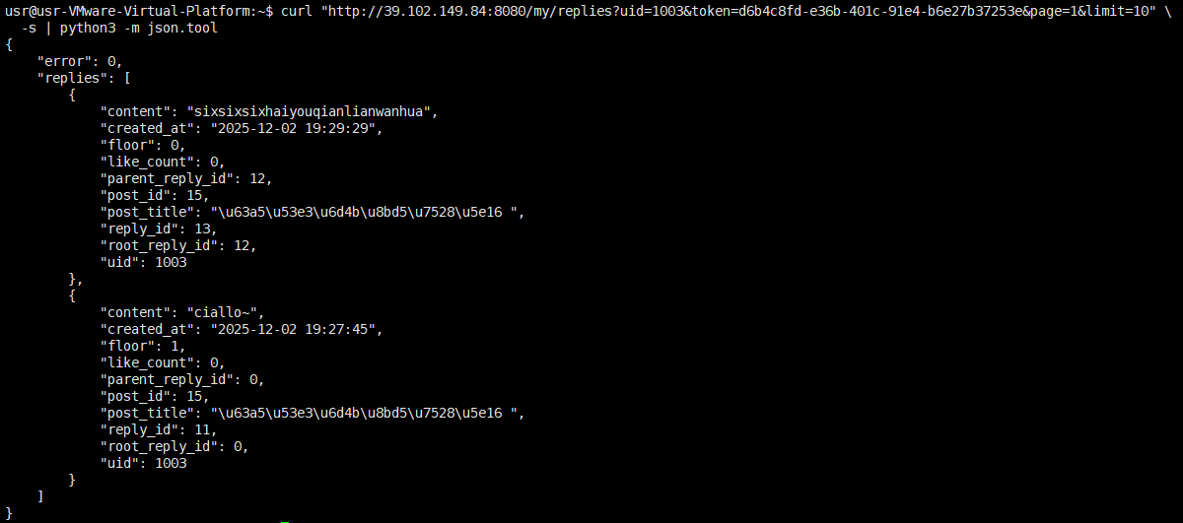

# 3. 获取用户收藏的帖子
curl "http://39.102.149.84:8080/my/collections?uid=1003&token=d6b4c8fd-e36b-401c-91e4-b6e27b37253e&page=1&limit=10" \
-s | python3 -m json.tool
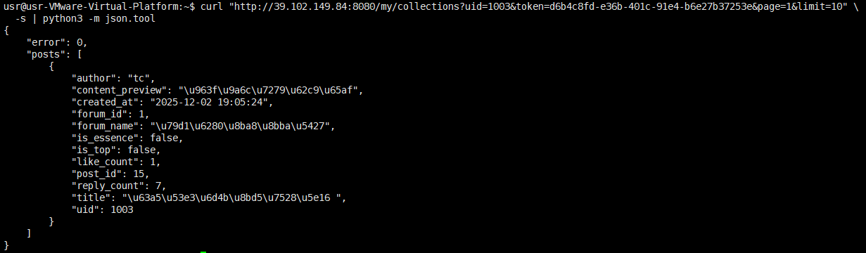

错误码检验
enum ErrorCodes {
Success = 0,
Error_Json = 1001, // Json 解析失败
RPCFailed = 1002, // RPC 调用失败
VarifyExpired = 1003, // 验证码过期
VarifyCodeErr = 1004, // 验证码错误
UserExist = 1005, // 用户已存在
PasswdErr = 1006, // 密码错误
EmailNotMatch = 1007, // 邮箱不匹配
PasswdUpFailed = 1008, // 更新密码失败
PasswdInvalid = 1009, // 密码无效
TokenInvalid = 1010, // Token 失效
UidInvalid = 1011, // uid 无效
ForumNotFound = 1012, // 贴吧不存在
AlreadyFollowed = 1013,// 已关注
NotFollowed = 1014, // 未关注
DbError = 1015, // 数据库错误
PostNotFound = 1016, // 帖子不存在
NoPermission = 1017, // 无权限
AlreadyLiked = 1018, // 已点赞
NotLiked = 1019, // 未点赞
AlreadyCollected = 1020,// 已收藏
NotCollected = 1021, // 未收藏
ReplyNotFound = 1022, // 回复不存在
AlreadyLikedReply = 1023, // 回复已点赞
NotLikedReply = 1024 // 回复未点赞
};

由于基础功能已于之前测试成功，因此错误码测试采用脚本进行
脚本如下：test_error_codes.sh

SERVER="http://39.102.149.84:8080"
LOG_FILE="error_test_$(date +%Y%m%d_%H%M%S).log"

echo "=== HTTP接口错误码测试 ===" | tee -a $LOG_FILE
echo "测试时间: $(date)" | tee -a $LOG_FILE
echo "==========================" | tee -a $LOG_FILE

# 记录函数
log_test() {
echo "[$(date '+%H:%M:%S')] $1" | tee -a $LOG_FILE
}

test_error_case() {
local test_name="$1"
local method="$2"
local endpoint="$3"
local data="$4"
local expected_code="$5"

log_test "测试: $test_name (期望: $expected_code)"

if [ "$method" = "GET" ]; then
response=$(curl -s "$SERVER$endpoint")
else
response=$(curl -s -X $method -H "Content-Type: application/json" -d "$data" "$SERVER$endpoint")
fi

# 解析错误码
actual_code=$(echo "$response" | python3 -c "
import sys, json
try:
data = json.load(sys.stdin)
print(data.get('error', -1))
except:
print(-2)
" 2>/dev/null)

log_test "响应: $response"

if [ "$actual_code" = "$expected_code" ]; then
log_test "✅ 通过: 期望 $expected_code, 实际 $actual_code"
return 0
else
log_test "❌ 失败: 期望 $expected_code, 实际 $actual_code"
return 1
fi
}

echo ""
echo "1. 测试JSON解析错误 (1001)" | tee -a $LOG_FILE
echo "==========================================" | tee -a $LOG_FILE

# 1.1 无效的JSON格式
test_error_case "无效JSON格式" "POST" "/user_login" '{"invalid json' "1001"

# 1.2 缺少引号
test_error_case "缺少引号" "POST" "/user_login" '{email: "test@test.com", passwd: "123"}' "1001"

# 1.3 多余的逗号
test_error_case "多余逗号" "POST" "/user_login" '{"email": "test@test.com", "passwd": "123",}' "1001"

echo ""
echo "2. 测试用户登录相关错误" | tee -a $LOG_FILE
echo "==========================================" | tee -a $LOG_FILE

# 2.1 不存在的邮箱（应该是1009或1011）
test_error_case "不存在的邮箱" "POST" "/user_login" '{"email": "nonexistent@example.com", "passwd": "123456"}' "1009"

# 2.2 错误密码
test_error_case "错误密码" "POST" "/user_login" '{"email": "18165031775@qq.com", "passwd": "wrongpassword"}' "1009"

# 2.3 缺少必填字段
test_error_case "缺少email" "POST" "/user_login" '{"passwd": "123456"}' "1009"
test_error_case "缺少password" "POST" "/user_login" '{"email": "test@test.com"}' "1009"

# 2.4 空字段
test_error_case "空邮箱" "POST" "/user_login" '{"email": "", "passwd": "123456"}' "1009"
test_error_case "空密码" "POST" "/user_login" '{"email": "test@test.com", "passwd": ""}' "1009"

echo ""
echo "3. 测试贴吧相关错误" | tee -a $LOG_FILE
echo "==========================================" | tee -a $LOG_FILE

# 先登录获取一个有效token用于测试
log_test "登录获取有效token..."
LOGIN_RESPONSE=$(curl -s -X POST "$SERVER/user_login" \
-H "Content-Type: application/json" \
-d '{"email": "18165031775@qq.com", "passwd": "123456"}')

VALID_TOKEN=$(echo "$LOGIN_RESPONSE" | python3 -c "
import sys, json
try:
data = json.load(sys.stdin)
print(data.get('token', ''))
except:
print('')
")

VALID_UID=$(echo "$LOGIN_RESPONSE" | python3 -c "
import sys, json
try:
data = json.load(sys.stdin)
print(data.get('uid', ''))
except:
print('')
")

if [ -n "$VALID_TOKEN" ]; then
log_test "获取到有效token: ${VALID_TOKEN:0:20}..."

# 3.1 不存在的贴吧 (1012)
test_error_case "不存在的贴吧ID" "GET" "/forum/detail?forum_id=999999&uid=$VALID_UID&token=$VALID_TOKEN" "" "1012"

# 3.2 无效的贴吧ID格式
test_error_case "非数字贴吧ID" "GET" "/forum/detail?forum_id=abc&uid=$VALID_UID&token=$VALID_TOKEN" "" "1001"

# 3.3 负数的贴吧ID
test_error_case "负数贴吧ID" "GET" "/forum/detail?forum_id=-1&uid=$VALID_UID&token=$VALID_TOKEN" "" "1012"

# 3.4 重复关注（先关注，再关注一次）
log_test "测试重复关注..."
# 先关注一个存在的贴吧
curl -s -X POST "$SERVER/follow_forum" \
-H "Content-Type: application/json" \
-d "{\"uid\": $VALID_UID, \"token\": \"$VALID_TOKEN\", \"forum_id\": 1}" > /dev/null

# 再关注一次（应该成功，但我们可以检查数据库是否处理了重复）
test_error_case "重复关注" "POST" "/follow_forum" "{\"uid\": $VALID_UID, \"token\": \"$VALID_TOKEN\", \"forum_id\": 1}" "1013"

# 3.5 关注不存在的贴吧
test_error_case "关注不存在的贴吧" "POST" "/follow_forum" "{\"uid\": $VALID_UID, \"token\": \"$VALID_TOKEN\", \"forum_id\":999 }" "1012"

# 3.6 取消关注未关注的贴吧
test_error_case "取消未关注的贴吧" "POST" "/unfollow_forum" "{\"uid\": $VALID_UID, \"token\": \"$VALID_TOKEN\", \"forum_id\":3 }" "1014"

else
log_test "❌ 无法获取有效token，跳过贴吧测试"
fi

echo ""
echo "4. 测试Token相关错误 (1010)" | tee -a $LOG_FILE
echo "==========================================" | tee -a $LOG_FILE

# 4.1 无效Token
test_error_case "无效Token" "POST" "/follow_forum" '{"uid": 1001, "token": "invalid_token_123", "forum_id": 1}' "1010"

# 4.2 空Token
test_error_case "空Token" "POST" "/follow_forum" '{"uid": 1001, "token": "", "forum_id": 1}' "1001"

# 4.3 Token与UID不匹配
if [ -n "$VALID_TOKEN" ]; then
test_error_case "Token与UID不匹配" "POST" "/follow_forum" "{\"uid\": 999999, \"token\": \"$VALID_TOKEN\", \"forum_id\": 1}" "1010"
fi

# 4.4 过期的Token（需要模拟token过期）
# 暂时跳过，因为需要知道token过期机制

echo ""
echo "5. 测试帖子相关错误" | tee -a $LOG_FILE
echo "==========================================" | tee -a $LOG_FILE

if [ -n "$VALID_TOKEN" ]; then
# 5.1 获取不存在的帖子详情 (1016)
test_error_case "不存在的帖子" "GET" "/post/detail?post_id=999999&uid=$VALID_UID&token=$VALID_TOKEN" "" "1016"

# 5.2 在不存在贴吧发帖
test_error_case "在不存在贴吧发帖" "POST" "/post/create" "{\"uid\": $VALID_UID, \"token\": \"$VALID_TOKEN\", \"forum_id\": 999999, \"title\": \"测试\", \"content\": \"测试内容\"}" "1012"

# 5.3 更新不存在的帖子
test_error_case "更新不存在的帖子" "POST" "/post/update" "{\"uid\": $VALID_UID, \"token\": \"$VALID_TOKEN\", \"post_id\": 999999, \"title\": \"新标题\", \"content\": \"新内容\"}" "1016"

# 5.4 删除不存在的帖子
test_error_case "删除不存在的帖子" "POST" "/post/delete" "{\"uid\": $VALID_UID, \"token\": \"$VALID_TOKEN\", \"post_id\": 999999}" "1016"

# 5.5 无权限操作（非作者删除帖子）
# 先创建一个帖子
log_test "创建测试帖子用于权限测试..."
CREATE_RESPONSE=$(curl -s -X POST "$SERVER/post/create" \
-H "Content-Type: application/json" \
-d "{\"uid\": $VALID_UID, \"token\": \"$VALID_TOKEN\", \"forum_id\": 1, \"title\": \"权限测试帖子\", \"content\": \"用于测试权限\"}")

TEST_POST_ID=$(echo "$CREATE_RESPONSE" | python3 -c "
import sys, json
try:
data = json.load(sys.stdin)
print(data.get('post_id', 0))
except:
print(0)
")

if [ "$TEST_POST_ID" -gt 0 ]; then
log_test "创建了测试帖子 ID: $TEST_POST_ID"

# 使用另一个"用户"尝试删除（模拟无权限）
test_error_case "无权限删除帖子" "POST" "/post/delete" "{\"uid\": 999999, \"token\": \"invalid_token\", \"post_id\": $TEST_POST_ID}" "1010"

# 清理：删除测试帖子
curl -s -X POST "$SERVER/post/delete" \
-H "Content-Type: application/json" \
-d "{\"uid\": $VALID_UID, \"token\": \"$VALID_TOKEN\", \"post_id\": $TEST_POST_ID}" > /dev/null
fi

# 5.6 置顶/加精权限测试（非贴吧owner）
# 先获取一个帖子ID
POSTS_RESPONSE=$(curl -s "$SERVER/posts?forum_id=1&page=1&limit=1")
SAMPLE_POST_ID=$(echo "$POSTS_RESPONSE" | python3 -c "
import sys, json
try:
data = json.load(sys.stdin)
posts = data.get('posts', [])
if posts:
print(posts[0].get('post_id', 0))
else:
print(0)
except:
print(0)
")

if [ "$SAMPLE_POST_ID" -gt 0 ]; then
test_error_case "非贴吧owner置顶" "POST" "/set_top_post" "{\"uid\": $VALID_UID, \"token\": \"$VALID_TOKEN\", \"post_id\": $SAMPLE_POST_ID, \"is_top\": true}" "1017"
test_error_case "非贴吧owner加精" "POST" "/set_essence_post" "{\"uid\": $VALID_UID, \"token\": \"$VALID_TOKEN\", \"post_id\": $SAMPLE_POST_ID, \"is_essence\": true}" "1017"
fi
fi

echo ""
echo "6. 测试回复相关错误" | tee -a $LOG_FILE
echo "==========================================" | tee -a $LOG_FILE

if [ -n "$VALID_TOKEN" ]; then
# 6.1 回复不存在的帖子
test_error_case "回复不存在的帖子" "POST" "/reply" "{\"uid\": $VALID_UID, \"token\": \"$VALID_TOKEN\", \"post_id\": 999999, \"content\": \"测试回复\", \"parent_reply_id\": 0}" "1016"

# 6.2 回复不存在的父回复
if [ "$SAMPLE_POST_ID" -gt 0 ]; then
test_error_case "回复不存在的父回复" "POST" "/reply" "{\"uid\": $VALID_UID, \"token\": \"$VALID_TOKEN\", \"post_id\": $SAMPLE_POST_ID, \"content\": \"测试回复\", \"parent_reply_id\": 999}" "1015"
fi

# 6.3 删除不存在的回复
test_error_case "删除不存在的回复" "POST" "/reply/delete" "{\"uid\": $VALID_UID, \"token\": \"$VALID_TOKEN\", \"reply_id\": 150}" "1022"
fi

echo ""
echo "7. 测试搜索功能错误" | tee -a $LOG_FILE
echo "==========================================" | tee -a $LOG_FILE

# 7.1 空关键词搜索
test_error_case "空关键词搜索" "GET" "/search?keyword=&type=post&page=1&limit=10" "" "1001" # 返回错误

# 7.2 无效的搜索类型
test_error_case "无效搜索类型" "GET" "/search?keyword=test&type=invalid&page=1&limit=10" "" "1001" # 返回错误

echo ""
echo "8. 测试用户内容管理错误" | tee -a $LOG_FILE
echo "==========================================" | tee -a $LOG_FILE

# 8.1 无效Token查看用户内容
test_error_case "无效Token查看我的帖子" "GET" "/my/posts?uid=1001&token=invalid_token&page=1&limit=10" "" "1010"

# 8.2 无权限查看他人内容（如果能测的话）
# 这个可能需要具体实现支持

echo ""
echo "9. 测试注册相关错误" | tee -a $LOG_FILE
echo "==========================================" | tee -a $LOG_FILE

# 9.1 用户已存在 (1005)
# 需要知道一个已存在的用户名和邮箱
test_error_case "用户名已存在" "POST" "/user_register" '{"email": "secondtonone1@163.com", "user": "tc", "passwd": "123456", "confirm": "123456", "icon": "", "varifycode": "123456"}' "1003"

test_error_case "邮箱已存在" "POST" "/user_register" '{"email": "18165031775@qq.com", "user": "newusersss", "passwd": "123456", "confirm": "123456", "icon": "", "varifycode": "123456"}' "1003"

# 9.2 两次密码不一致 (1006)
test_error_case "密码不一致" "POST" "/user_register" '{"email": "testregister@example.com", "user": "testregister", "passwd": "123456", "confirm": "654321", "icon": "", "varifycode": "123456"}' "1006"

# 9.3 验证码错误 (1004)
test_error_case "验证码错误" "POST" "/user_register" '{"email": "testregister@example.com", "user": "testregister", "passwd": "123456", "confirm": "123456", "icon": "", "varifycode": "wrongcode"}' "1003"

# 9.4 验证码过期 (1003)
# 需要有一个过期的验证码，暂时跳过

echo ""
echo "10. 边界值和异常输入测试" | tee -a $LOG_FILE
echo "==========================================" | tee -a $LOG_FILE

# 10.1 超长输入
LONG_STRING=$(printf '%*s' 10000 | tr ' ' 'x')
test_error_case "超长标题" "POST" "/post/create" "{\"uid\": $VALID_UID, \"token\": \"$VALID_TOKEN\", \"forum_id\": 1, \"title\": \"$LONG_STRING\", \"content\": \"测试内容\"}" "1015" # 可能成功或失败

# 10.2 SQL注入尝试（应该被参数化查询阻止）
test_error_case "SQL注入标题" "POST" "/post/create" "{\"uid\": $VALID_UID, \"token\": \"$VALID_TOKEN\", \"forum_id\": 1, \"title\": \"test'); DROP TABLE forum; --\", \"content\": \"测试内容\"}" "0"

# 10.3 XSS尝试
test_error_case "XSS内容" "POST" "/post/create" "{\"uid\": $VALID_UID, \"token\": \"$VALID_TOKEN\", \"forum_id\": 1, \"title\": \"测试标题\", \"content\": \"<script>alert('xss')</script>\"}" "0"

# 10.4 特殊字符
test_error_case "特殊字符" "POST" "/post/create" "{\"uid\": $VALID_UID, \"token\": \"$VALID_TOKEN\", \"forum_id\": 1, \"title\": \"测试!@#$%^&*()标题\", \"content\": \"内容!@#$%^&*()\"}" "0"

echo ""
echo "11. 测试分页参数错误" | tee -a $LOG_FILE
echo "==========================================" | tee -a $LOG_FILE

# 11.1 无效的分页参数
test_error_case "负数的页码" "GET" "/forums?page=-1&limit=10" "" "0"
test_error_case "零页码" "GET" "/forums?page=0&limit=10" "" "0"
test_error_case "负数的每页数量" "GET" "/forums?page=1&limit=-1" "" "0"
test_error_case "零每页数量" "GET" "/forums?page=1&limit=0" "" "0"
test_error_case "超大每页数量" "GET" "/forums?page=1&limit=10000" "" "0"

# 11.2 非数字参数
test_error_case "非数字页码" "GET" "/forums?page=abc&limit=10" "" "1001"
test_error_case "非数字每页数量" "GET" "/forums?page=1&limit=abc" "" "1001"

echo ""
echo "=== 测试总结 ===" | tee -a $LOG_FILE
echo "详细日志已保存到: $LOG_FILE" | tee -a $LOG_FILE
echo "==========================" | tee -a $LOG_FILE

# 显示错误码统计
echo ""
echo "📊 测试的错误码分布:"
grep -o '"error":[0-9]*' "$LOG_FILE" | sed 's/"error"://' | sort | uniq -c | sort -rn | tee -a $LOG_FILE

echo ""
echo "建议:"
echo "1. 检查未覆盖的错误码"
echo "2. 重点关注返回码不是期望值的测试用例"
echo "3. 查看日志文件获取详细响应信息"

得到的结果存于：error_test_20251203_001828.log

=== HTTP接口错误码测试 ===
测试时间: Wed Dec 3 12:18:28 AM CST 2025
==========================
1. 测试JSON解析错误 (1001)
==========================================
[00:18:28] 测试: 无效JSON格式 (期望: 1001)
[00:18:28] 响应: {
"error" : 1001
}
[00:18:28] ✅ 通过: 期望 1001, 实际 1001
[00:18:28] 测试: 缺少引号 (期望: 1001)
[00:18:28] 响应: {
"error" : 1001
}
[00:18:28] ✅ 通过: 期望 1001, 实际 1001
[00:18:28] 测试: 多余逗号 (期望: 1001)
[00:18:28] 响应: {
"error" : 1001
}
[00:18:28] ✅ 通过: 期望 1001, 实际 1001
2. 测试用户登录相关错误
==========================================
[00:18:28] 测试: 不存在的邮箱 (期望: 1009)
[00:18:28] 响应: {
"error" : 1009
}
[00:18:28] ✅ 通过: 期望 1009, 实际 1009
[00:18:28] 测试: 错误密码 (期望: 1009)
[00:18:29] 响应: {
"error" : 1009
}
[00:18:29] ✅ 通过: 期望 1009, 实际 1009
[00:18:29] 测试: 缺少email (期望: 1009)
[00:18:29] 响应: {
"error" : 1009
}
[00:18:29] ✅ 通过: 期望 1009, 实际 1009
[00:18:29] 测试: 缺少password (期望: 1009)
[00:18:29] 响应: {
"error" : 1009
}
[00:18:29] ✅ 通过: 期望 1009, 实际 1009
[00:18:29] 测试: 空邮箱 (期望: 1009)
[00:18:29] 响应: {
"error" : 1009
}
[00:18:29] ✅ 通过: 期望 1009, 实际 1009
[00:18:29] 测试: 空密码 (期望: 1009)
[00:18:29] 响应: {
"error" : 1009
}
[00:18:29] ✅ 通过: 期望 1009, 实际 1009
3. 测试贴吧相关错误
==========================================
[00:18:29] 登录获取有效token...
[00:18:29] 获取到有效token: 417404f8-08a6-41ef-9...
[00:18:29] 测试: 不存在的贴吧ID (期望: 1012)
[00:18:30] 响应: {
"error" : 1012
}
[00:18:30] ✅ 通过: 期望 1012, 实际 1012
[00:18:30] 测试: 非数字贴吧ID (期望: 1001)
[00:18:30] 响应: {
"error" : 1001
}
[00:18:30] ✅ 通过: 期望 1001, 实际 1001
[00:18:30] 测试: 负数贴吧ID (期望: 1012)
[00:18:30] 响应: {
"error" : 1012
}
[00:18:30] ✅ 通过: 期望 1012, 实际 1012
[00:18:30] 测试重复关注...
[00:18:30] 测试: 重复关注 (期望: 1013)
[00:18:30] 响应: {
"error" : 1013
}
[00:18:30] ✅ 通过: 期望 1013, 实际 1013
[00:18:30] 测试: 关注不存在的贴吧 (期望: 1012)
[00:18:30] 响应: {
"error" : 1012
}
[00:18:30] ✅ 通过: 期望 1012, 实际 1012
[00:18:30] 测试: 取消未关注的贴吧 (期望: 1014)
[00:18:30] 响应: {
"error" : 1014
}
[00:18:30] ✅ 通过: 期望 1014, 实际 1014
4. 测试Token相关错误 (1010)
==========================================
[00:18:30] 测试: 无效Token (期望: 1010)
[00:18:31] 响应: {
"error" : 1010
}
[00:18:31] ✅ 通过: 期望 1010, 实际 1010
[00:18:31] 测试: 空Token (期望: 1001)
[00:18:31] 响应: {
"error" : 1001
}
[00:18:31] ✅ 通过: 期望 1001, 实际 1001
[00:18:31] 测试: Token与UID不匹配 (期望: 1010)
[00:18:31] 响应: {
"error" : 1010
}
[00:18:31] ✅ 通过: 期望 1010, 实际 1010
5. 测试帖子相关错误
==========================================
[00:18:31] 测试: 不存在的帖子 (期望: 1016)
[00:18:31] 响应: {
"error" : 1016
}
[00:18:31] ✅ 通过: 期望 1016, 实际 1016
[00:18:31] 测试: 在不存在贴吧发帖 (期望: 1012)
[00:18:31] 响应: {
"error" : 1012
}
[00:18:31] ✅ 通过: 期望 1012, 实际 1012
[00:18:31] 测试: 更新不存在的帖子 (期望: 1016)
[00:18:31] 响应: {
"error" : 1016
}
[00:18:31] ✅ 通过: 期望 1016, 实际 1016
[00:18:31] 测试: 删除不存在的帖子 (期望: 1016)
[00:18:32] 响应: {
"error" : 1016
}
[00:18:32] ✅ 通过: 期望 1016, 实际 1016
[00:18:32] 创建测试帖子用于权限测试...
[00:18:32] 创建了测试帖子 ID: 31
[00:18:32] 测试: 无权限删除帖子 (期望: 1010)
[00:18:32] 响应: {
"error" : 1010
}
[00:18:32] ✅ 通过: 期望 1010, 实际 1010
[00:18:32] 测试: 非贴吧owner置顶 (期望: 1017)
[00:18:32] 响应: {
"error" : 1017
}
[00:18:32] ✅ 通过: 期望 1017, 实际 1017
[00:18:32] 测试: 非贴吧owner加精 (期望: 1017)
[00:18:32] 响应: {
"error" : 1017
}
[00:18:32] ✅ 通过: 期望 1017, 实际 1017
6. 测试回复相关错误
==========================================
[00:18:32] 测试: 回复不存在的帖子 (期望: 1016)
[00:18:32] 响应: {
"error" : 1016
}
[00:18:32] ✅ 通过: 期望 1016, 实际 1016
[00:18:32] 测试: 回复不存在的父回复 (期望: 1015)
[00:18:33] 响应: {
"error" : 1015
}
[00:18:33] ✅ 通过: 期望 1015, 实际 1015
[00:18:33] 测试: 删除不存在的回复 (期望: 1022)
[00:18:33] 响应: {
"error" : 1022
}
[00:18:33] ✅ 通过: 期望 1022, 实际 1022
7. 测试搜索功能错误
==========================================
[00:18:33] 测试: 空关键词搜索 (期望: 1001)
[00:18:33] 响应: {
"error" : 1001
}
[00:18:33] ✅ 通过: 期望 1001, 实际 1001
[00:18:33] 测试: 无效搜索类型 (期望: 1001)
[00:18:33] 响应: {
"error" : 1001
}
[00:18:33] ✅ 通过: 期望 1001, 实际 1001
8. 测试用户内容管理错误
==========================================
[00:18:33] 测试: 无效Token查看我的帖子 (期望: 1010)
[00:18:33] 响应: {
"error" : 1010
}
[00:18:33] ✅ 通过: 期望 1010, 实际 1010
9. 测试注册相关错误
==========================================
[00:18:33] 测试: 用户名已存在 (期望: 1003)
[00:18:33] 响应: {
"error" : 1003
}
[00:18:33] ✅ 通过: 期望 1003, 实际 1003
[00:18:33] 测试: 邮箱已存在 (期望: 1003)
[00:18:33] 响应: {
"error" : 1003
}
[00:18:33] ✅ 通过: 期望 1003, 实际 1003
[00:18:33] 测试: 密码不一致 (期望: 1006)
[00:18:33] 响应: {
"error" : 1006
}
[00:18:33] ✅ 通过: 期望 1006, 实际 1006
[00:18:33] 测试: 验证码错误 (期望: 1003)
[00:18:33] 响应: {
"error" : 1003
}
[00:18:33] ✅ 通过: 期望 1003, 实际 1003
10. 边界值和异常输入测试
==========================================
[00:18:33] 测试: 超长标题 (期望: 1015)
[00:18:34] 响应: {
"error" : 1015
}
[00:18:34] ✅ 通过: 期望 1015, 实际 1015
[00:18:34] 测试: SQL注入标题 (期望: 0)
[00:18:34] 响应: {
"error" : 0,
"post_id" : 32
}
[00:18:34] ✅ 通过: 期望 0, 实际 0
[00:18:34] 测试: XSS内容 (期望: 0)
[00:18:34] 响应: {
"error" : 0,
"post_id" : 33
}
[00:18:34] ✅ 通过: 期望 0, 实际 0
[00:18:34] 测试: 特殊字符 (期望: 0)
[00:18:34] 响应: {
"error" : 0,
"post_id" : 34
}
[00:18:34] ✅ 通过: 期望 0, 实际 0
11. 测试分页参数错误
==========================================
[00:18:34] 测试: 负数的页码 (期望: 0)
[00:18:34] 响应: {
"error" : 0,
"forums" :
[
{
"avatar" : "/res/forum_tech.jpg",
"description" : "\u804a\u786c\u4ef6/AI/\u540e\u7aef",
"follower_count" : 2,
"forum_id" : 1,
"name" : "\u79d1\u6280\u8ba8\u8bba\u5427",
"post_count" : 25
},
{
"avatar" : "/res/forum_photo.jpg",
"description" : "\u5668\u6750\u3001\u540e\u671f\u4e0e\u65c5\u62cd\u5206\u4eab",
"follower_count" : 2,
"forum_id" : 2,
"name" : "\u6444\u5f71\u4ea4\u6d41\u5427",
"post_count" : 2
},
{
"avatar" : "/res/forum_game.jpg",
"description" : "\u5f00\u9ed1\u3001\u653b\u7565\u4e0e\u8054\u673a\u7ea6\u6218",
"follower_count" : 1,
"forum_id" : 3,
"name" : "\u6e38\u620f\u7ec4\u961f\u5427",
"post_count" : 1
}
]
}
[00:18:34] ✅ 通过: 期望 0, 实际 0
[00:18:34] 测试: 零页码 (期望: 0)
[00:18:34] 响应: {
"error" : 0,
"forums" :
[
{
"avatar" : "/res/forum_tech.jpg",
"description" : "\u804a\u786c\u4ef6/AI/\u540e\u7aef",
"follower_count" : 2,
"forum_id" : 1,
"name" : "\u79d1\u6280\u8ba8\u8bba\u5427",
"post_count" : 25
},
{
"avatar" : "/res/forum_photo.jpg",
"description" : "\u5668\u6750\u3001\u540e\u671f\u4e0e\u65c5\u62cd\u5206\u4eab",
"follower_count" : 2,
"forum_id" : 2,
"name" : "\u6444\u5f71\u4ea4\u6d41\u5427",
"post_count" : 2
},
{
"avatar" : "/res/forum_game.jpg",
"description" : "\u5f00\u9ed1\u3001\u653b\u7565\u4e0e\u8054\u673a\u7ea6\u6218",
"follower_count" : 1,
"forum_id" : 3,
"name" : "\u6e38\u620f\u7ec4\u961f\u5427",
"post_count" : 1
}
]
}
[00:18:34] ✅ 通过: 期望 0, 实际 0
[00:18:34] 测试: 负数的每页数量 (期望: 0)
[00:18:34] 响应: {
"error" : 0,
"forums" :
[
{
"avatar" : "/res/forum_tech.jpg",
"description" : "\u804a\u786c\u4ef6/AI/\u540e\u7aef",
"follower_count" : 2,
"forum_id" : 1,
"name" : "\u79d1\u6280\u8ba8\u8bba\u5427",
"post_count" : 25
},
{
"avatar" : "/res/forum_photo.jpg",
"description" : "\u5668\u6750\u3001\u540e\u671f\u4e0e\u65c5\u62cd\u5206\u4eab",
"follower_count" : 2,
"forum_id" : 2,
"name" : "\u6444\u5f71\u4ea4\u6d41\u5427",
"post_count" : 2
},
{
"avatar" : "/res/forum_game.jpg",
"description" : "\u5f00\u9ed1\u3001\u653b\u7565\u4e0e\u8054\u673a\u7ea6\u6218",
"follower_count" : 1,
"forum_id" : 3,
"name" : "\u6e38\u620f\u7ec4\u961f\u5427",
"post_count" : 1
}
]
}
[00:18:34] ✅ 通过: 期望 0, 实际 0
[00:18:34] 测试: 零每页数量 (期望: 0)
[00:18:34] 响应: {
"error" : 0,
"forums" :
[
{
"avatar" : "/res/forum_tech.jpg",
"description" : "\u804a\u786c\u4ef6/AI/\u540e\u7aef",
"follower_count" : 2,
"forum_id" : 1,
"name" : "\u79d1\u6280\u8ba8\u8bba\u5427",
"post_count" : 25
},
{
"avatar" : "/res/forum_photo.jpg",
"description" : "\u5668\u6750\u3001\u540e\u671f\u4e0e\u65c5\u62cd\u5206\u4eab",
"follower_count" : 2,
"forum_id" : 2,
"name" : "\u6444\u5f71\u4ea4\u6d41\u5427",
"post_count" : 2
},
{
"avatar" : "/res/forum_game.jpg",
"description" : "\u5f00\u9ed1\u3001\u653b\u7565\u4e0e\u8054\u673a\u7ea6\u6218",
"follower_count" : 1,
"forum_id" : 3,
"name" : "\u6e38\u620f\u7ec4\u961f\u5427",
"post_count" : 1
}
]
}
[00:18:34] ✅ 通过: 期望 0, 实际 0
[00:18:35] 测试: 超大每页数量 (期望: 0)
[00:18:35] 响应: {
"error" : 0,
"forums" :
[
{
"avatar" : "/res/forum_tech.jpg",
"description" : "\u804a\u786c\u4ef6/AI/\u540e\u7aef",
"follower_count" : 2,
"forum_id" : 1,
"name" : "\u79d1\u6280\u8ba8\u8bba\u5427",
"post_count" : 25
},
{
"avatar" : "/res/forum_photo.jpg",
"description" : "\u5668\u6750\u3001\u540e\u671f\u4e0e\u65c5\u62cd\u5206\u4eab",
"follower_count" : 2,
"forum_id" : 2,
"name" : "\u6444\u5f71\u4ea4\u6d41\u5427",
"post_count" : 2
},
{
"avatar" : "/res/forum_game.jpg",
"description" : "\u5f00\u9ed1\u3001\u653b\u7565\u4e0e\u8054\u673a\u7ea6\u6218",
"follower_count" : 1,
"forum_id" : 3,
"name" : "\u6e38\u620f\u7ec4\u961f\u5427",
"post_count" : 1
}
]
}
[00:18:35] ✅ 通过: 期望 0, 实际 0
[00:18:35] 测试: 非数字页码 (期望: 1001)
[00:18:35] 响应: {
"error" : 1001
}
[00:18:35] ✅ 通过: 期望 1001, 实际 1001
[00:18:35] 测试: 非数字每页数量 (期望: 1001)
[00:18:35] 响应: {
"error" : 1001
}
[00:18:35] ✅ 通过: 期望 1001, 实际 1001
=== 测试总结 ===
详细日志已保存到: error_test_20251203_001828.log
==========================

