Shape in document xml:

Bookmark in document xml:

Second shape in document xml

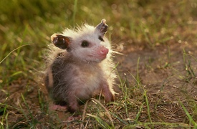

Hidden bookmark in document xml

Third shape in document xml

Comments everywhere.

Footnotes[1] for[2] more[3] objects[4] in[5] notes[6].

1. FN shape here:

   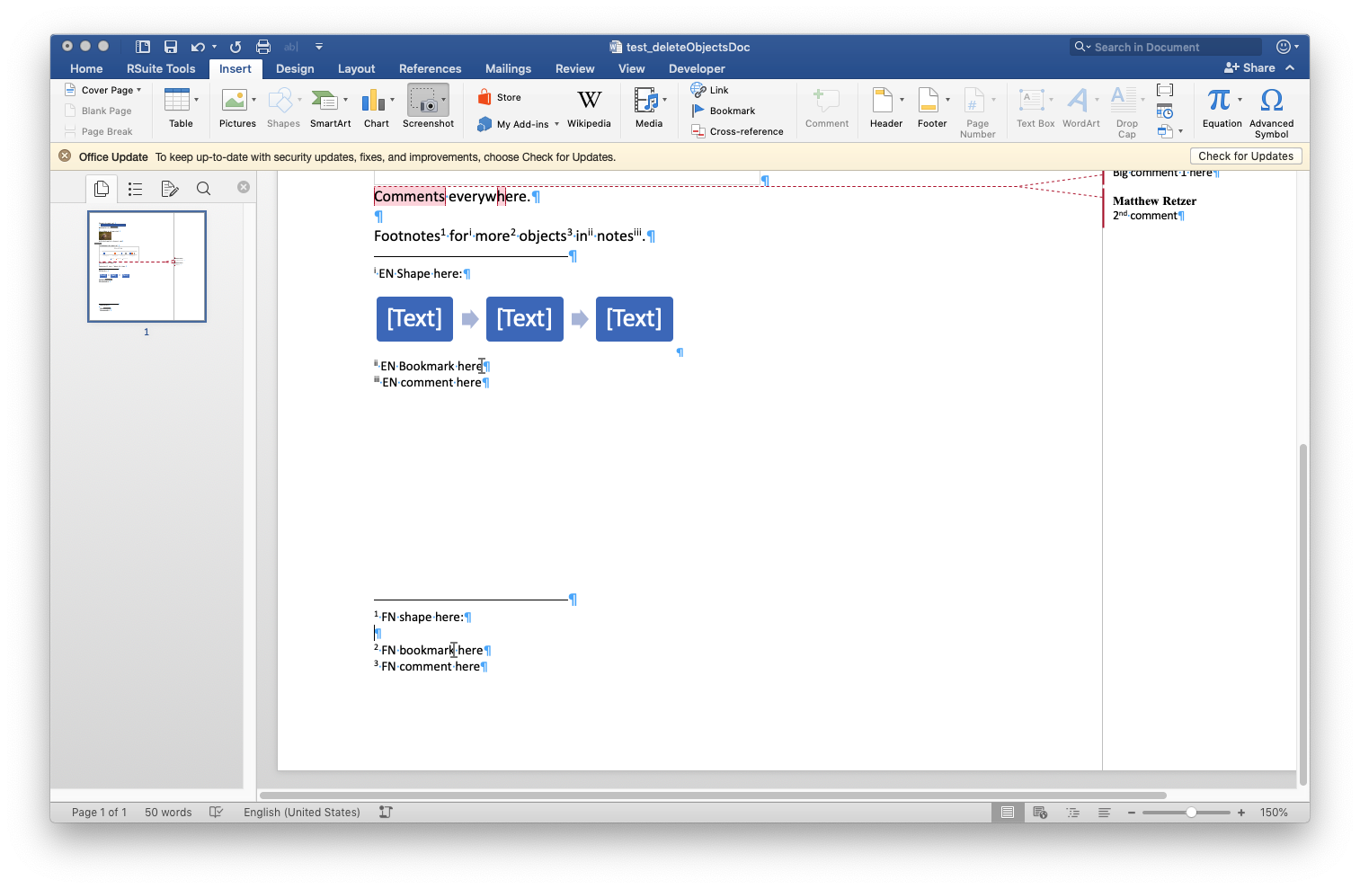
2. EN Shape here:
3. FN bookmark here
4. FN comment here
5. EN Bookmark here
6. EN comment here: NOT ALLOWED!?