**Datasets for IWG Report on Energy Communities**

This folder contains *.csv files for all the datasets associated with figures in the Initial Report to the President on Empowering Workers Through Revitalizing Energy Communities (available at: <https://netl.doe.gov/sites/default/files/2021-04/Initial%20Report%20on%20Energy%20Communities_Apr2021.pdf>) from the Interagency Working Group for Coal and Power Plant Communities.

These data align to the White House’s The Interagency Working Group on Coal and Power Plant Communities and Economic Revitalization, <https://energycommunities.gov/>

Link to datasets: [Datasets for IWG Report on Energy Communities - Submissions - EDX (doe.gov)](https://edx.netl.doe.gov/dataset/datasets-for-iwg-report-on-energy-communities)

Citation for Datasets:

Jennifer Bauer, Kelly Rose, Briggs White, Interagency Working Group for Coal and Power Plant Communities, Datasets for IWG Report on Energy Communities, 2/18/2022, https://edx.netl.doe.gov/dataset/datasets-for-iwg-report-on-energy-communities, DOI: 10.18141/1787670

**CSV files available:**

* CLOSED_CoalMines_btwn2005_2020.csv
  + Represents abandoned or abandoned and sealed coal mines in the U.S. between 1/1/2005 and 12/31/2020.
    - These data are modified from the U.S. Energy Information Administration, Form EIA-7A "Coal Production and Preparation Report" and the U.S. Department of Labor, Mine Safety and Health Administration Form 7000-2, "Quarterly Mine Employment and Coal Production Report.“
      * Original data available at: <https://atlas.eia.gov/datasets/eia::coal-mines/about>
  + Data Fields
    - OID_ - unique identifier
    - MINE_ID – Mine’s Identifier (ID) from the Department of Labor’s, Mine Safety and Health Administration (MSHA)
    - CURRENT_MINE_NAME – Name of the Mine from MSHA
    - COAL_METAL_IND – Material produced from the mine (C = coal) from MSHA
    - CURRENT_MINE_TYPE – Surface, Underground, or facility
    - CURRENT_MINE_STATUS – Reported Status of Mine, as of the current status date provided to MSHA. Since this dataset is focused on coal mines, only mines with a status of abandoned or abandoned and sealed are provided.
    - CURRENT_STATUS_DT – date current status was reported to MSHA
    - YEAR_CLOSED – If mine has a status of abandoned or abandoned and sealed, the year that status was reported
    - County_GEOID – Unique Geographic identifier for the U.S. County and State where the mine is located, per U.S. Census Bureau’s 2021 definitions
    - County Name – U.S. County where the mine is located, per U.S. Census Bureau’s 2021 definitions
    - State – State where the mine is located, per U.S. Census Bureau’s 2021 definitions
    - State code – 2 letter state code for where the mine is located, per U.S. Census Bureau’s 2021 definitions
* RETIREDPowerPlants_wCoalGen_btwn2005_2020.csv
  + Records for Coal Generators retired between 1/1/2005 and 12/31/2020 for U.S. power plants.
    - Data was modified from the EIA and paired with information extracted from 2019 EIA-860 forms to provide generator-level data for the surveyed generators, split into operable (i.e., generators which are currently operating, out of service or on standby), proposed (i.e., generators which are planned and not yet in operation), and retired/canceled (i.e., generators which were cancelled prior to completion and operation as well as retired generators at existing plants). These data were joined with the spatial records for coal powered electric generating plants in the U.S. with a combined nameplate capacity of 1 megawatt or more that are operating, are on standby, are retired, or are temporarily or permanently out of service (EIA, 2019).
      * Link to EIA spatial data: <https://atlas.eia.gov/maps/power-plants-1/about>
      * Link to EIA-890 forms: <https://www.eia.gov/electricity/data/eia860/>
  + Data Fields
    - OID_ - unique identifier
    - Entity_ID – Identification number of plant operator
    - Plant_Name – Name of plant where coal generator is operating
    - Nameplate_Capacity__MW_ - nameplate capacity (in MW) of coal generator
    - Technology - Coal generator’s technology
    - Operating_Year - Year of coal generator’s operation
    - Retirement_Year – Year of coal generator’s retirement
    - County_GEOID - Unique Geographic identifier for the U.S. County and State where the plant is located, per U.S. Census Bureau’s 2021 definitions
    - County Name - U.S. County where the plant is located, per U.S. Census Bureau’s 2021 definitions
    - State - State where the plant is located, per U.S. Census Bureau’s 2021 definitions
    - State code - 2 letter state code for where the plant is located, per U.S. Census Bureau’s 2021 definitions
* IWG_Top75_BLS_MSAs_byFEEmpRank.csv
  + Rank of Metropolitan or Non-metropolitan Statistical Areas (MSAs) across the U.S. based off the total number of employees in each MSA with direct fossil energy (FE) related employment (including extraction and power generation; Fig. 1) and within 200km of a coal mine, coal or natural gas power plant, or oil and/or gas well. These FE related employment values were then divided by the total number employees for all occupational codes in the MSA to create a percentage rank for each MSA. The top 75 MSAs for FE related employment are provided.
  + Table 1 provides details on which Occupational Employment Statistic (OES) codes were used to quantify direct FE related employment numbers.
  + Data Fields
    - OID_ – unique identifier
    - BLS_MSA_Name – Name of the Metropolitan or Non-metropolitan Statistical Area (MSA), as defined by the Bureau of Labor Statistics (BLS).
    - BLS_MSA_Rank_Coalemp – Rank of all MSAs based off the ranked percentage of total number of direct FE jobs versus jobs for all BLS occupations, as reported in the 2019 BLS Occupational Employment and Wage Statistics (OWES) Program.
* IWG_Top70_BLS_MSAs_byCoalEmpRank.csv
  + Rank of Metropolitan or Non-metropolitan Statistical Areas (MSAs) across the U.S. based off the total number of employees in each MSA with direct coal related employment (including coal extraction and power generation; Fig. 1) and within 200km of a coal mine or a coal power plant. These coal related employment values were then divided by the total number employees for all occupational codes in the MSA to create a percentage rank for each MSA. The top 70 MSAs for coal related employment are provided.
  + Table 1 provides details on which Occupational Employment Statistic (OES) codes were used to quantify direct coal related employment numbers.
  + Data Fields
    - OID_ – unique identifier
    - BLS_MSA_Name – Name of the Metropolitan or Non-metropolitan Statistical Area (MSA), as defined by the Bureau of Labor Statistics (BLS).
    - BLS_MSA_Rank_Coalemp – Rank of all MSAs based off the ranked percentage of total number of direct coal extraction and power generation jobs versus jobs for all BLS occupations, as reported in the 2019 BLS Occupational Employment and Wage Statistics (OWES) Program.

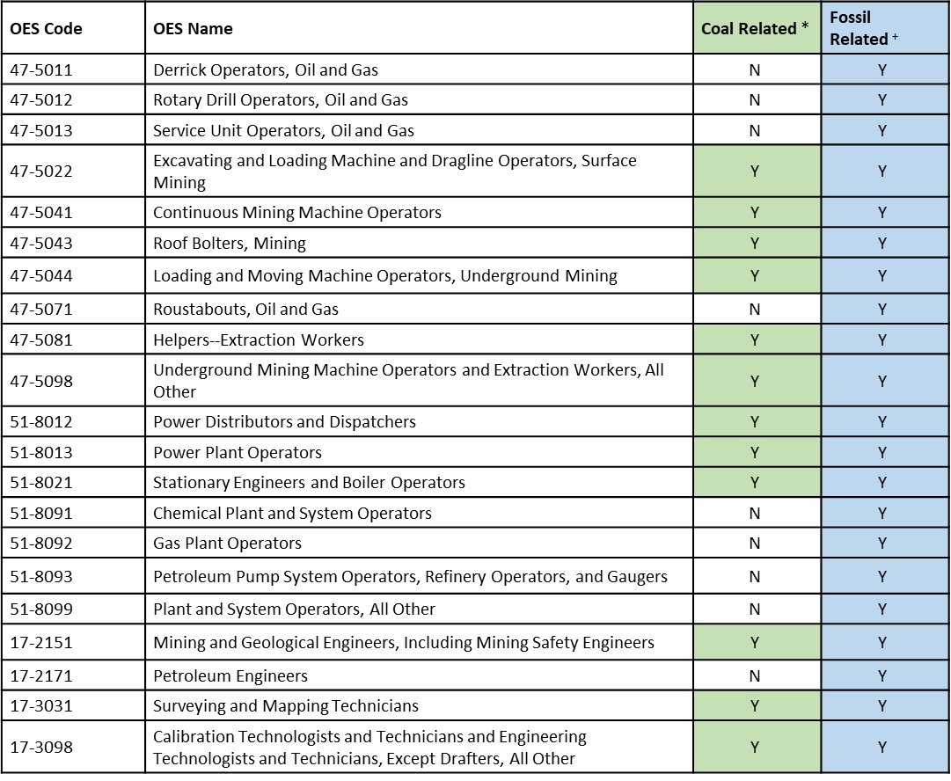

Figure . List of Occupational Employment Statistic (OES) codes from the Bureau of Labor Statistics (BLS), that were used to quantify direct coal and FE related employment numbers.