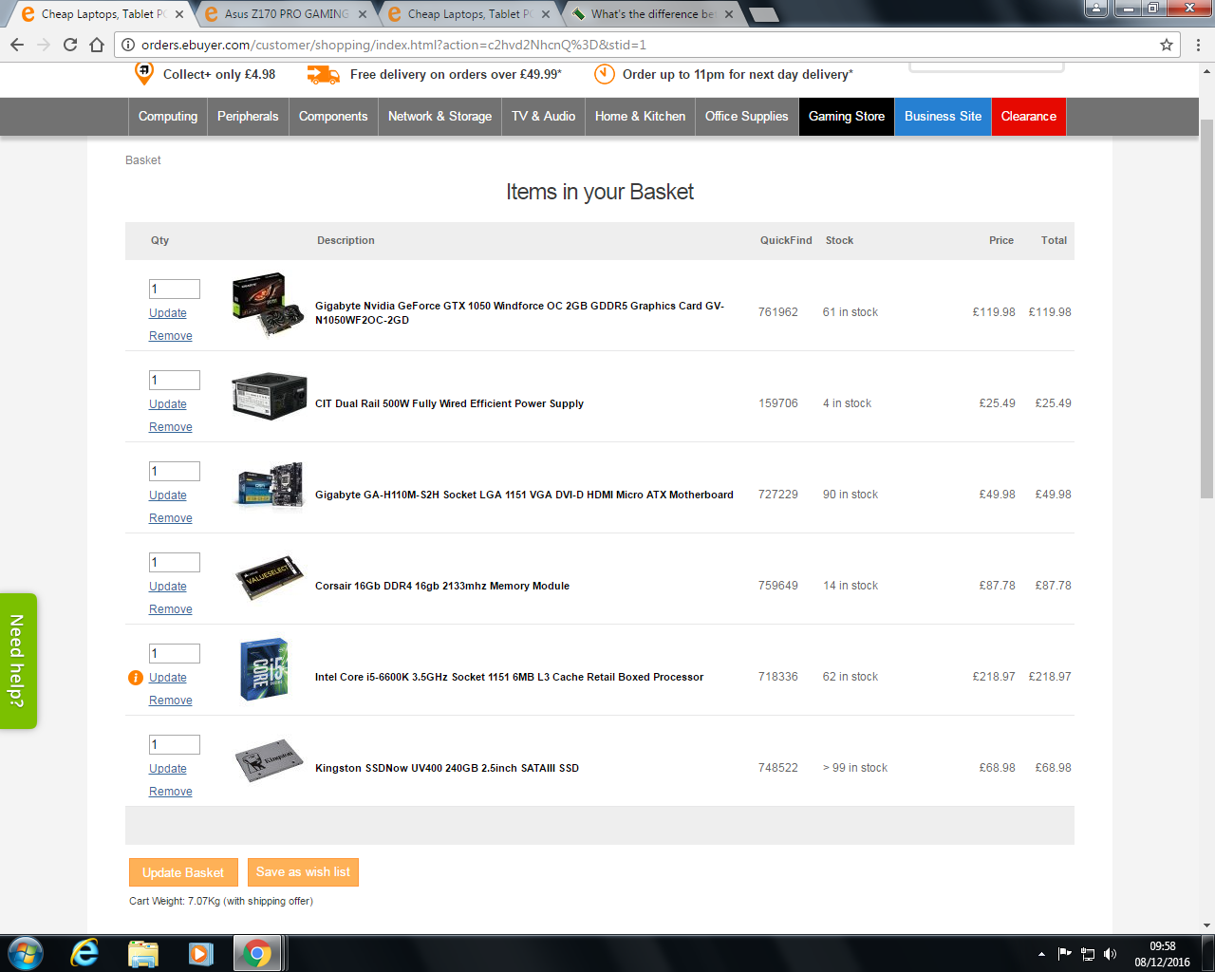

|  |  |
| --- | --- |
| CPU: Intel Core i5-6600K 3.5ghz quad-core | £218.97 |
| GPU: Nvidia GTX 1050 2GB GDDR5 | £119.98 |
|  |  |
|  |  |

