**In addition, you can visit the medina of Tunis. It’s an old town with excellent museums and temples. There’s plenty of modern architecture to see in the capital, including the French colonial buildings of the Avenue Habib Bourguiba. Besides the most spoken language in Tunisia is Arabic so you can find lots of Muslims and many traditional mosques such as Zitona mosque in Tunis and the great mosque of kairouan : Uqba ibn nafaa**

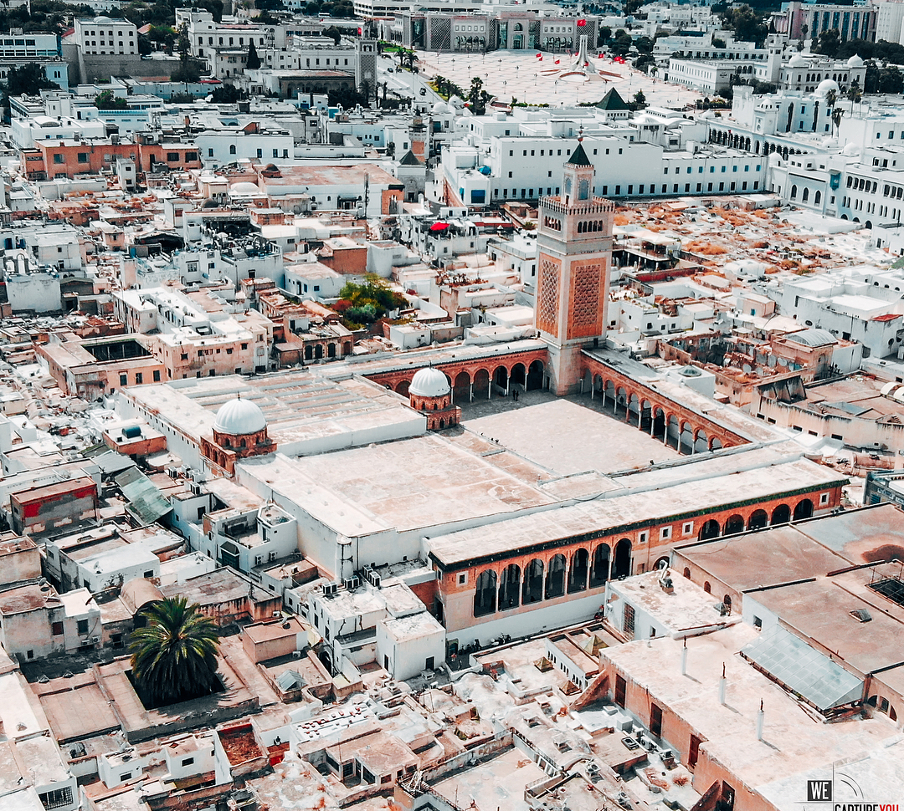

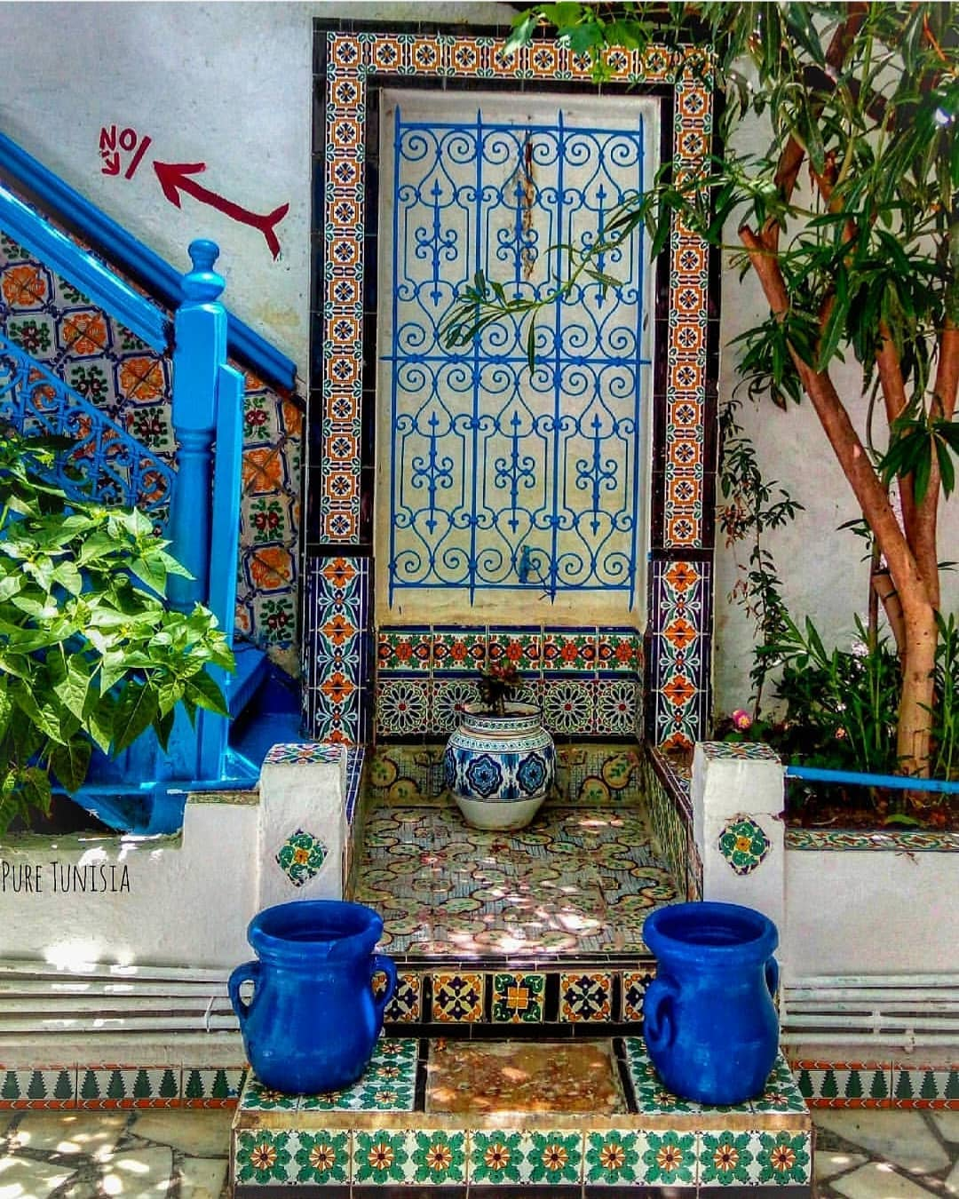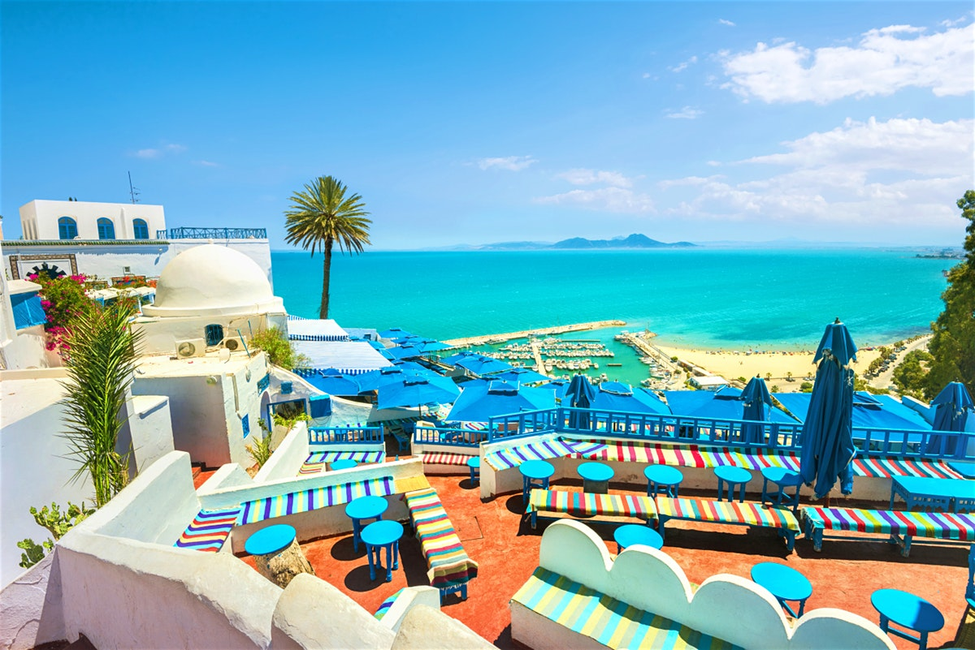

**It may be just a slim wedge of North Africa’s vast horizontal expanse, but Tunisia has enough history and diverse natural beauty to pack a country many times its size. Whatever the season, your first glimpse of Tunisia will be one of golden beaches and a deep blue sea. Here’s Sidi Bou Said the classic blue and white sun-soaked town, sitting on the north coast. You’ll admire its view on the blue Mediterranean sea. It’s a paradise for the vacationer.**

**Your great**

**Escape**

**Let’s go to Tunisia**









**Karoui Eya**

**1ere S4**

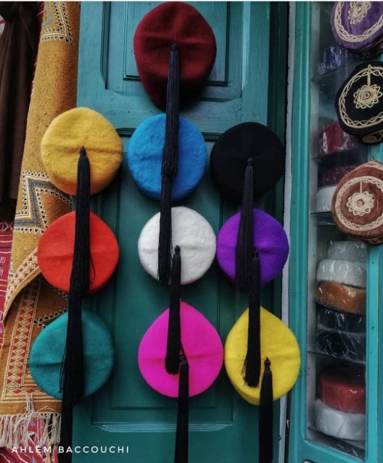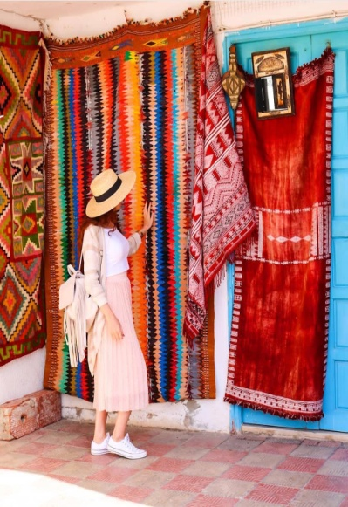

**Finally, touring Tunisia is the ideal opportunity to discover the exciting cultures and traditions. You can wear traditional clothes such as jebba and chachiya. You’ll enjoy the Tunisian spicy meals and plats with fresh fish. Tunisan cuisine is known by: Couscous and harissa which is basically ground up red chillies with some stuff added to it to give a very yummy flavour .**

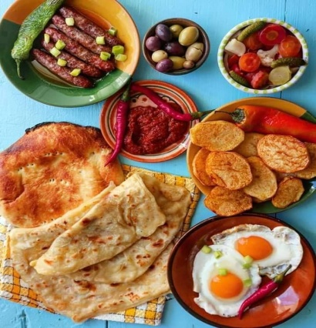

**Furthermore, the charming city in the south west of Tunisia is based around a large Oasis famous for its palm trees and production of dates, which are exported around the world. Tozeur is a good place to glimpse the Sahara from and take in traditional Tunisian culture including a wide range of architectural styles. It's easy to spend a few days there so you can also sightsee in ong jmal where the early parts of the first Star Wars films were shot there.**

**It’s a city that will leave memories of a lifetime.**

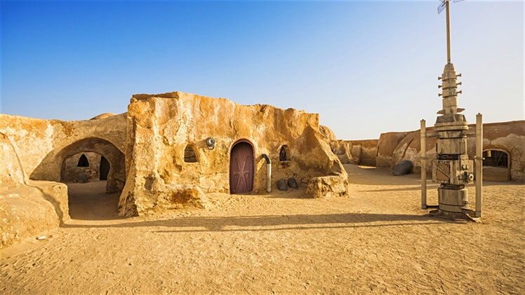

**On the top of that, if you Feel guilty about the long lazy days spent in delicious idleness bronzing, you can drive just for an hour and these modern resorts will bring you to another Tunisia, one of ancient Roman, Arab or Berber sites. Reminders of this rich historical past abound and visitors will return again and again captivated by the diversity of this Mediterranean land. The ancient ampitheatre at El Jem is a dramatic and impressive sight that you should visit.**

