Results

10 clases, sonidos del 1 al 10
150 sonidos de cada clase

Feedforward NN

Epochs: 10000
Batch size: 100

Dense 500 → RELU -> Dropout (0.4) → Dense 300 → RELU → Dropout (0.4) → Dense 10 → Softmax

Accuracy: 0.86-0.95 (muy inestable)

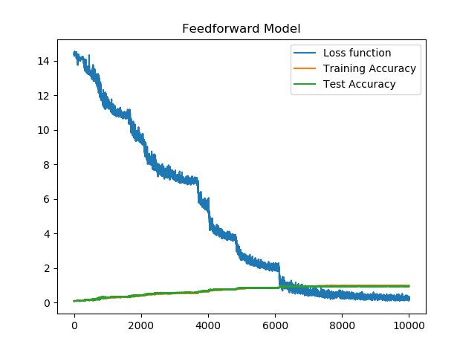
LSTM NN

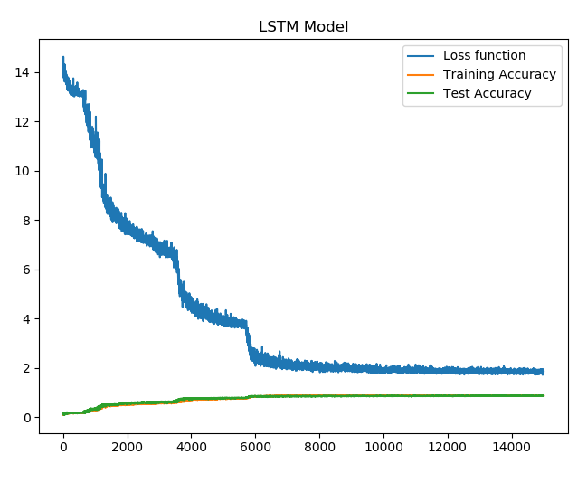
epochs = 50 #10000
batch_size = 100

dropout=0.5, recurrent_dropout=0.3
Accuracy: 0.88

_________________________________________________________________
Layer (type) Output Shape Param #
===============================================
lstm_8 (LSTM) (None, 26, 500) 1042000
_________________________________________________________________
lstm_9 (LSTM) (None, 300) 961200
_________________________________________________________________
dense_12 (Dense) (None, 10) 3010
_________________________________________________________________
activation_12 (Activation) (None, 10) 0
===============================================
Accuracy: 0.92

