Wine Quality Explorer
An R Shiny Case Study — Predicting Wine Quality with Random Forest

1. What Data Did We Collect?
This project uses the Wine Quality (Red Wine) data set published on the UCI Machine Learning Repository (Cortez, Cerdeira, Almeida, Matos & Reis, 2009). It contains 1,599 samples of the Portuguese “Vinho Verde” red wine, each described by 11 physicochemical laboratory measurements plus a quality score.
- fixed acidity, volatile acidity, citric acid
- residual sugar, chlorides
- free sulfur dioxide, total sulfur dioxide
- density, pH, sulphates, alcohol
- quality — the target: the median score (0–10) given by at least 3 wine-tasting experts
The full data set (about 84 KB as a CSV) is checked in to the project's GitHub repository under data/winequality-red.csv, alongside the app source code.

2. Why This Topic? (Motivation)
Wine quality is traditionally assessed by human sensory panels — a process that is slow, expensive, and subjective, and doesn't scale well for producers who need fast quality feedback during production. This data set is a great case study for the data-science life cycle because it asks a concrete, high-value business question: can objective, inexpensive lab measurements (acidity, sugar, alcohol, sulfates, etc.) predict the quality score a human panel would assign? A working model would let producers get near-instant, repeatable quality signals instead of waiting on a tasting panel, and would highlight which chemical properties most influence perceived quality — useful for decisions in the vineyard and in the cellar.

3. How Did We Analyze the Data?

3.1 Life-cycle steps followed
- Business question: can lab-measurable chemistry predict expert-rated wine quality?
- Data collection: UCI Wine Quality (Red) data set, 1,599 rows, no missing values.
- Exploratory data analysis: distribution of quality scores, per-feature histograms, and a full correlation matrix (built into the app's “Explore Data” tab).
- Feature/target split and modeling: an interactive train/test split (default 75/25) feeds two model families.
- Evaluation: RMSE and R² (regression) or accuracy and a confusion matrix (classification), plus the Random Forest's built-in out-of-bag (OOB) error.
- Interpretation: permutation-based variable importance ranks which chemical properties drive predictions.
- Deployment: the finished app is published on shinyapps.io so anyone can explore it interactively.

3.2 Algorithm: Random Forest
Random Forest is an ensemble of decision trees that combines two sources of randomness to reduce variance versus a single tree:
- Bagging: each tree is fit on an independent bootstrap resample of the training rows.
- Random subspace: at every node split, only a random subset of “mtry” candidate features is evaluated, which de-correlates the trees.
At each split, a regression tree chooses the feature/threshold pair (j, s) that minimizes the sum of squared errors across the two resulting child regions; a classification tree instead minimizes Gini impurity, G = Σ p_k(1 − p_k) summed over classes k. The forest's final prediction averages the individual trees' outputs (regression) or takes a majority vote (classification). Because roughly one-third of rows are excluded from each bootstrap sample (“out-of-bag” rows), the forest gets a nearly free, unbiased estimate of test error without needing a separate validation split — the app reports this OOB error alongside a genuinely held-out test set. Variable importance is measured by how much prediction error increases when a feature's values are randomly permuted in the OOB data — a bigger increase means the model relied on that feature more heavily.
As a simple, fully interpretable baseline, the app also fits an Ordinary Least Squares linear regression, quality = β₀ + β₁x₁ + … + β₁₁x₁₁ + ε, so users can see how much (if any) predictive power the extra flexibility of Random Forest buys over a plain linear model.

3.3 Interactive parameters exposed in the app
- Task type: Regression (predict the 0–10 quality score) vs. Classification (“good” wine above a user-chosen quality cutoff, vs. “not good”)
- ntree — number of trees in the forest (50–1000)
- mtry — number of candidate features considered at each split (1–11)
- Training set proportion (50%–90%)
- Quality cutoff for the “good wine” class (classification task only)
- A live “Predict” tab where users move sliders for the 11 chemical properties and get an instant prediction from whichever model is currently trained

4. What Did We Find in the Data?

4.1 Exploratory findings
Quality scores are concentrated in the middle of the 0–10 scale — almost all wines in the sample are rated 5, 6, or 7, with very few rated as low as 3–4 or as high as 8. This class imbalance is important context for the classification task.
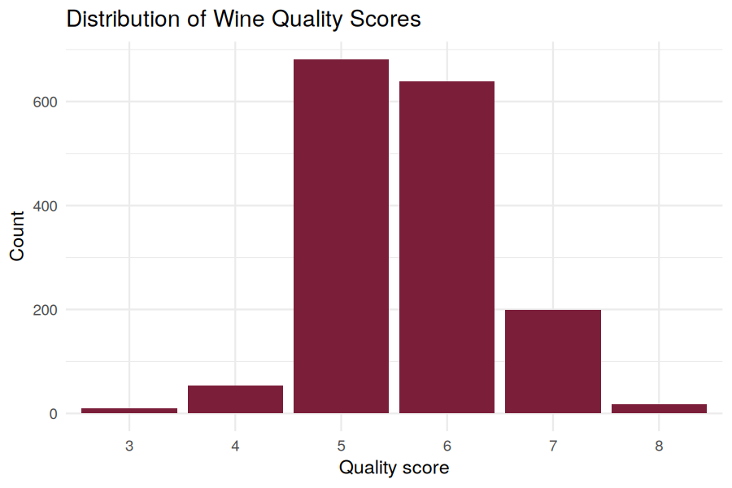
Figure 1. Distribution of wine quality scores in the sample (n = 1,599).
The correlation matrix below shows the expected chemistry relationships — for example, fixed acidity correlates strongly with density and citric acid, and free/total sulfur dioxide are strongly correlated with each other (as expected, since free SO₂ is a component of total SO₂). Quality itself correlates most positively with alcohol and most negatively with volatile acidity.
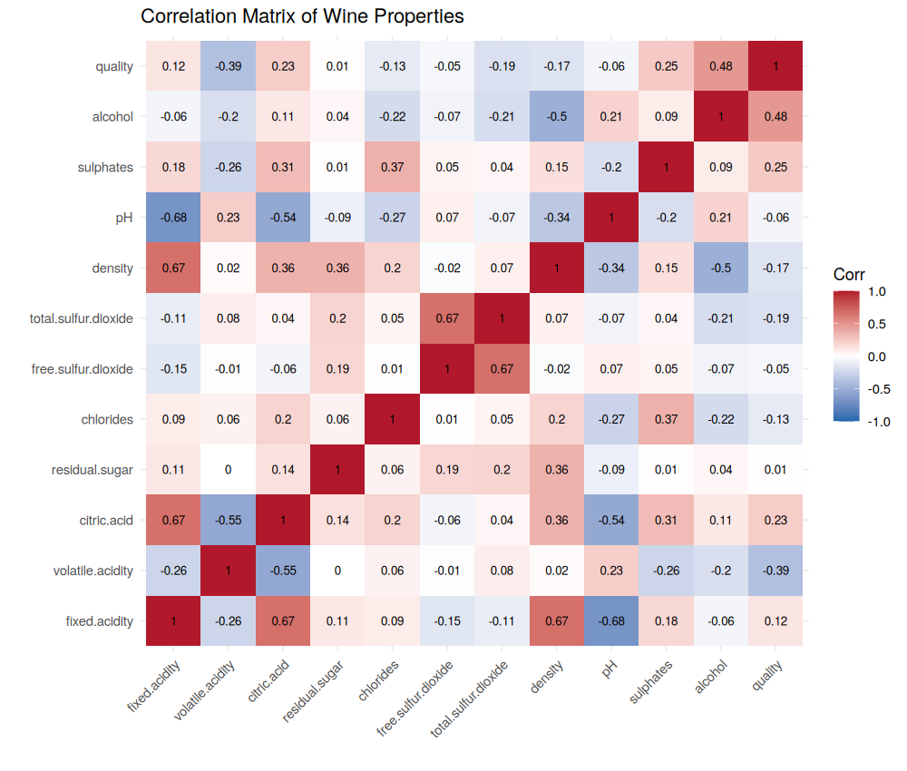
Figure 2. Correlation matrix across all physicochemical properties and quality.
Alcohol content shows a clear upward relationship with quality: higher-rated wines tend to have noticeably higher alcohol content.
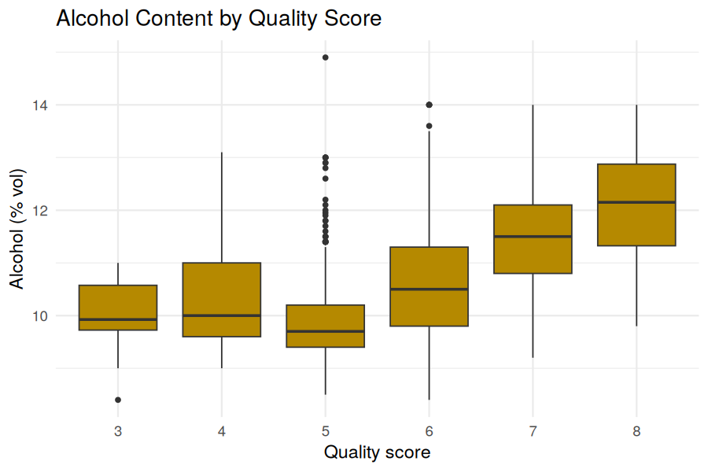
Figure 3. Alcohol content by quality score.

4.2 Model performance (default settings: ntree = 300, mtry = 4, 75/25 split)
On a held-out 25% test set, Random Forest clearly outperformed the linear regression baseline:
Metric | Random Forest | Linear Regression
Test RMSE | 0.535 | 0.607
Test R² | 0.496 | 0.404

Random Forest's out-of-bag MSE (≈ 0.362) closely tracked its held-out test RMSE², confirming the model is not overfitting and that OOB error is a reliable, essentially free proxy for test performance as ntree and mtry are tuned.
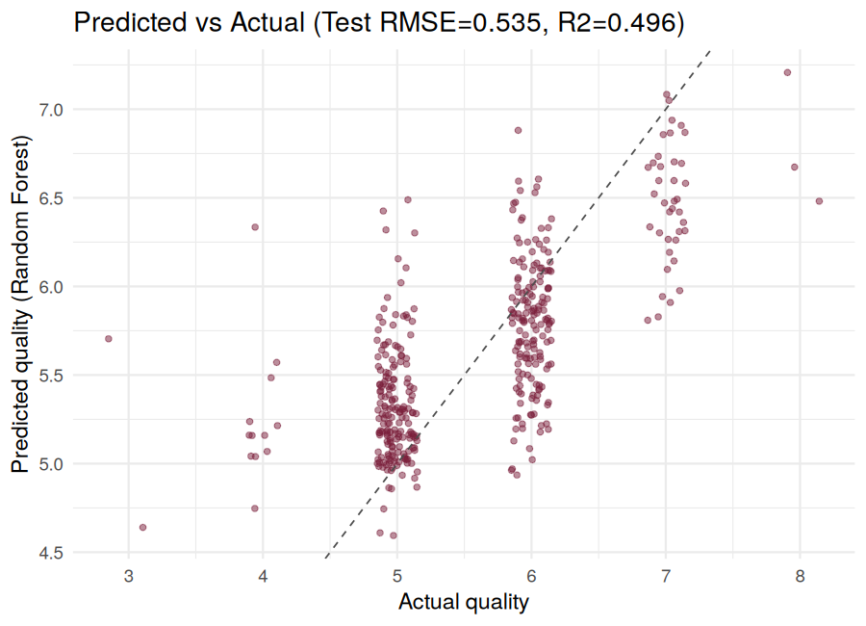
Figure 4. Predicted vs. actual quality on the test set (Random Forest). The dashed line marks perfect prediction.

4.3 Which features matter most?
Permutation importance consistently ranks alcohol and volatile acidity as the two strongest predictors of quality, followed by sulphates and total sulfur dioxide — aligning with wine-science literature and the correlation analysis above.
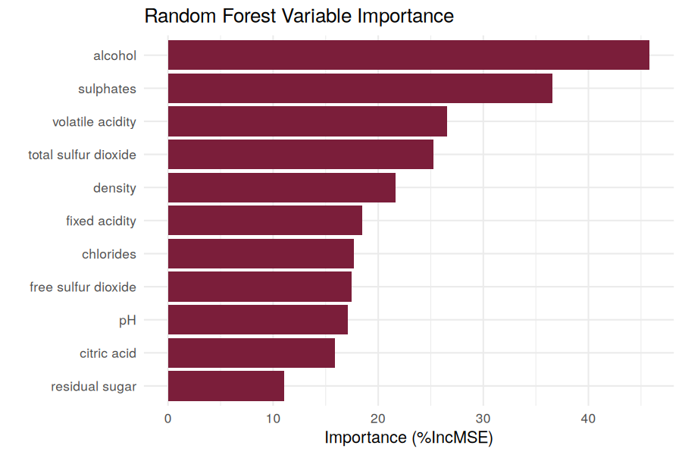
Figure 5. Random Forest variable importance (% increase in MSE when a feature is permuted).

4.4 Classification view
When the task is reframed as classification (“good” wine defined as quality ≥ 7, about 14% of the sample), Random Forest reached roughly 94% test accuracy — but because “good” wines are a minority class, accuracy alone is optimistic; the app's confusion matrix breaks out how many good wines were correctly identified versus missed, which is more informative than accuracy for this imbalanced setting.

5. Conclusions
- Objective lab chemistry has real, if moderate, predictive power for expert-perceived wine quality (R² ≈ 0.50) — useful as a fast screening signal, but not a full replacement for sensory panels.
- Random Forest meaningfully outperforms a linear baseline, implying the quality relationship is at least partly non-linear or involves feature interactions.
- Alcohol and volatile acidity are the most influential chemical properties, consistent with established oenology research.
- The class imbalance in quality scores (few very-low or very-high ratings) is an important caveat for both the regression and classification views.

6. Links
Live app (shinyapps.io): https://YOUR-ACCOUNT.shinyapps.io/wine-quality-explorer/
Source code (GitHub): https://github.com/YOUR-USERNAME/wine-quality-shiny
(Replace the placeholders above with your actual shinyapps.io and GitHub URLs before submitting.)

7. Data Source & Citation
P. Cortez, A. Cerdeira, F. Almeida, T. Matos and J. Reis. Modeling wine preferences by data mining from physicochemical properties. Decision Support Systems, Elsevier, 47(4):547-553, 2009.
UCI Machine Learning Repository: https://archive.ics.uci.edu/dataset/186/wine+quality

