The task is about Modern Pentathlon competition

*Hint: Scoring rules are simplified for this task, do not use official scoring systems.*

*Hint: Time format in Athlete result table mm:ss.ms*

The input of the Java program is a CSV-like text file (Athlete_Results.csv).

*Hint: Athlete_Results file format*

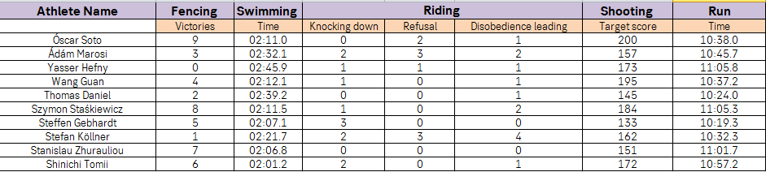

The task is to create a REST end point to output all athletes in ascending order of their places, containing all the input data plus total score, plus "The concluding event" time in time format and the place in the competition (in case of equal scores, athletes must share the places, e.g. 3-4 and 3-4 instead of 3 and 4).

* The project must be Java based.
* Be sure to keep the code design simple and clean, but allowing to easily change or add more input and/or output sources.
  + Use at least one design pattern. Explain it in short in java doc.
* Unit tests for the code are mandatory.
  + Using extended frameworks for testing will be a big plus.
* Gradle should be used as building tool.
* Use Github if possible or zip solution to one file.
* Manual how to run the application is mandatory.
* Containerized application is not mandatory but would be a big plus.