UNIT TESTING

* GET all data from car_info table
* Search car by id
* Create new car information
* Update car information
* Delete car information

**GET all data from car_info table**

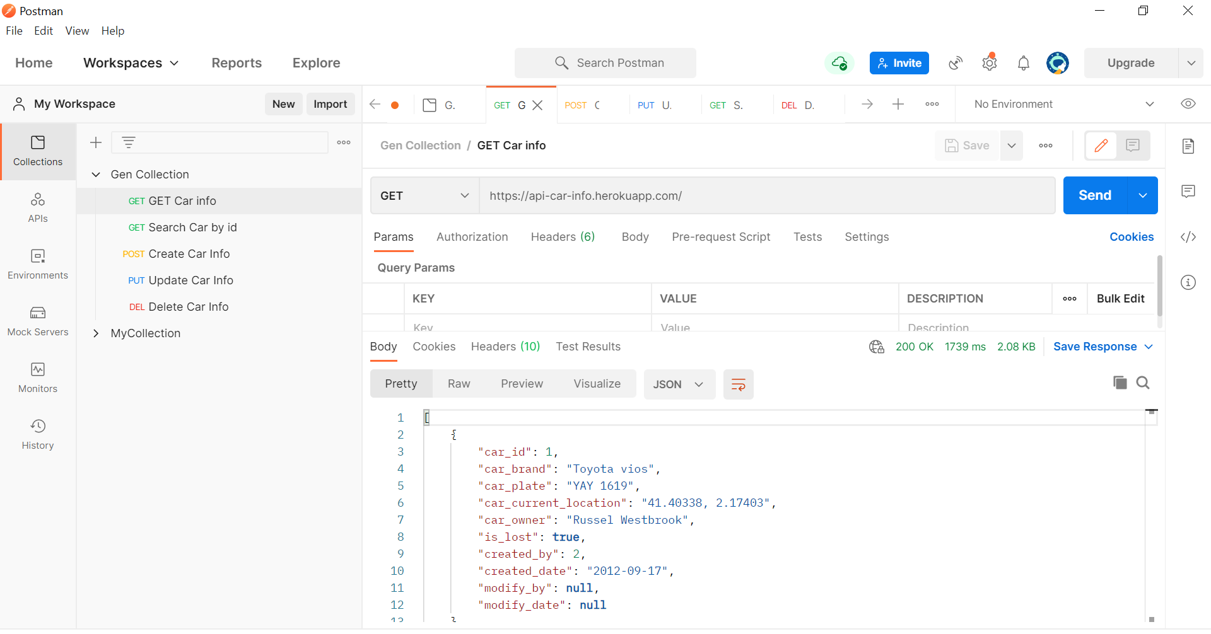

**Search car by id**

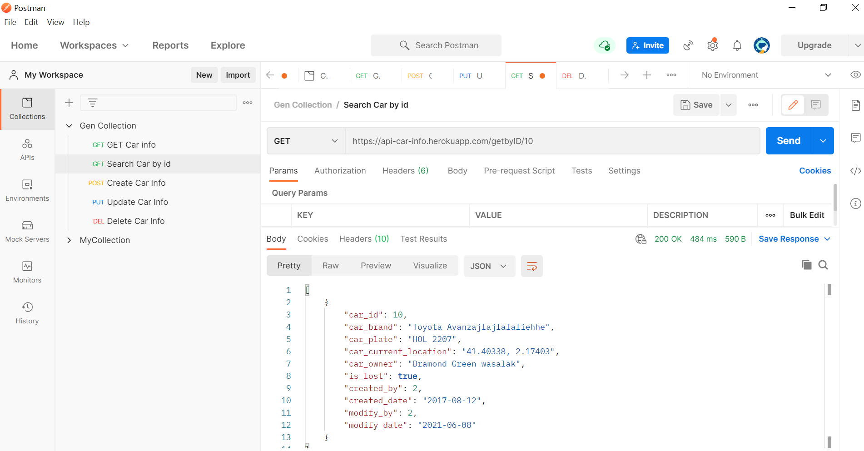

**Create new car information**

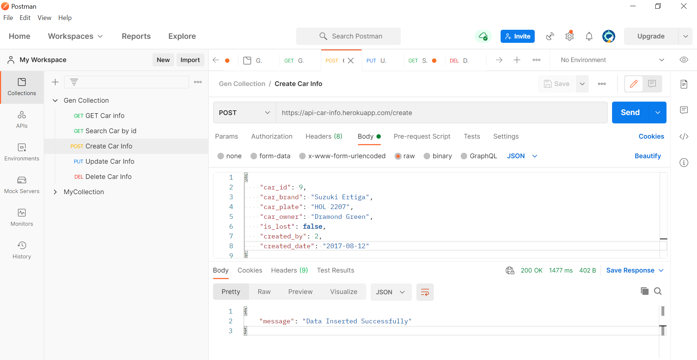

Check if data was successfully inserted in database

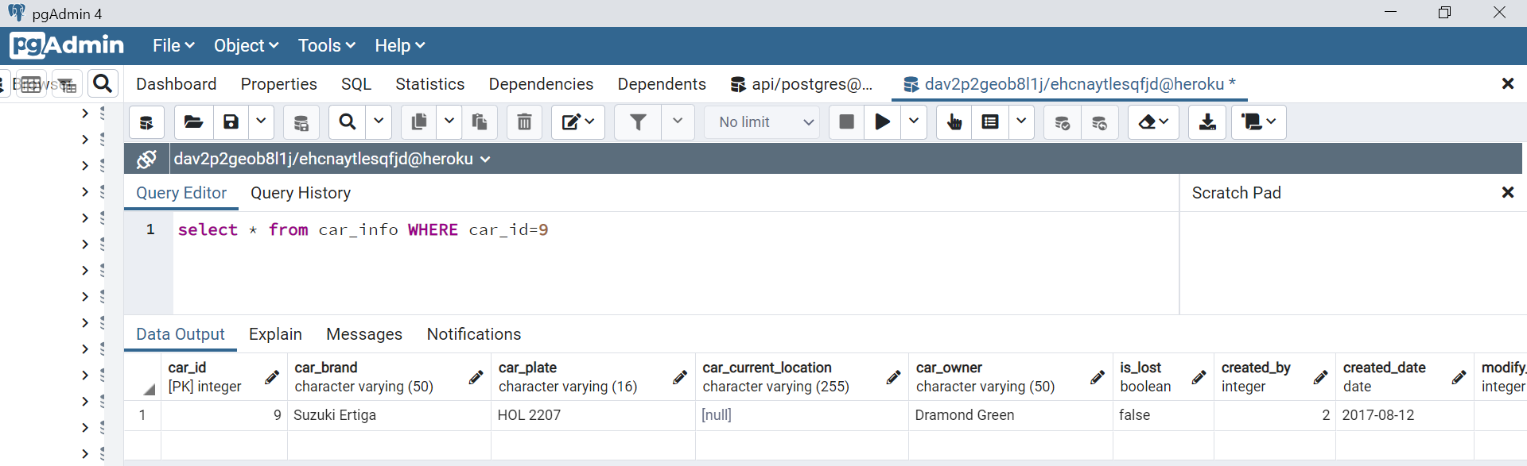

**Update car information**

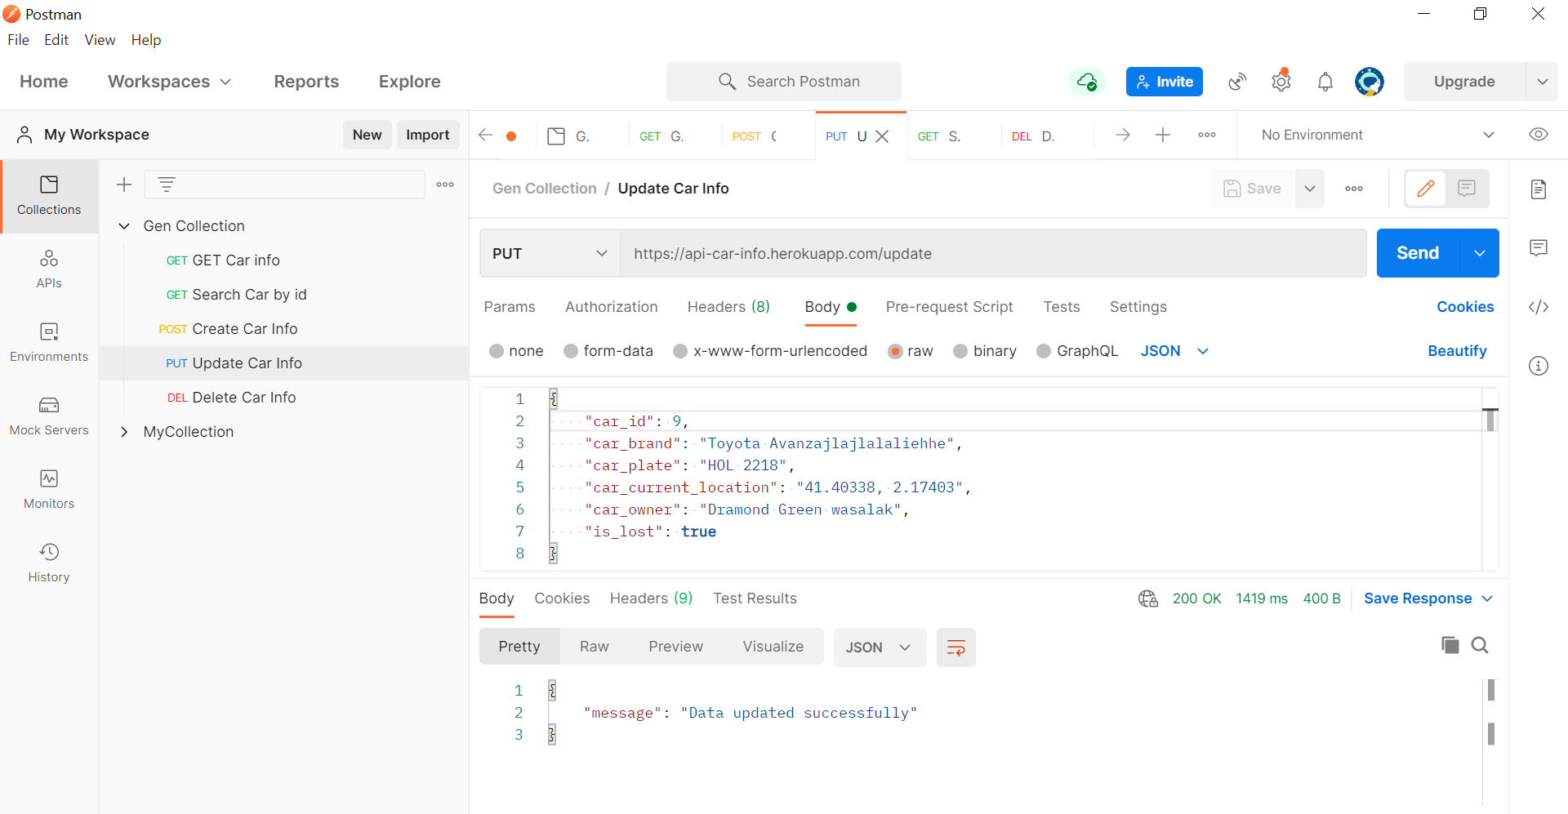

Check if data was successfully updated in database

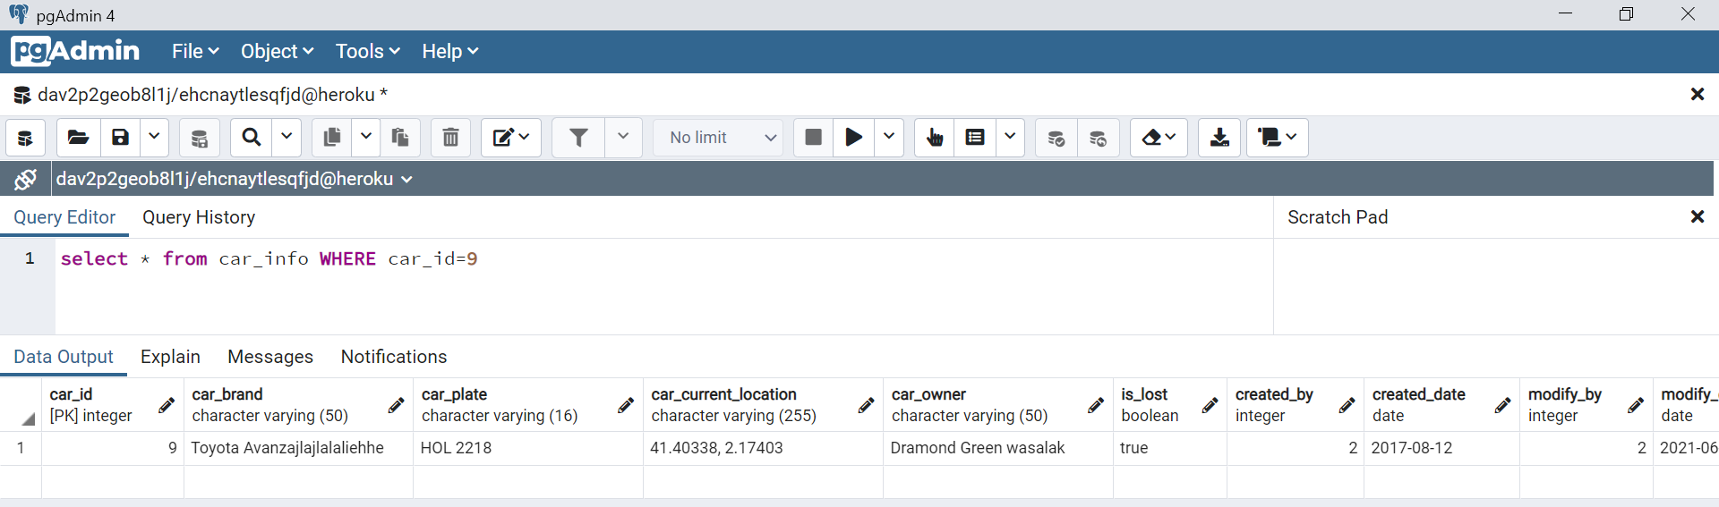

Delete car information

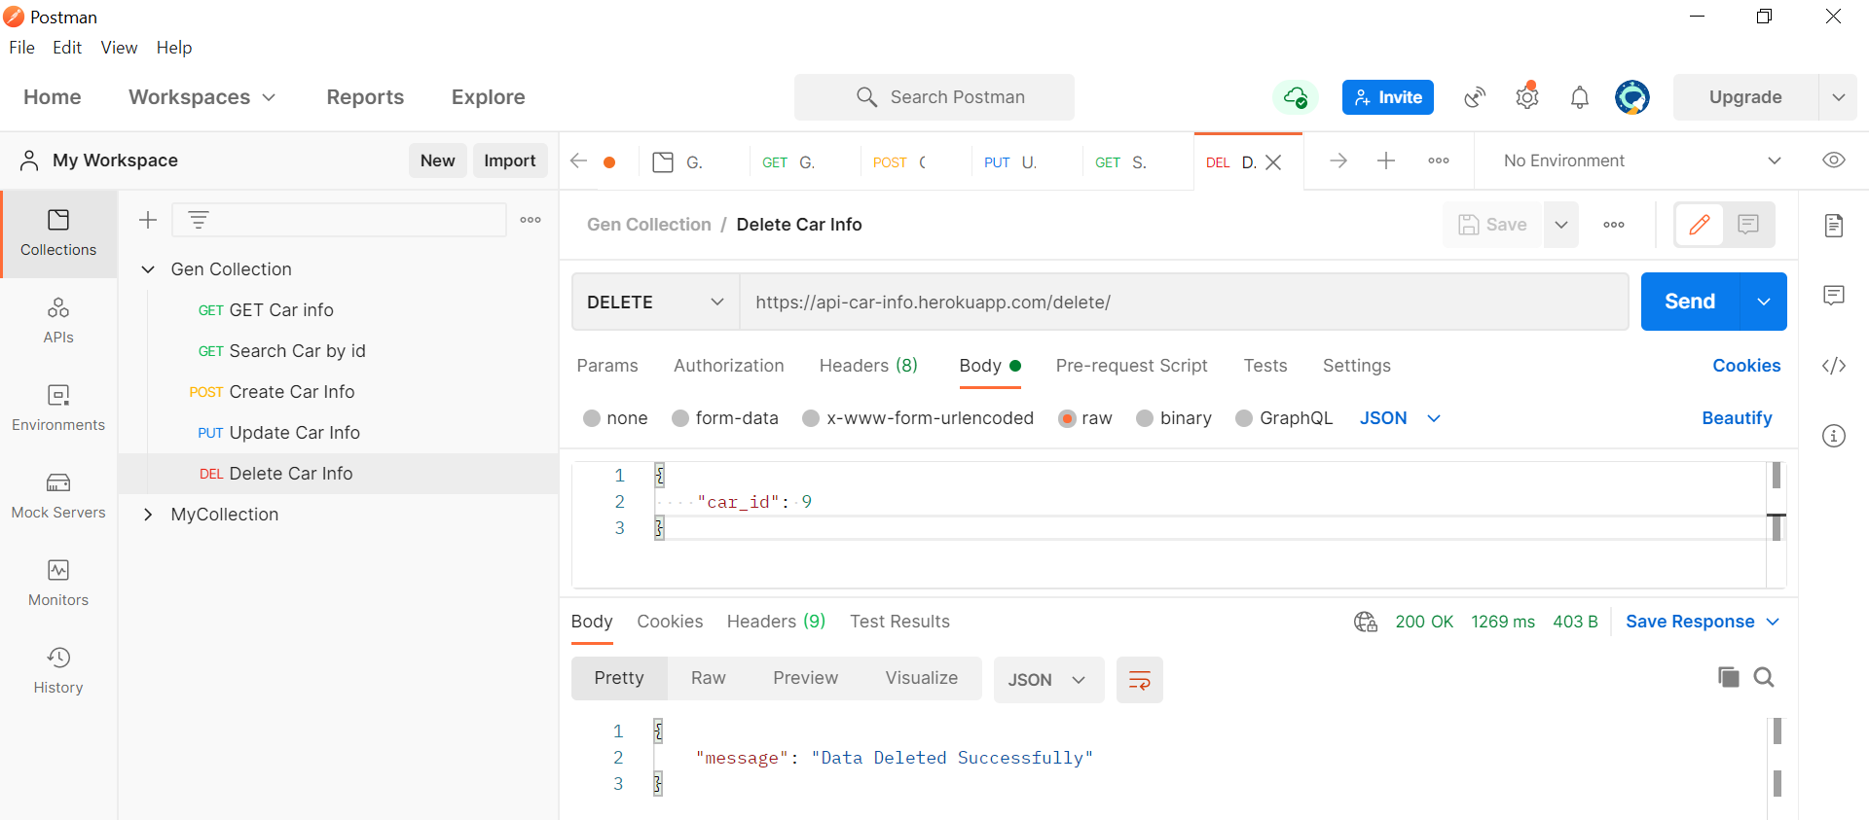

Check if data was successfully deleted in database

