SWF Documentation Overview

The SWF File Format Documentation is provided in both HTML and MS Word 97 formats. Documentation is provided for both the SWF File Format, explaining how it works, and for the SWF manager, which gives programmers an API with which to write SWF files.
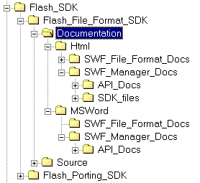

The directories are laid out as follows:

Documentation

HTML
Documentation in the HTML format.

SWF_File_Format_Docs
Documentation, in 14 files, describing the SWF file format and how it works. Each file discusses some aspect of SWF, such as bitmaps, morphing, etc. The file “intro.htm” contains an overview and links to the other files.

SWF_Manager_Docs
The file SDK.htm gives an overview to the developers toolkits, and how to use them.

API_Docs
The full API and all its methods, in hyperlinked HTML. The API document begins at “index.html.”

MSWord
Documentation in the HTML format.

SWF_File_Format_Docs
Documentation, in 14 files, describing the SWF file format and how it works. Each file discusses some aspect of SWF, such as bitmaps, morphing, etc. The file “intro.doc” contains an overview and links to the other files.

SWF_Manager_Docs
The file SDK.doc gives an overview to the developers toolkits, and how to use them.

API_Docs
The full API and all its methods, in hyperlinked HTML. The API document begins at “index.html.”

Please ignore directories that end in *_files, as these merely contain support data for the other documents.

