**Birth Buddy – Personal moral guide to pregnancy and Childbirth**

Contest: Code Bot

Team:

Mounish (AIE sem-2)

Madhav (AIE sem-2)

Amrit Subramanian (AIE sem-2)

Technologies used:

Html5

Css3

JavaScript

Django / Python

LLM -> Openai [Api Linkage]

Abstract:

Pregnancy and childbirth can be a very exciting and fulfilling experience for many women, but it can also be overwhelming, confusing, and even scary at times. That is why having a "birth buddy" or personal moral guide can be helpful during this journey. A birth buddy is someone who can provide emotional support, offer advice and guidance, and help you make informed decisions about your pregnancy and childbirth experience. This document will provide an overview of what a birth buddy is, why having one is important, and how to choose the right person to be your birth buddy.

Introduction:

Pregnancy and childbirth are significant milestones in a woman's life. The process of carrying a child and giving birth can be both exciting and daunting. Many women experience a range of emotions during this time, including joy, anxiety, fear, and uncertainty. It is important to have a support system during this time to help navigate the challenges that may arise.

A birth buddy is someone who can offer support and guidance during pregnancy and childbirth. This person can be a friend, family member, or a trained professional such as a doula. A birth buddy can help you prepare for childbirth, offer emotional support, and advocate for your wishes during labour and delivery

Guidelines to use this App:

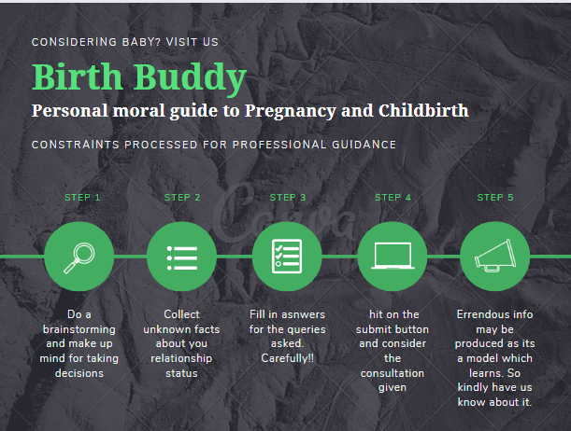

Our Usp:

* This one of a kind technology/application makes statements with more precision as it’s trained for everything
* No dedicated birth advisory systems have been made which only uses LargeLearningModel (LLM)
* The idea put behind is unique and exclusive for this project
* UI Friendly design

Videos With Explanation by us:

Part1: [overboarding]

<https://share.vidyard.com/watch/FJ3rba8o3ZUbFpELzvr1Wp>?

Part2: [code explanation + prompt-design-explanation]

<https://share.vidyard.com/watch/CSf4c8GEnSAfLt6guwtxhM>

Conclusion:

In conclusion, having a birth buddy can be an asset during pregnancy and childbirth. A birth buddy can offer emotional support, help you prepare for childbirth, and advocate for your wishes during labour and delivery. When choosing a birth buddy, it is important to consider their availability, communication skills, knowledge, and respect for your wishes. With the right birth buddy by your side, you can have a positive and empowering childbirth experience.