TeamHappi – Architecture and Multi-Tenancy Requirements
Field | Value
Document | TH-DEV-04 Architecture and Multi-Tenancy Requirements
Version | 0.1 – Draft for review
Date | 6 October 2026
Owner | Macrovision Digital Solution (product owner)
Related | TH-DEV-03, TH-DEV-05, TH-DEV-06, TH-DEV-07, TH-DEV-08

1. Purpose
This document states what the TeamHappi architecture must achieve. It does not choose the technology. The development team proposes the design and stack in TH-DEV-05, and records decisions as architecture decision records (ADRs).
Requirements marked MUST are mandatory. Items marked SHOULD are strong recommendations that need a recorded reason if not followed.

2. Logical structure
TeamHappi has one shared platform and seven capability modules. Modules exchange data through defined interfaces and events, not by reading each other's tables directly.
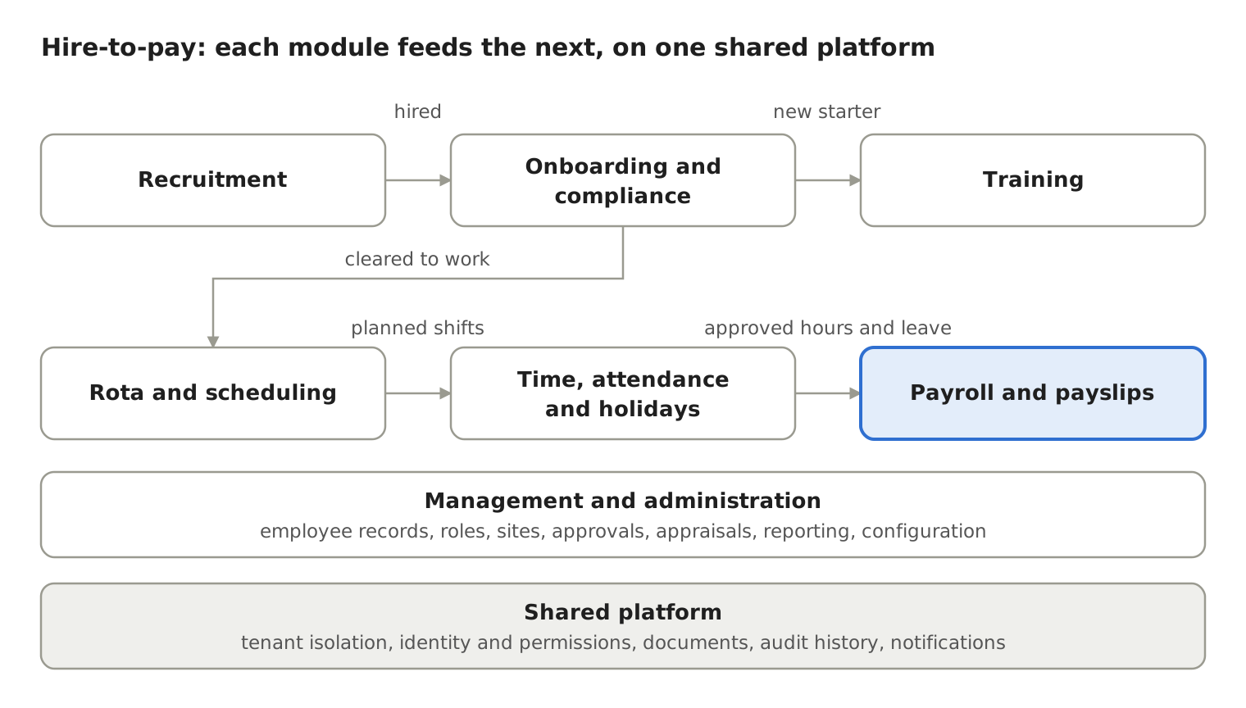
Key data hand-offs between modules:
From | To | What passes
Recruitment | Onboarding | Hired candidate becomes a new starter (TH-DEV-06, section 4)
Onboarding | Rota | Worker is marked cleared to work only when required onboarding steps are complete
Onboarding | Training | New starter receives required training assignments
Training | Rota | Expired mandatory training can be flagged when scheduling
Rota | Time and attendance | Planned shifts are compared with time worked
Time and attendance | Payroll | Only approved hours and leave enter a pay run
Payroll | Worker | Finalised payslip becomes visible to the worker

3. Architecture principles
ID | Requirement | Level
AR-REQ-01 | One codebase and one product for all clients; client differences handled through configuration, not custom code | MUST
AR-REQ-02 | Modules have clear boundaries and can be switched on or off per tenant | MUST
AR-REQ-03 | Shared platform services (tenancy, identity, permissions, people, sites, documents, audit, notifications) are built once and used by all modules | MUST
AR-REQ-04 | All server functions are available through a versioned API used by the web and mobile clients | MUST
AR-REQ-05 | Design for many tenants from day one, including tenants with many sites | MUST
AR-REQ-06 | Prefer managed cloud services over self-managed infrastructure where they meet security and residency needs | SHOULD
AR-REQ-07 | Start as a modular monolith unless the team gives a recorded reason for separate services | SHOULD

4. Multi-tenancy requirements
ID | Requirement | Level
MT-01 | Every record holding client data carries a tenant identifier | MUST
MT-02 | Tenant context is set on the server from the authenticated session, never from a value the client can change | MUST
MT-03 | Tenant filtering is enforced in a central layer (for example database row-level security or a mandatory data-access layer), not left to each query | MUST
MT-04 | Files, caches, search indexes, background jobs, logs, exports and reports are all tenant-scoped | MUST
MT-05 | A user who works for two client businesses has a separate membership per tenant and sees only the data of the tenant they are working in | MUST
MT-06 | Tenant creation, configuration and suspension are automated and audited | MUST
MT-07 | A tenant's data can be exported in full and deleted in full at the end of a contract | MUST
MT-08 | One tenant's heavy usage must not degrade service for others (rate limits, queue fairness) | MUST
MT-09 | The design allows a large client to be moved to dedicated resources later without rewriting the application | SHOULD

Tenancy model options (developers to recommend one in TH-DEV-05)
Model | Isolation | Operational effort | Points to assess
Shared database, shared schema, row-level security | Logical | Lowest | Strength of central enforcement, risk of a missed filter, noisy neighbours
Shared database, schema per tenant | Stronger logical | Medium | Migrations across many schemas, connection management
Database per tenant | Strongest | Highest | Cost per tenant, provisioning, cross-tenant platform reporting

5. Identity and access
ID | Requirement | Level
IA-01 | Authentication meets TH-DEV-07, section 3 (multi-factor authentication for privileged roles) | MUST
IA-02 | Authorisation follows the role, scope and tenant model in TH-DEV-03 | MUST
IA-03 | Candidates register with a separate, lighter account type that cannot reach employee functions | MUST
IA-04 | Workers without a work email can sign in (for example by mobile number or personal email) | MUST
IA-05 | Single sign-on for client administrators (Google, Microsoft) is supported by the design, even if built later | SHOULD
IA-06 | Permissions are cached safely and invalidated immediately when roles change | MUST

6. Documents and files
ID | Requirement | Level
DOC-01 | Files stored in encrypted object storage, separated by tenant | MUST
DOC-02 | Every upload is malware-scanned before anyone else can open it | MUST
DOC-03 | File type and size limits are enforced on the server | MUST
DOC-04 | Files are served only through short-lived, permission-checked links | MUST
DOC-05 | Every view and download of identity, right-to-work and payroll documents is audited | MUST
DOC-06 | Documents carry a type, owner, expiry date (where relevant) and retention rule | MUST

7. Audit history
ID | Requirement | Level
AUD-01 | Record who did what, to which record, when, from where, and the before and after values for sensitive fields | MUST
AUD-02 | Audit records cannot be edited or deleted by any application user | MUST
AUD-03 | Audit history is tenant-scoped and searchable by authorised client administrators | MUST
AUD-04 | Macrovision support access is recorded and visible to the client | MUST

8. Notifications and background processing
ID | Requirement | Level
NT-01 | A central notification service supports email, SMS, push and in-app channels | MUST
NT-02 | Users can manage non-essential notification preferences | MUST
NT-03 | Notifications never include sensitive data such as pay amounts or document contents | MUST
JOB-01 | Scheduled jobs (reminders, expiry checks, leave accruals, pay runs, reports) run per tenant, can be retried safely and are monitored | MUST

9. Payroll engine readiness
Payroll rules are not yet specified. The architecture must still be ready for them.
ID | Requirement | Level
PAY-01 | Pay calculations are deterministic: the same inputs and rules always give the same result | MUST
PAY-02 | Pay rules are versioned by effective date and tax year, so past pay runs can be reproduced exactly | MUST
PAY-03 | Finalised pay runs are locked; corrections are made through recorded adjustments or reversals, never by editing history | MUST
PAY-04 | Monetary values use exact decimal types, never floating point | MUST
PAY-05 | The design allows statutory submissions to HMRC to be added later. HMRC publishes payroll technical specifications and test data for developers each tax year; requirements for recognition must be confirmed with HMRC and the payroll specialist | MUST
PAY-06 | Payroll data and payslips are encrypted and access-restricted as the highest sensitivity tier (TH-DEV-06) | MUST

10. Reporting, observability and recovery
ID | Requirement | Level
REP-01 | Reporting respects the same tenant and scope rules as the application | MUST
REP-02 | Heavy reports do not slow down day-to-day use (for example by using a read replica or reporting store) | SHOULD
OBS-01 | Centralised logging, metrics, tracing and alerting, with tenant identifier on every log line | MUST
OBS-02 | Logs never contain passwords, tokens, bank details, identity document numbers or pay amounts | MUST
DR-01 | Automated, encrypted backups with regular restore tests; targets in TH-DEV-08 | MUST
DR-02 | All infrastructure defined as code so environments can be rebuilt | MUST

11. Hosting and data residency
The UK is the launch country. Hosting provider and region are OPEN and part of the developer proposal. The proposal must state where all personal data, backups and logs are stored, and list every third-party service that receives personal data.

12. Client applications
The client approach (responsive web, installable web app, or native mobile apps) is OPEN and part of the developer proposal. Whatever is chosen MUST:
- work well on mid-range and older phones used by shift workers;
- support push notifications for shift changes;
- handle poor connectivity in kitchens and back-of-house areas, including for clocking in (exact offline behaviour to be agreed);
- meet the accessibility level in TH-DEV-08.

13. Deliverables required from the development team
Deliverable | Due
Completed TH-DEV-05 proposal | Sprint 0
Solution architecture document with C4 context and container diagrams | Sprint 0
ADRs for tenancy model, stack, hosting, identity, client approach | Sprint 0
Threat model for the shared platform | Sprint 0
API conventions (versioning, errors, pagination) | Before first module build

