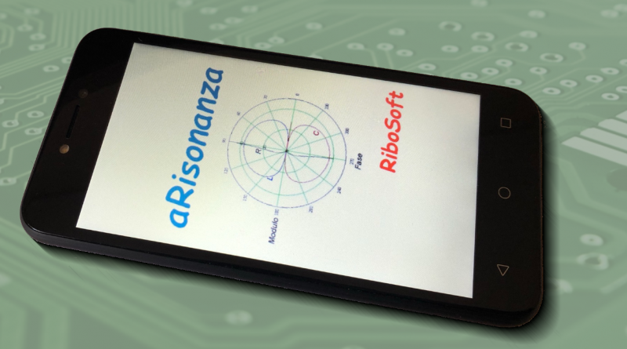 | The resonant frequency in an RLC circuit is that particular frequency at which the reactive components of the impedance of the circuit in question cancel each other out. This characteristic is used in resonant filters to pass an unaltered frequency and attenuate the other frequencies.  This simple app calculates the resonance value of a serial circuit composed of a resistance, an inductance and a capacitance. As a result it provides resonant frequency and overvoltage value.

