**QUIZ IT**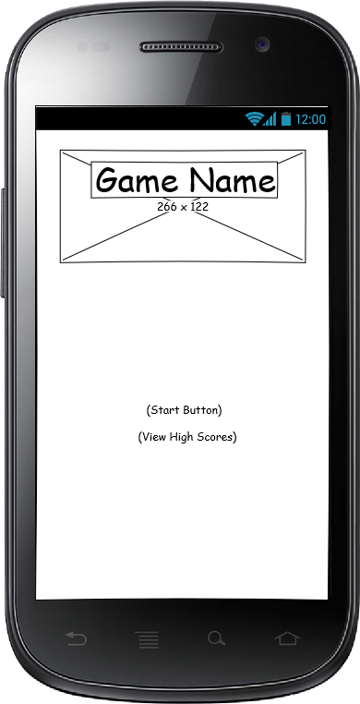

**Wireframe**

**W**e had decided to come up with an app called “QUIZ IT”. Looking on the illustration, there will be functions that the user can interact with, let us start on the section below which is the start button for the game to start and “view high score” to display your updated high score. The objective of this application is to help the user to gain extra knowledge.

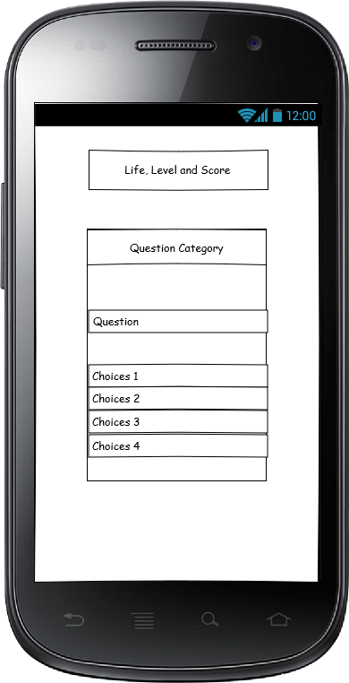

**Mockups**

This visualizes our continuous development of the application. This is where the question will pop up and underneath that are the choices. When the user was able to guess the correct answer he/she will go to the next level and every correct answer will be given a score and if the user gives an incorrect answer he/she will lose one life.

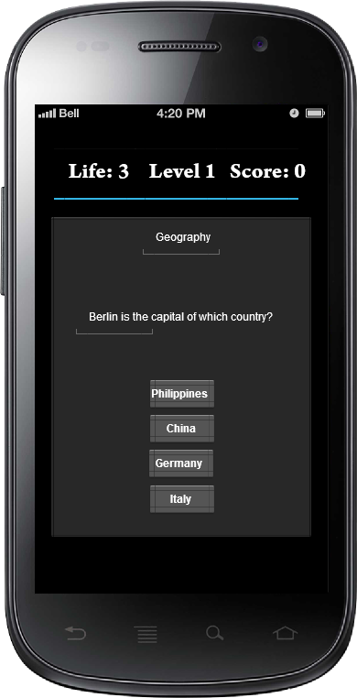

**Prototype**

This is the prototype of the “QUIZ IT". It is inspired of the game “Quizoid”, where there are 3 different game mode which is Classic, Arcade and 20 Question . In “Quizoid” there are 10 categorized topic wherein, user will pick on what topic he/she wants. And the user can choose what difficulty level he/she wants.

The difference between “QUIZ IT” and “Quizoid” is that “QUIZ IT” has a life when you answer a question incorrect you will lose one life, but in “Quizoid” when you give a wrong answer it will be a game over. The goal of this game is to expand knowledge and have the highest score.