7. Artist list/search talent/genre list can be one page: I love the layout we just have to add more search options. Search by content (audio,video,image), Search by Location, Search by Role, Search by gender, search by genre of music: (A cappella, Alternative Rock, Bluegrass, Blues, Classical, Country, Dance, Disco, Drum and Bass, Dubstep, Electronic, Euphoric, Folk, Funk, Gospel, Grunge, Hip Hop, House, Instrumental, Jazz, Metal, Musical Theatre, Neosoul, Opera, Pop, Punk Rock, R'n'B, Rap, Reggae, Rock'n'Roll, Soul, Techno)

8. Artist Detail/ Video Detail can be one page: This page will be where you can view the audio/video/image of the talent you searched for. From here you can like the content, comment, and follow the talent. On this page the talent will have just a small bio about this particular content they uploaded, we can take out the long bio because if you want to know more about this talent you can view their full personalized page. So we will need options to view their full profile, to do business with this talent and to search other related talents. (The same way it is on the artist detail page you sent me.)

#8 continued: We put together some icons to for following talent, commenting, and liking. Click on star to follow talent.... Click on the hand to let the talent know that their content is cool.... when commenting we only want good comments, so show love to the talent, anyone who sends hateful comments will be fined or have their subscription suspended.





9. Artist Page: I love the layout, being able to scroll through the talent's content, products, and at the bottom you can see the amount of bronze, silver and gold executive cards they have collected. We can add a place for the talent's full bio at the top of the page, add the star follow icon as well, and the do business option. We could also add a list so it can be seen who this talent is following and who is following this talent.

#9 continued: Executive cards are rewarded everytime a talent does business on the site. You get a bronze executive card every time you do a business transaction less that $100, silver executive card every time you do a business transaction $100 - $999, and a gold executive card every time you do a business transaction for $1000 or more. Whether you are the buyer or seller. I guess we can put a number counter next to each icon, so it can be seen how many of each executive card the talent has.

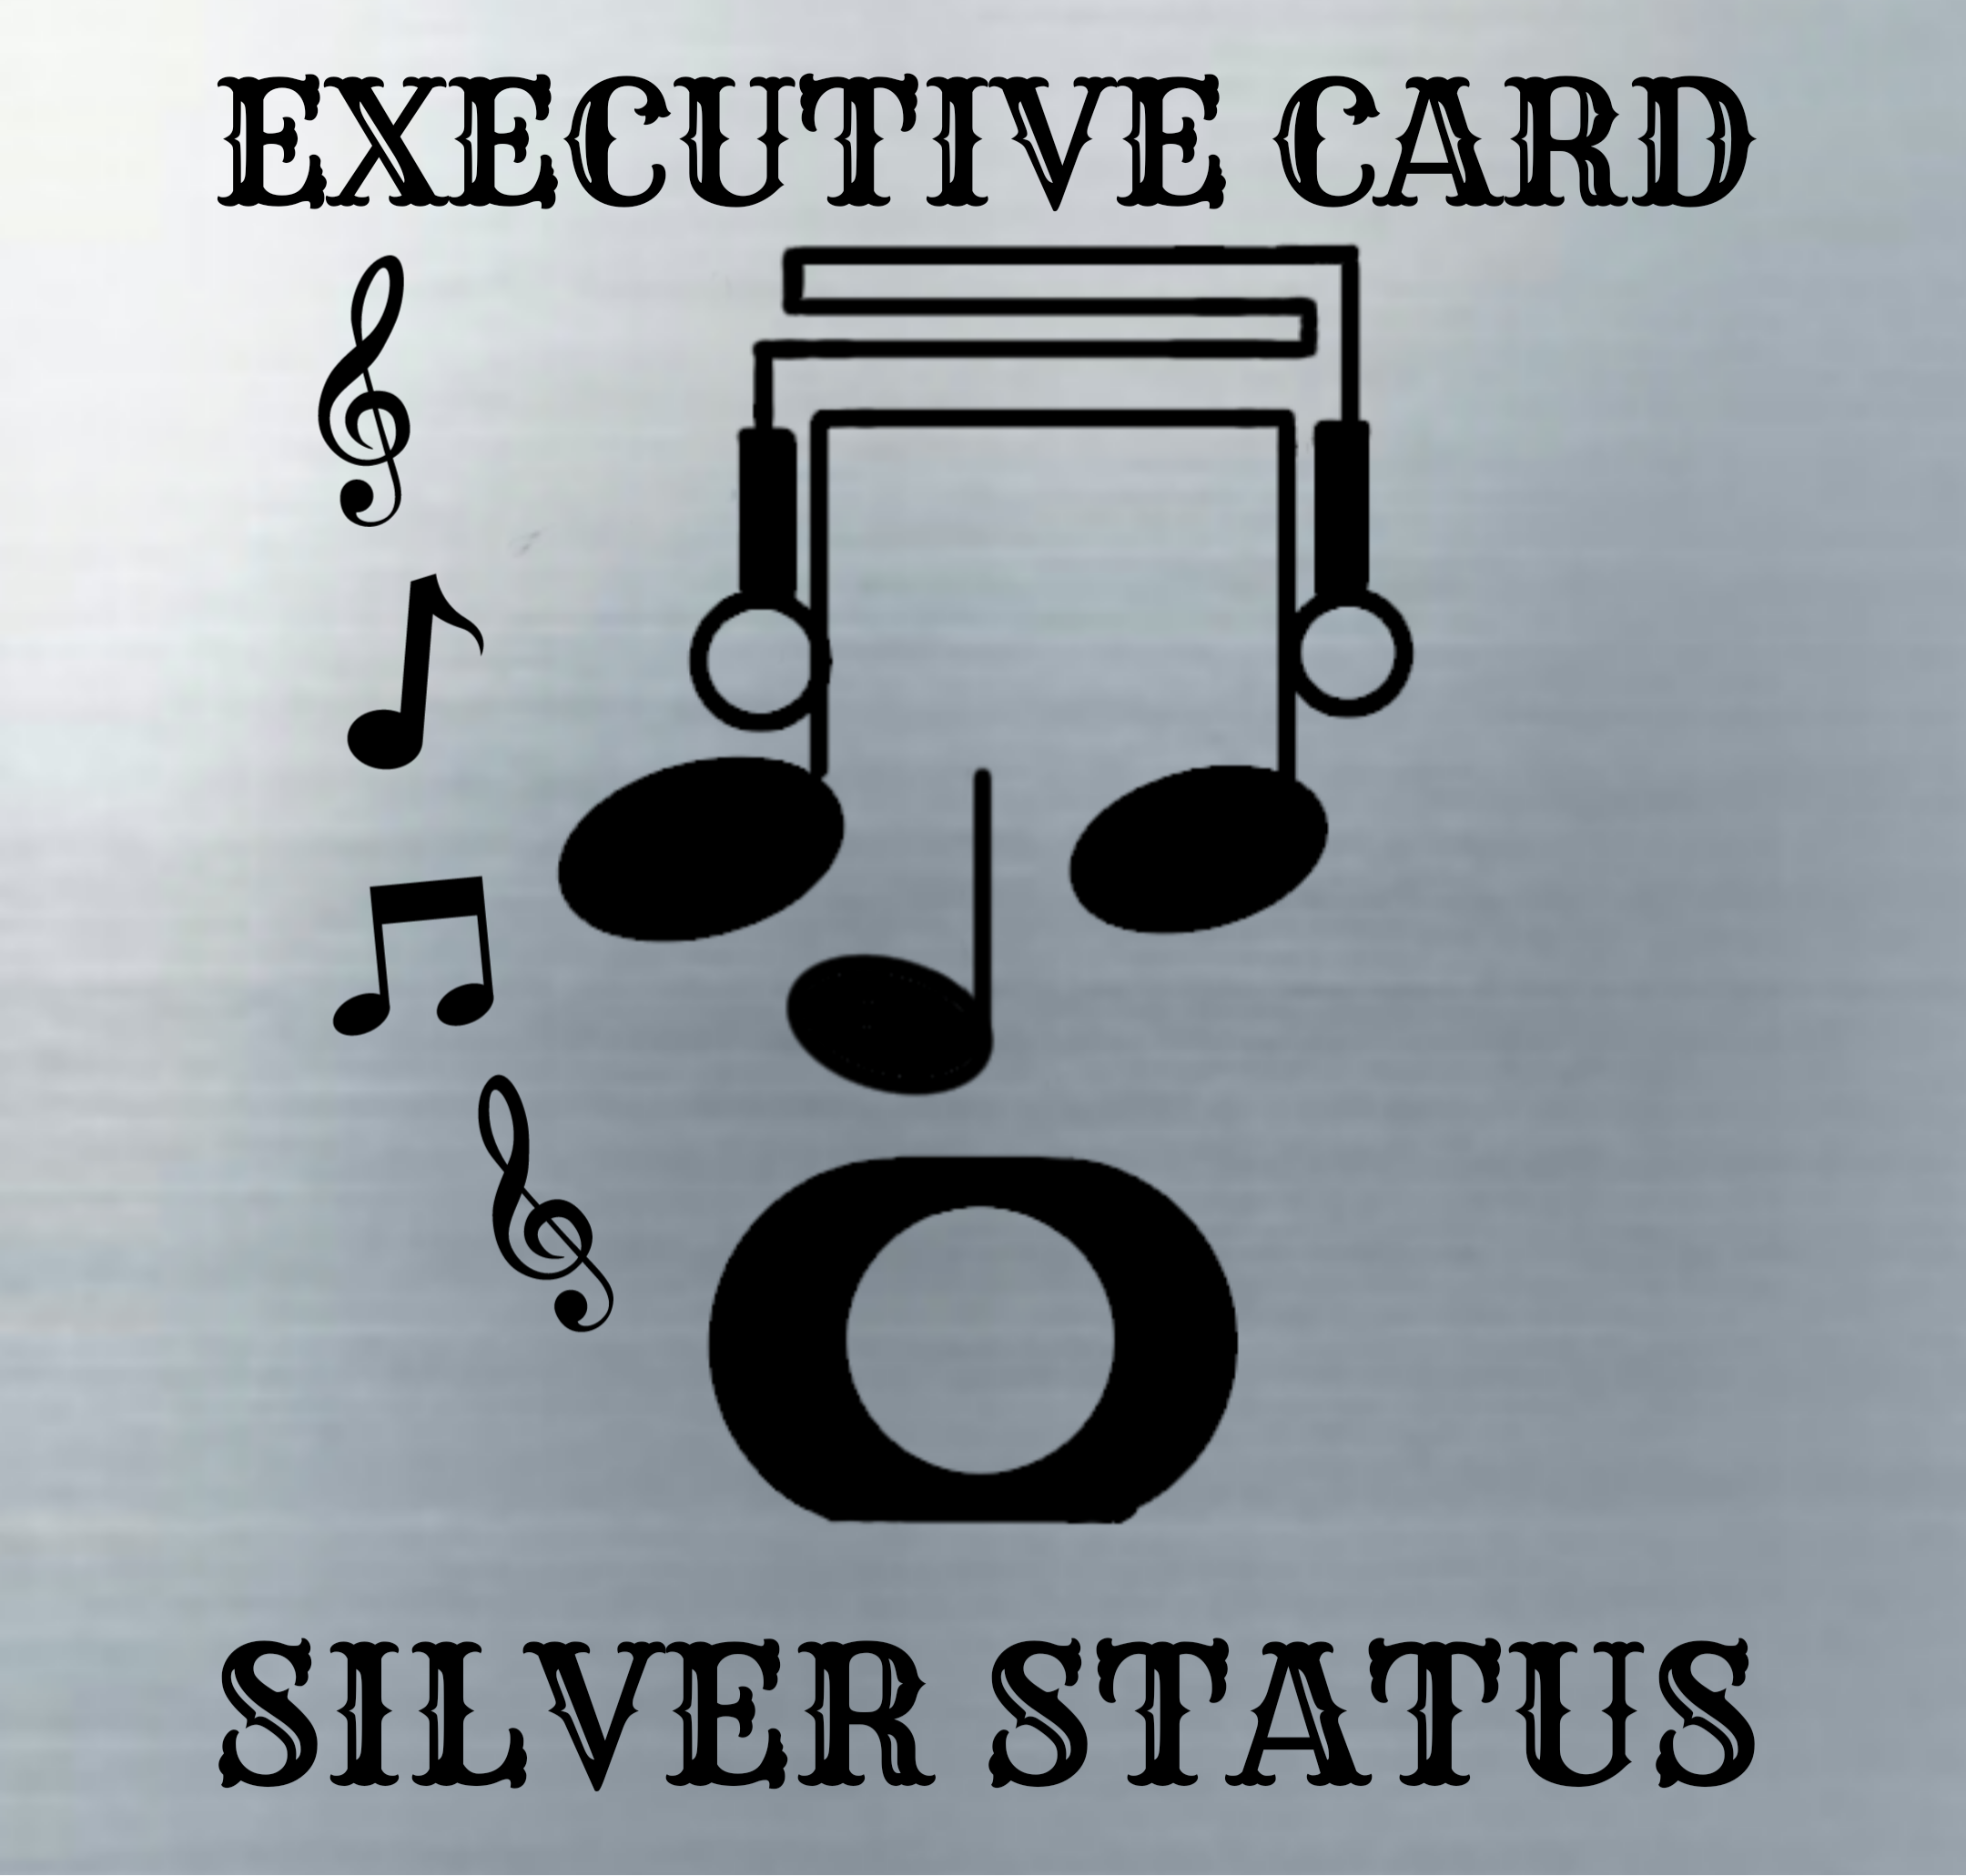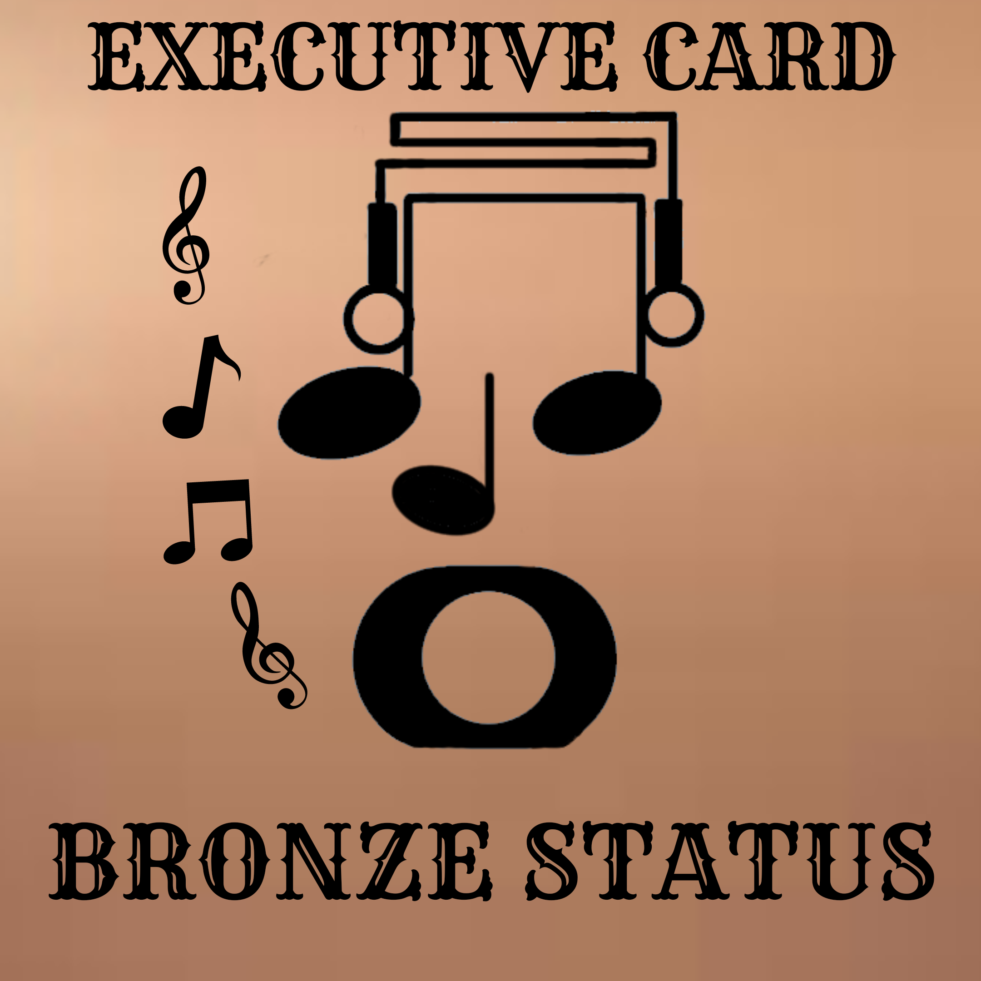

10. We need a page for posting jobs, which will be uploaded then added to the job list.

11. Job list page: I love the layout, we just have to take off the full time and part time icons, and add icons for details and apply.

12. Job detail/search job page: I love the layout. Applying for the job should send your profile in for consideration to whoever is hiring for that particular job. If you are chosen for the job you will be directed to the (do business page ) to accept the offer.

13. Do Business page: Perfect layout, maybe we can add a chat board for negotiations between the two parties. When a talent is notified that someone has made an offer, they will be sent to this page. We have to add an icon to accept offer. After the talent accepts the offer they will be directed to the contract page.

14. Contract Page: Perfect Layout, maybe we can add a chat board so the two parties can share the content to one another directly.