RESUME

Martin Altman

May 2019

Resume

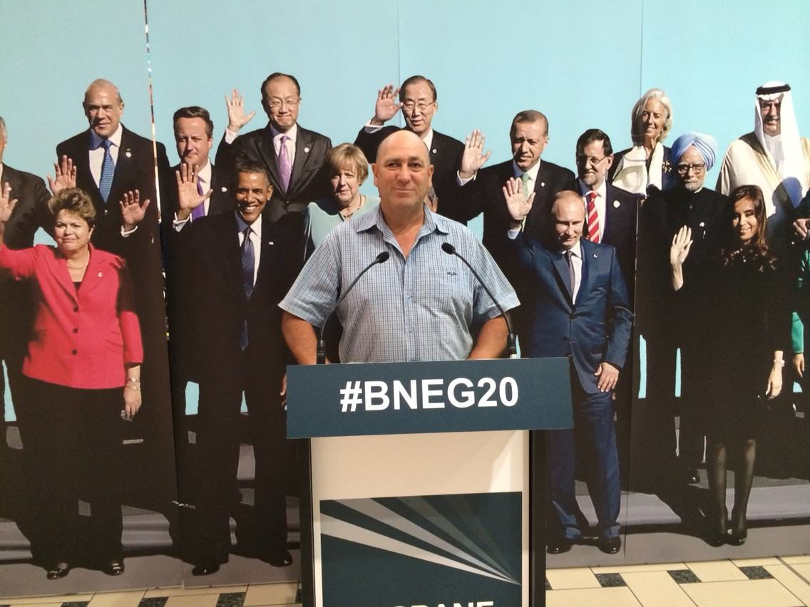
Martin Altman

Personal Details

Address: 71 Marlborough Avenue,
Glenfield Auckland 0629.

Telephone: Mobile: 027 482 3051

Email: brenmart2000@gmail.com

Qualifications:
Electrical Installation City & Guilds (Part 1 & Part 2) England
REINZ Real Estate Sales Persons Course N.Z.
Queensland Resident Letting Agents Course 2009
Queensland RSA
Queensland Approved Manager
Queensland Food Safety Supervisor
RYA Day Skipper (Practical)
Australian Residency
Senior First Aid
Queensland Driving License
Solar Energy Course

Strengths: Confident Communicator
Self Motivated
Customer Focused
Relationship Building
Business Acumen
Interpersonal Skills
Computer Literate
Key Account Management
Staff Supervision
Business Development
Energetic, Ambitious, Positive Attitude

Interests: Sailing
Fishing
Snorkeling
Walking
Cycling

Work Experience

2016-2018 Polyworld
Sales Consultant
Polyethylene manufacture of water tanks trolleys and handling equipment.

2014-2015 Lighting Illusions – (Windsor)
Manager

2013-2014 Rexel Electrical Wholesalers (Cairns)
Assistant Manager

2010-2012 Best Western Colonial Palms Airlie Beach Queensland
This is a 30 room motel and restaurant/bar with two swimming pools.
I worked as one half of a management couple in Airlie Beach.
I obtained my bar managers licence and food safety supervisor qualifications. We ran the Best Western booking site & RMS reservation system, introducing Siteminder and booking button software to manage the various booking sites the motel was listed under.
The Colonial Palms is a beautiful venue, we tendered and won seniors coach tour business, and also held regular events in the restaurant, from Regional tourism association functions, which saw us secure Whitsunday Council business, to Weddings.
Colonial Palms was where I learnt about pool maintenance, I was responsible for grounds and pool upkeep.

2009 – 2010 Affordable Accommodation -Proserpine
Motel Management
This is a 6 unit motel and 20 room boarding house.
Management, Cleaning, Ground Maintenance, Building Maintenance, Reception. Manual booking system. We both took a Letting Agents course for short term leases in the boarding house side of the business. We provided photography and content to help the owner build his web site.

2006 – 2008 Barfoot & Thompson
Real Estate Sales Person NZ

Responsibilities
Property Sales, Open Homes
Residential & Rural Agent
Advertising and marketing
Creating new business
Achieving Sales Budgets
Maintaining customer relations

2000-2009 Lamp & Tube Limited NZ
Managing Director

Responsibilities
Lighting Maintenance
Lamp Replacement
Project Management
Staff Management
Sales and Marketing
Domestic & Commercial Lighting
Customer Service
Key Account Management
Trade Show Promotions
Business Development
Energy Auditing
Energy Saving Consulting

1997 - 2000 Mastertrade Limited Electrical Wholesaler
Sales Representative NZ

Responsibilities: Territory Planning, Market Reporting, Key Account management, Business development, Achieving Sales Budgets, Maintaining ongoing customer relations, Contract Purchasing, Counter Sales.

1993 - 1997 JA Russells Limited Electrical Wholesaler
Purchasing / Sales NZ
Responsibilities: Key account management, Ordering and purchasing stock, Product sourcing, Quotations, Stocktaking, Customer service, Counter sales

