Need to make the headings slightly bigger and bolder with a few space tabulations between the heaading and the detail -> **Done**

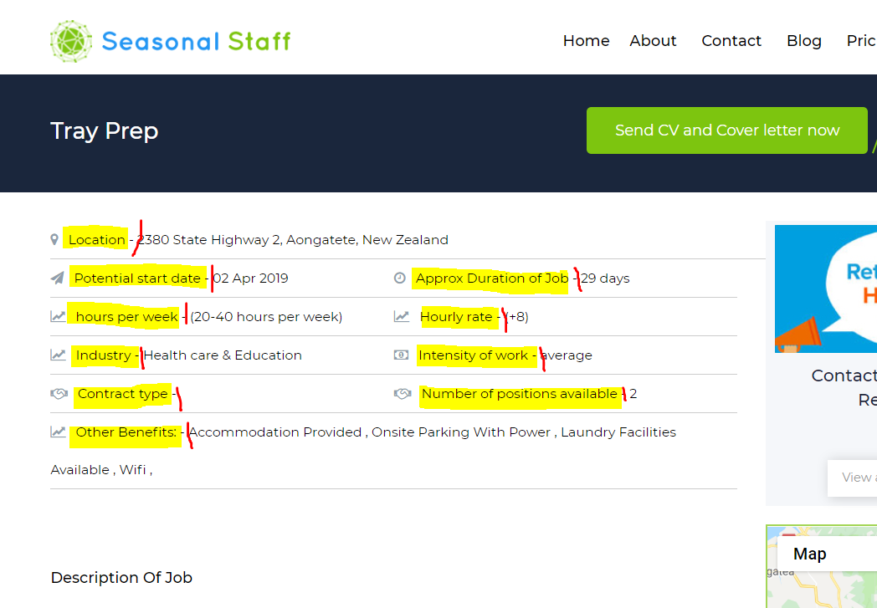

Can we make the “view more” button the Green of the (favourite button) so it stands out a bit more

Can we make the “heart button” soft red when not checked and bright red when checked

-> **Done**

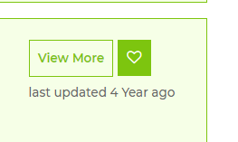

The error message does not look right when you have missed selecting which type of account you want. Please can this be more obvious and able to be read correctly.

Please can you centre “ Sign up to your account”

Please can you change the wording “Choose your account type” to “ Please choose your type of membership” - Please can this be made bigger so is more obvious. -> **Done**

Remove the “over age “ heading and change the wording from “ Over 18 years age” to “I am over 18” Please can “ I am over 18 be bigger and take up the space that is there. -> **Done**

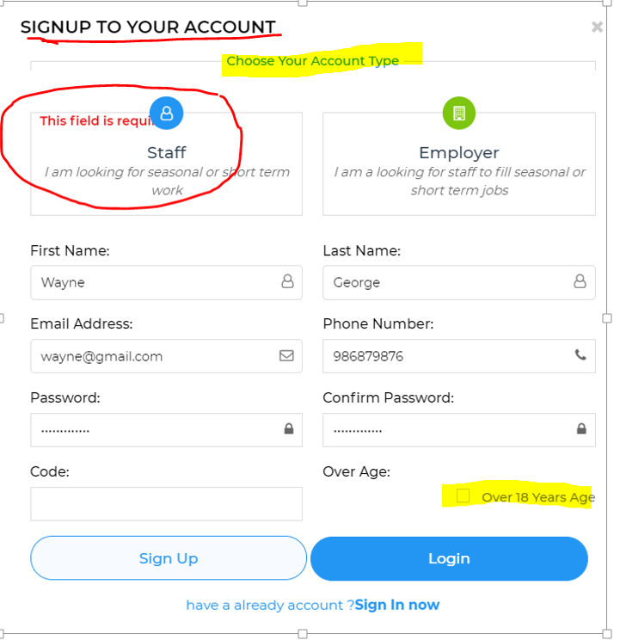

When I have tried putting a code in for the sign up I have received this message, it does not appear to be working. Is it possible to detail what the error is and a direction back to where the error occurred so it can be corrected.

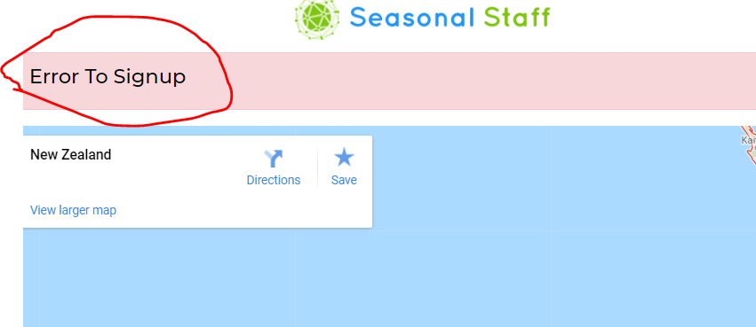

The calculator that works out the “duration of job” is not working please can you check. -> **Done**

The hourly rates does not display properly it looks all squashed together. Negotiable needed to be its own selection eg. So they could type in hourly rate… or select “By negotiatioin” -> **Done**

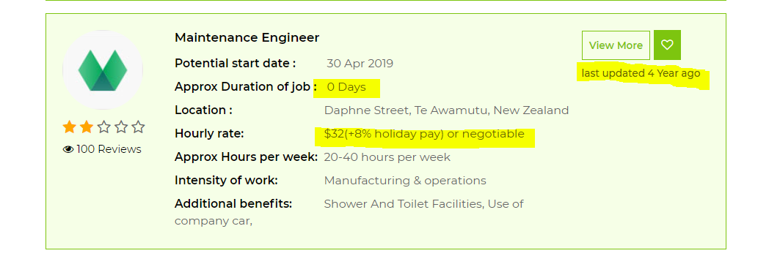

Hours per week can this be shown without ( ) the brackets around the selection

Hourly rate needs to always be displayed as a $ figure eg $4 not (4) please remove the brackets here also around the selectioin -> **Done**

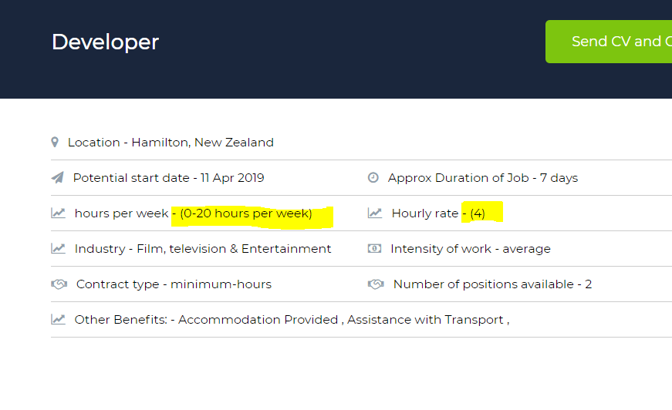

When I put in Hamilton to search for a job (I know there is a job listed for Hamilton) it did not find any, the search does not seem to be working properly yet.

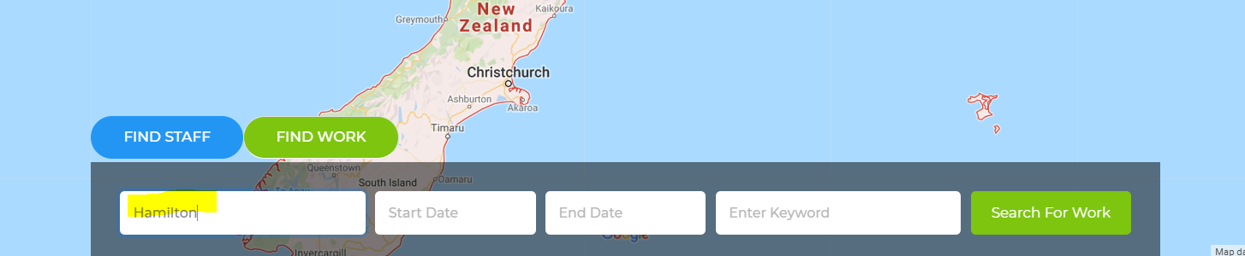

Below the Blue search button can we please add another blue button that says “return to main search” This would take users back to the main page. (if we don’t have this users may get confused about how to get back to main page” -> **Done**

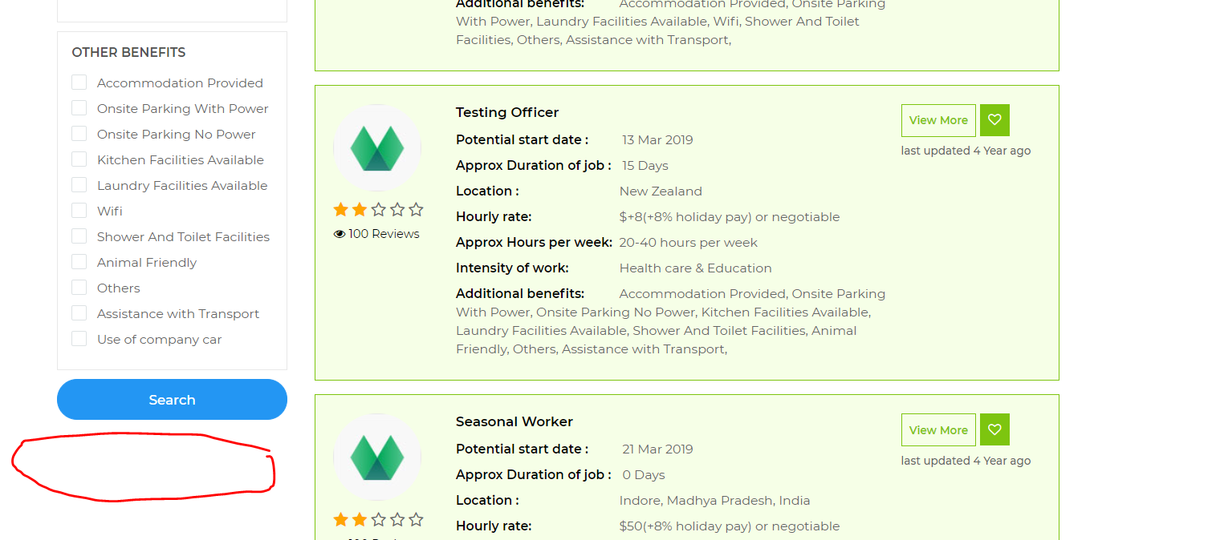

When a user (that has not registered) clicks on the logo please the (log in) box come up this should also happen when you select the “View more” and they are not registered. -> **Done**

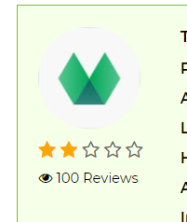

When a (Staff) user first registers and logs on can there be a message that says “Welcome, now complete your profile” with a continue button

We want as many people completing a profile as possible. -> **Done**

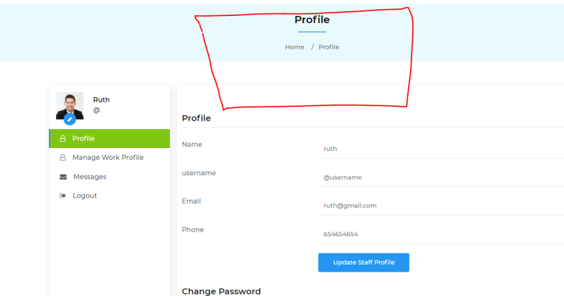

Nationality needs to be a free text box so that people can put in their own Nationality as there are far to many to list.

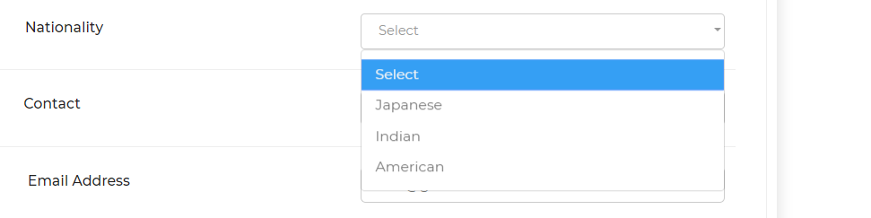

Please remove what I have marked in red.

Can you change “For candidates” to “for staff”

Question will the users (Staff and Employers) be able to click on the links below and if so if they are logged in will they be taken to these pages?

All the titles under “Information” should be able to be accessed by all users whether they are registered or logged in or not”

