Corrections to be made,

On the Login page…one you have registered please can you change the “signin” button to the word “login” so the same wording is used. - > (**Done**)

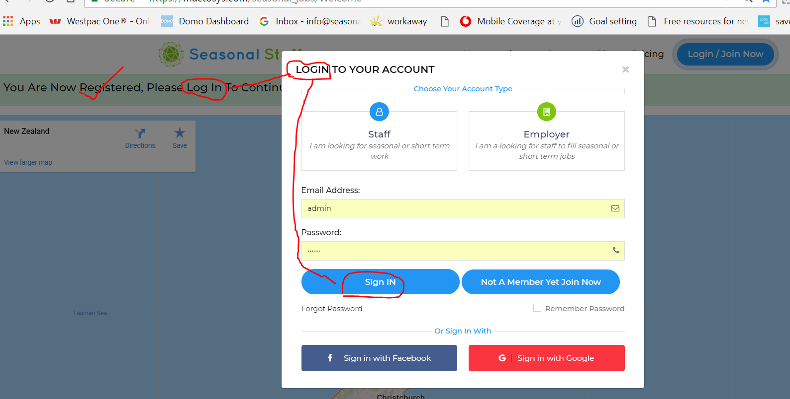

Once they have logged in for the first time, either as a staff member or a business, please the they be directed to the profile page

Please change the wording from “choose pricing option” to “Please choose your Annual pricing option” - > (**Done**)

Can you also on the last option Change wording from “ Needing 500 staff” to “Needing 500 + staff” ” - > (**Done**)

Can you please add after each price add “Annual membership

What does the “Skip” button do?

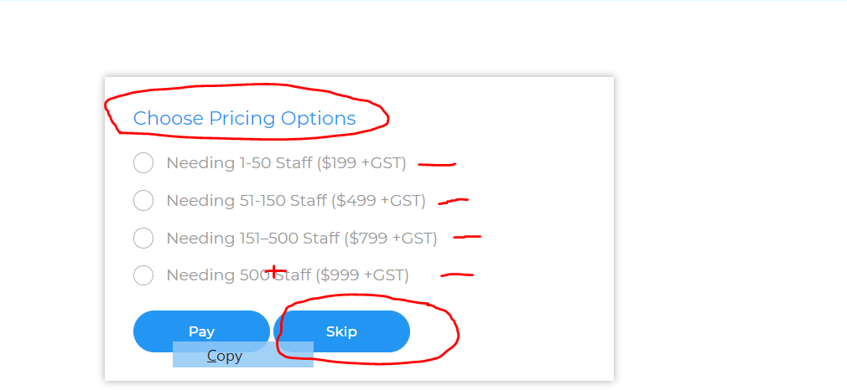

Please change the below wording to “Please complete your business profile.

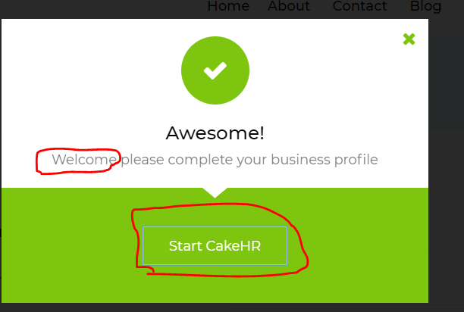

Once they complete “business profile” and update the same message shows…. Can this please show another message to say “ Awesome! Now Tell us about your Business”

Please can you change the below wording from “About Company” to “About your Business” - > (**Done**)

And change all the wording to “match” changing the wording from “Company” to “Business” - > (**Done**)

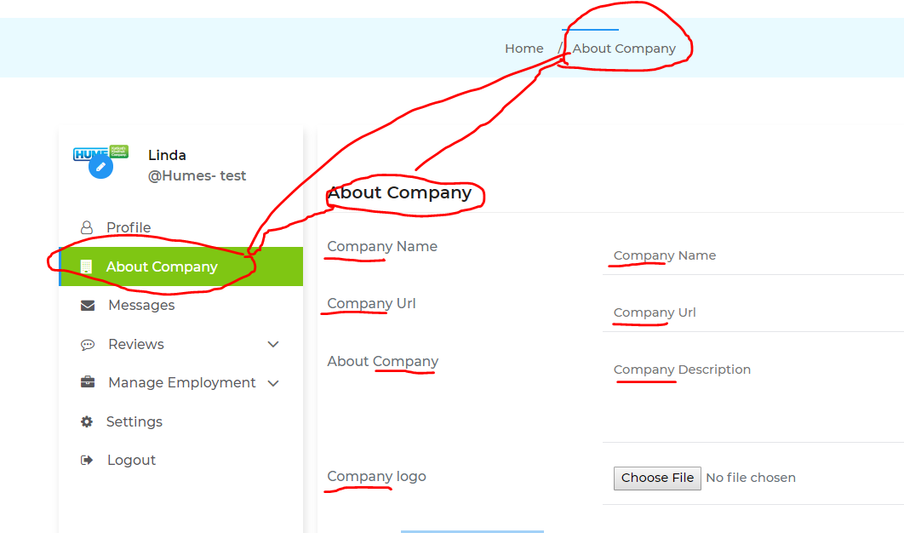

- > (**Done**)

Changes for the “list a job” page. - > (**Done**)

Remove the “Edit your job” button – Because you are already in the page where you would edit it there is no need to have this on this page”

Please ensure that the select package buttons can be “untickable” This selection is not a compulsory. (Please ensure that is it is not “Complusary“ and stops users from progressing.

The “You accept our Terms and conditions and privacy policy” tick box. This needs to be on the sign up page and if it is not “Ticked” they are unable to progress. Also please can you ensure that the word “Terms and conditions” and “Privacy policy” are links which will take the users to those pages.

Please can you add a button called “Publish your Job” We want the adds to be able to be published straight way and do not require approval from us. We just want the ability to suspend and advert or delete one if it is not suitable.

Also when **“Save as draft”** is pushed, please can you ensure that the user is taken back to the it “Manage Employment / Manage Jobs

When the “Publish your Job” button is pushed. Please can you ensure that the users is taken to the ‘view ‘of that advert that they have just created.

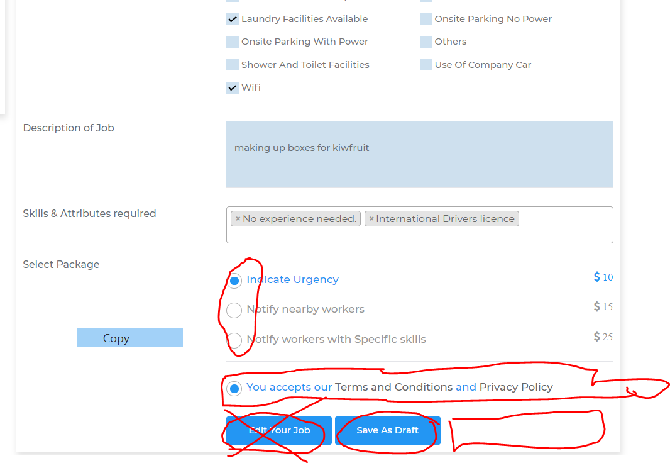

When a Business user goes to the “View” of the job you have just posted, when “Receive expressions of interest” it does not appear on the heading area

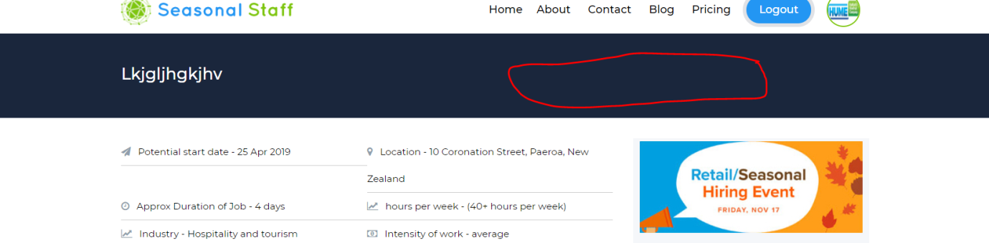

Please can you put a big blue “Search for Staff” button underneath “logout”

This would taken the business user directly to The main home page with the Blue “Search for staff” Tabs ready for them to push.

For all of the pages….. where we have used a title eg “Name of Account Manager” or “Username” please can these all bolded, so they stand out a bit more.

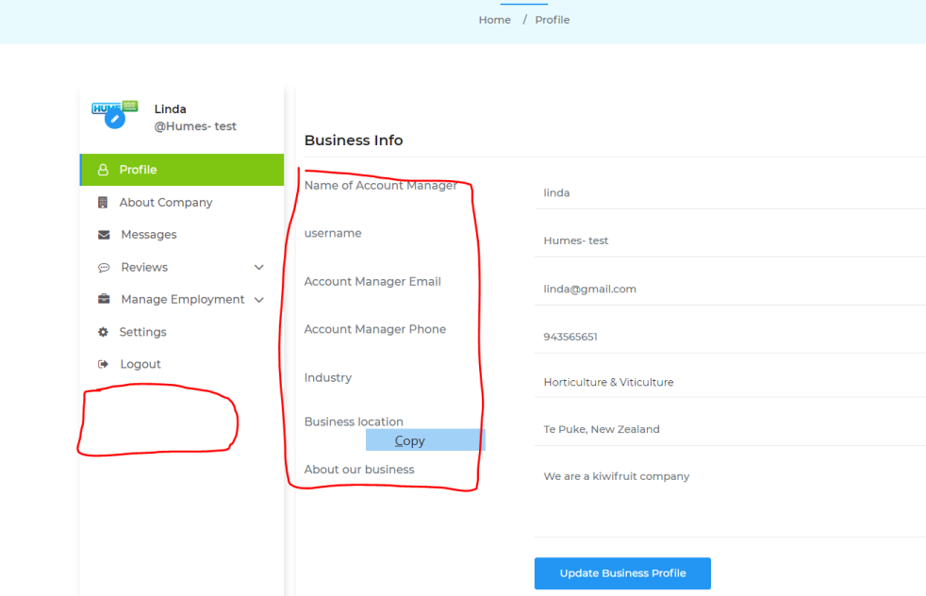

- > (**Done**)

Can you Change the wording below from “ Manage Applicant” can this be changed to “Manage applicants” also When you select Applicants can it please take them to show all the applicants that have applied for jobs. (below)

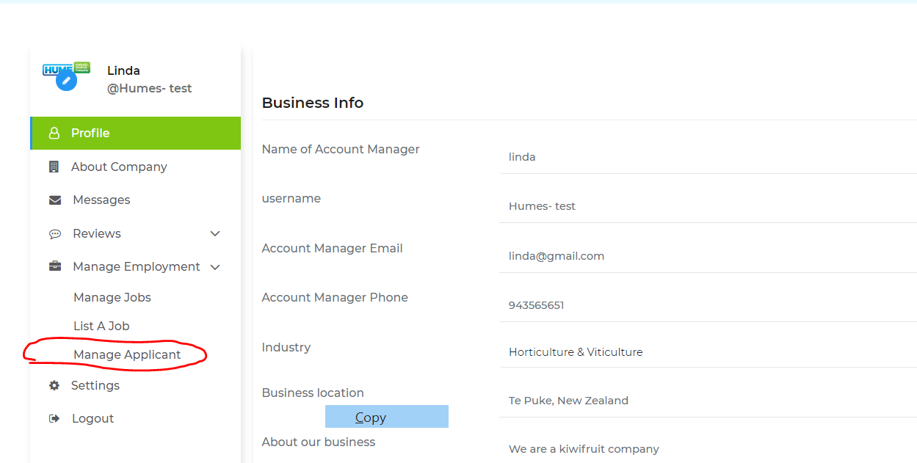

On the manager applicant page and all the other pages that use the below “email, chat, View,or Delete “ icon .. please can you make this bigger.

Can the job or jobs that this applicant has applied for be listed “where the read line is” Can these please be in Bold font.

Is it also possible to mark where you have received an application from an applicant multiple times.

- > (**Done**)

