|  |  |
| --- | --- |
| **Mactosy Software Solution Pvt. Ltd.** | **Indore, India**  **www.mactosys.com** |

**The Organization**

**Mactosys Software Solution Pvt. Ltd.** Has started its journey by holding hands of four exceptional talented experts in the Web Development, Mobile Apps Development and Internet Marketing domains. We have in our assortment Internet Marketing experts, Far-sighted Web Developers, well-versed Content Writers and creative Web Designers. These skilled professionals have the zeal to win and strive to combat a professional scuffle amongst other prominent vendors.

**Our Strengths**

The joint efforts of highly professional and experienced members make Tensaprk Software Solutions to flutter with the flying colors. The company works towards the seamless assimilation of striking web applications, fresh contents and successful web promotion strategies to get business highest visibility in the teeming avenues of the online world. The missions with which we get started include setting up long-standing goals, working in collaboration with development team to describe business goals and also the implementation and observing of such goals.

We have a dream to extend the chain of our service throughout the globe and we will leave no stone unturned to make it a reality. Our company experts can stand up and announce that we have the power and capability to put any product or service of our client higher up on any search engine listing with our strenuous effort and dedication.

**Spectrum of Service**

Mactosys Software Solution Pvt. Ltd has set up with the objective to fulfill the needs of small and medium sized business. We take the pride of accumulating a high degree of credibility among our clientele for our best services within your budget.

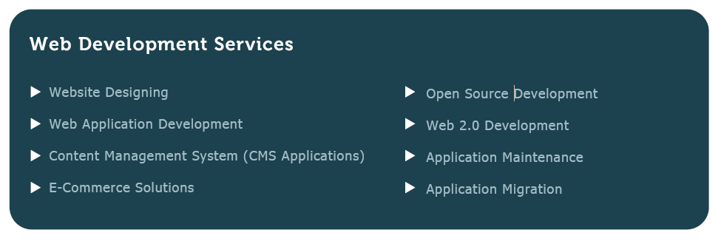

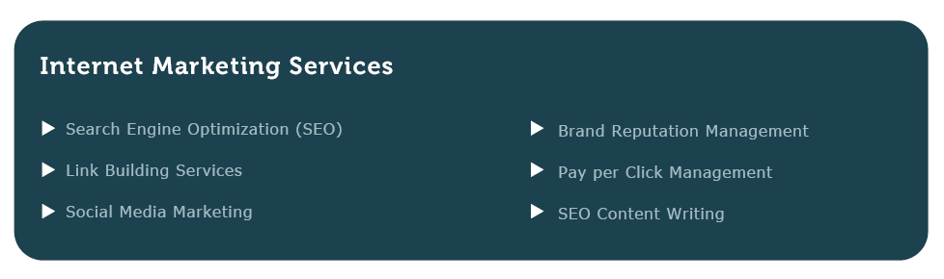

**Customer Relationship**

We are committed to our values. As one of the most responsible Web Development and SEO companies, we do not mislead our customers with ambiguous or any false promise. If we feel like we cannot help you, we will let you know by respectfully declining your project. But if we take the responsibility, it becomes our sole mission to deliver the work on time with 100% commitment. We believe in maintaining long-term relationship with our clients and thus, we put every possible effort to satisfy them with our work.

The business value of the company is to focus on Human Values and Personal Relations. Major emphasis is laid on good communication, lucidity and human relations, which forms the very basis of the corporate culture. At Mactosys, we not only grow up products, but also we develop a healthy relationship.

**Some of Our Valuable Clients**



|  |  |
| --- | --- |
| Initial Understanding & Scope of Work for Online Tutor Platfrom |  |

1. **Introduction**

Client want to be develop website for Online Teaching where Student can find Tutor for their subject and learn Online with virtual classroom.

* 1. **Background**

Web Application will be based on tutorhub.com. It will take only required Functionality Reference, Design & Implementation will be totally unique and it will be Responsive.

It will be developed in Open Source.

* 1. **Scope of Work**
* Design & Development of Responsive Website
* Admin Login
* Tutor/Student Login as per access level
* Innovative & Intuitive Dashboard
* Subject Listing
* Offered Service listing
* Student can buy tutor time and join classes
* Tutor review rating
* Payment system
* Service Guarantee
* Voice and Video (Gomeeting/join.me API)
* Message Feature within website
* Complain system
  1. **Requirements**
* Web Application must be responsive and Easy to Use.
* Admin can Create User.
* Tutor can manage class.
* Both Admin & tutor can use various Features to manage their Web Account.
* Admin can generate Various Reports based on the Data Submitted

**1.3.1 Tutor**

* Tutor can list profile on portal.
* Tutor Can set their hourly Price on portal.
* Tutor can accept payment via portal.
* Tutor Manage all lesson .
* Tutor can schedule online class and participant.
* Tutor can request for money earned on website.
* Tutor can ask question in Q & A section.

**1.3.2 Student**

* Search Tutor and subject offer on portal with filter (Price, Review, Subject)
* Buy tutor time and pay via PayPal and credit card.
* Review Tutor after purchasing
* View previous purchased tutor time from website
* Ask question before purchasing time from tutor
* Student can add credit in their account
* Student can Ask Question in Q & A section

**1.3.3 Admin**

* User management
* Manage user complaint
* Manage photo gallery
* Blog writing
* Manage basic pages like contact us, About us, FAQ, How it’s work
* Can see transaction history

1. **Compliance**

Phase wise Approval & Payments will ensure that Work is on right Track and as per Schedule.

We’ll mutually agree for Milestones.

1. **Project Deliverables**

**Milestone 1**:

1. A Complete SRS will be given for Approval to Client, We’ll follow and provide everything mentioned in that document

**Milestone 2**:

1. Preparation for Admin Login
2. Mockup Preparation for Tutor Login
3. We’ll Provide All HTML Screens with Dummy Data, Buttons and Links will be clickable to get the understanding of complete flow.

**Milestone 3**:

1. Development of Screens Done in Milestone 2
2. We’ll start coding and DB Design for Milestone 2 Screens
3. QA: Will do Unit Testing
4. Client Review & Feedback
5. Feedback Implementation

**Milestone 4**:

1. Mockup Preparation for Student Login.
2. Development of Screens Done in Milestone 4
3. We’ll start coding and DB Design for Milestone 3 Screens
4. QA: Will do Unit Testing
5. Client Review & Feedback
6. Feedback Implementation

**Milestone 6**:

1. Complete Integration
2. We’ll integrate Admin, Student & Tutor
3. QA: Will do Complete Testing
4. Client Review & Feedback
5. Feedback Implementation

**Milestone 7**:

1. Beta Launch
2. Client can start entering data and test it
3. Prepare for Launch

**Milestone 8**:

1. LIVE Launch.
2. We’ll deploy the website on your server.
3. Post Deployment Support.
4. We’ll be happy to give Post Deployment Support based on feedback.
5. **Project Timeline : 50 Working days**

|  |  |  |  |
| --- | --- | --- | --- |
| **S.No** | **Task** | **Duration** | **Cost** |
| 1 | Milestone 1 | 2 Days | **0$** |
| 2 | Milestone 2,3 | 15 Days | **600$** |
| 3 | Milestone 4 | 20 days | **450$** |
| 4 | Milestone 5,6 | 4 Days | **50$** |
| 5 | Milestone 7,8 | 2 Days | **50$** |
|  | At Start | 0 | **250$** |
|  |  | **Total :-** | **140$** |

1. **Assumptions**
2. Paypal and one card processing payment gateway is involved in this .
3. System will NOT be Extracting/Reading any data from any 3rd Party Website
4. System will not be Integrated with any other website.
5. **Technology**
6. System will be development in Open Source ,LAMP.
7. We’ll use MVC Architecture which is best supported by CodeIgniter(3.x)
8. Database will be MySQL
9. HTML 5.0 and CSS 3.0 will be used

**Please feel free to write us at: -** [**info@tenspark.com**](mailto:info@tenspark.com)

**Or**

**You can visit us at: -** [**www.tenspark.com**](http://www.tenspark.com)

Proposed by: - Mr. Durgesh Mandal

Business Development Manager

Tenspark Software Solutions.

Indore (M.P.) , 452001

E-mail :- durgesh@tenspark.com

Skype :- durgeshmandal

What’s app :- +91-9479447719