I have tried listing a job for an employer and there are multiple errors

That have happened… please can you fix

The Code “prelaunch001” did not work, to give 100% discount to the membership

The tabulation is all wrong in the text box

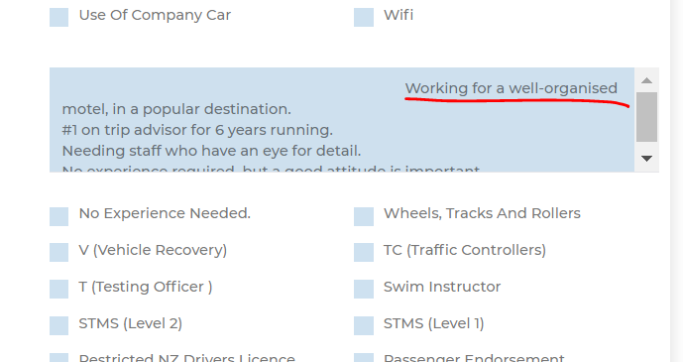

Second while the jobs says it is published (it appears on the map) but there is not information in the job profile

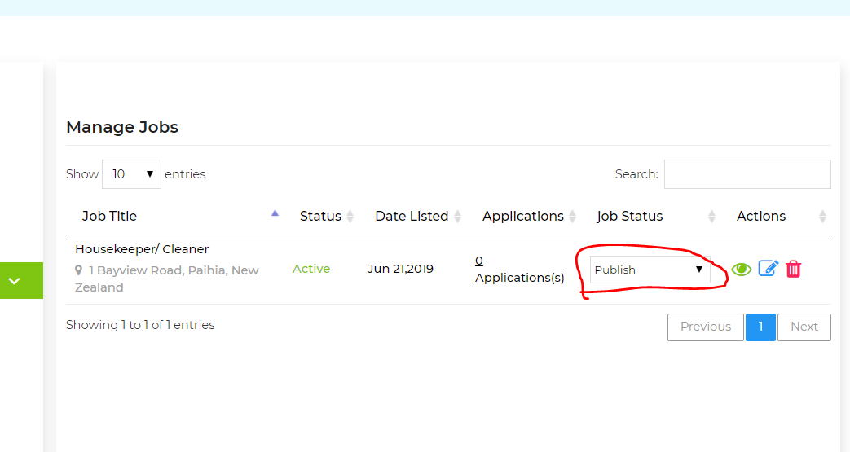

When you click on the view icon… the below message comes up

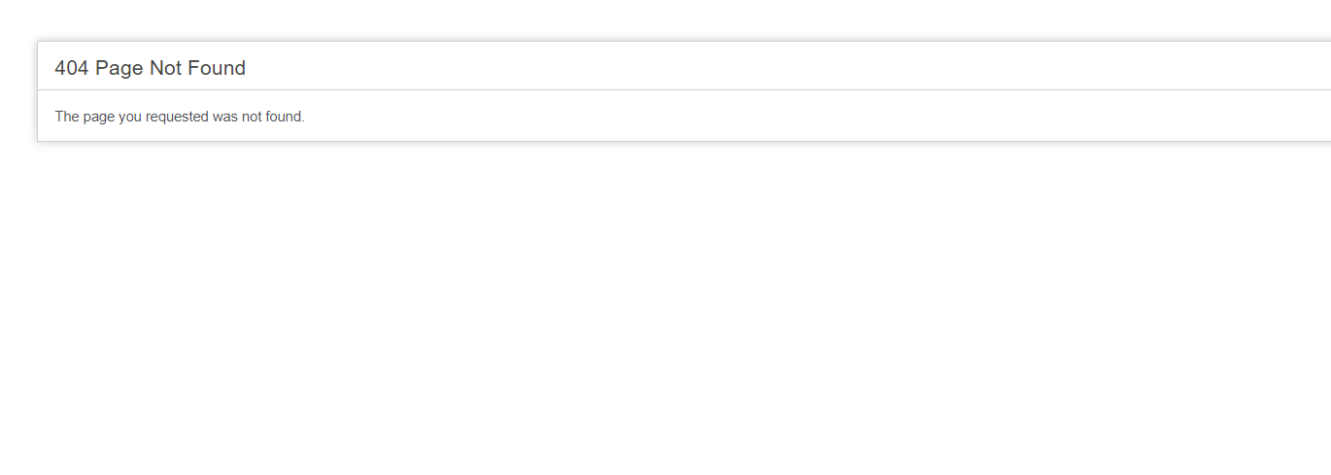

Information is missing from the job advert including the “Cover letter and CV” Button

