Issues and fixes 15th of June

First of all please can all listings that we currently have listed “for employers” please stay on their.

Please ensure that once the server is transferred the are not lost. As they are actual holdings of jobs around the country.

Would also be good to see the new layout on the front page.

Please can you move the top part of the page down to the top of the country. There is too much blue sea above.

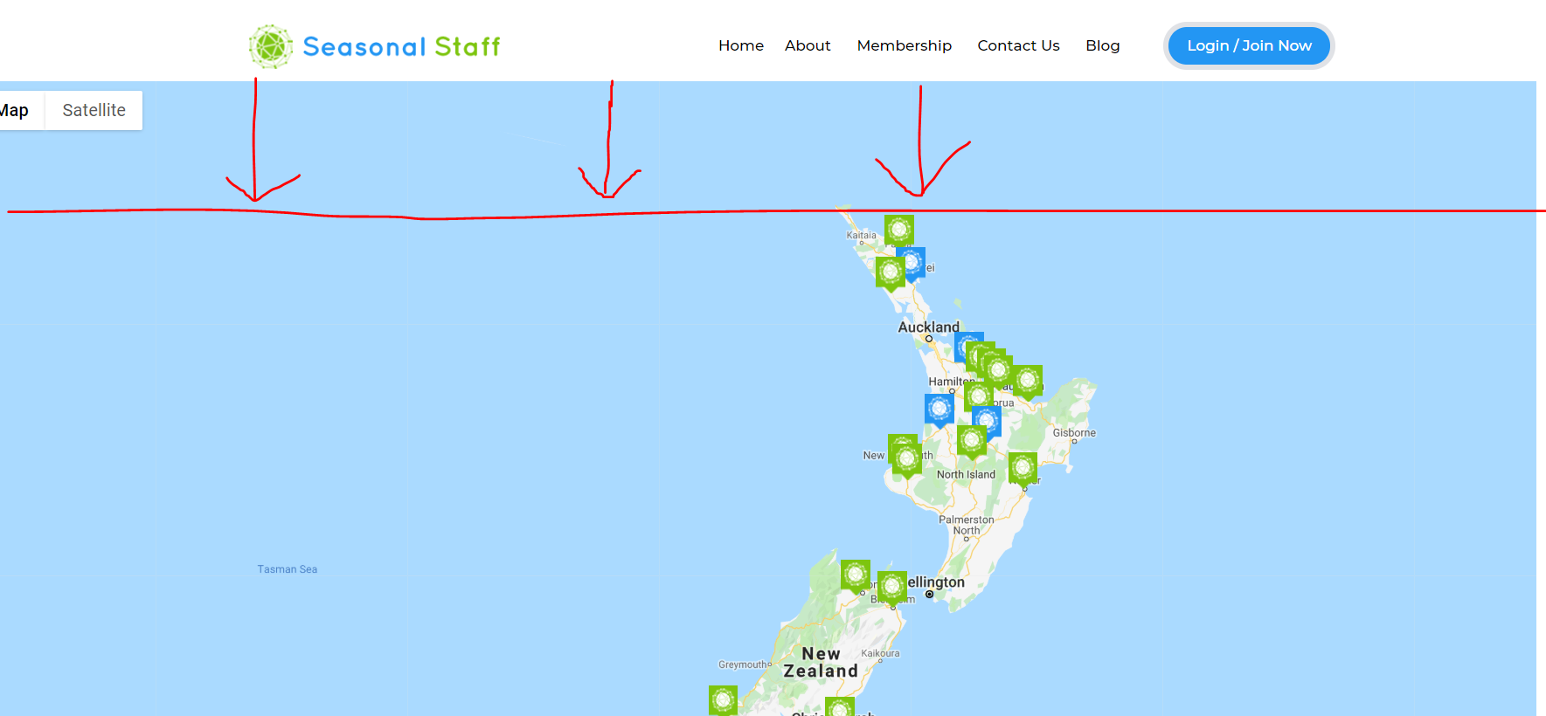

Can this page be bigger…. You have to scroll to finish completing it … if possible it would be good to have all the imput information able to be seen in the box

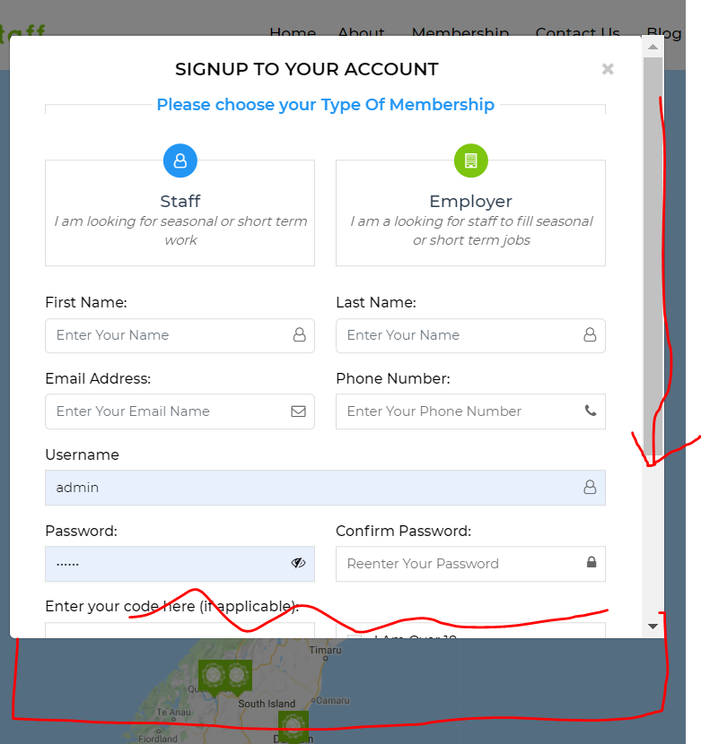

The code section is not working

I tried imputing 100% discount for an employer code “paypaltest”

And it did not calculate the discount and took me through to paypal to pay and wanted to charge the full price. Please can this be fixed this is very important.

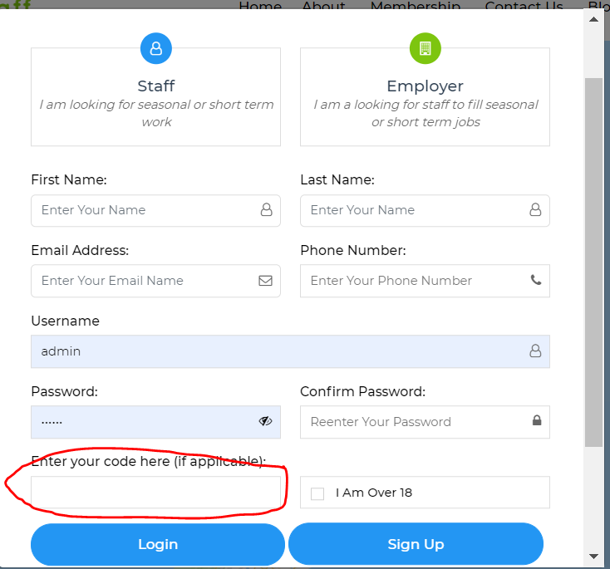

The mail notice icon does not all display (see below)

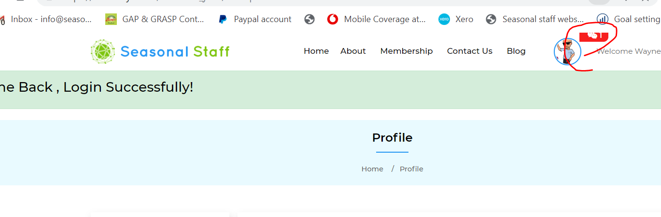

This button needs to take the user to “about your business” page… rather than the “profile” page as this has already been completed from the “sign up” process.

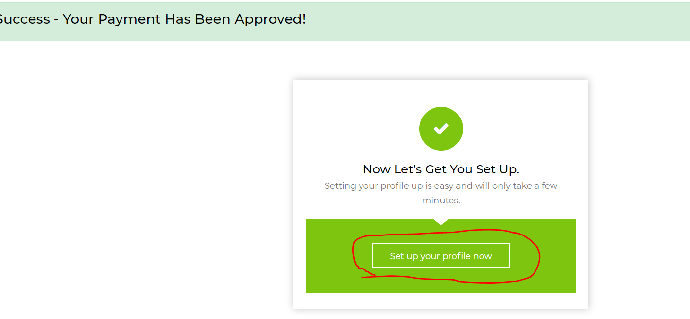

Once they push the save button this would then take you to the “Green Box” that asks “what they want to do next “ and gives them the option to “list a job” or “Search for staff”

In the message box for both Employer and Staff…..you cant scroll up to see all the messages if you are having a conversation 4 messges. It wont allow you to read them all.

If you are an employer and want to delete your job… it deleted the job from the list…. But sill shows on the map. (it was the first of three jobs listed for an employer” If a job is deleted it needs to also deleted from the map

If you want to put the job advert on hold it does not allow you to put it on hold it still remains on the map.

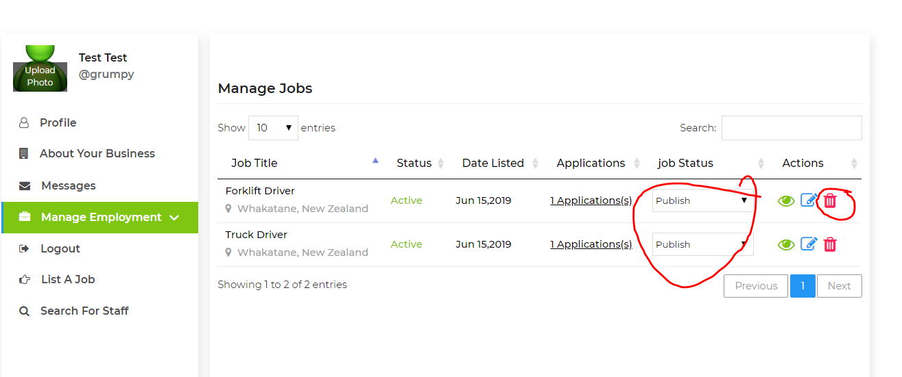

When an employer is going to send an email from the “manage applicants” page… please the the email box be changed to the following

“Send Mail” Changed to “Send the an email.”

Below the txt box can an attachment be able to be added. (this is important incase they need to send them an application form to fill out..

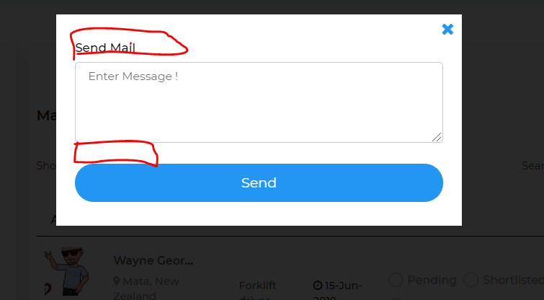

Can the red circled be changed from “ Manage interested user our jobs” to “ People watching your Job”

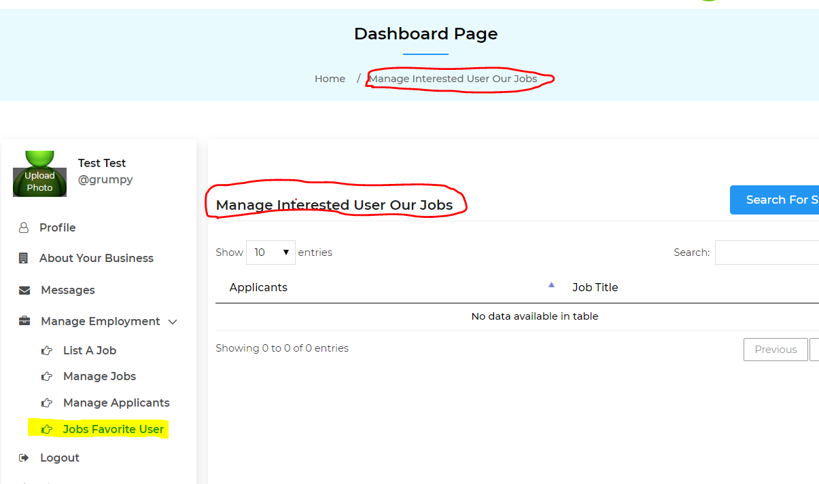

Listings for both staff and employers appear on the map but them they start disappearing for no reason.

Here is the map we have done… earlier today

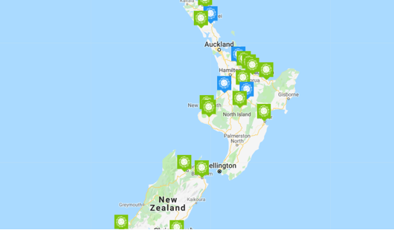

Here is the map a few hour later. (this is heaps our work that has been deleted please reinstate.

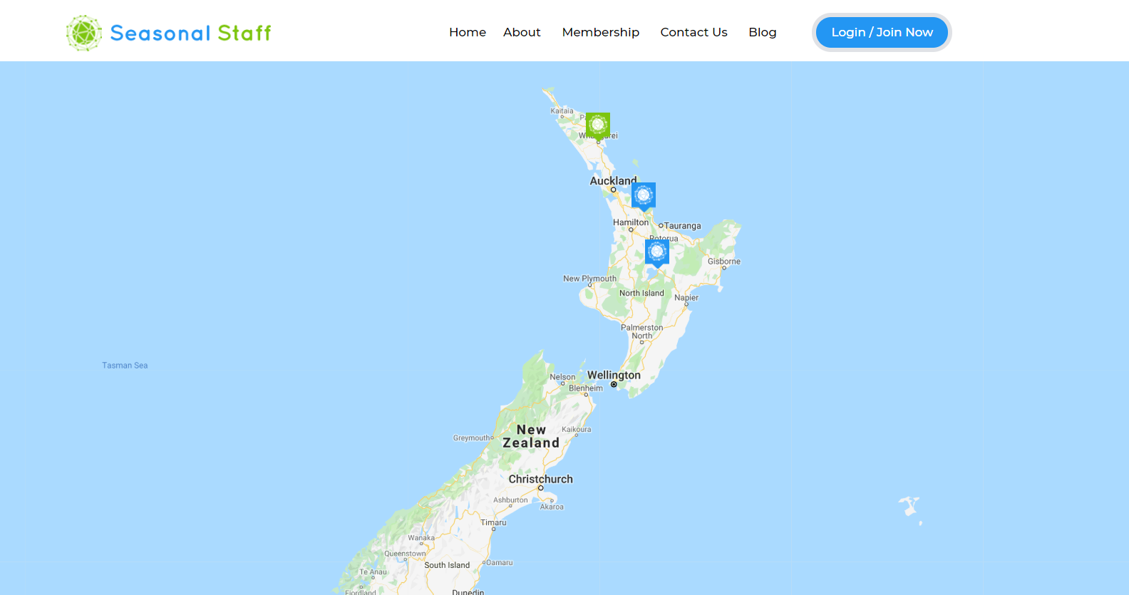

I have noticed that when you are searching using the search bar below the map, the listings that come do not necearilly match the pin drops on the map. (this needs to be fixed)

