Fixes and breaks 23rd of June.

I have been testing and notice that when a person verify’s their email effects if there are any error messages when they list a jobs.

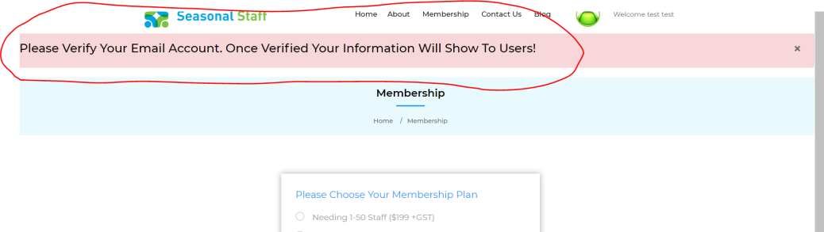

Please verify your email is not in the right place…. To Ensure that we do not get error messages can there be a pop up notification (like the green Box) that pops up over top of this box that the user has to click out of. (we have had feedback that it is not noticeable enough)

Please can you move “Verify your email notification” to here (over top of this box)

Then once they have verified and clicked out of the “verify email box” then this box will remain.

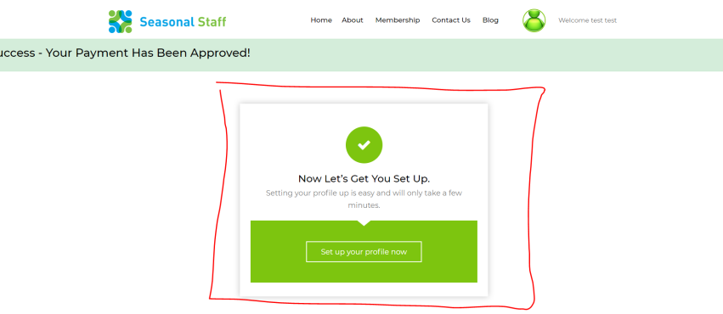

At the moment it pops up once you have logged back in after registering (and is being missed)

The email the verify email …. Does not need to take them back to the page… that is just further complication. (as they are already in the right place and will save them having to have a new screen open) Please keep the “verify your email” but do not open another box and as it takes them away from where they were and disrupts the flow.

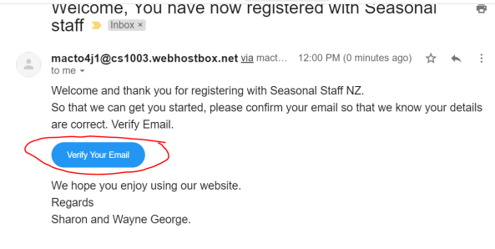

Broken link. This message comes up after you push save “when saving your business profile- if you have not put anything in “Tell us about your business”)

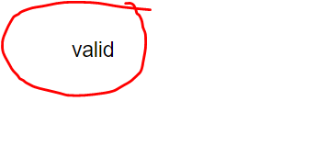

At the moment it is not saving any of the information if the boxes is not filled in. ->**done**

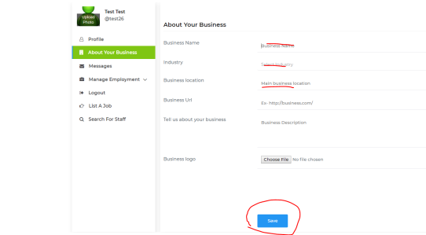

Please can we ensure that an of the emails that go out they attach a copy of the staff members profile.

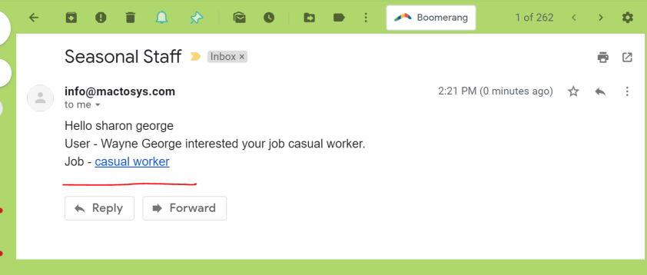

Also a problems. I did a test with one employer having 4 jobs. I applied for 3 (2 iminterested ) and 1 with a cv attached.)

As the employer I only got 1 message about the first job only… and none of the other emails or cv came through. – Please fix. Notification needs to come through on every job they apply for.

When a staff member or employer (logs in ) this does not include the first time logging in)

Can they be taken to the main search map first please. Not the “ My information “ or “profile”

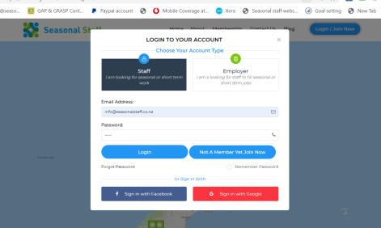

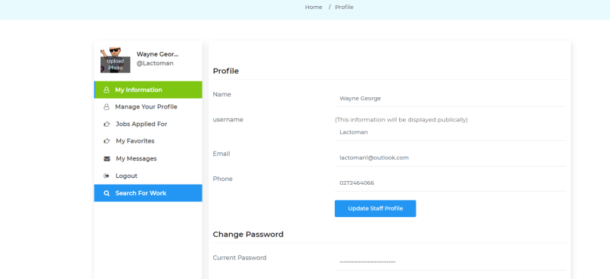

We cant see the messages properly, can this be moved to be more visible eg under neath the person icon.

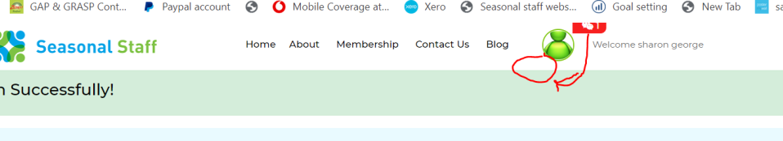

“Eligibility to work” should display “

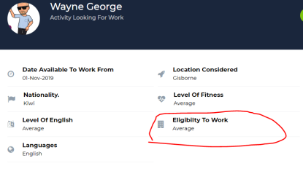

If an staff member is deleted, unfortunately the profile page still shows their application, even though when you click on it there is no staff member.

Can we please make sure that when the a staff member is deleted permantly all the applications are also deleted

