How to guide for Employers using seasonal staff

It’s easy…Green are the jobs available and Blue are the staff looking for work.

When you login as an employer you will see the Blue icons…because your looking for workers.

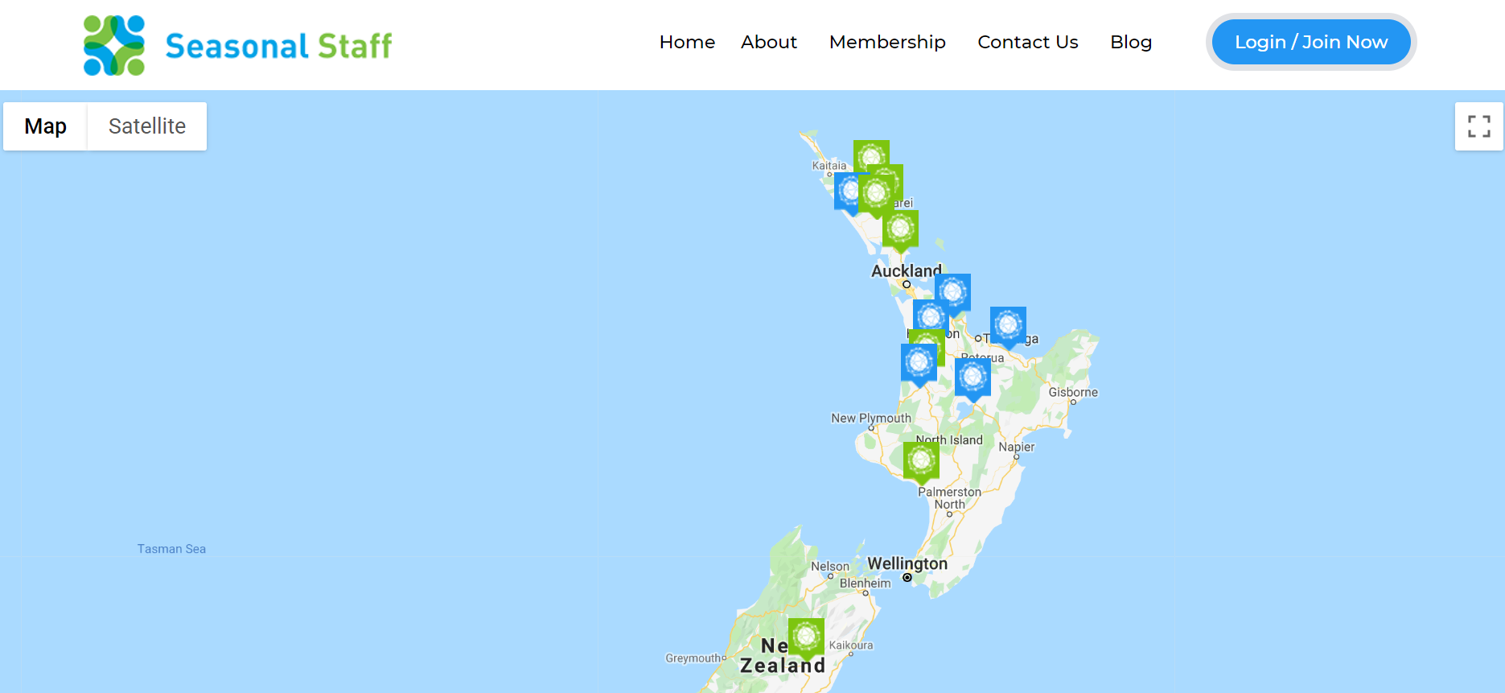

Once you have logged in and completed your profile, check out your Dashboard. You will find it by clicking up the top right hand corner.

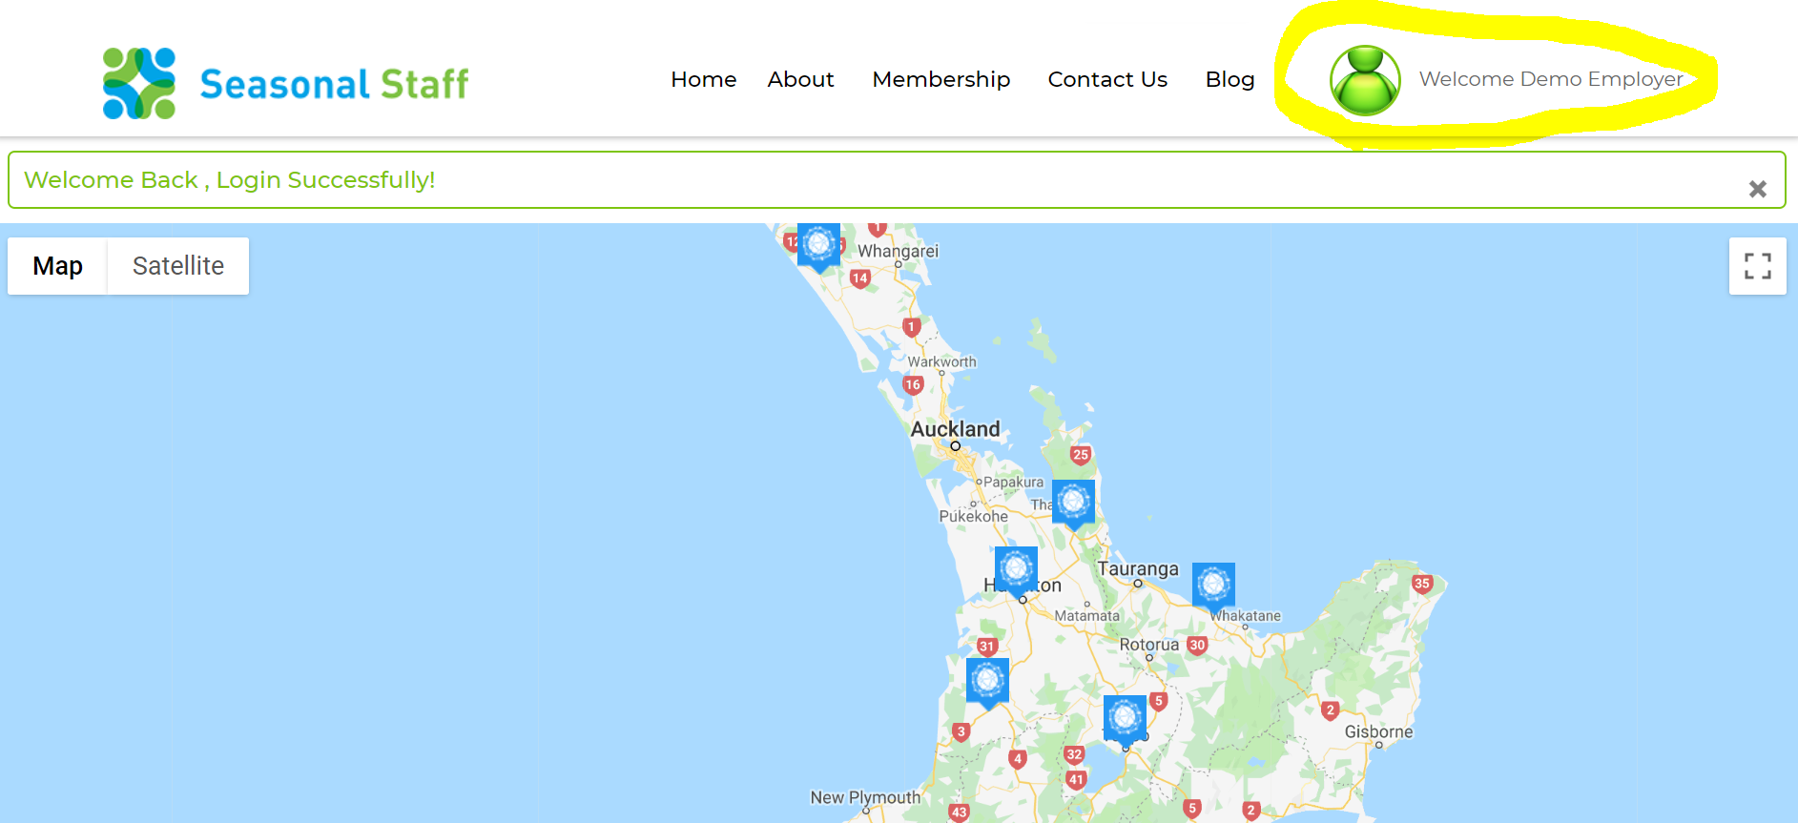

**In your Dashboard you can do lots of things all in one place**

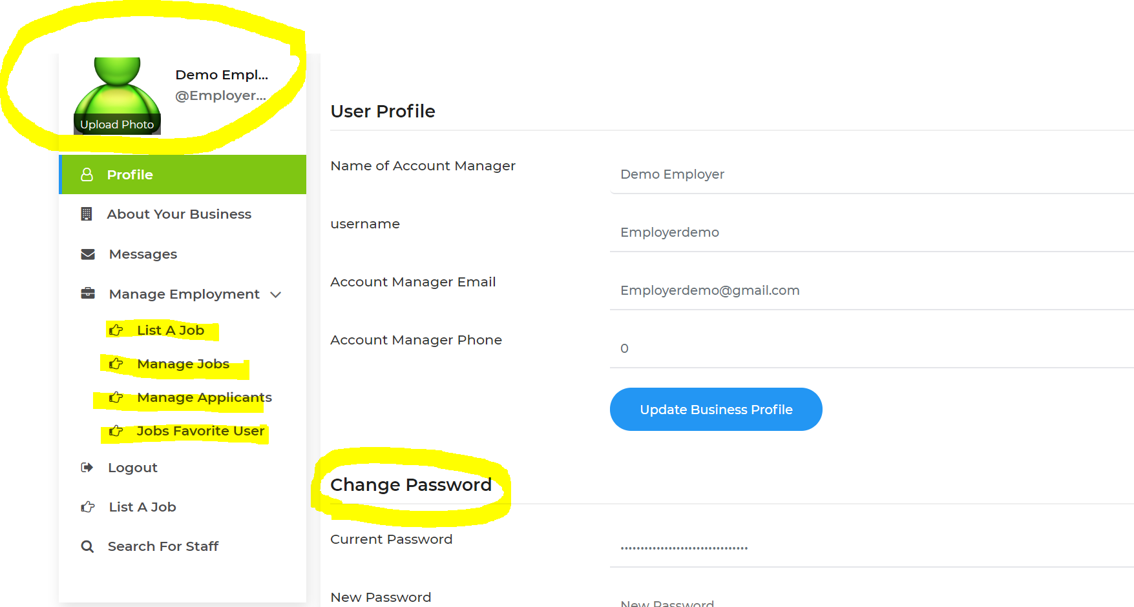

1. Personalise your settings by adding a photo
2. List a job
3. Find, edit and Manage all your jobs in the “Manage jobs” tab
4. See all your applicants in one place in the “ Manage Applicants” tab
5. See who has added your job to their favourites list
6. Change your password.

**Add your business website and your Business logo.**

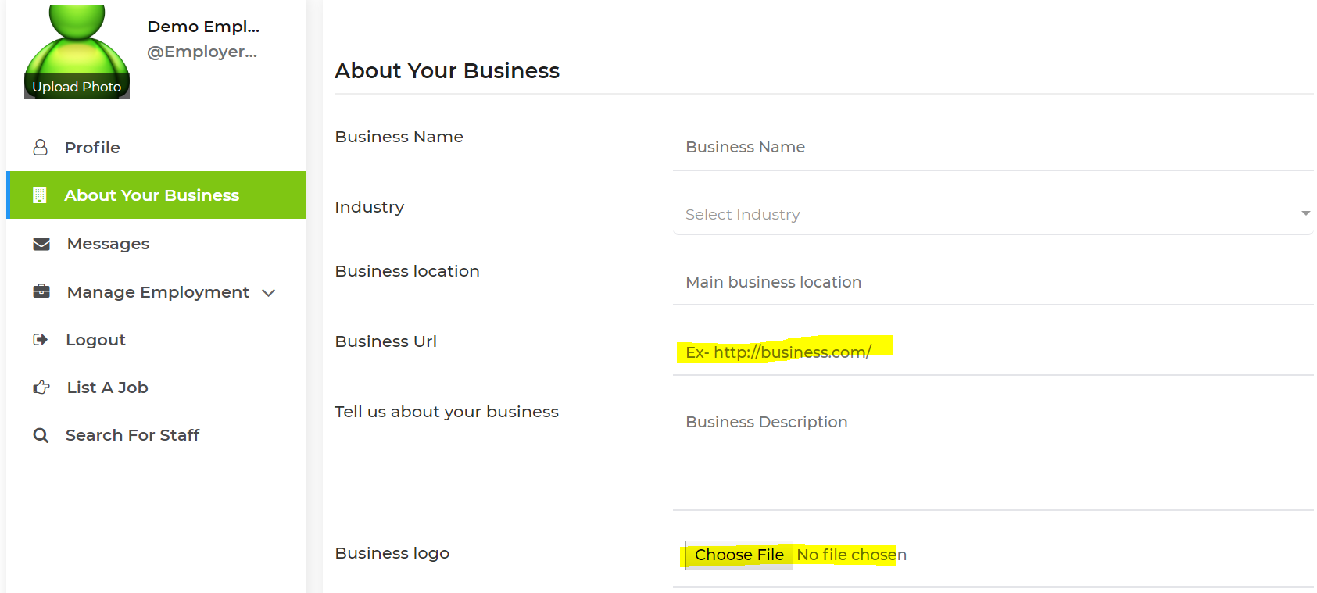

**You choose how you received applications.**

If you check “Received a full CV & Cover letter” then applicants will supply you with a CV & Cover letter

If you check “Receive expressions of interest” you will received an email notification when someone is interested in your job and a link to the person’s profile. (quick and easy)

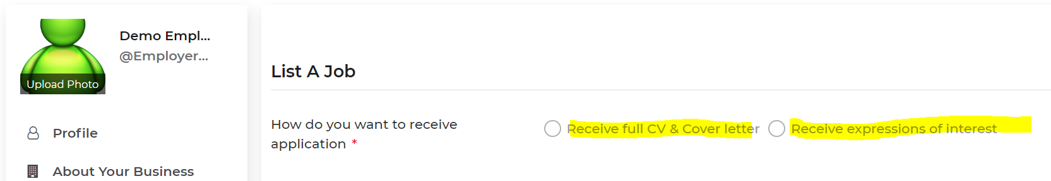

**Manage your jobs with ease.**

See all your jobs quickly, change their job status easily, See how many applicants you have and view edit or delete your advert.

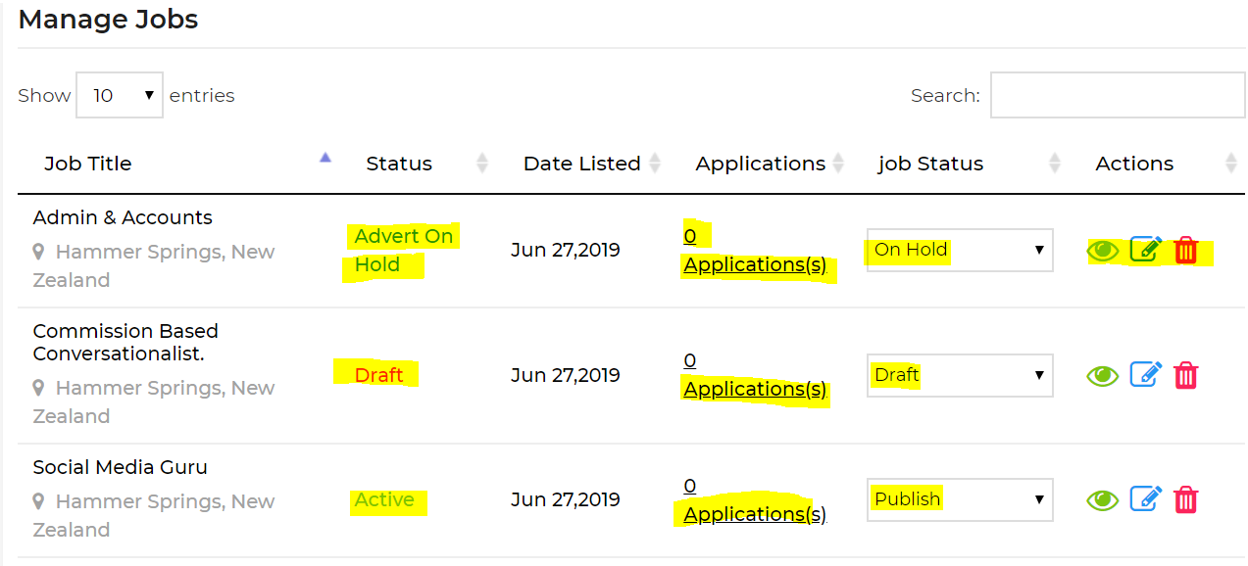

**Because we know you are busy, we have made it easy with drop down lists**

1. We have given you options with Drop down lists for contracts
2. We also know that because you are a seasonal business, when you’re thinking about what you need in the future you don’t really know the exact dates, so we have allowed for flexibility. This helps people looking for work plan their work also.
3. You can add advertise for multiple people for the same position.
4. We have also banded the hours because we know that there may need to be flexibility.
5. For Hourly rate, you need to advise $amount + Holiday pay or you can type in by “negotiation” if you’re not sure.
6. We have added “intensity of work” so you can get people with the right level of fitness.

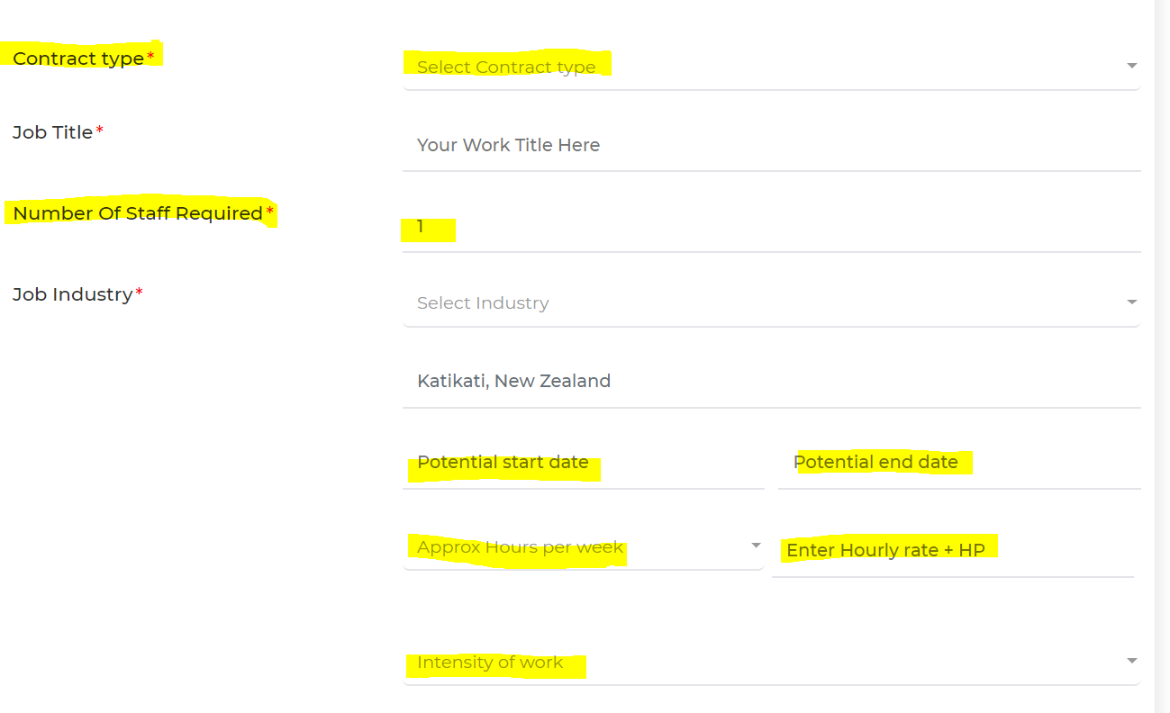

**Because it’s not always about the money**

1. We know lots of you have other things that you can offer as **your point of difference**, so we have created a section where you can add this. The staff can search by these other benefits too, making your job stand out over others.
2. You can copy and paste your jobs description

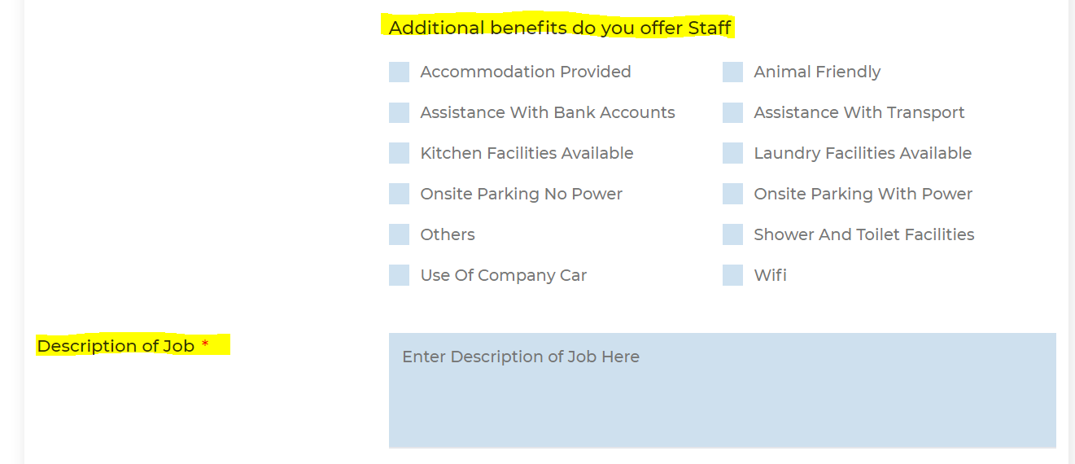

We have also made it easy to details the “other” Skills and attributes that you may need also.

