Changes that still need to be fixed.

Please can you add the search critera (skills and attributes) for the employer side. This is so the employer can search of the below critera.

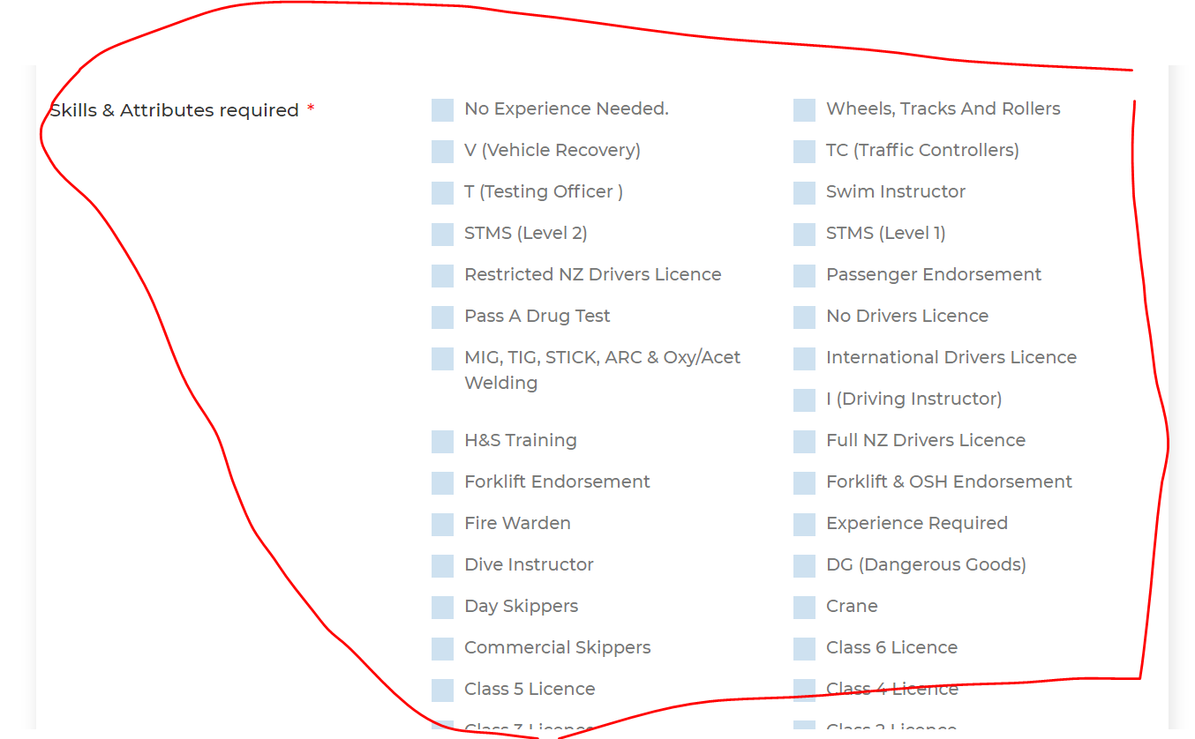

There is now way to delete an employment history if you no longer wanted it to show. Can the (x) be put beside each employment history so that the user has the options to remove if they no longer wanted to show.(please add)

Also no calendar shows when you add another employment history. (This has not been fixed) Please fix. -->**done**

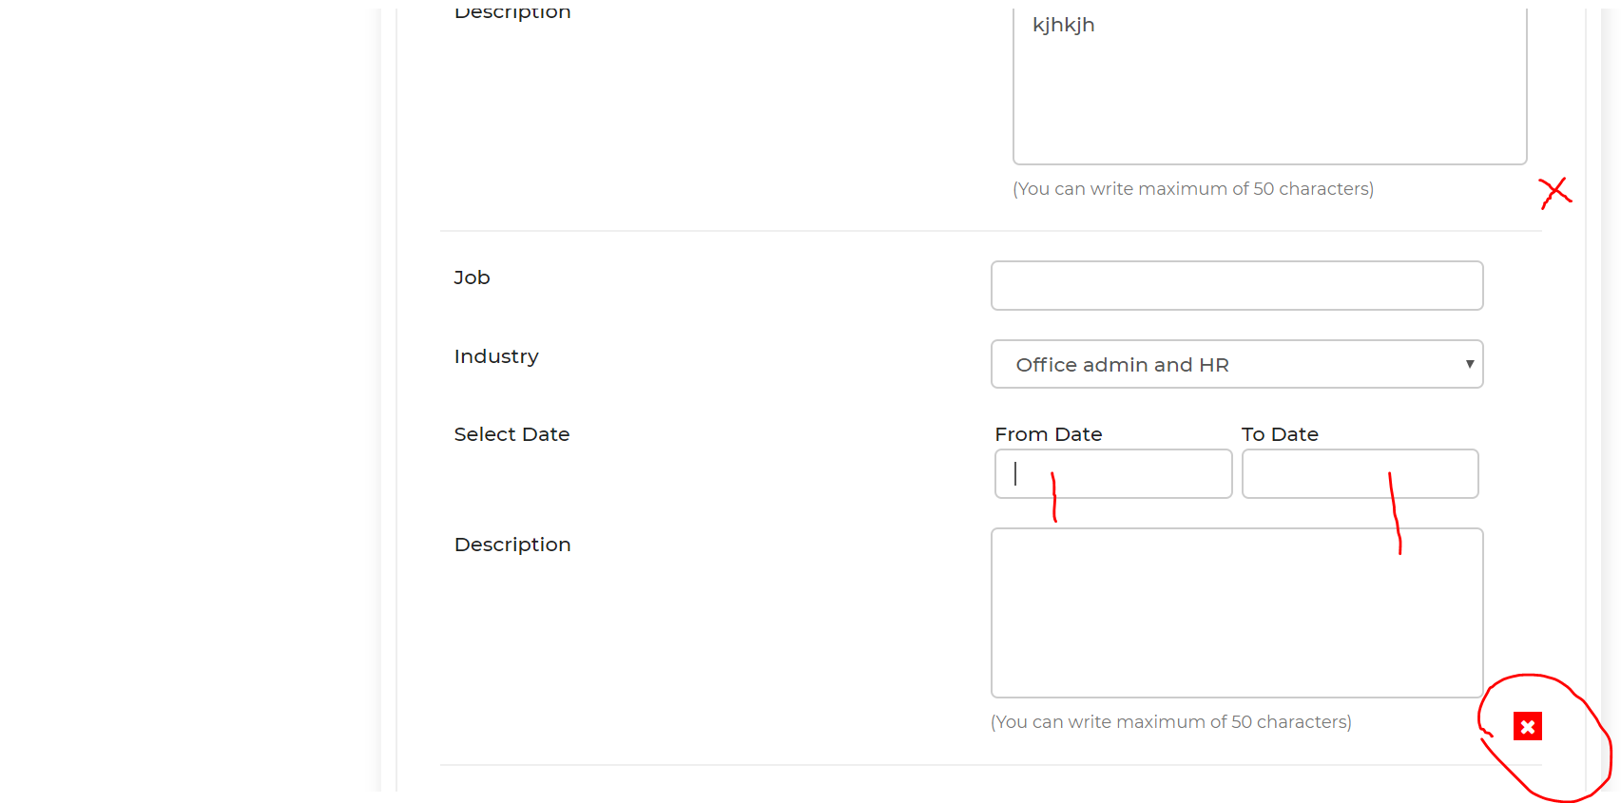

The calendar is not working properly as the last date of the previous calendar pre populates into the next calendar. Can we please have it that the dates are independent of each other. –This has not been fixed please can it be fixed – this has been requested several times.

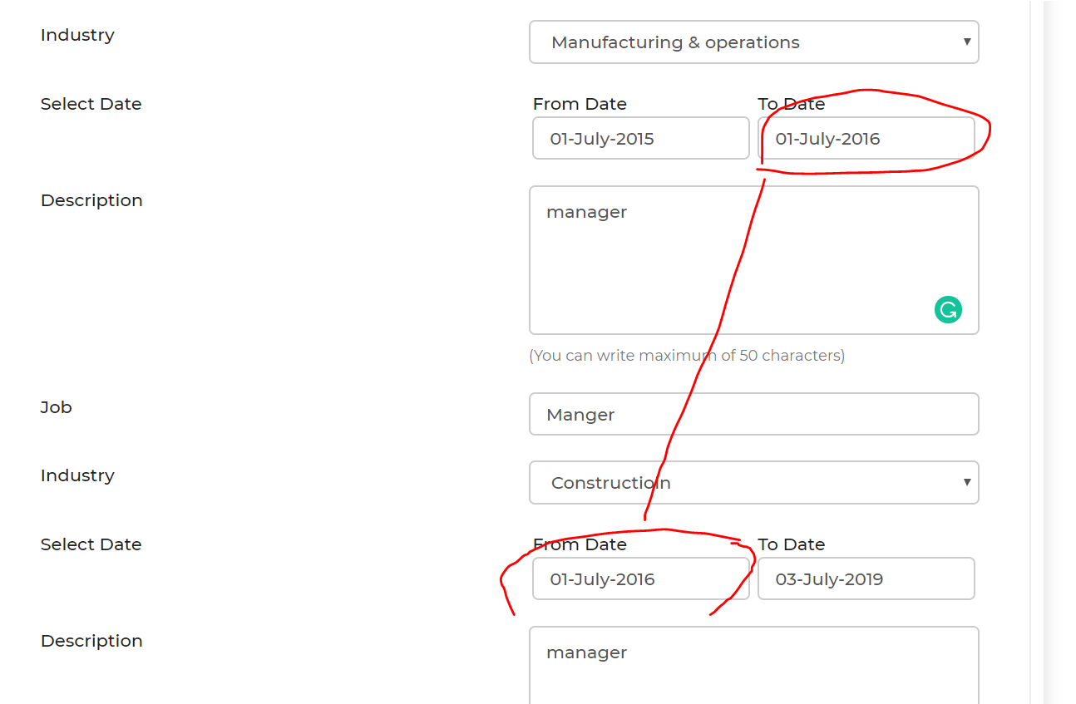

Please can you ensurethat both the “Im interested “email and the “Cover letter & CV are both updates. (there were not both updated as below)

Please can you change the “im Interested “email to the following

Remove the word “User” that is circled in red. -> **done**

Change the wording from “Wayne George interested you job email system advisor” ->**done**

To “Wayne George **is** interested **in**your “Email Systems advisor” **Job**

Please add the users name between Here and Staff profile. ->**done**

So it should read “Check out “Wayne Georges” staff profile here

Please add the below to the email also (with the links) ->**done**

To Manage your jobs & applications, Please log in to [Seasonastaff.co.nz](https://www.seasonalstaff.co.nz/Welcome/).  
View your Dashboard - [Manager Employment Tab](https://www.seasonalstaff.co.nz/manage-work-profile/). Here you will find all your Jobs and Applicants

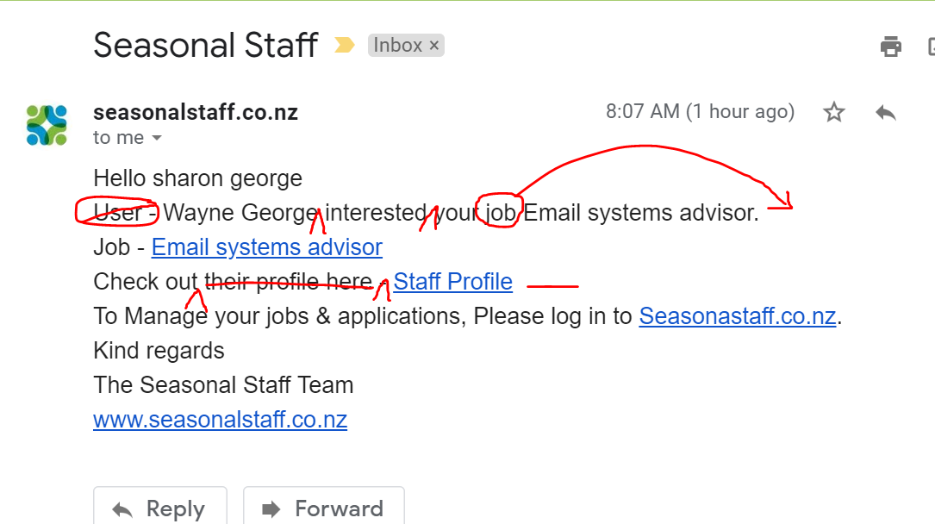

Hello sharongeorge   
You have interest in your Email systems advisor. Jobs  
Message - test to see if two attachments could be included   
Job - [Email systems advisor](https://www.seasonalstaff.co.nz/Welcome/work_detail/Email-systems-advisor%20/)  
Check out their profile here - [Staff Profile](https://www.seasonalstaff.co.nz/staff-detail/260)   
Seetheir Attached CV & Information - [5d3a27f0b0203.docx](https://www.seasonalstaff.co.nz/public/upload/cv/5d3a27f0b0203.docx)  
To Manage your jobs & applications, Please log in to [Seasonastaff.co.nz](https://www.seasonalstaff.co.nz/Welcome/).  
View your Dashboard - [Manager Employment Tab](https://www.seasonalstaff.co.nz/manage-work-profile/). Here you will find all your Jobs and Applicants

Can we change the wording here from “Good luck from the Seasonal Staff team” to “To view jobs you have applied for here” and then have a button that says (Jobs applied for). This will then take them to the same place as if they had pressed the “jobs applied for” button. (see below) ->**done not done**

**This has not been done for both “Im interested “ & “Send CV & cover letter” (please complete)**

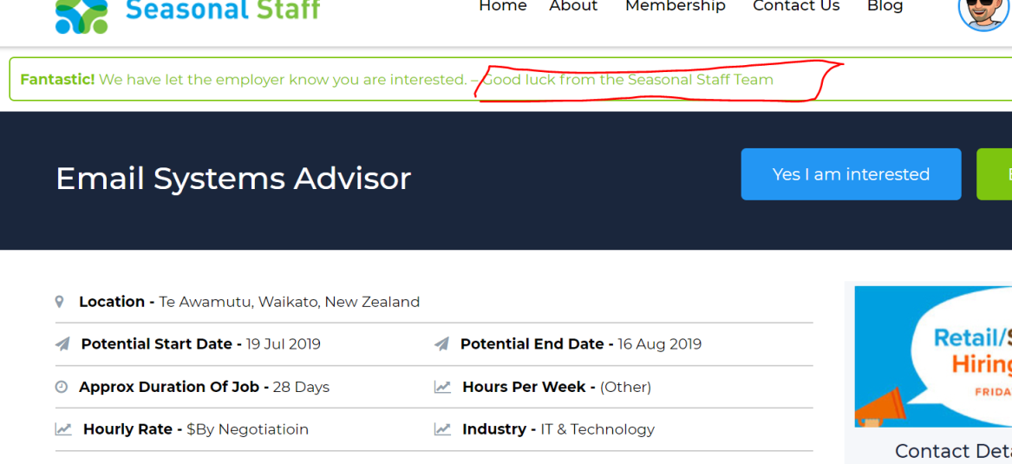

On the Chat window can their be a heading where marked in red “Ask a question”

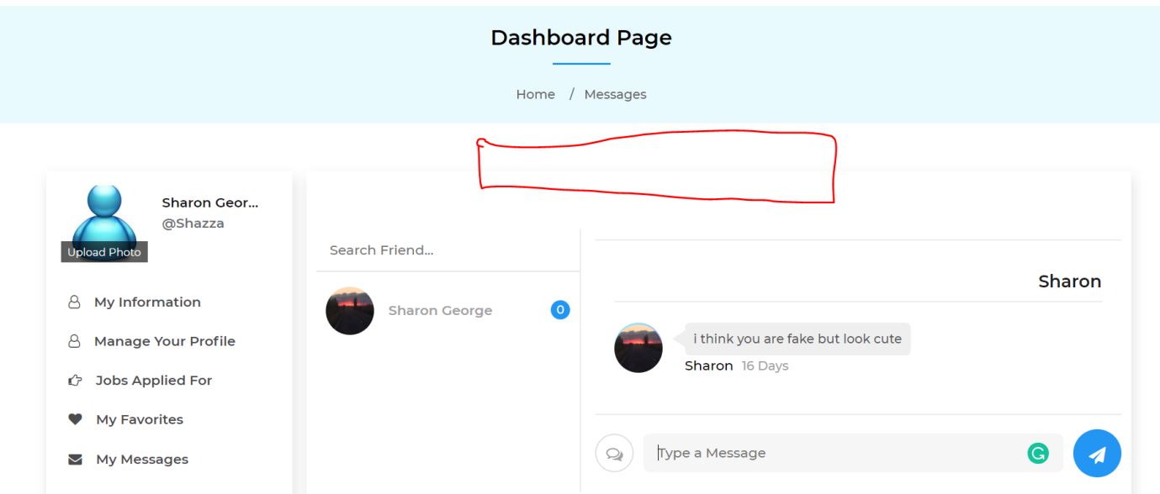

Can we also have that when you hover over the “Chat” icon it says “chat”

Please can you move the error message to above please put in the centre. (the message is not seen very well below the pay button.

Can you please change the wording to “Please select the type of membership you need)

The “pay” button is not working.

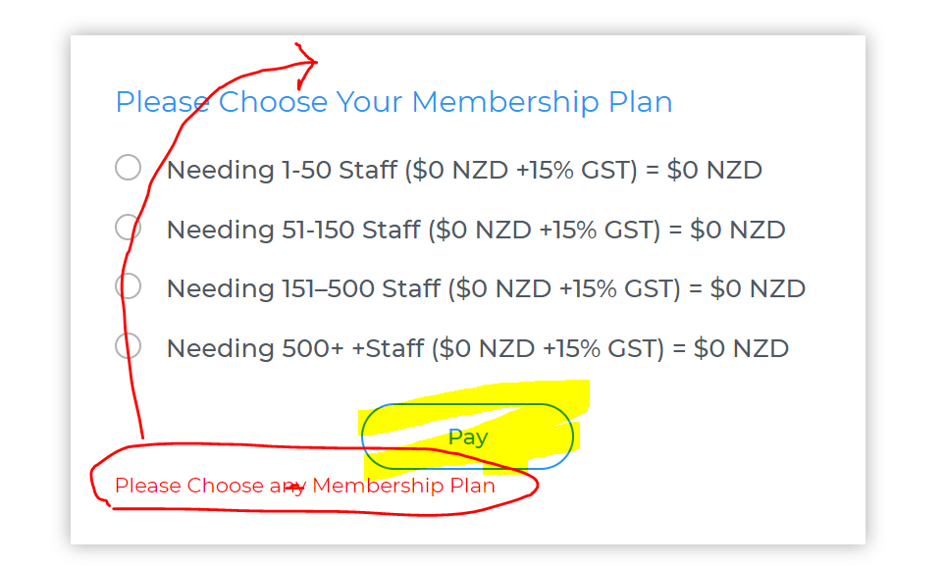

When you are an employer and you are looking for a staff member. When you are in the staff members profile and want to keep searching and press the “Back to main search” can this please go to the below search page.

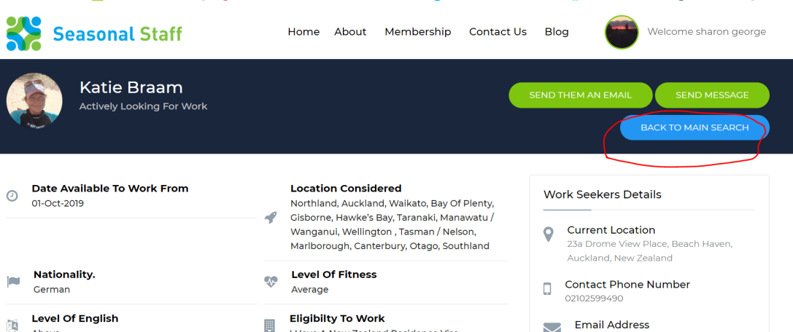

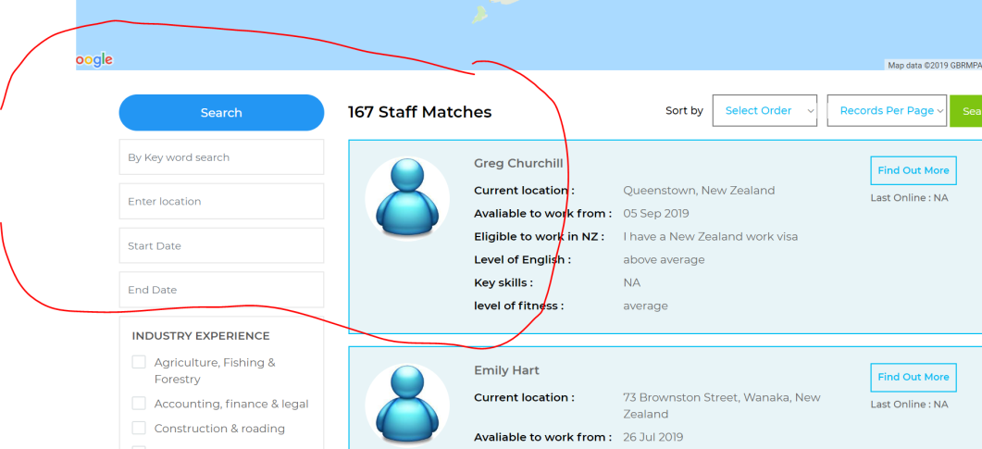

These search boxes are not working

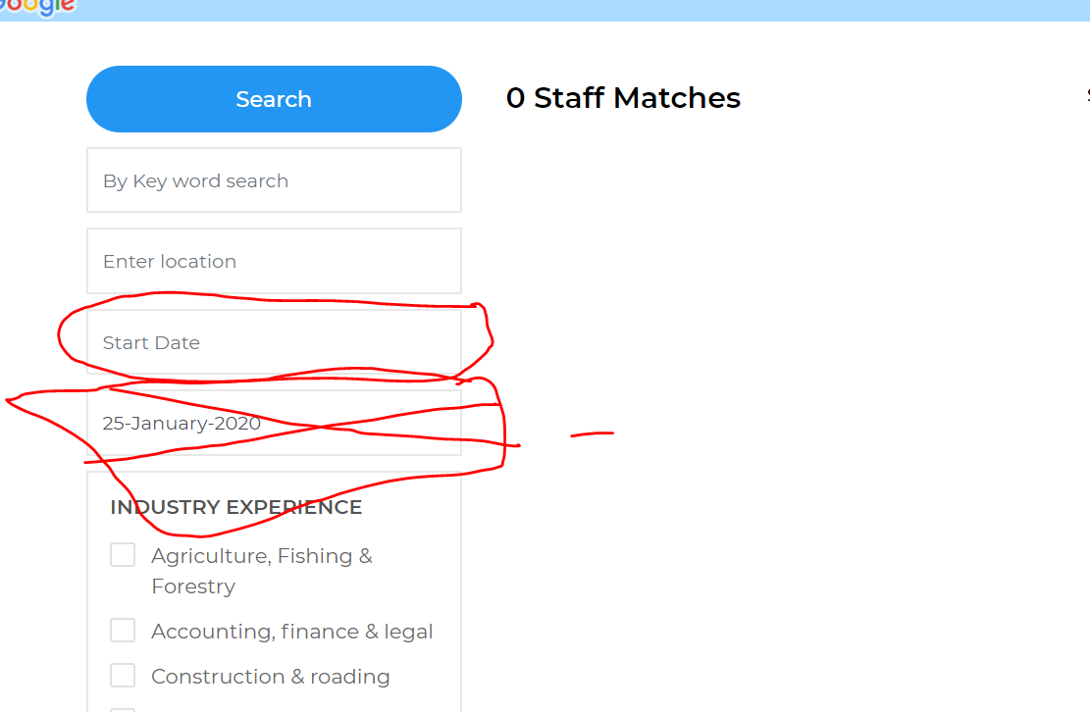

Remove the end date search feature…….. as this not of any value. Keep the Start date search…

How they are meant to work is……Start date…… If an employer puts a date in here….. anyone who is has put their “available to work from “ Date set before this date…. Would show up. Currently no one is showing up ..if an employer