Things still needing to be fixed.

No calendar comes up when you add a second another employment history. – Please fix – not working properly ->**done**

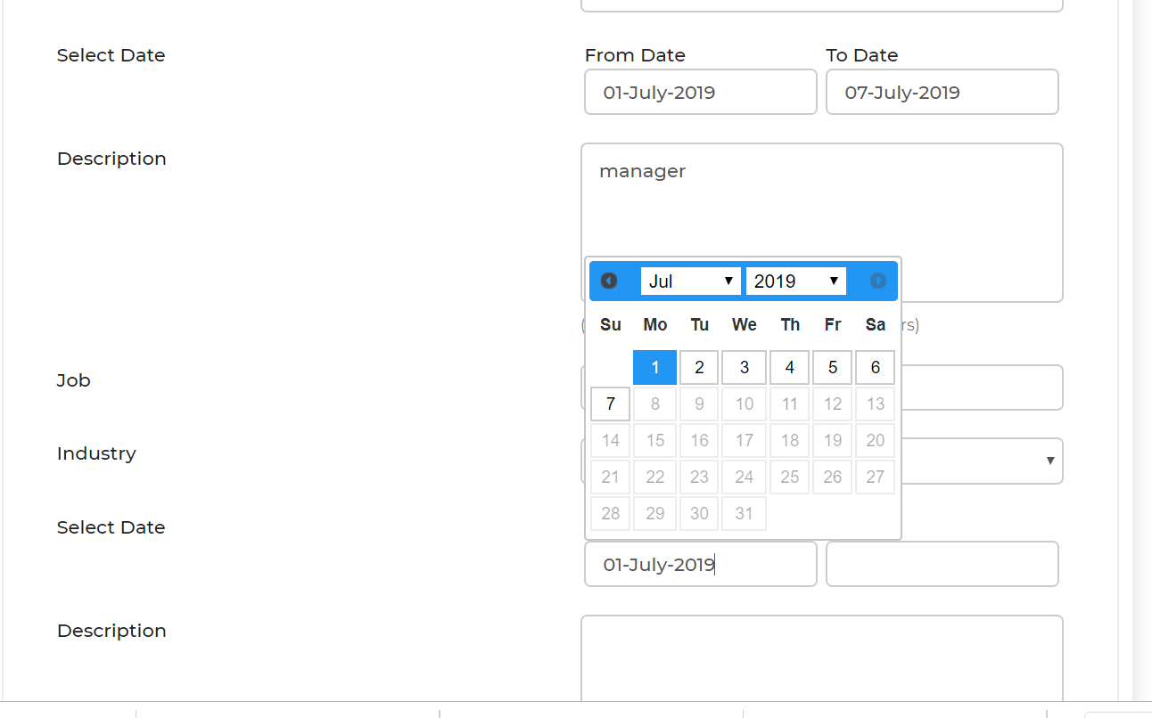Calendars not working at all

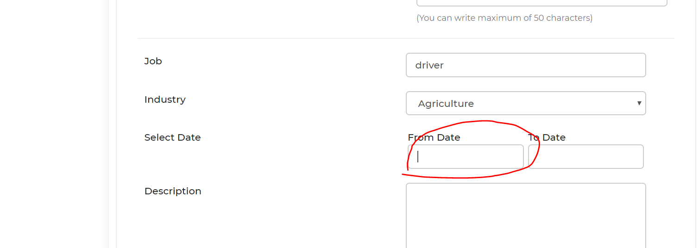

Can we please shift the blue “search” button up under the “End date” and above the “ duration of work” ->**done**

Reason for this is the button is too out of site for people to see to push. For Staff and employers too ->**done**

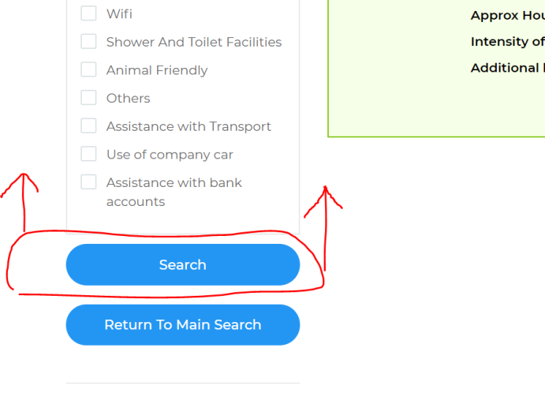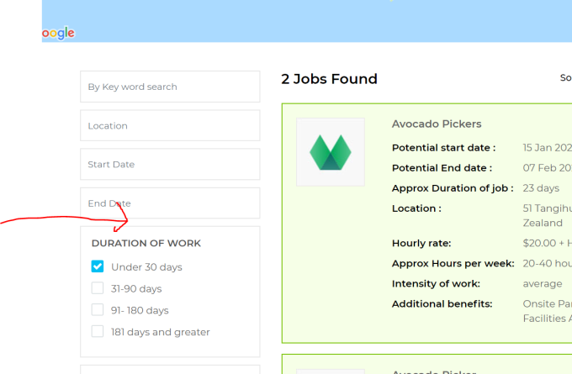

The corresponding email that employers get, have the following changes

Can you please make sure the Persons Name is Starts with a capital letter

Remove the word “user” -> **done**

Please change the wording from “you have interest in one of your jobs computer maintenance”

To

You have interest in your “Computer Maintenance” Job -> **done**

Please put a Space between See their. -> **done**

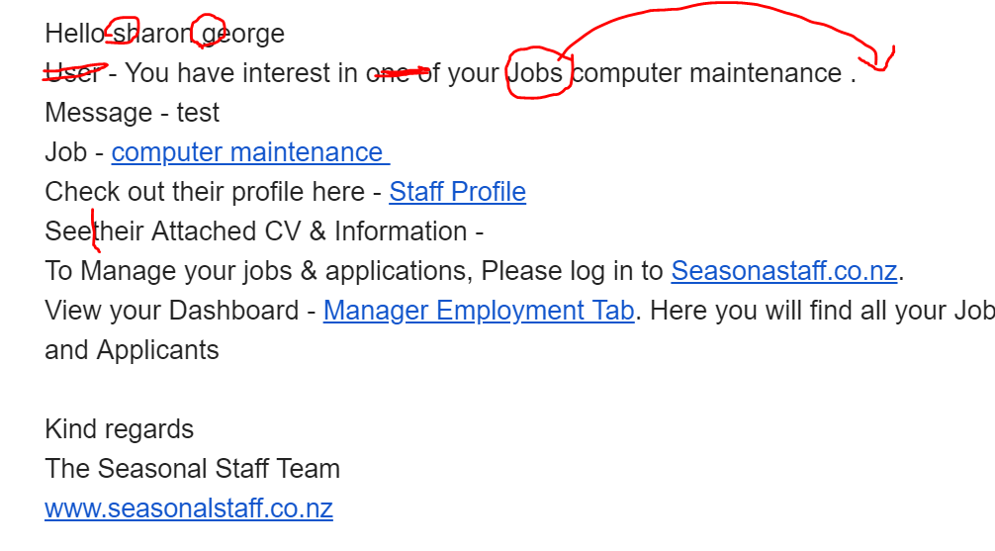

Please can you also add to the “Im interested” Email that the employers get the following wording and sign off

From “To Manager your jobs & applications, Please log in………… -> **done**

All the way through to the sign off and website address. (onbelows email)

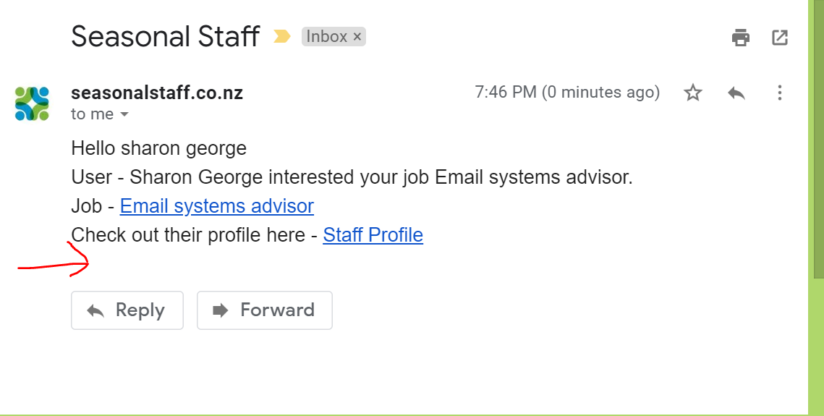

Can we change the wording here from “Good luck from the Seasonal Staff team” to “To view jobs you have applied for here” and then have a button that says (Jobs applied for). This will then take them to the same place as if they had pressed the “jobs applied for” button. (see below) -> **done**

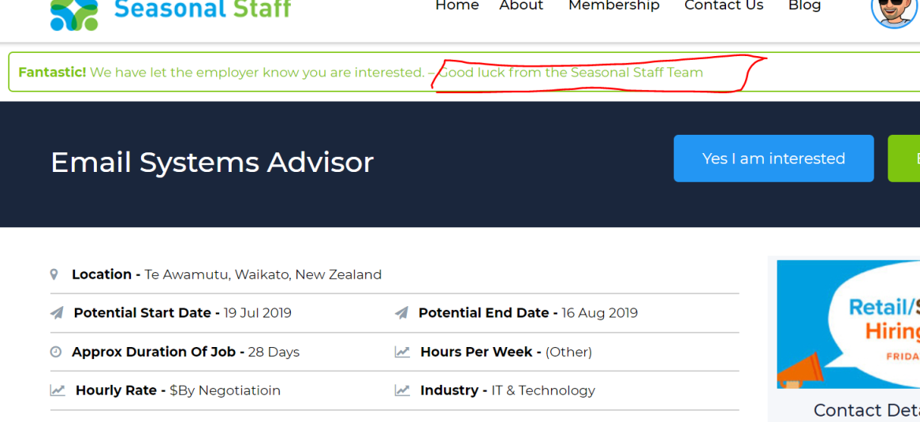

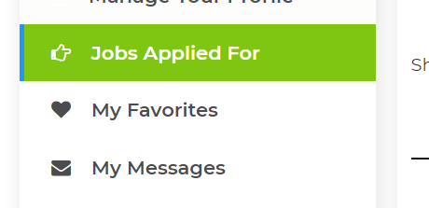

Staff profile “Jobs applied for” fixes

Can we please add a “email “ and “Delete” icon here. Can we also have that when you hover over the “Chat” icon that it says “Start a chat with employer”

“Email” icon when you hover it says “Send employer a email”

“Delete “ icon it says “delete job from your list” -> **done**

Can we bring the chat box up to the top of the page……(it gets lost down the bottom of the page) and people are not using it…. Bring it up to just below the persons name that you are going to message. This makes more sense as people don’t have to scroll all the way to the bottom of the page.(see below for placement suggestion for message box”

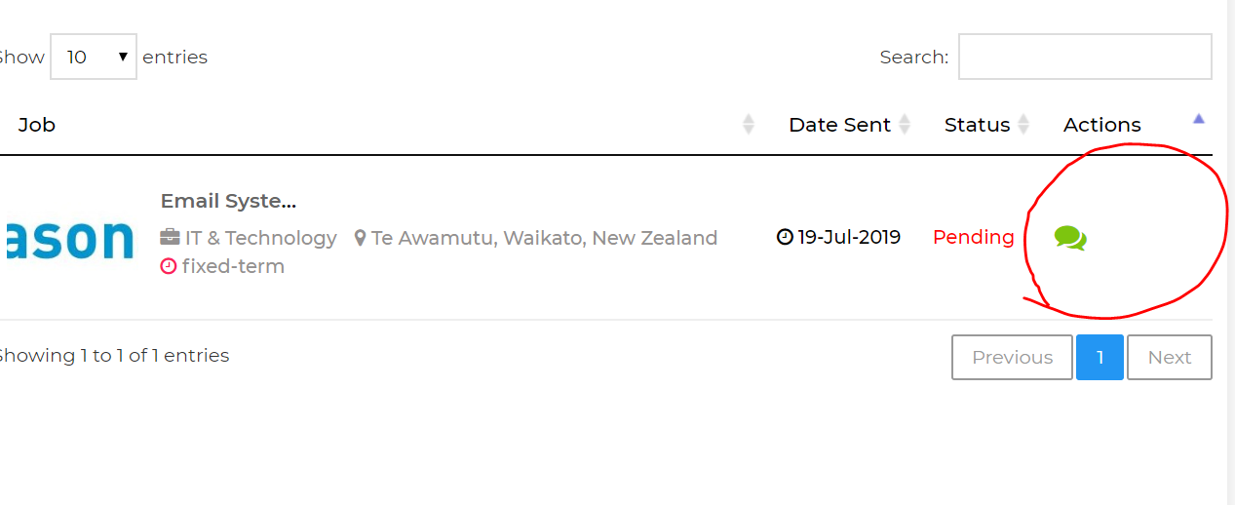

Can we bring the chat box up to the top of the page……(it gets lost down the bottom of the page) and people are not using it…. Bring it up to just below the persons name that you are going to message. This makes more sense as people don’t have to scroll all the way to the bottom of the page.(see below for placement suggestion for message box” ->**done**

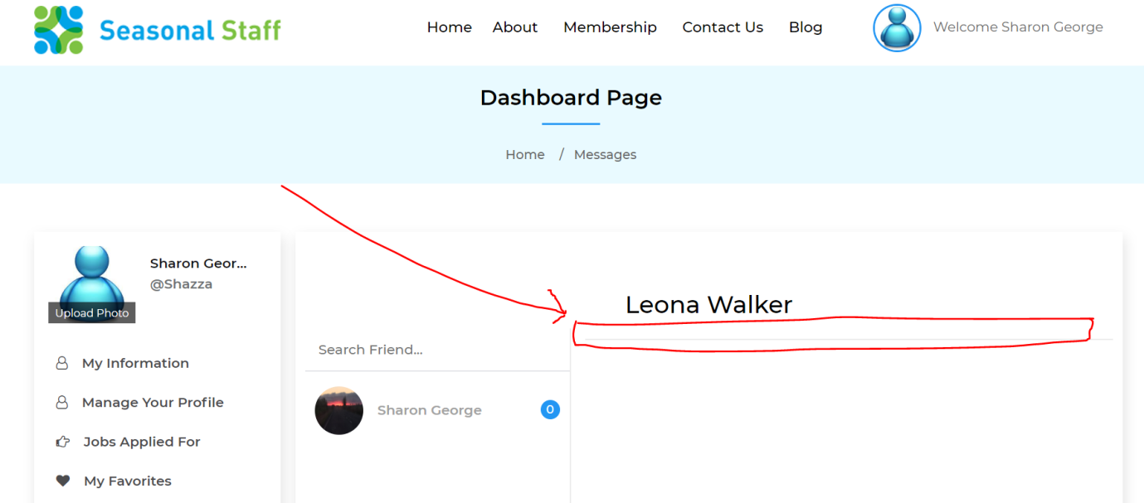

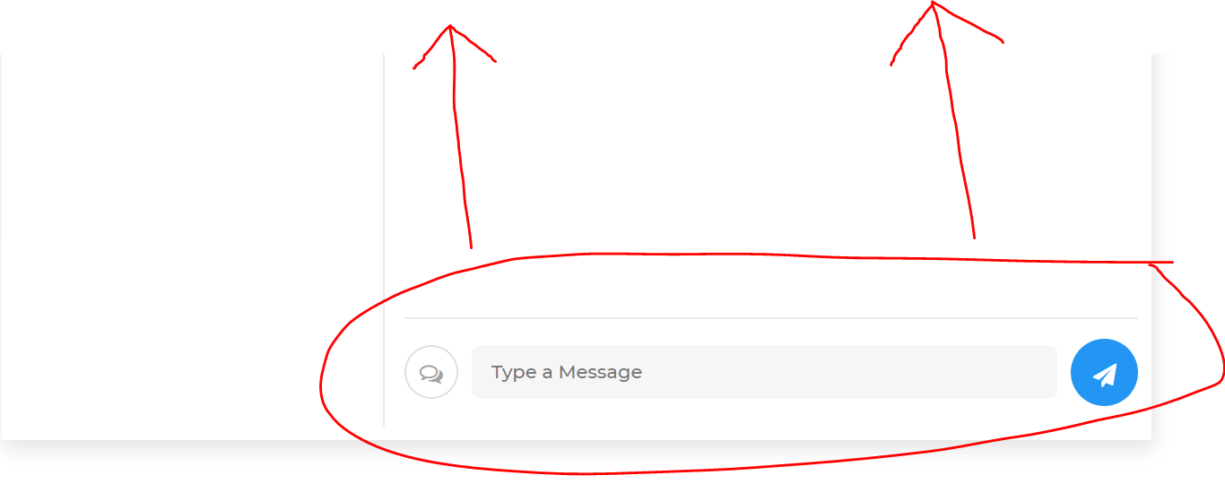

When we go into a users profile, if we do anything in the back end, it automatically the effect is that the user and their password has to get reset. I think this is because the password and confirm passwords are blank. Is it possible to show the passwords here, so that if we update the address their passwords are showing, and this does not mean they have to reset all the time.

We like the feature that we can reset the password in here so please do not remove this functionality. -> **not done**

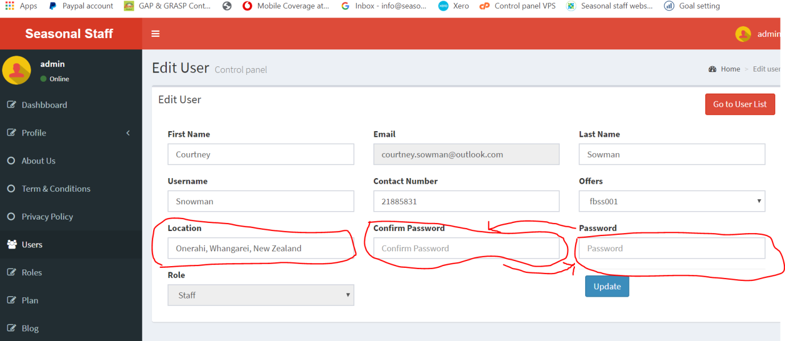

Can you change the order the boxes appear in the back end. Can you put “Password” where Confirm Password” is, and put “Confirm Password” where “Password is” This means it is the correct flow of how people do things.

We are finding that a few people are getting their address wrong so having the ability to go in and change or correct the location is great…. But when we change the location it changes it in the back end, but does not change it in the profile. (see below screen shots)

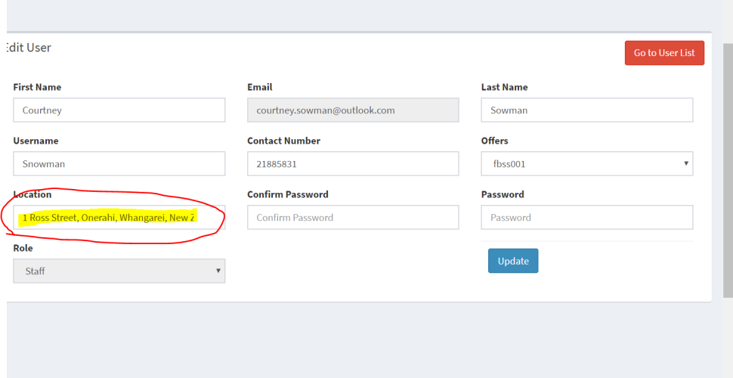

Remove the word “Now”

Please can you change the wordingfrom

“Please verify your Email account. Once verified your information will show to users.” -> **done**

To

“Check your email, to verify your account. If this email is in not in your Inbox check your Spam or junk Folder”

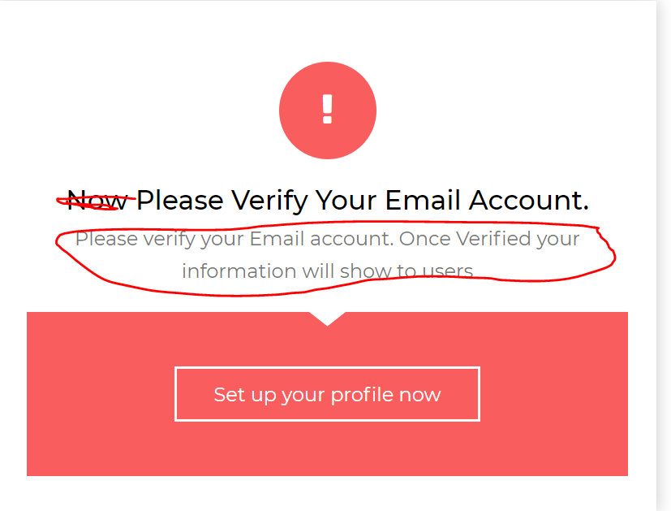

The Save & publish box is great…. However once you push save the green box comes up – it directs you to “find work” but the “Skills & attributes and Employment history” part of profile is not complete. Can this be changed to

Can “Save & publish profile” be changed to “Save &Continue” - > **done**

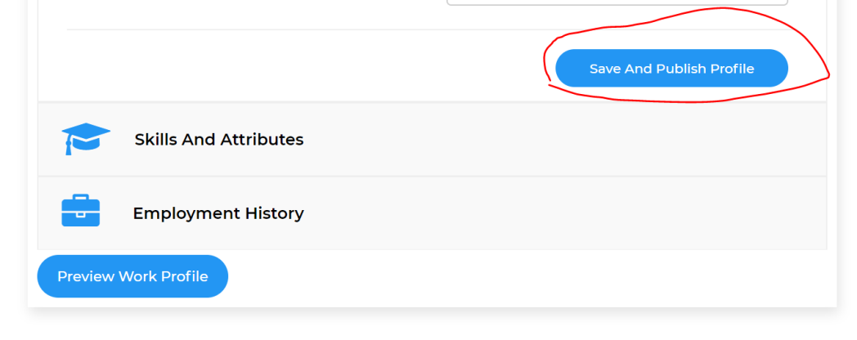

Once you push the save and continue the this box have the following changes.

Change “Hello ….” To “Great Job …….” **->done**

Change “Welcome to Seasonal staff “ to “ Now add your Skills & Employment History so Employers can search for your Skills”

Can we have a Button that says “ Skills& Employment History” and also Keep the “Find work Button’ **->done**

If they pushed the “Skills & Employment History” button it would take them directly to the “Skills & Attributes “ Section of the “Your profile” -**->done**

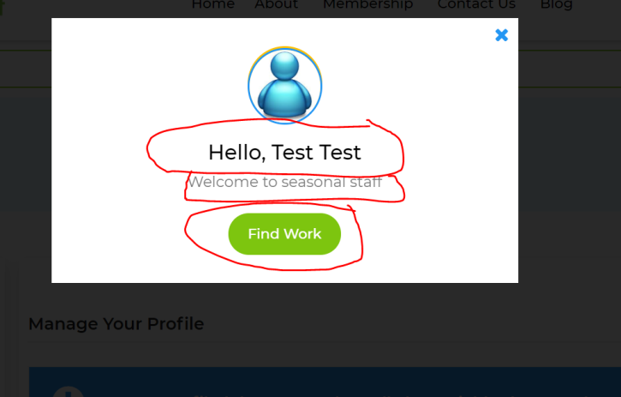

Delete button needs to be here - > **done**

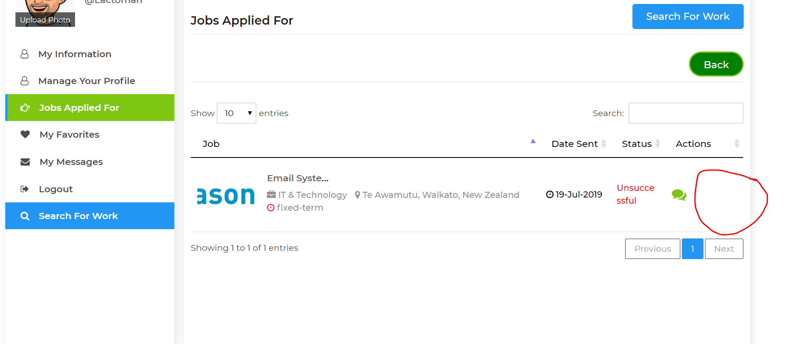

Please can you make sure that one option has to be checked at the moment you can procced with out checking on of the boxes. Please can you make it that one has to be selected.. -> **done**

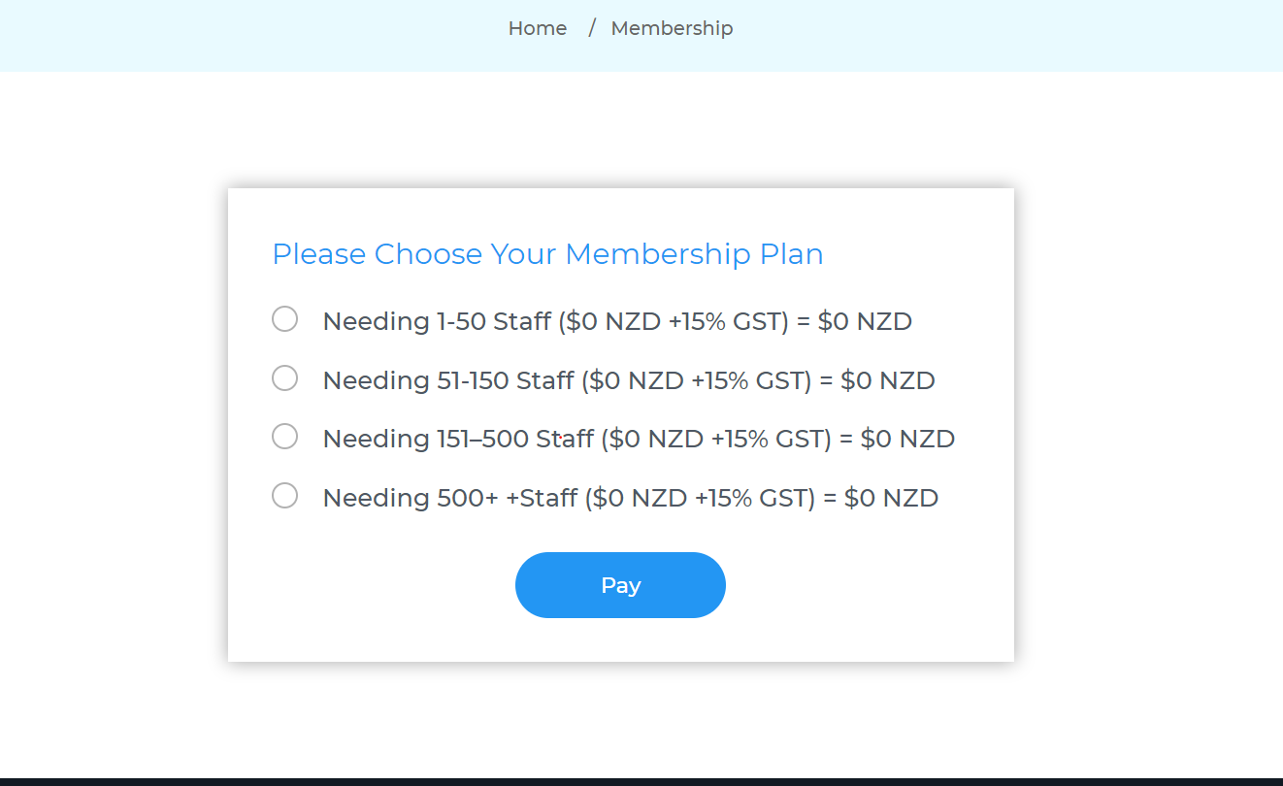

When you push this button “search for staff” they land on this page. ->**done**

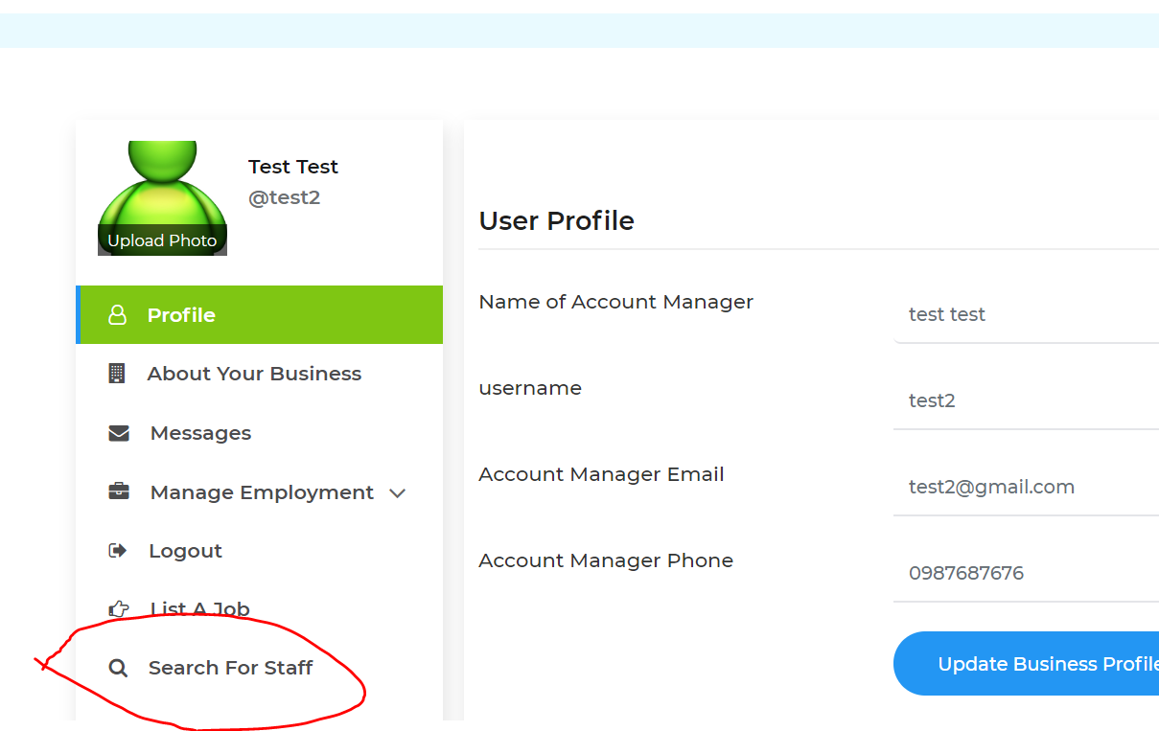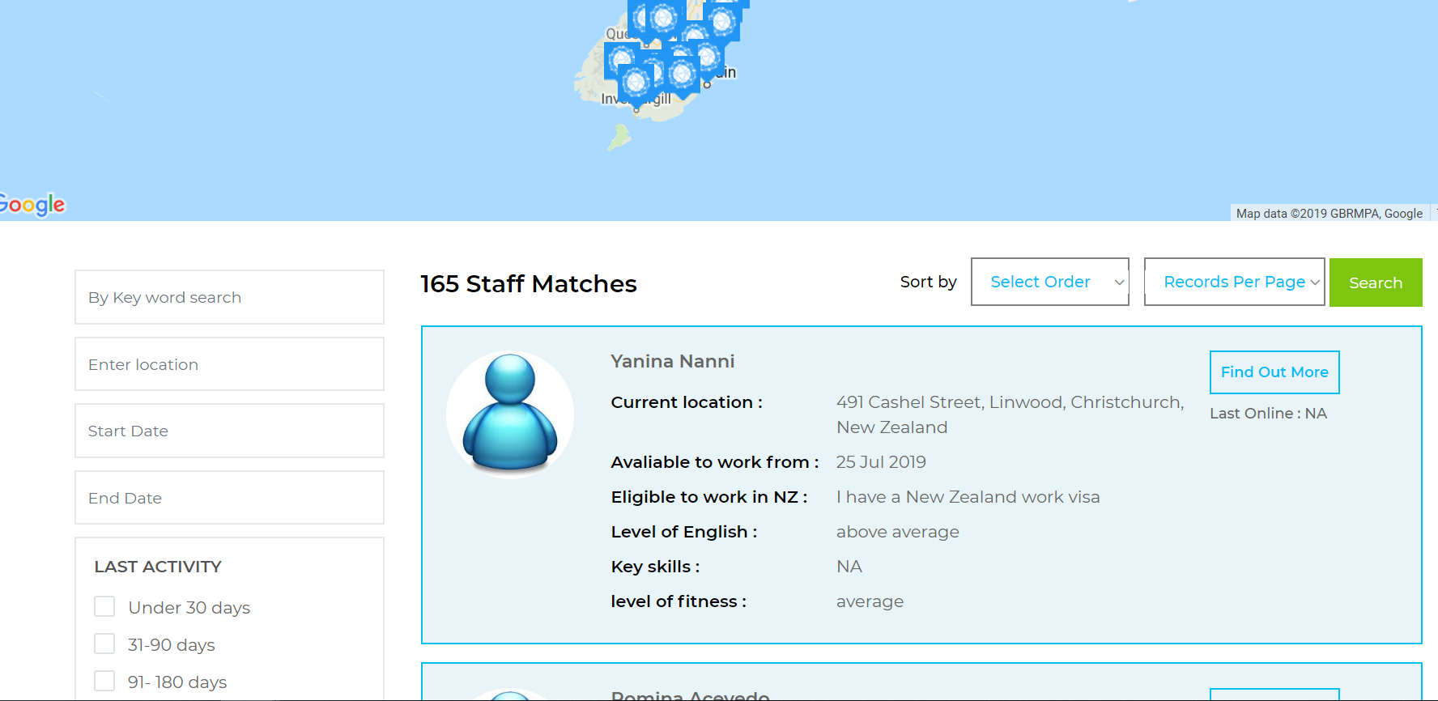

Please remove this from the employer section -> **done**

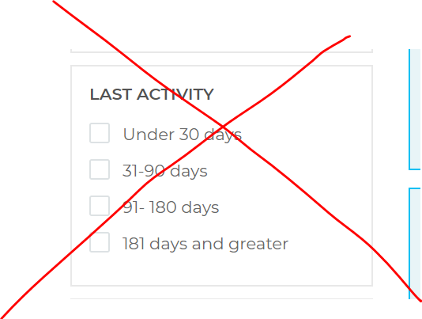

We need to be able to search by the Skills – Please can this be a drop down filter similar to the Industry experience filter

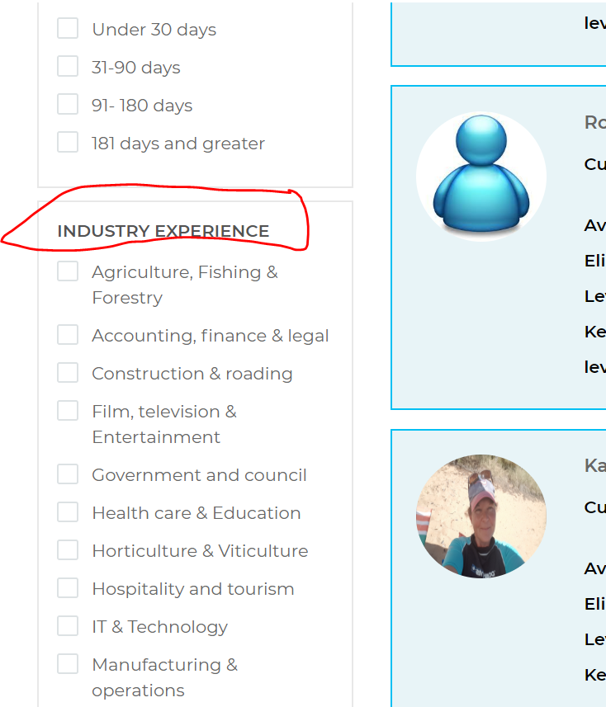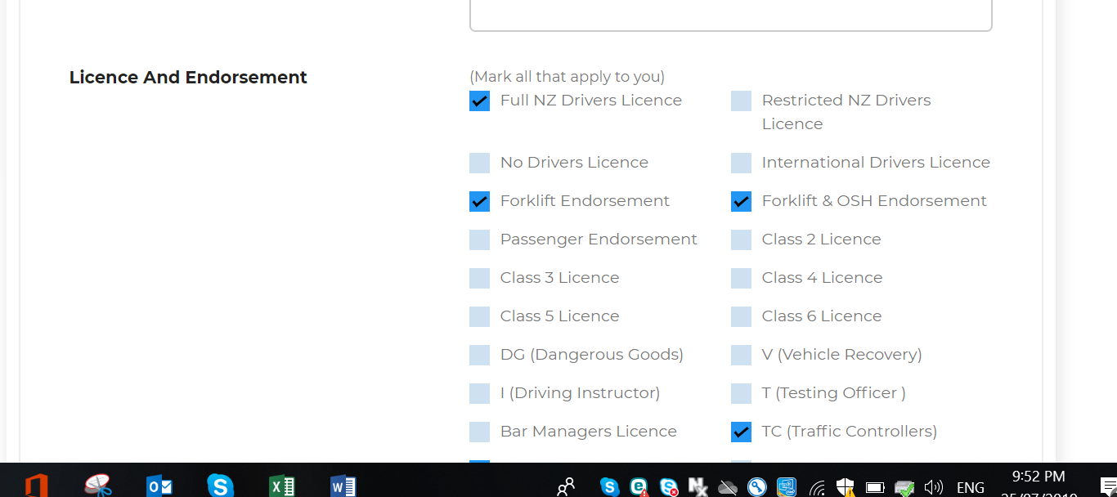

Perhaps use a drip down filter like this

