Things still needing to be fixed.

When people have register and logged in and completed their profile. When they go back to “update” their current location, by using the “select your street address” on the Your profile page, the address updates there, but not on the map

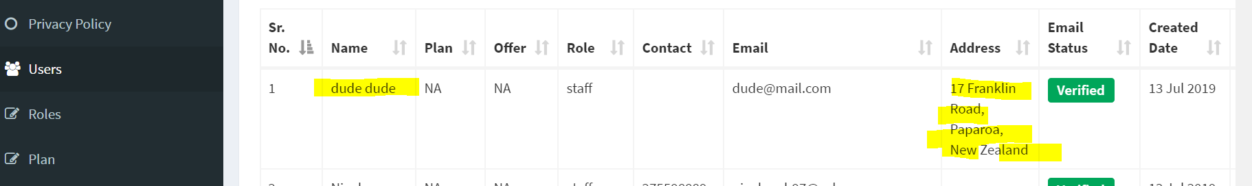

This is the same profile and is in the wrong location. (below) – please fix

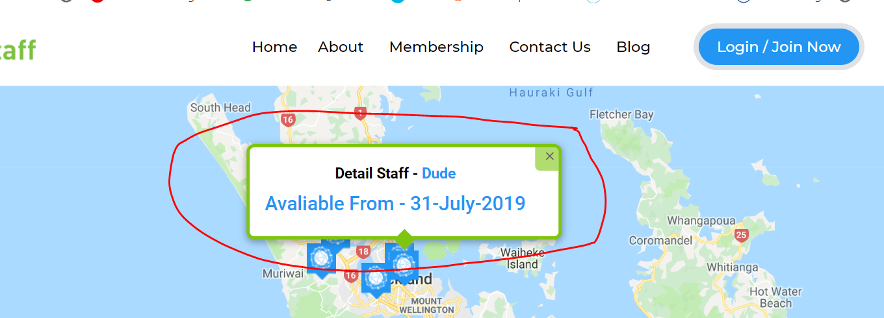

No calendar comes up when you add a second another employment history. – Please fix

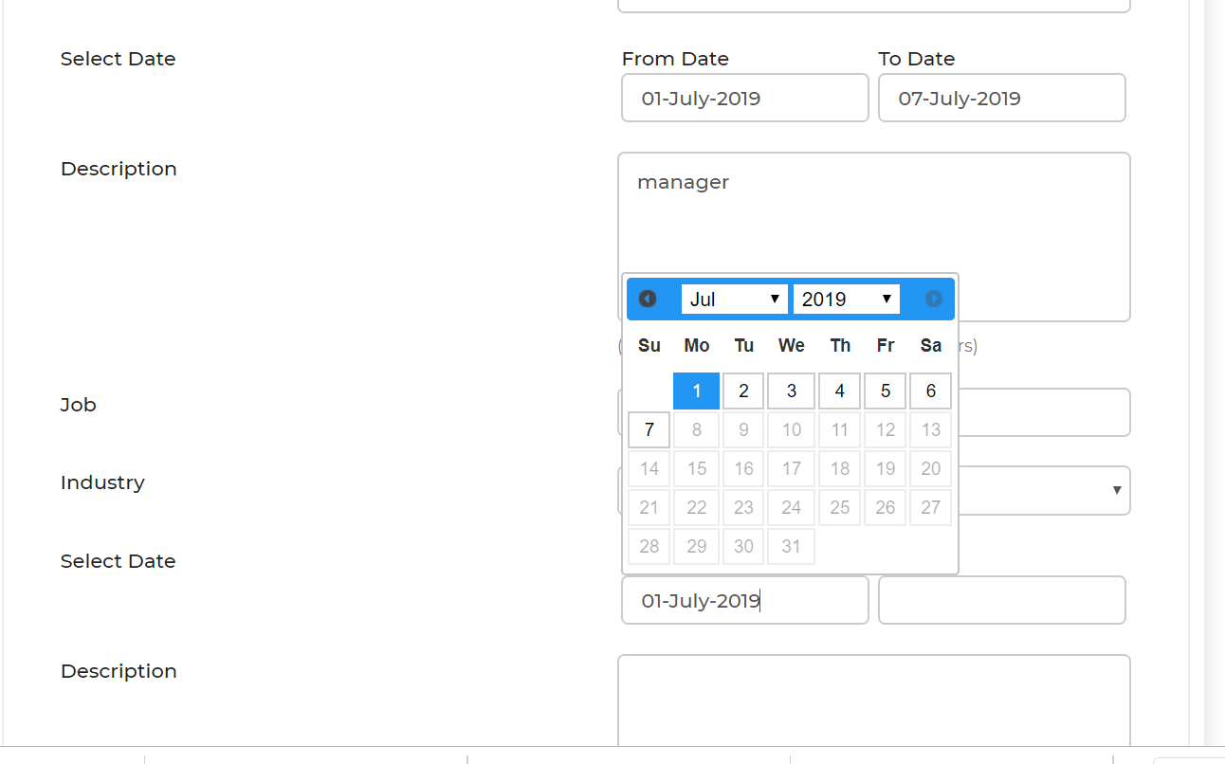Calendars not working at all

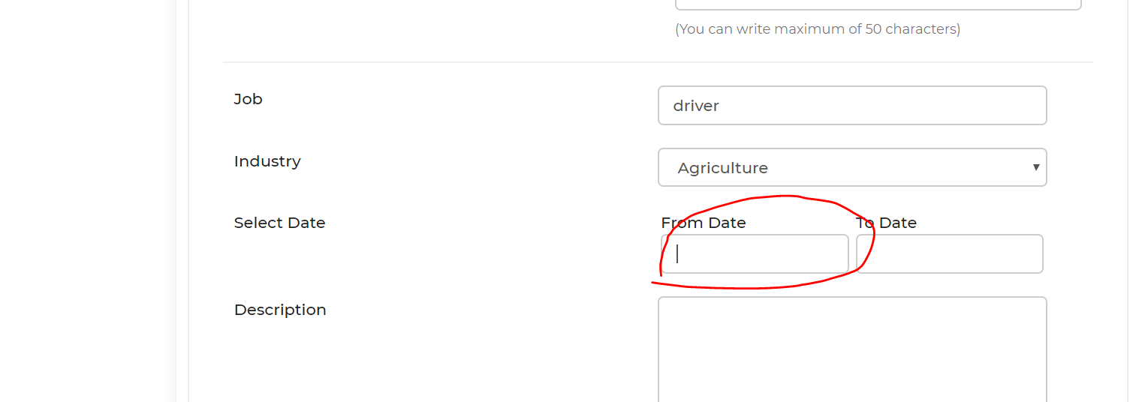

The Publish button does not appear on the bottom of the profile page (under Employment history) Is that because as soon as you hit the saves the profile is updated on line? – can you confirm please

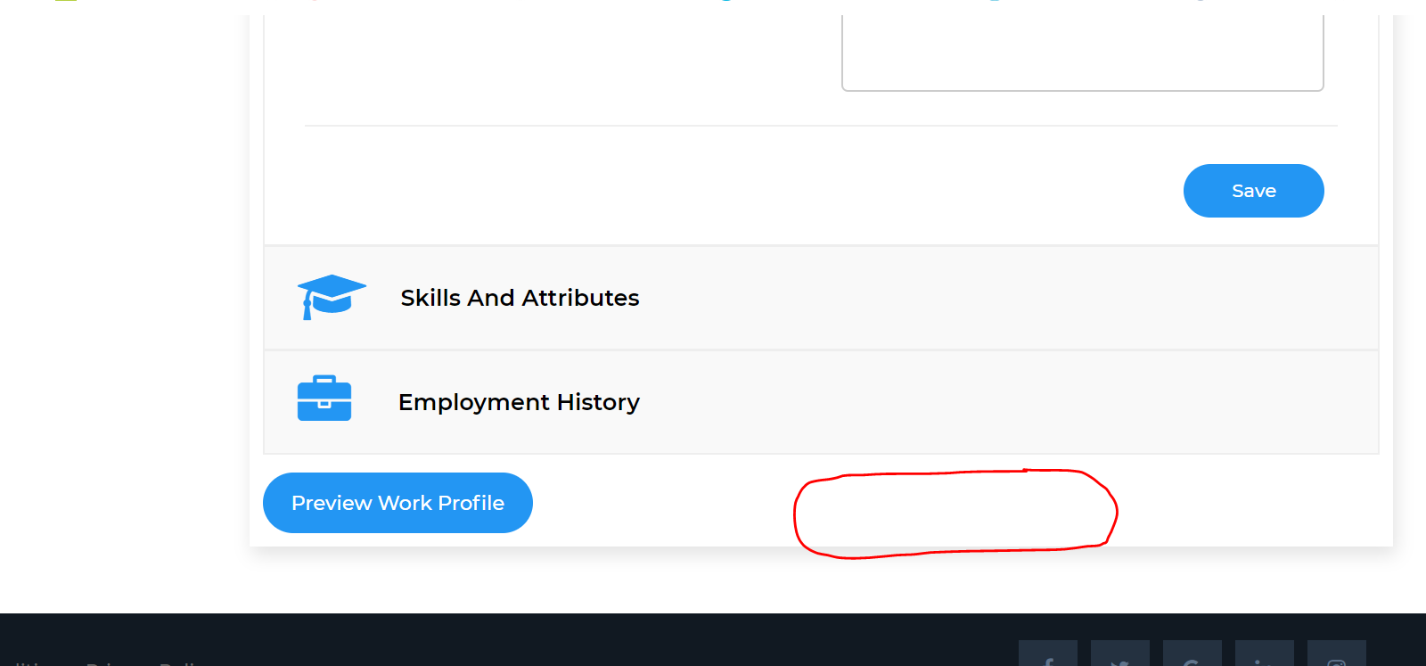

Can we please shift the blue “search” button up under the “End date” and above the “ duration of work”

Reason for this is the button is too out of site for people to see to push. -> **done**

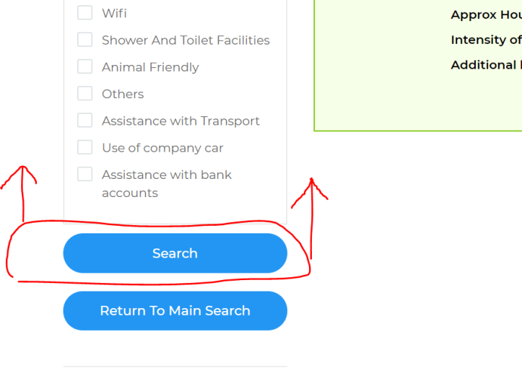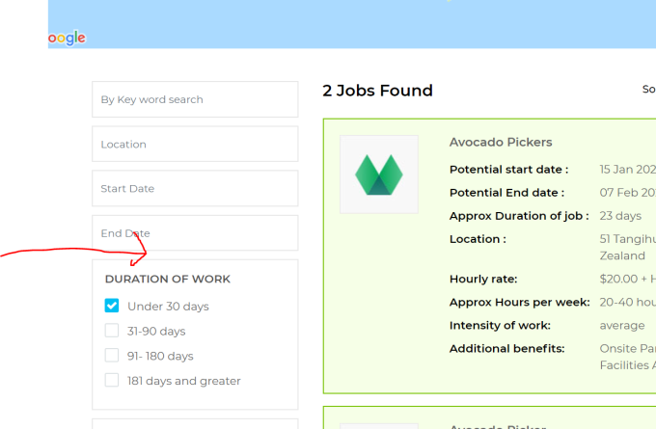

The corresponding email that employers get, have the following changes

Can you please make sure the Persons Name is Starts with a capital letter

Remove the word “user” -> **done**

Please change the wording from “you have interest in one of your jobs computer maintenance”

To -> **done**

You have interest in your “Computer Maintenance” Job

Please put a Space between See their.

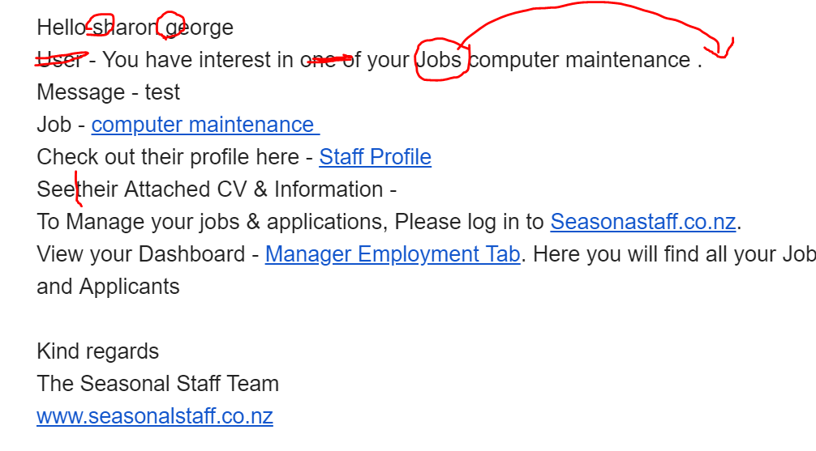

Please can you also add to the “Im interested” Email that the employers get the following wording and sign off

From “To Manager your jobs & applications, Please log in………… -> **done**

All the way through to the sign off and website address. (onbelows email)

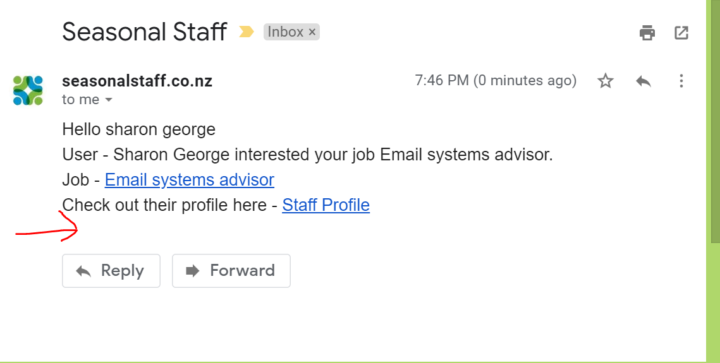

The changes still need to be made to the “your profile page” and publish button

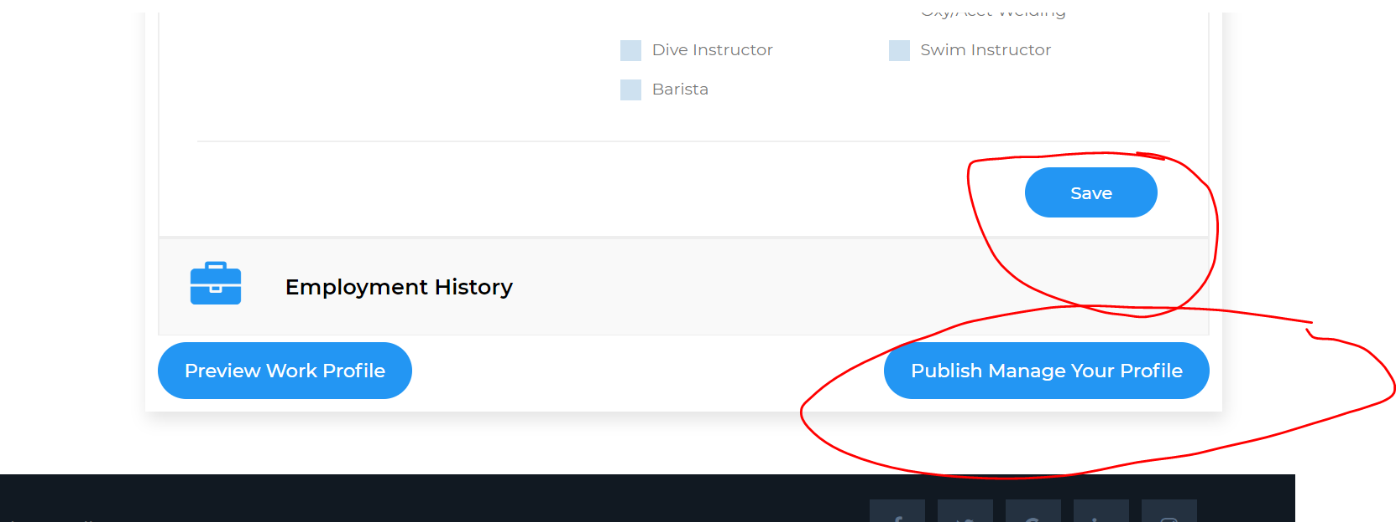

Can we change the wording here from “Good luck from the Seasonal Staff team” to “To view jobs you have applied for here” and then have a button that says (Jobs applied for). This will then take them to the same place as if they had pressed the “jobs applied for” button. (see below) ->**done**

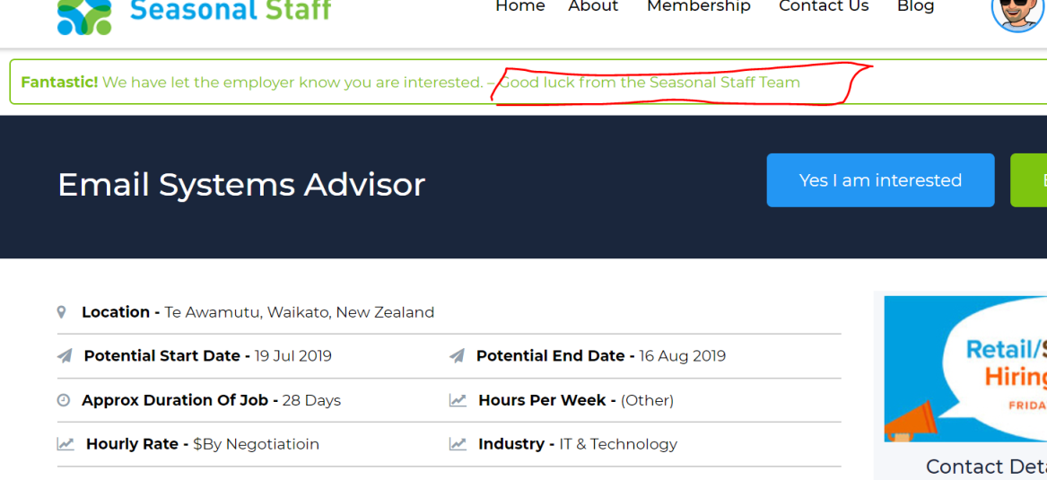

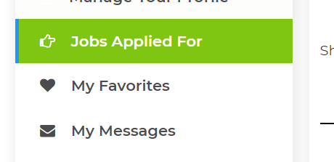

Staff profile “Jobs applied for” fixes

Can we please add a “email “ and “Delete” icon here. Can we also have that when you hover over the “Chat” icon that it says “Start a chat with employer”

“Email” icon when you hover it says “Send employer a email”

“Delete “ icon it says “delete job from your list”

Can we bring the chat box up to the top of the page……(it gets lost down the bottom of the page) and people are not using it…. Bring it up to just below the persons name that you are going to message. This makes more sense as people don’t have to scroll all the way to the bottom of the page.(see below for placement suggestion for message box”

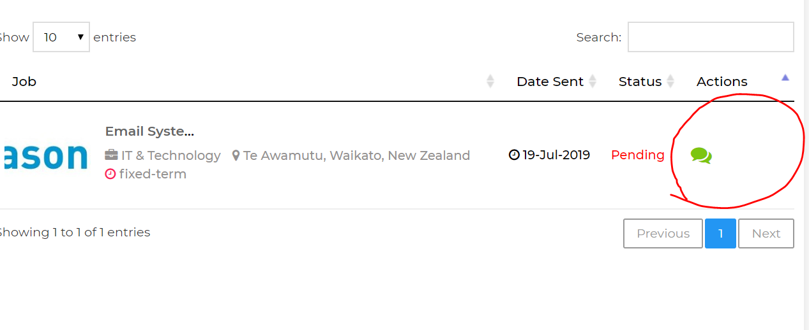

Can we bring the chat box up to the top of the page……(it gets lost down the bottom of the page) and people are not using it…. Bring it up to just below the persons name that you are going to message. This makes more sense as people don’t have to scroll all the way to the bottom of the page.(see below for placement suggestion for message box”

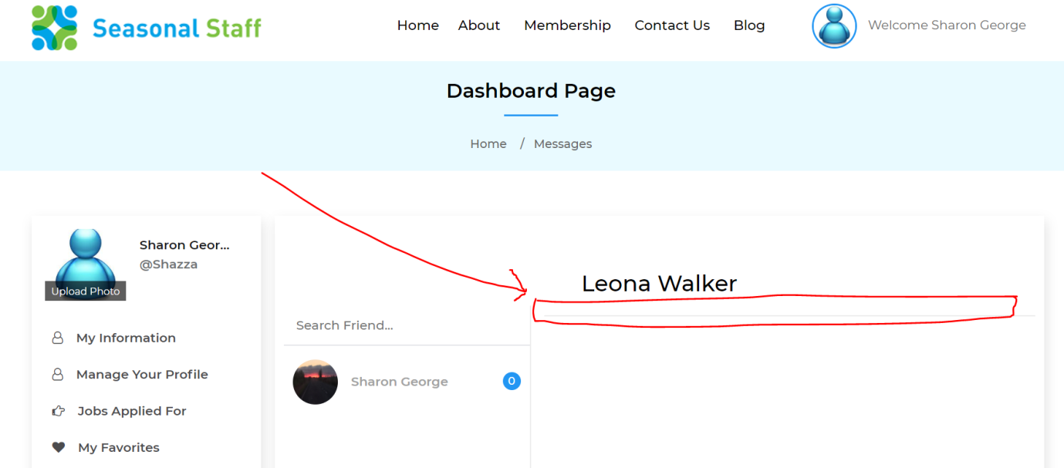

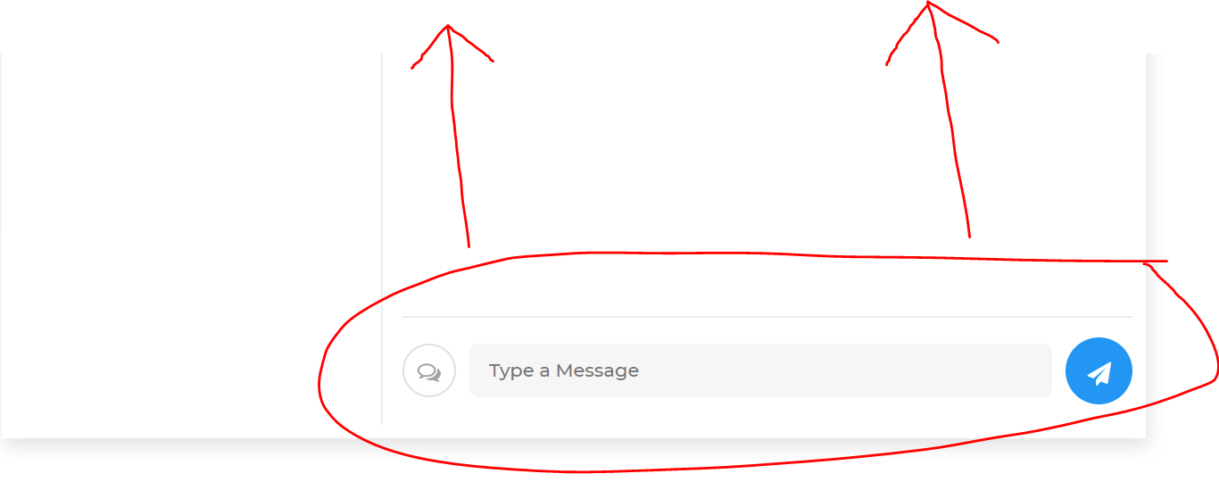

Admin back end functions –

Can you make the following changes in the back end.

The “Deactivate account” does not appear to be working. (please remove as The “Suspend account” actually deactivates the account. (we don’t need both bottons)

Can you change “ Permanently delete” to just say “Delete”

We don’t think there is much of a use for the “Email not verified” button (please remove) Keep the “Email verified” just change the wording to “Verify Email”

Could we have a “Publish profile” button in here

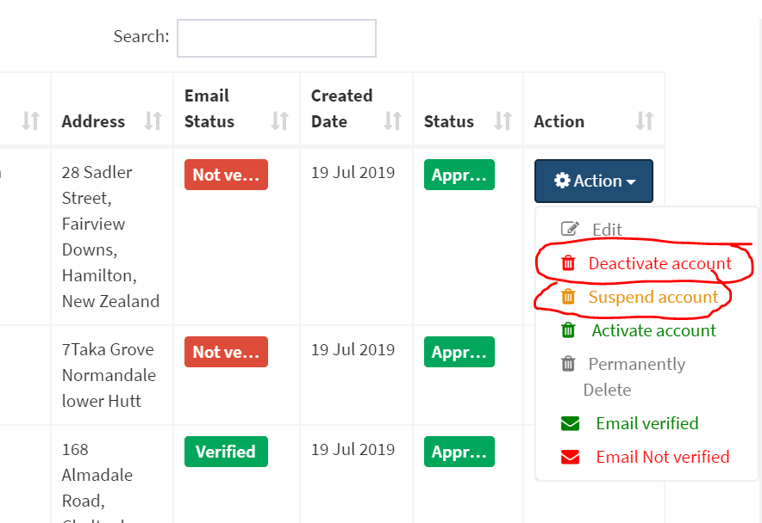

Then Can you reorder them in this way

Verify Email.

Edit

Activate account

Suspend account

Delete

When we go into a users profile, if we do anything in the back end, it automatically the effect is that the user and their password has to get reset. I think this is because the password and confirm passwords are blank. Is it possible to show the passwords here, so that if we update the address their passwords are showing, and this does not mean they have to reset all the time.

We like the feature that we can reset the password in here so please do not remove this functionality.

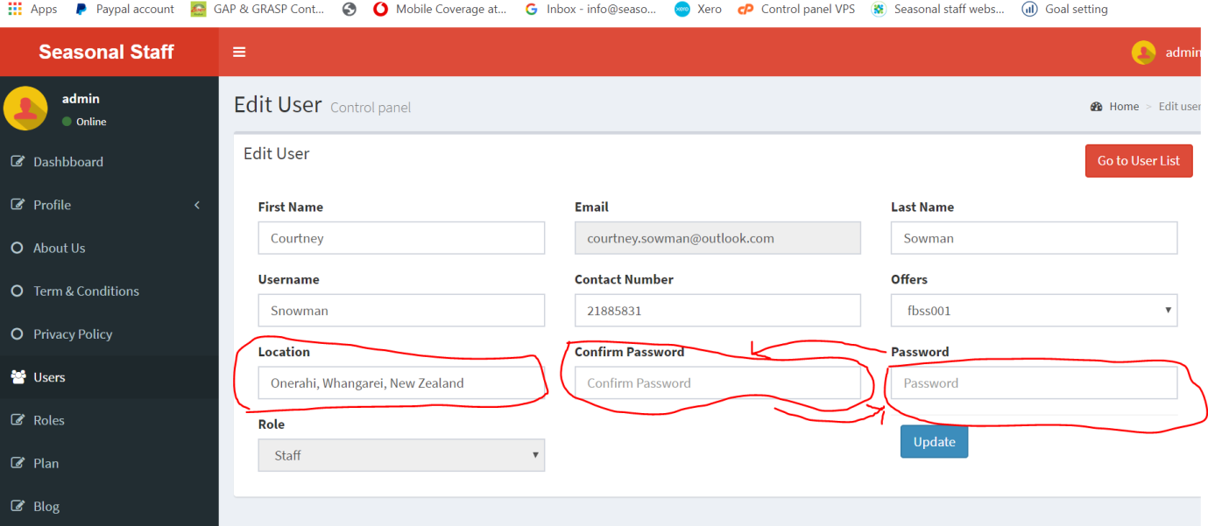

Can you change the order the boxes appear in the back end. Can you put “Password” where Confirm Password” is, and put “Confirm Password” where “Password is” This means it is the correct flow of how people do things.

We are finding that a few people are getting their address wrong so having the ability to go in and change or correct the location is great…. But when we change the location it changes it in the back end, but does not change it in the profile. (see below screen shots)

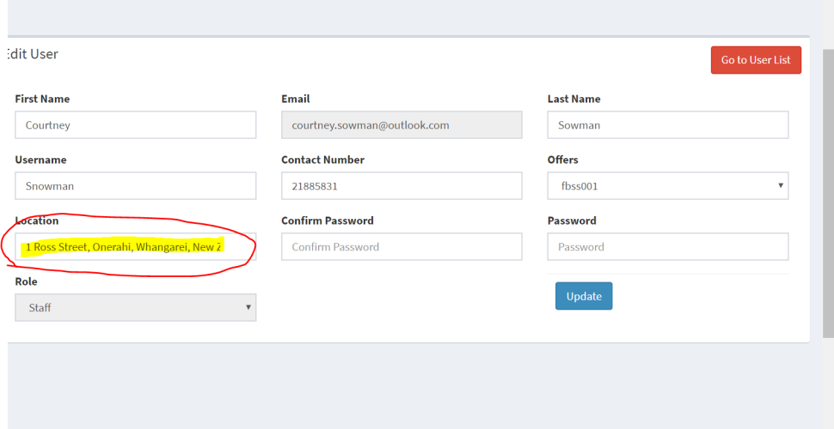

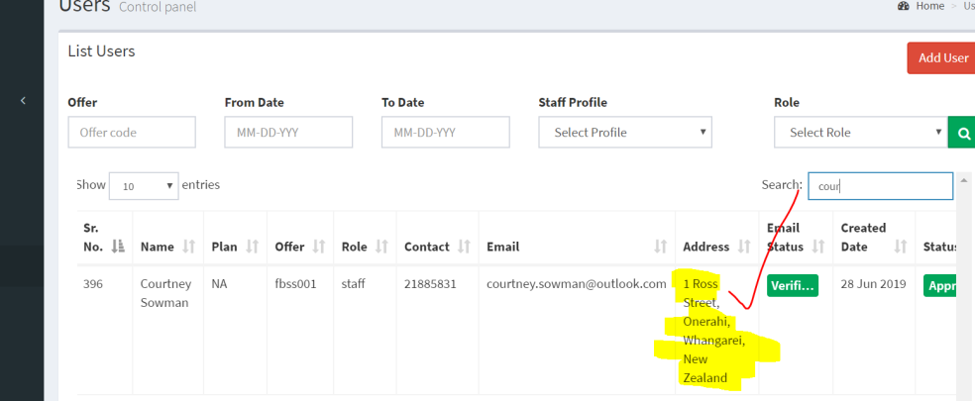

But does not change it here (see below)

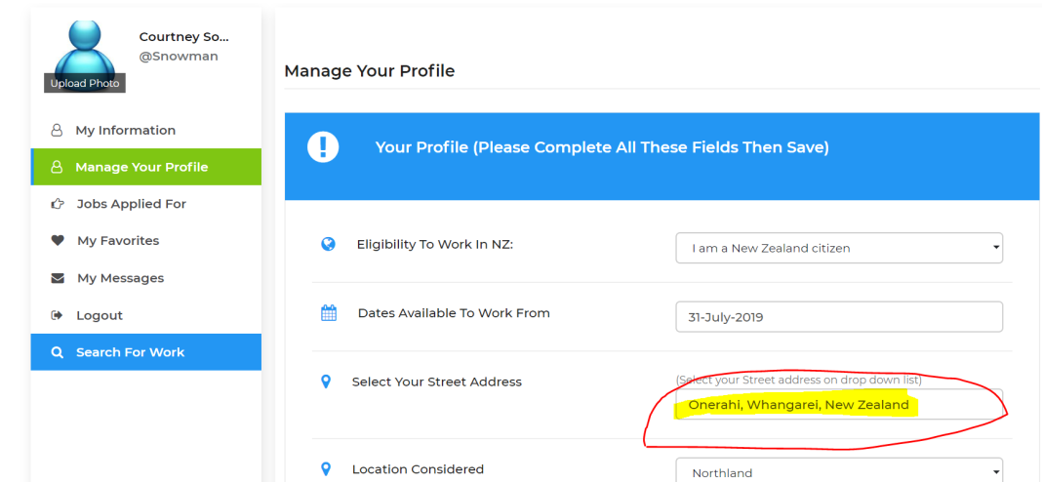

Or here (see below)

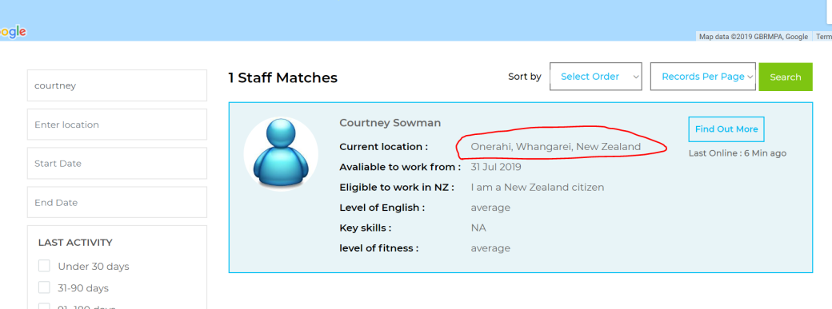

And is not in the right location on the map. (see below)

