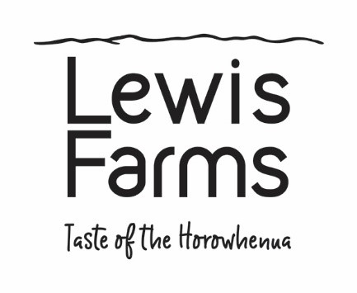

**LEWIS FARMS PRE-EMPLOYMENT FORM**

**Personal Details**

|  |  |
| --- | --- |
| Name |  |
| Address |  |
| Email |  |
| Phone |  |
| Date of Birth |  |

**Previous Experience**

Please provide details of your recent employment history including any information that may be relevant to the role at Lewis Farms (if known).

|  |  |  |
| --- | --- | --- |
| Employer | Dates Employed | Main Tasks |
|  |  |  |
|  |  |  |
|  |  |  |

**Eligibility to work in New Zealand**

To be employed at Lewis Farms you must be eligible to work in New Zealand. Please ensure you have the necessary documentation needed to do this as, should you become a preferred candidate, you may be asked to show us that documentation. Some examples of the types of documentation needed are set out below.

|  |  |  |  |
| --- | --- | --- | --- |
|  | Yes | No | Examples of documentation |
| Are you a New Zealand citizen? | [ . ] | [ . ] | NZ passport |
| If not, are you a permanent resident of New Zealand? | [ . ] | [ . ] | NZ resident visa |
| Or, do you hold a current New Zealand visa?  If so, please provide visa type and  expiration date. | [ . ] | [ . ] | A non-NZ passport &  a current NZ work visa, |

**Health**

|  |  |
| --- | --- |
| Do you presently suffer, or have you suffered in the past, from any medical or physical condition (including OOS or gradual process injury) that may affect your ability to perform the functions and responsibilities of the position? | |
| Yes [ . ] (please provide all relevant details) | **No [ . ]** |

**Criminal record**

|  |  |
| --- | --- |
| Do you have any criminal convictions or pending charges? | |
| Yes [ . ] (please provide all relevant details) | **No [ . ]** |

**Referees**

If you are a preferred candidate we will also undertake referee checks. Please provide two referees who can comment on your ability to meet the requirements of the position (i.e. work referees).

|  |  |  |  |  |  |
| --- | --- | --- | --- | --- | --- |
| Name |  | Relationship |  | Phone |  |
| Name |  | **Relationship** |  | **Phone** |  |

**Declaration**

I      ……………………………………………………….. (full name) acknowledge that Lewis Farms will undertake the following background checks if I am a preferred candidate:

* eligibility to work in New Zealand
* referee checks

I agree to the above background checks being undertaken.

I agree to undergo a pre-employment drug screening test.

I declare that all information provided by me to Lewis Farms, whether verbally or in writing, is true, accurate and complete and is not designed to mislead in any way. I understand and agree that any material misrepresentation or deliberate omission of a fact in my application may be justification for refusal of or, if employed, termination of my employment.

I understand that this form, together with written material I have supplied will be held confidentially and used only for purposes of this job application.

I will notify Lewis Farms of any future changes to this information during this application process or for my records if I am successful.

Applicant’s signature…………..………………………………………………………Date………..………