Table of Contents

Heading 1 1

Sub-Heading 1 1

Sub-sub-heading1 1

# Heading 1

This is not really important, I wish there was an important thing to write in here but I feel like a complete idiot.

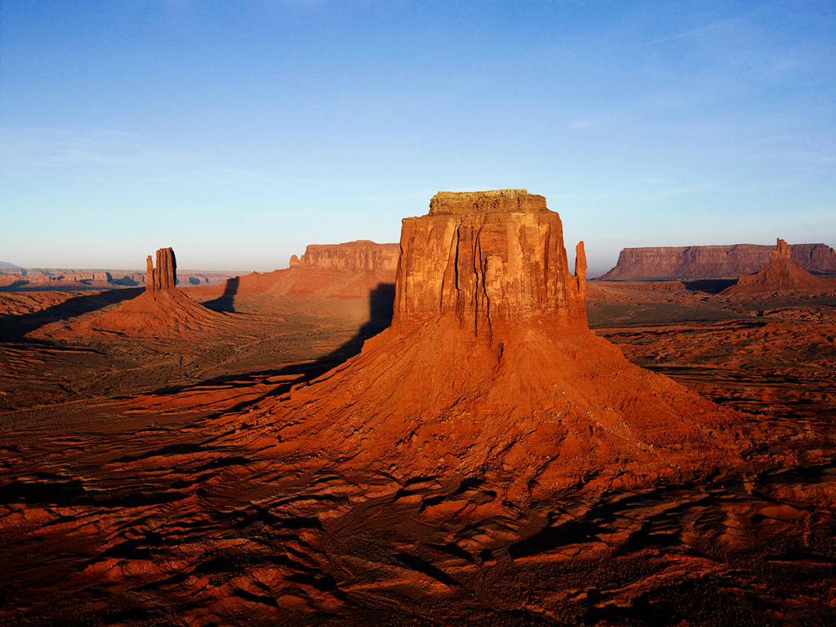

Figure : Sample Picture of the Desert

## Sub-Heading 1

For the little details that doesn’t nessecarily require a main heading of their own.

### Sub-sub-heading1

I feel like a total idiot, but in tiny details.

$$x=\frac{-b±\sqrt{b^{2}-4ac}}{2a}$$