Cenfotec
Student: Mauricio Acuna Gomez.
Course 2
Task 2
Data Science with Python.

Learnings

During the analysis I got different kind of errors I had to resolve. Here are the list of them:

- Some errors installing the Pandas profiling. The solutions was to install it from the console or terminal:
    - conda install -c conda-forge pandas-profiling

- Some errors with the data were not letting me run and generate the charts and tables I needed like:
  - Duplicated records in the data I got from the MySQL database.
  - Some values were empty or nulls.
  - Some columns were nod characterized.

- So, I solved it by creating a simple SQL sentence in charge of clean the data.

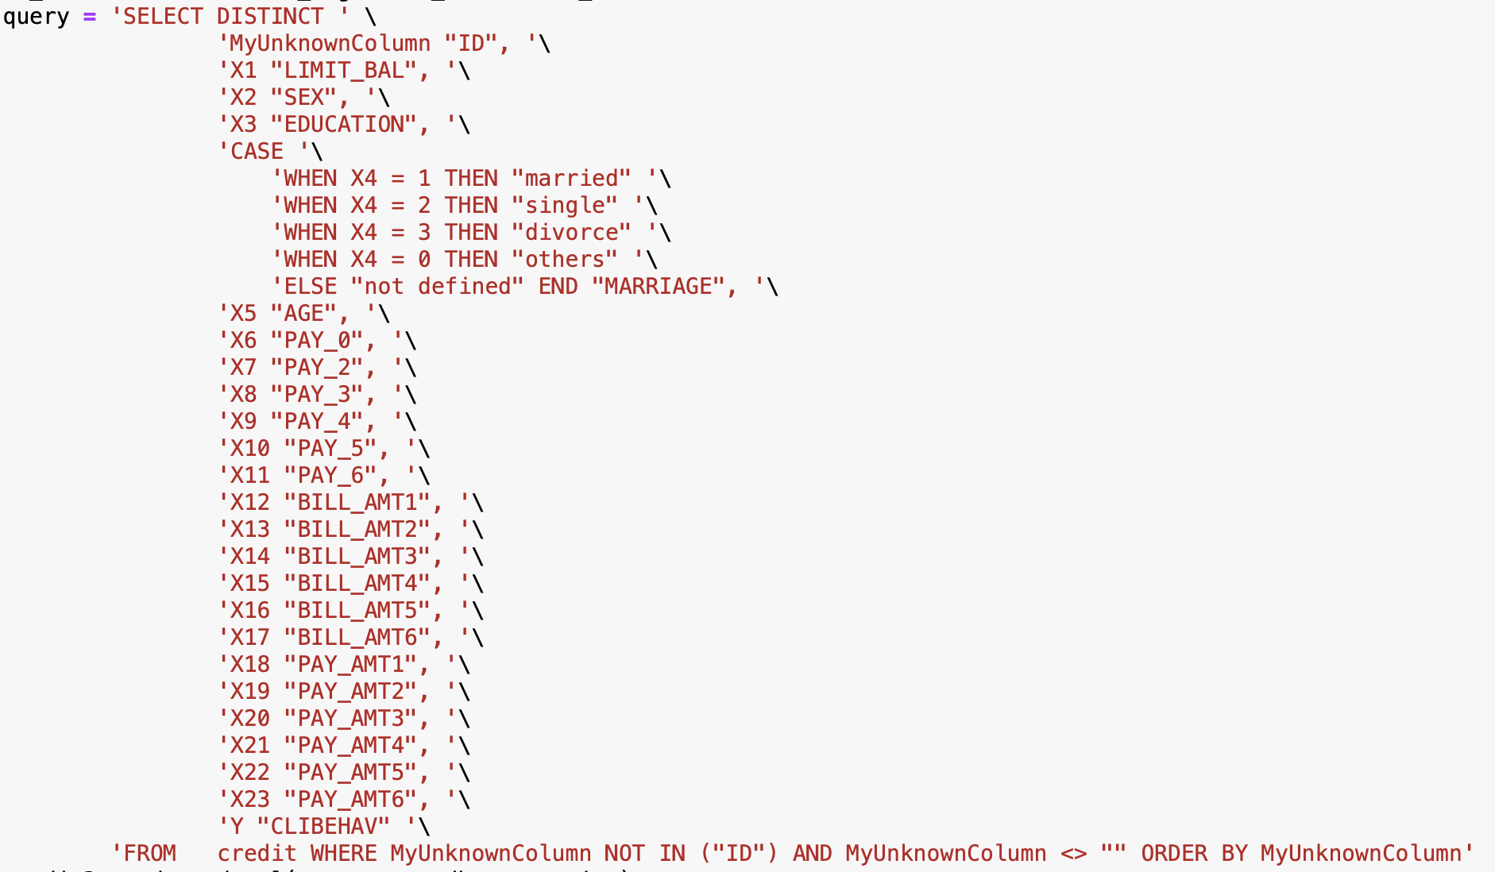

- Other issue I had was with the datatypes. In a case I needed to process number and the column was an object. So the solution was to convert it to str and int accordingly.

