**CSD201 PROGRESS TEST 1**

**Time (60 minutes) The Question will be submitted along with your source code to edu-next.**

**PART 1: Answer the Question. (40 pts)**

**1. How can you measure the efficiency of an algorithm?**

1. Processor and memory
2. Complexity and capacity
3. Time and space
4. Data and space

**2.** **Which data structure is not a linear data structure?**

1. Linked-List
2. Stack
3. Queue
4. BST tree
5. None of the above

**3.** **Array is the best data structure for?**

1. For relatively permanent collections of data
2. For a collection of data that need constant add and remove
3. Both of the above
4. None of the above

**4. Maximum number of edges in a binary tree with height k, where root is height 0, is**

1. $2^{k}$ − 2
2. $2^{k+1}$ − 1
3. $2^{k+1}$ + 1
4. $2^{k}$ + 1

**4. In order traversal of binary search tree will produce**

1. unsorted list
2. reverse of input
3. sorted list
4. none of the above

**5.** **Lets F be defined as follow?**

F(0) = 3; F(n+1) = 2F(n) + $n^{2}$: F(3) is ?

1. 16
2. 32
3. 30
4. 28

**6. The post-order traversal of the BST is ADBFGHE what is the pre order of this tree?**

1. EBAGDFH
2. ABDEFGH
3. EBADGFH
4. ABDFGHE

**7. How do you insert a node at the beginning of the list?**

**a.**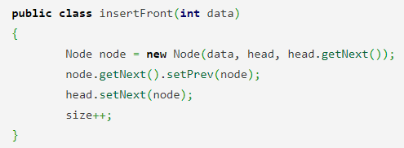

**b.**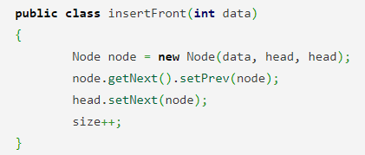

**c.**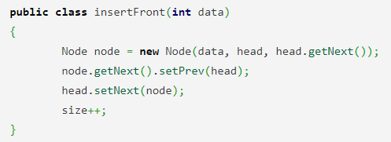

**d.**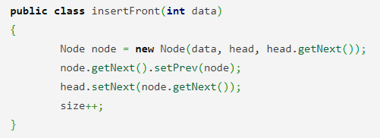

**8. What is the function of this following function?**

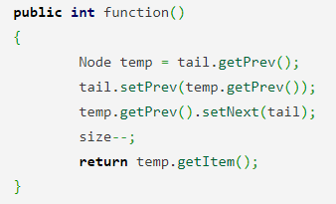

* 1. Return the element at the tail of the list but do not remove it
  2. Return the element at the tail of the list and remove it from the list
  3. Return the last but one element from the list but do not remove it
  4. Return the last but one element at the tail of the list and remove it from the list

**9. Convert the following Infix expression to Postfix form using a stack.**

**x + y * z + (p + q * r) * s, Follow usual precedence rule and assume that the expression is legal?**

1. xyz*+pq*r+s*+
2. xyz*+pq*r+s+*
3. xyz*+pqr*+s*+
4. xyzp+**qr+s*+

**10. If the elements of a stack are “ABEFDBDAGA” and are deleted one element at a time, what is the order of removal?**

1. ABEFDBDAGA
2. AGADBDFEBA
3. AGDAABEFDB
4. ABEFDDAGAD

**11. A normal queue, if implemented using an array of size MAX_SIZE, gets full when?**

1. Rear = MAX_SIZE – 1
2. Front = (rear + 1)mod MAX_SIZE
3. Front = rear + 1
4. Rear = front

**12. The in-order traversal of a tree will yield a sorted listing of elements of the tree in?**

1. Binary Trees.
2. Binary Search Tree.
3. Tree.
4. Perfect Binary Tree.

**13.**  **In Linked List implementation, a node carries information regarding** ___________

1. Data
2. Link
3. Data and Link
4. Node?

**14. Which of the following points is/are not true about Linked List data structure when it is compared with an array?**

1. Arrays have better cache locality that can make them better in terms of performance
2. It is easy to insert and delete elements in Linked List
3. Random access is not allowed in a typical implementation of Linked Lists
4. Access of elements in a linked list takes less time than compared to arrays

**15. Given a pointer to node X in a singly linked list. Only one point is given, and a pointer to the head node is not given, can we delete the node X from the given linked list?**

* 1. Possible if X is not the last node
  2. Possible if the size of the linked list is even
  3. Possible if the size of the linked list is odd
  4. Possible if X is not the first node

**16. You are given pointers to the first and last nodes of a singly linked list, which of the following operations are dependent on the length of the linked list?**

1. Delete the first element
2. Insert a new element as a first element
3. Delete the last element of the list
4. Add a new element at the end of the list

**17, What is the functionality of the following piece of code?**

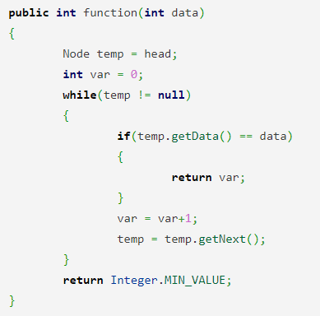

1. Find and delete a given element in the list
2. Find and return the given element in the list
3. Find and return the position of the given element in the list
4. Find and insert a new element in the list

**18)**  **Which of the following application makes use of a circular linked list?**

1. Undo operation in a text editor
2. Recursive function calls
3. Allocating CPU to resources
4. Implement Hash Tables

**19) What is the functionality of the following piece of Java code? With a is not empty and with size of n > 2**

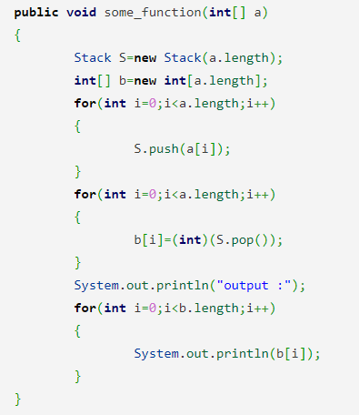

1. print alternate elements of array
2. b) duplicate the given array
3. c) parentheses matching
4. reverse the array

**20) The essential condition which is checked before insertion in a linked queue is?**

* 1. Underflow.
  2. Overflow.
  3. Front value.
  4. Rear value.

**PART 2: (60 pts)**

**Write your implementation of a link-queue to manage information of students.**

**note that: the Node is singular linked-list and the implementation should not use any external library.**

studentID: private String

name: private String

pe: private double

fe: private double

avg: private double

Write the following methods for your Queue:

**enQueue()** : add student to the back(rear) of the Queue

**deQueue():** remove student from the front of the Queue

**size():** return the size of the Queue

**searchByID:** search for student by ID

**max():** return data of student(s) with the max avg

**remove():** remove student(s) with the avg bellow 5.0