

CAPSTONE PROJECT REPORT
Report 1 – Project Introduction

– Hanoi, Jan 2026 –
Table of Contents
I. Record of Changes 3
II. Definition and Acronyms 4
III. Project Introduction 4
1. Overview 4
1.1 Project Information 4
1.2 Project Purpose 4
1.3 Project Stakeholders 5
2. Product Background 5
3. Existing Solutions 5
3.1 Teachworks 5
3.2 TutorBird 6
3.3 Google Classroom 7
4. Solution & Opportunity 8
5. Product Vision 9
6. Project Scope & Limitations 9
6.1 Major Features 9
6.2 Limitations & Exclusions 10
6.2.1 Limitations 10
● The system does not support automatic tuition fee collection, invoicing, or online payment processing. 10
● Income calculation is limited to internally recorded teaching sessions and attendance data. 10
6.2.2 Exclusions 10

I. Record of Changes
Date | A*  M, D | In charge | Change Description
12/1/2026 | A | DuongDQ | Create document
12/1/2026 | A | DuongDQ | Add Project background
12/1/2026 | A | DuongDQ | Add Project Scope & Limitations
12/1/2026 | A | DuongDQ | Software Product Vision
12/1/2026 | A | DuongDQ | Add Existing System Tutorbird
12/1/2026 | A | DuongDQ | Add Existing System Teachworks
12/1/2026 | A | DuongDQ | Add Existing System Google Classroom
12/1/2026 | A | DuongDQ | Add Project Background
12/1/2026 | A | DuongDQ | Add Business Opportunity
12/1/2026 | A | DuongDQ | Add Solution Opportunity
12/1/2026 | A | DuongDQ | Add Project Purpose and Overview
12/1/2026 | A | DuongDQ | Add Limitations & Exclusions
24/01/2026 | M | DuongDQ | Modified Major feature
*A - Added M - Modified D - Deleted

II. Definition and Acronyms
Acronym | Definition
AWS | Amazon Web Services
BA | Business Analysis
BR | Business Rule
ERD | Entity Relationship Diagram
GUI | Graphical User Interface
PM | Project Manager
SDD | Software Design Description
SPMP | Software Project Management Plan
SRS | Software Requirement Specification
UAT | User Acceptance Test
UC | Use Case
API | Application Program Interface

III. Project Introduction

1. Overview

1.1 Project Information
- English name: Tutor note
- Vietnamese name: Sổ tay gia sư
- Project code: TN
- Group name: Group 04
- Software type: Web
- Technical stack:

1.2 Project Purpose
The Tutor note (TN) website provides an effective online platform for managing tutoring activities between tutors, parents, and students. The website offers comprehensive tools for managing students, teaching schedules, learning sessions, evaluations, and homework, helping tutors organize their teaching process efficiently. The system automatically generates teaching sessions from weekly schedules, tracks attendance, calculates income based on completed sessions, and sends timely notifications to all related users. With integrated contextual messaging and real-time updates, parents and students can easily monitor learning progress and communicate directly with tutors. The user-friendly interface operates smoothly across devices, improving teaching efficiency, transparency, and overall learning outcomes.

1.3 Project Stakeholders
Full Name | Role | Email | Mobile
 | Lecturer
Trần Văn Hoàng | Member | hoangtvhe160642@fpt.edu.vn
Đinh Quý Dương | Leader | duongdqhe160154@fpt.edu.vn | 0389887060
Nguyễn Văn Minh | Member | minhnvhe172822@fpt.edu.vn
Phan Duy Hưng | Member | hungpdhe173329@fpt.edu.vn
Vũ Đình Phú | Member | phuvdhe176675@fpt.edu.vn

2. Product Background
In the context of rapid digital transformation and the increasing demand for personalized education in Vietnam, private tutoring has become an essential solution for students seeking to improve academic performance. Along with the growing number of tutors and learning centers, the need for effective management of students, schedules, learning progress, and communication has become more urgent. However, tutoring activities are currently managed mainly through fragmented and manual methods such as notebooks, spreadsheets, phone calls, and social messaging applications, which leads to inefficiency, data inconsistency, and limited transparency for parents and students.
This situation has driven the development of a specialized online tutor management platform aimed at addressing these challenges. The evolution of educational technology in Vietnam shows a clear trend toward digital learning management systems that not only support teaching activities but also optimize administrative processes. Modern web-based platforms enable automatic schedule generation, session tracking, attendance management, and centralized storage of learning data, helping tutors reduce manual workload while improving teaching quality. In addition, integrated communication and notification systems enhance interaction among tutors, parents, and students, ensuring timely updates and better learning coordination.
The target users of this product include individual tutors and small tutoring groups, as well as parents who wish to closely monitor their children’s learning progress and students who need clear schedules, feedback, and learning materials. The individuals proposing the idea and defining the requirements for this project are primarily tutors, education managers, and educational technology developers who recognize the lack of an integrated, role-based tutor management system in the current market. Their goal is to build a flexible, user-friendly platform that improves teaching efficiency, learning transparency, and overall educational outcomes.

3. Existing Solutions

3.1 Teachworks
- Link: https://www.teachworks.com
- Brief description: Teachworks is a tutoring management software designed for tutoring companies and independent tutors to manage students, schedules, billing, and lesson notes in a centralized system.
- System actors:
  - Administrators/Tutors:
- Create and manage student and parent profiles.
- Schedule lessons and manage tutor availability.
- Record lesson notes and attendance.
- Manage billing, invoices, and payment tracking.
  - Students/Parents:
- View lesson schedules and attendance history.
- Access lesson notes and invoices.
- Receive notifications about schedule changes.
- Features:
  - Online Session Scheduling: Intuitive calendar for booking, managing, and tracking tutoring sessions.
  - Student and Family Management: Centralized management of student profiles, parents, and lesson history.
  - Lesson Notes and Reports: Structured lesson records for tutors to document session content and feedback.
  - Billing and Invoicing System: Automated invoice generation and payment tracking for tutoring sessions.
  - Automated Notifications: Email reminders for upcoming sessions, schedule changes, and invoices.
  - Progress Tracking and Reporting: Basic reporting on attendance, lesson frequency, and tutor activity.
- Pros:
  - Comprehensive tutoring management features
  - Suitable for medium and large tutoring organizations
  - Supports online payments and integrations
- Cons:
  - Complex interface for individual tutors
  - Limited academic evaluation per session (scores, evaluation)
  - Most features require paid plans

3.2 TutorBird
- Link: https://www.tutorbird.com/
- Brief description: TutorBird is a web-based tutoring management platform focused on simplifying scheduling, student management, and billing for private tutors and small tutoring businesses.
- System actors:
  - Tutors: Manage student and family information; schedule tutoring sessions and set reminders; track attendance and lesson history; generate invoices and manage payments.
  - Students/Parents: View upcoming and past sessions; receive reminders and notifications; access invoices and payment history.
- Features:
  - Online Session Scheduling: Simple and user-friendly calendar for scheduling and tracking tutoring lessons.
  - Student and Family Profiles: Centralized repository for student and parent information and lesson records.
  - Tutor and Student Dashboards: Clear dashboards showing upcoming sessions, past lessons, and payment status.
  - Billing and Payment Tracking: Invoicing and payment history management for tutoring services.
  - Automated Notifications: Email and system reminders for scheduled lessons and payment updates.
  - Basic Activity Tracking: Overview of completed sessions and attendance history.
- Pros:
  - User-friendly and easy to set up
  - Affordable for small tutoring teams
  - Clean dashboard design
- Cons:
  - Limited support for scores, evaluations, and homework
  - Customization options are limited

3.3 Google Classroom
- Link: https://classroom.google.com
- Brief description: Google Classroom is an online learning management system primarily designed for schools, but it is often used by tutors to distribute materials, assign homework, and communicate with students.
- System actors:
  - Teachers: Create classes and manage student enrollment; assign homework and learning materials; review submissions and provide feedback; communicate announcements to students.
  - Students: Access class materials and assignments; submit homework and view feedback; receive notifications about new tasks.
  - Parents/Guardians: Receive summary emails about student activities; monitor assignment completion status.
- Features:
  - Class & Assignment Scheduling: Structured class timelines and assignment deadlines for online learning activities.
  - Resource Library: Central repository for documents, videos, links, and learning materials.
  - User-Friendly Course Interface: Clear organization of classes, assignments, and announcements for easy navigation.
  - Assignment Submission & Feedback: Online homework submission with teacher feedback and grading.
  - Automated Notifications: Email and in-app alerts for new assignments, deadlines, and announcements.
  - Basic Learning Progress Tracking: Visibility into assignment completion and submission status.
- Pros:
  - Free and widely accessible
  - Easy to use and reliable
  - Strong integration with Google tools
- Cons:
  - Not designed specifically for tutoring management
  - Limited scheduling and attendance management

4. Solution & Opportunity
After analyzing existing tutoring management solutions (Teachworks, TutorBird, Google Classroom), a clear gap emerges for a tutor-centric, session-based management platform tailored to individual tutors and small tutoring groups. Current products provide general scheduling or learning management features, but each has significant limitations: Teachworks focuses heavily on billing and administrative workflows, making it complex for individual tutors; TutorBird offers simplified scheduling and invoicing but lacks academic tracking and contextual communication; Google Classroom is course-oriented and not designed for tutoring workflows such as session-based income calculation, attendance marking, or parent transparency.
The proposed Tutor note is designed specifically to support private tutoring activities rather than formal classroom teaching or institutional course delivery. It emphasizes session-level management, real-time academic feedback, and role-based transparency among tutors, parents, and students. The platform focuses on:
- Automated generation of teaching sessions from weekly schedules, with flexible attendance marking (attended, absent, online/offline).
- Session-based academic records, including scores, evaluations, and tutor notes linked directly to each lesson/session.
- Integrated communication channels contextualized by student and session, improving clarity and reducing fragmented messaging.
- Automatic income calculation based on completed sessions, with warnings when session details are modified.
- Real-time notifications for upcoming sessions, unmarked attendance, and new feedback.
Unlike generic scheduling tools or course-centric learning platforms, the system allows tutors to manage their teaching activities in a structured yet lightweight manner, while parents gain transparent access to learning progress and session outcomes. Students benefit from clear schedules, online learning links, and consistent academic feedback.
With the increasing demand for personalized education in Vietnam and the growing adoption of digital tools in the education sector, a dedicated, role-based tutor management platform presents a strong opportunity. By addressing both academic tracking and administrative efficiency in a single system, the proposed solution offers clear differentiation and scalability, with potential future extensions such as online learning integration, digital homework submission, and advanced learning analytics.

5. Product Vision
Tutor Note aims to become a simple, efficient, and transparent online tutor management platform, specifically designed for individual tutors and small tutoring groups. The product not only supports scheduling but also focuses on session-based academic tracking, helping tutors manage their teaching effectively while enabling parents to clearly monitor students’ learning progress.

The vision of Tutor Note is to build a system that:

- Puts tutors at the center, minimizing manual administrative tasks so tutors can focus on teaching quality.
- Enhances learning transparency, allowing parents to track schedules, attendance, evaluations, and feedback in a timely and intuitive manner.
- Supports session-based management, seamlessly linking schedules, attendance, evaluations, notes, and income into a unified workflow.
- Is user-friendly and flexible, suitable for non-technical users and accessible across multiple devices.
- Is scalable and future-ready, with the potential to integrate advanced features such as pay online, virtual teaching platform integration, and learning data analytics.

In the long term, Tutor Note aspires to become a reliable “digital notebook” for tutors, contributing to improved tutoring quality, stronger collaboration between tutors, parents, and students, and accelerating digital transformation in personalized education.

6. Project Scope & Limitations

6.1 Major Features
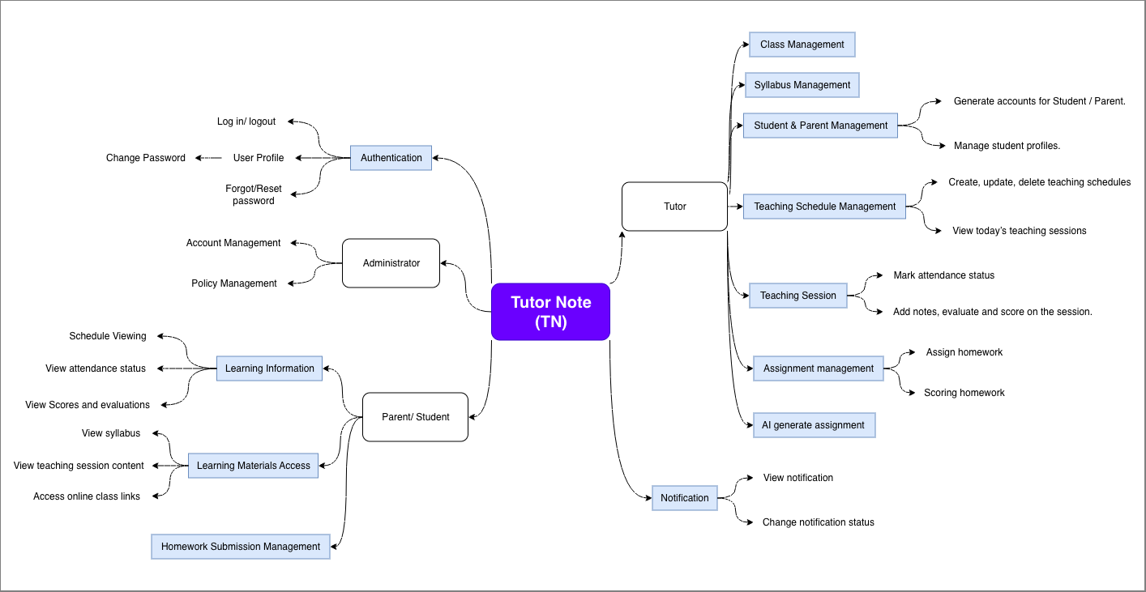

# | Role | Feature | Description
FE-01 | Guest | Authentication | Allows users to log in and out of the system. It includes functions like login, logout, and forget password.
FE-02 | Administrator | Account Management | Allows administrators to create accounts, reset passwords, ban/unban accounts and view the account list.
FE-03 | Administrator | Policy Management | Allows administrators to  - Define the maximum number of students per tutor.  - Monitor and record platform fees collected from tutors.  Automatically applies platform service fees when a tutor manages the third student or more.
FE-04 | Tutor | Class Management | Allows tutors to:  - Add, delete student into class  - Add, update, and delete class
FE-05 | Tutor | Syllabus Management | Allows tutors to upload and manage syllabus for each subject.
FE-06 | Tutor | Student & Parent Management | Allows tutors to:  - Generate accounts for students/parents.  - Add, update, and delete student profiles
FE-07 | Tutor | Teaching Schedule Management | Allows tutors to:  - Manage teaching schedules by days of the week.  - View today’s teaching sessions.
FE-08 | Tutor | Teaching Session | Allows tutors to:  - Mark attendance status.  - Add notes, evaluate and score on the session for each teaching session.
FE-09 | Tutor | Assignment Management | Allows tutors to:  - AI generate assignment base on Syllabus that tutor uploaded  - Assign homework for students by Image, link, file, text.  - Scoring homework
FE-10 | Tutor | AI generate assignment | AI generate assignment base on Syllabus that tutor uploaded
FE-11 | Parent/Student | Learning Information Viewing | Allows parent/ student to:  - View past teaching schedules and upcoming teaching schedules.  - View completed teaching sessions, attendance status, scores and evaluations, tutor progress remarks.
FE-12 | Parent/Student | Learning Materials Access | Allows parent/ student to:  - View syllabus uploaded by tutors.  - View teaching session content.  - Access online class links.
FE-13 | Parent/Student | Homework Submission Management | Allows parent/ student to:  - Submit homework by image, link, file, text.  - View score homework  - Add, update, and delete (Once the tutor has graded the assignment, students/parents are only allowed to view the results.) the homework
FE-14 | All users | Notification | Allow user to:  - Receive notification for attendance / scores / remarks; homework.  - Change status of notification

6.2 Limitations & Exclusions

6.2.1 Limitations
LI-01: No Built-in Payment or Billing Automation

The system does not support automatic tuition fee collection, invoicing, or online payment processing.

Income calculation is limited to internally recorded teaching sessions and attendance data.
LI-02: Limited External System Integration
- The system does not fully integrate with external school management systems (SMS), accounting software, or third-party communication platforms.
- Data synchronization with external systems requires manual handling or future development.
LI-03: No Live Video Teaching Feature
- The system does not provide built-in live video conferencing or virtual classroom functionality.
- Online teaching sessions must be conducted using third-party platforms (e.g., Zoom, Google Meet).

6.2.2 Exclusions
EX-01: The tool will not support online payment integration (e.g., credit card, e-wallets) in this phase. Purchases or subscriptions are out of scope.
EX-02: The system does not support offline access or offline data entry. An active internet connection is required to use all features.
EX-03: The system does not replace official school systems and does not manage formal school grading, transcripts, or certifications. It is limited to tutoring-related teaching activities only.
EX-05: The system does not include advanced AI-driven learning recommendations, automated lesson planning, or predictive performance analysis in the current release.

