

CAPSTONE PROJECT REPORT
Report 2 – Project Management Plan

– Hanoi, Sep 2025 –
Table of Contents
I. Record of Changes 3
II. Project Management Plan 4
1. Overview 4
1.1 Cost & Time Estimations 4
1.2 Project Objectives 5
1.3 Project Risks 6
2. Management Approach 6
2.1 Project Processes 6
2.1.1 Initiation and Planning 7
2.1.2 Requirements Analysis 7
2.1.3 System Design 8
2.1.4 Development 8
2.1.5 Testing 9
2.1.6 Deployment 9
2.1.7 Maintenance and Support 9
2.2 Quality Management 9
2.2.1 Defect Prevention 9
2.2.2 Reviewing 9
2.2.3 Unit Testing 10
2.2.4 Integration Testing 10
2.2.5 System Testing 10
2.3 Project Training Plan 10
3. Responsibility Assignments 11
4. Project Communications 13
5. Configuration Management 14
5.1 Document Management 14
5.2 Source Code Management 14
5.3 Tools & Infrastructures 14

I. Record of Changes
Date | A*  M, D | In charge | Change Description
24/9/2025 | A |  | Add Project Objectives
24/9/2025 | A |  | Add Cost & Time Estimations
24/9/2025 | A |  | Add Project Risks
24/9/2025 | A |  | Add Project Processes
24/9/2025 | A |  | Add Quality Management
24/9/2025 | A |  | Add System Design
24/9/2025 | A |  | Add Responsibility Assignments
24/9/2025 | A |  | Add Project Communications
24/9/2025 | A |  | Add Configuration Management
24/9/2025 | A |  | Add Document Management
24/9/2025 | A |  | Add Source Code Management
24/9/2025 | A |  | Add Tools & Infrastructures
26/9/2025 | M |  | Modify Development
26/9/2025 | M |  | Modify Unit Testing
26/9/2025 | M |  | Modify Tools
28/9/2025 | M |  | Modify Project Training Plan, Tool&Infrastructures
28/9/2025 | M |  | Modify Cost & Time Estimations
28/9/2025 | M |  | Modify Responsibility Assignments
*A - Added M - Modified D - Deleted

II. Project Management Plan

1. Overview

1.1 Cost & Time Estimations
# | Work Package | Est. Effort  (pds) | Deadline
1 | Stage 1: Project Initiation (week 1)
1.1 | Kick-off | 0.5 | Week1
1.2 | Research and determine project scopes and features | 5 | Week1
1.3 | Set up a development environment and project management tools. | 2 | Week1
1.4 | Report 1 – Project Introduction. | 10 | Week1
2. | Stage 2: Planning & Initial Requirements (weeks 2-3)
2.1 | Technical training | 5 | Week2
2.2 | Report 2: Project Management Plan v0.9 | 4 | Week2
2.3 | Report 3: SRS v0.9 (Overall Requirement) | 12 | Week2
2.4 | Vertical Prototypes  - Demo AI feature: Score Speaking&Writing test | 15 | Week
2.5 | Review code demo | 0.5 | Week3
2.6 | Report 2: Project Management Plan v1.0 | 4 | Week3
2.7 | Report 3: SRS v1.0 (Overall Requirement) | 8 | Week3
3 | Stage 3: Software Design (weeks 4-5)
3.1 | Vertical Prototypes (POC, or Proof Of Concepts) | 4 | Week4
3.2 | Report 4: SDS v1.0 (High Level Design Specifications) | 7 | Week4
3.3 | Report 5: Test Planning (ref Report5_Test Documentation) | 4 | Week5
3.4 | Report 3: SRS v1.0 (Detailed Requirements for Iteration 1) | 5 | Week5
4 | Stage 4: Implementation (weeks 6-11)  (Ref: Project Tracking, WBS sheet)
4.1 | Implementation Iteration 1 (weeks 6-7)
4.1.1 | Code Package & Unit Testing Report | 30 | Week6
4.1.2 | Report 4: Detailed Design Specifications (SDS) v1.1 | 2 | Week6
4.1.3 | Report 5: Integration Test Cases | 2 | Week6
4.1.4 | Report 5: Integration Test Report | 2 | Week7
4.1.5 | Report 3: SRS v1.1 (Detailed Requirements for Iteration 2) | 5 | Week7
4.1.6 | Software Package Version 1 | 6 | Week7
4.2 | Implementation Iteration 2 (weeks 8-9)
4.2.1 | Report 4: Detailed Design Specifications (SDS) v1.2 | 5 | Week8
4.2.2 | Code Package & Unit Testing Report | 30 | Week8
4.2.3 | Report 5: Integration Test Cases | 1 | Week8
4.2.4 | Report 5: Integration Test Report | 1 | Week9
4.2.5 | Report 3: SRS v1.2 (Detailed Requirements for Iteration 3) | 5 | Week9
4.2.6 | Software Package Version 2 | 10 | Week9
4.3 | Implementation Iteration 3 (weeks 10-11)
4.3.1 | Report 4: Detailed Design Specifications (SDS) v1.3 | 4 | Week10
4.3.2 | Code Package & Unit Testing Report | 30 | Week10
4.3.3 | Report 5: Integration Test Cases | 1 | Week10
4.3.4 | Report 5: Integration Test Report | 1 | Week11
4.3.5 | Report 5: System Test Cases | 5 | Week11
4.3.6 | Software Package Version 3 | 10 | Week11
5 | Stage 5: Verification & Validation (weeks 12-13)
5.1 | Report 5: System Test Report | 6 | Week12
5.2 | Report 6: User Guides (Installation Guides, User Manuals) | 2 | Week12
5.3 | Acceptance Test and Support | 3 | Week13
5.4 | Final Software Package (Documents, Source Codes, etc.) | 30 | Week13
6 | Stage 6: Closing (week 14)
6.1 | Report 7: Final Project Report. | 5 | Week14
6.2 | Presentation File | 3 | Week14

1.2 Project Objectives
# | Metric | Unit | Planned | Actual | Notes / References
1 | Effort Usage | Person-day | 375 |  | Total planned effort for the entire project (5 members)
2 | Review Defects | No of defects | 75 |  | Total defects found during review activities
3 | Unit Test Defects | No of defects | 45 |  | Total defects found during unit testing
4 | Integration Test Defects | No of defects | 45 |  | Total defects found during integration testing
5 | System Test Defects | No of defects | 15 |  | Total defects found during system testing
6 | Acceptance Test Defects | No of defects | 75 |  | Total defects found during acceptance testing
7 | Timeliness | % | 95% |  | Total on-time deliverables / Total project deliverables
8 | Requirement Completeness | % | 90% |  | Failed if <=75%

1.3 Project Risks
# | Risk Description | Impact | Possibility | Response Plans
1 | Members have argued, conflicted with others, leads to stressful working environments. | Medium | High | Define clear tasks for each member and agree on ideas before starting work.
2 | Technical outages (server downtime, unstable connections) | High | Medium | Build redundant infrastructure (load balancers, backup servers), monitor 24/7, establish rapid recovery protocols and run regular failover tests.
3 | Data security breaches and unauthorized access. | High | Low | Enforce SSL/TLS encryption, comply with ISO/IEC 27001 or equivalent, conduct periodic security audits, apply strict access controls and logging.
4 | Legal and copyright issues related to content usage. | Medium | Low | Engage legal counsel, secure all necessary copyrights/licenses; stay updated on education laws; maintain full records permissions and licenses.

2. Management Approach

2.1 Project Processes
The TOEIC Online Test Preparation tool development methodology is built on a structured process to ensure the project achieves its objectives effectively. This process consists of a series of clearly defined steps, presented in the "Project Process" section below.
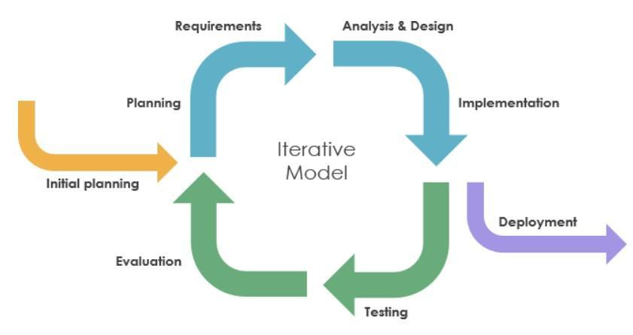
The development process of the TOEIC Online Test Preparation tool project includes the following steps:

2.1.1 Initiation and Planning
- Identify Core Objectives: Develop an online TOEIC test preparation tool that helps examiners improve their test-taking skills and automatically grades their test scores.
- Identify Core Objectives:
  - User-friendly interface, accessible on a web platform.
  - Rich question bank for skills, closely following the official test format.
  - Automatic scoring tool that analyzes errors.
  - Adaptive practice mode, automatically adjusting time.
- Collect Insights: Interview and survey both examinee and TOEIC teachers to understand their limitations (e.g., fast speaking speed, lack of detailed feedback) and desired functionality (e.g., variable difficulty, intuitive visual reporting).

2.1.2 Requirements Analysis
- Needs Collection and Documentation: Identify issues such as limited number of practice tests, manual grading, and lack of detailed error analysis by surveying current app and website users.
- Prioritize Features:
  - Automated assessment for skills
  - Intuitive user interface
- Development Requirements Document:
  - Functional Requirements: Generate tests by topic (Academic/General), display scorecards, store practice history.
  - Non-Functional Requirements: Real-time feedback (≤1 second per action), cross-platform compatibility, secure handling of personal data.

2.1.3 System Design
- Detailed Planning: Adopt a microservices or modular architecture, separating components for question banks, grading tools, reports, and forums. Use a relational database for user profiles and results.
- Model Building:
  - Student Dashboard: displays tests and allows for individual sections to be tested.
  - Admin/Instructor Dashboard: provides overall statistics, manages the question bank, and tracks interactions.
  - ERD Diagram: models the relationship between users, tests, questions, and results.
- Ensure Flexibility: Design so that modules can be added later and allow for automatic scaling in the cloud as the number of users increases.

2.1.4 Development
- Ensure Flexibility:
  - Frontend: React
  - Backend: .NET Core and Python.
  - Scoring Engine: implemented as a module inside the backend, responsible for handling all scoring logic:
- Listening & Reading: auto-graded using predefined answer keys for multiple-choice questions.
- Writing: integrates with ChatGPT API to evaluate essays (grammar, vocabulary, coherence, etc.).
- Speaking: uses a Voice-to-Text service (Whisper) to generate transcripts, then applies a Pronunciation Assessment service (Azure Speech) to evaluate pronunciation, intonation, and fluency.
- Iterative Approach:
  - Sprint 1 – Lay the Foundation: Curate a rich Listening question bank and implement an automated scoring tool to provide accurate, immediate feedback.
  - Sprint 2 – Expand Scope: Build a Reading question bank and extend a similar automated scoring tool, ensuring seamless assessment across both skills.
  - Sprint 3 – Lay the Foundation: Curate a rich Writing question bank and implement an automated scoring tool to provide accurate, immediate feedback.
  - Sprint 4 – Lay the Foundation: Curate a rich Speaking question bank and implement an automated scoring tool to provide accurate feedback.
  - Sprint 5 – Enhance with AI: Integrate advanced AI capabilities for scoring.
- Incremental testing: Validate score accuracy before integrating with dashboard, then enable the forum at the end.

2.1.5 Testing
- Testing Strategy:
  - Unit testing for each API endpoint and UI component.
  - Integration testing between microservices (e.g., when an examinee submits an answer, the grading service processes and stores the result).
  - User Acceptance Testing (UAT) with a pilot group of examinee and instructors to collect
- realistic feedback.
- Collect Feedback: Collect examinee feedback on aspects such as response latency and UI navigation, then refine the interface and optimize performance.
- Quality Assurance: Aim for ≥95% grading accuracy and ensure key interactions respond within ≤1 second.

2.1.6 Deployment
- System Launch: Deploy to AWS, using CI/CD pipeline from GitHub. Package services using Docker.
- User Support: In-app user guides and FAQs.
- Performance monitoring: Set up alerts for any service failures or degradations.

2.1.7 Maintenance and Support
- Operational Maintenance: Perform regular security patches, upgrade libraries, and optimize code. Schedule daily backups and check availability.
- User Support: Update documentation and FAQs based on common issues.

2.2 Quality Management

2.2.1 Defect Prevention
- Communicate Clear Requirements: During kick off meetings, articulate all project tasks and challenges—such as automating test delivery, synchronizing scorecards with audio, and implementing an automated grading process—to every team member.
- Review General Requirements: Collectively review functional specifications (e.g., timed test sections, performance analytics dashboards) to ensure everyone fully understands what needs to be built.
- Assign Roles Based on Strengths: Assign backend developers with database expertise to manage question banks and audio files, while UI/UX experts focus on designing the test interface and student dashboards.
- Stable Responsibilities: Ensure roles and responsibilities are consistent throughout the project to streamline collaboration, avoid overlap, and minimize confusion.

2.2.2 Reviewing
- Periodic Product Reviews: Regularly review requirements documents, source code for delivery and scoring modules, and development schedules to verify alignment with project goals.
- Identify and Prioritize Issues: Document any bugs—such as automated scoring errors or mismatches between transcripts and audio—and rank them by impact (e.g., inaccurate scoring errors are prioritized).
- Regular Peer Code Reviews: Require developers to regularly review each other's code to catch bugs early and maintain high quality standards.

2.2.3 Unit Testing
- Framework Selection: Use xUnit for backend logic (question communication, timing, scoring) and Jest for frontend React components (test interface, dashboard).
- Comprehensive Test Cases: Write test cases for skills, timed sections, and auto-scoring logic.
- Test Case Validation: Review and fix assertions in test cases; ensure scenarios such as slow networks, lost connections, and variable playback speeds are covered.
- Coding Standards Enforcement: Verify that every line of code adheres to the project's coding standards to ensure consistency and maintainability.
- Rapid Bug Resolution: Assign developers responsibility for fixing issues immediately, minimizing delays in the development process.

2.2.4 Integration Testing
- Unit Testing First: Start integration testing only after all unit tests for each component (test selection, scoring, result storage) have passed.
- Logical Testing Sequence: First, test the flow from audio playback to question display to answer submission; then integrate the auto-scoring and result storage modules.
- Issue Tracking & Retesting: Log integration errors, assign solutions, and retest after resolution.

2.2.5 System Testing
- Clear Entry/Exit Criteria: Define that all integration test cases must pass before system testing begins, and that every system test case must pass before testing concludes.
- End-to-End Validation: Simulate complete user journeys—login, test selection, exam execution, and result review—ensuring the system behaves as expected at every step.
- Defect Remediation: Identify and promptly fix issues such as audio loading delays or analytics chart errors to guarantee stability.
- Operational Maintenance: Confirm the platform meets performance, reliability, and usability requirements, with minimal downtime and a seamless user experience.

2.3 Project Training Plan
Training Area | Participants | When, Duration
Reactjs + Vite | All team members | 15/09/2025, 1pds
.NET Core | All team members
Azure, OpenAI | All team members | 18/09/2025, 1pds
Git, Github | All team members | 13/09/2025, 1 pds
Figma | All team members | 14/09/2025, 1 pds

3. Responsibility Assignments

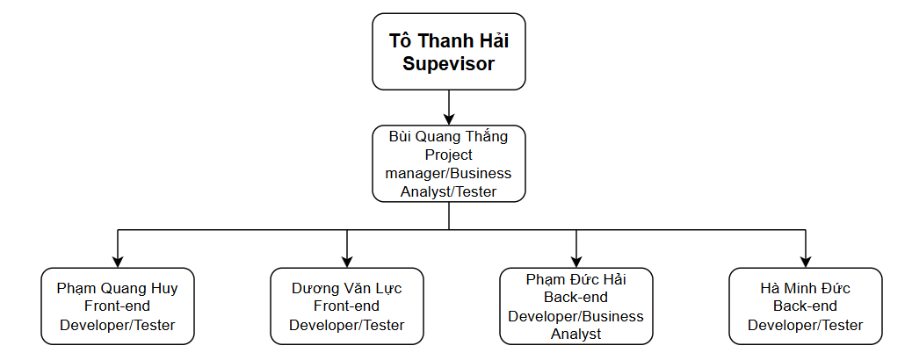
RACI Chart: R~Responsible, A~Accountable, C~Consulted, I~Informed
Work Package | ThangBQ  HE173004 | DucHMHE172440 | HuyPQ  HE171458 | HaiPDHE172178 | LucDV  HE163042
Kick-off | R | I | I | I | I
Research and determine project scopes and features | R-A | R-A | R-A | R-A | R-A
Set up a development environment and project management tools. | I | R | R-A | R-A | R
Report 1 – Project Introduction. | R | A-I | A-I | A-C-I | A-I
Technical training | I | R-C-I | R-C-I | R-C-I | C-I
Report 2: Project Management Plan v0.9 | R | C-I | C-I | A-C-I | C-I
Report 3: SRS v0.9 (Overall Requirement) | R-A-I | R-A-I | R-A-I | R-A-I | R-A-I
Vertical Prototypes  - Demo AI feature: Score Speaking&Writing test | I | R-A | I | I | I
Review code demo | R-C | R-C | R-C | R-C | R-C
Report 2: Project Management Plan v1.0 | R | C-I | C-I | A-C-I | C-I
Report 3: SRS v1.0 (Overall Requirement) | R-A-I | R-A-I | R-A-I | R-A-I | R-A-I
Vertical Prototypes (POC, or Proof Of Concepts) | R-A-I | R-A-I | R-A-I | R-A-I | R-A-I
Report 4: SDS v1.0 (High Level Design Specifications) | R-A-I | R-A-I | R-A-I | R-A-I | R-A-I
Report 5: Test Planning (ref Report5_Test Documentation) | R-A-I | I | R-A-I | R-A-I | I
Report 3: SRS v1.0 (Detailed Requirements for Iteration 1) | R-A-I | R-A-I | R-A-I | R-A-I | R-A-I
Code Package & Unit Testing Report | R-A-I | R-A-I | R-A-I | R-A-I | R-A-I
Report 4: Detailed Design Specifications (SDS) v1.1 | R-A-I | I | R-A-I | R-A-I | I
Report 5: Integration Test Cases | R-A-I | I | R-A-I | R-A-I | I
Report 5: Integration Test Report | R-A-I | I | R-A-I | R-A-I | I
Report 3: SRS v1.1 (Detailed Requirements for Iteration 2) | R-A-I | R-A-I | R-A-I | R-A-I | R-A-I
Software Package Version 1 | R-A-I | R-A-I | R-A-I | R-A-I | R-A-I
Report 4: Detailed Design Specifications (SDS) v1.2 | R-A-I | R-A-I | R-A-I | R-A-I | R-A-I
Code Package & Unit Testing Report | R-A-I | I | R-A-I | R-A-I | I
Report 5: Integration Test Cases | R-A-I | I | R-A-I | R-A-I | I
Report 5: Integration Test Report | R-A-I | I | R-A-I | R-A-I | I
Report 3: SRS v1.2 (Detailed Requirements for Iteration 3) | R-A-I | R-A-I | R-A-I | R-A-I | R-A-I
Software Package Version 2 | R-A-I | R-A-I | R-A-I | R-A-I | R-A-I
Report 4: Detailed Design Specifications (SDS) v1.3 | R-A-I | R-A-I | R-A-I | R-A-I | R-A-I
Code Package & Unit Testing Report | R-A-I | I | R-A-I | R-A-I | I
Report 5: Integration Test Cases | R-A-I | I | R-A-I | R-A-I | I
Report 5: Integration Test Report | R-A-I | I | R-A-I | R-A-I | I
Report 5: System Test Cases | R-A-I | I | R-A-I | R-A-I | I
Software Package Version 3 | R-A-I | R-A-I | R-A-I | R-A-I | R-A-I
Report 5: System Test Report | R-A-I | I | R-A-I | R-A-I | I
Report 6: User Guides (Installation Guides, User Manuals) | R-A-I | R-A-I | R-A-I | R-A-I | R-A-I
Acceptance Test and Support | R-A-I | I | C-I | C-I | I
Final Software Package (Documents, Source Codes, etc.) | R-A-I | R-A-I | R-A-I | R-A-I | R-A-I
Report 7: Final Project Report. | R-A-I | R-A-I | R-A-I | R-A-I | R-A-I
Presentation File | R-A-I | R-A-I | R-A-I | R-A-I | R-A-I

4. Project Communications
Communication Item | Who/ Target | Purpose | When, Frequency | Type, Tool, Method(s)
Weekly Meeting | Team members, supervisor | Monitor on the  project's progress  ,tackle issues, define next week plan | 2 hours per week | Online  (Google Meet)
Daily Meeting | All team member | Explore and clarify  the partner’s  requirements | Daily | Google Meet
Daily Report | All team member | Report completed  work. | Whenever  someone  finishes | Messenger, Zalo
Unscheduled Meeting | All team member | Discuss and solve  important issues | When there  are issues of  disagreement  that need to  be resolved  and  understood | Google Meet, Messenger, Zalo

5. Configuration Management

5.1 Document Management
To manage our project documentation effectively, we utilize Docs Online, Sheet Online, and Canva, which enable us to track progress and document changes seamlessly. These tools help us organize Document Reports, User Guides, Test Case Lists, and Slide Presentations, making it easy to compare versions and consolidate updates. Using these applications ensures that all team members stay aligned, with clear and accessible documentation, allowing everyone to follow the project’s development with ease.

5.2 Source Code Management
We use GitHub for source code management, which simplifies the process of storing, sharing, and updating code. These platforms allow us to assign tasks, collaborate efficiently, and manage changes quickly and accurately. This streamlined approach enhances our ability to deliver high-quality source code for the TOEIC Online Test Preparation System, ensuring the smooth development of key features such as practice test management, scoring automation, and user progress tracking.

5.3 Tools & Infrastructures
Category | Tools / Infrastructure
Technology | Reactjs + Vite, C#/.NET Core 8.0
Database | SQL Server Management Studio 2019
IDEs/Editors | Visual Studio Code, Visual Studio 2022
Diagramming | DrawIO
Documentation | Google Docs/Sheets/Slides,Canva
Version Control | GitHub (Source Codes), Google Drive (Documents)
Deployment server | Amazon Web Service (AWS)
Project management | GitHub: Tasks, TimeLogs, Defects, Issues Management

