Modelling Formula 1 Tyre Degradation and Optimising Pit-Stop Strategy
From-scratch numerical methods, validated degradation models and a verified race-time optimiser for the Hungarian Grand Prix, 2022–2025
Student: Marcus Aurelius Chan Jia Xian Student ID: ________ Unit: MMA3001 Numerical Methods and Machine Learning
GitHub repository: https://github.com/macuzzzz/F1-tire-Degradation-Model- (all numbers below come from running the code in this repository; the decision log DECISIONS.md is cited as D1–D92 and the challenge log CHALLENGES.md as C1–C24)

1. Engineering problem and objectives
A racing tyre loses grip as it wears, so lap time rises with tyre age. A pit stop restores the pace but costs about 21 s in the pit lane, so race strategy is a trade-off between running slower on worn tyres and paying for extra stops. A useful strategy model therefore needs a quantitative degradation curve for each tyre compound. Raw lap times cannot provide it directly, because degradation is mixed with other effects: the car becomes lighter as fuel burns (faster laps), the track rubbers in, safety cars and yellow flags slow laps, in- and out-laps include pit-lane time, and every car and driver has its own base pace.
Objective. From public race timing data: (i) remove the confounding effects (lap filtering, fuel correction, pit laps); (ii) fit a degradation model d(tyre age) per Pirelli compound; (iii) validate the models on laps and a race they were not fitted to; (iv) use the validated model in a race-time model to find the pit lap(s) that minimise total race time; and (v) test how sensitive that answer is to the uncertain inputs. All numerical methods (Euler, Heun, RK4, adaptive RK45, bisection, secant, Newton, finite differences, Gaussian elimination, least squares, KNN) are written from scratch with NumPy; SciPy and scikit-learn are used only as benchmarks.
Intended use and scope. The result is an engineering screening tool and a numerical-methods study, not an operational team strategy system. The scope is one circuit (Hungaroring), Pirelli compounds C3 and C4, seasons 2022–2025 and all teams. Car performance is not modelled: a separate base lap time per stint absorbs car, driver and compound pace (D39). Only free data are used, because F1’s timing archive has required an F1 TV login since about 15 October 2026 (D14).

2. Inputs, outputs and data
Table 1. Top-level inputs (all in config.yaml).
Input | Unit / format | Valid range (checked by config.py) | Value used
Races: season, event, train/test role, source | YAML list | 2018 to current year; OpenF1 ≥ 2023; ≥ 1 train and 1 test race; no duplicates | Hungary 2022–24 train, 2025 test
Pirelli compounds | C0–C6 | known codes only | C3, C4
Fuel coefficient k_fuel | s per lap of fuel | ≥ 0 and within [k_min, k_max] | 0.046 (range 0.015–0.070)
Pit-loss override | s | > 0, or null = estimate from data | null → 20.89 s (median)
Outlier threshold k / min. stint | robust SD / laps | > 0 / integer ≥ 1 | 3.0 / 10 laps
Numerical and model settings, seed | see config.yaml | validated per section | seed 42

Table 2. Top-level outputs.
Output | Unit | Meaning and use | File (reports/)
Degradation model per compound + bootstrap SE | s, s/lap | lap-time increase vs tyre age; input to the strategy | phase6_inputs.csv
Validation metrics (RMSE, MAE, bias, R²) | s, s/lap | accuracy on withheld races | phase5_cv_*.csv, phase5_test_results.csv
Optimal pit lap(s), total race time | lap, s | strategy ranking for a 70-lap race | phase6_strategy_ranking.csv
Sensitivity coefficients, break-even values | s, laps, – | which inputs can change the decision | phase7_*.csv
Audit, manifest, 24 figures | – | leakage/constraint checks, reproducibility hashes | audit_*.csv, figures/

Invalid input handling. The configuration is validated when it is loaded, with clear errors for wrong types, out-of-range values or missing keys. Every public function documents and checks its inputs and raises TypeError or ValueError (a review script confirms 213 public objects with complete NumPy docstrings, D86). Missing lap times are kept as NaN and removed by a cleaning rule; an unknown race raises RaceNotFoundError, and a blocked download raises RaceDataUnavailableError.

2.1 Data and preparation
Lap data come from FastF1 (2022, its free mirror) and the OpenF1 API (2023–2025), merged into one table and cached on disk; the raw data are never committed. Because SOFT/MEDIUM/HARD are relative labels, every stint is mapped to its Pirelli compound with a sourced allocation table (C3 was the MEDIUM in 2022 and the HARD in 2023–2025). Green-flag laps are detected from FastF1’s track status (2022) or rebuilt from race-control messages (OpenF1). Eight cleaning rules are then applied in a fixed order, and each lap is counted against the first rule that removes it (Table 3).
Table 3. Cleaning rules and the laps they removed.
Rule (in order) | Why the lap cannot be used | Laps removed (4 races)
1 Missing lap time | no time recorded | 7
2 First lap | standing start, pack racing | 79
3 In- and out-laps | contain pit-lane time (used for the pit loss instead) | 294
4 Not green flag | yellow flag, safety car, VSC or red flag during the lap | 184
5 Inaccurate (FastF1 flag) | timing marked unreliable (none in these races) | 0
6 Missing stint data | stint, compound or tyre age unknown (none) | 0
7 Outlier within its stint | residual > 3 × 1.4826·MAD from a Theil–Sen line (traffic, mistakes) | 313
8 Stint shorter than 10 laps | too few laps to separate offset and slope | 114
Total | 5,363 laps loaded → 4,372 clean laps (2022: 1012, 2023: 1013, 2024: 1118, 2025: 1229) | 991

The outlier rule is robust on purpose: the Theil–Sen slope is the median of all pairwise slopes in a stint, and 1.4826·MAD estimates the standard deviation from the median absolute deviation, so a few slow laps cannot distort the line that judges them. Fuel correction: corrected time = t + k_fuel (n − 1) with k_fuel = 0.046 s per lap of fuel, i.e. every lap is expressed at the lap-1 fuel load. The value agrees with a joint fit on the training data (0.0456 s/lap) and with a rule of thumb (0.03 s/kg × 110 kg / 70 laps = 0.047); because track evolution also makes laps faster linearly, the coefficient contains both effects. Pit loss: in-lap plus out-lap minus two typical clean laps of the same driver, median of 105 green-flag stops in 2023–2025: 20.89 s (IQR 19.82–22.31 s).
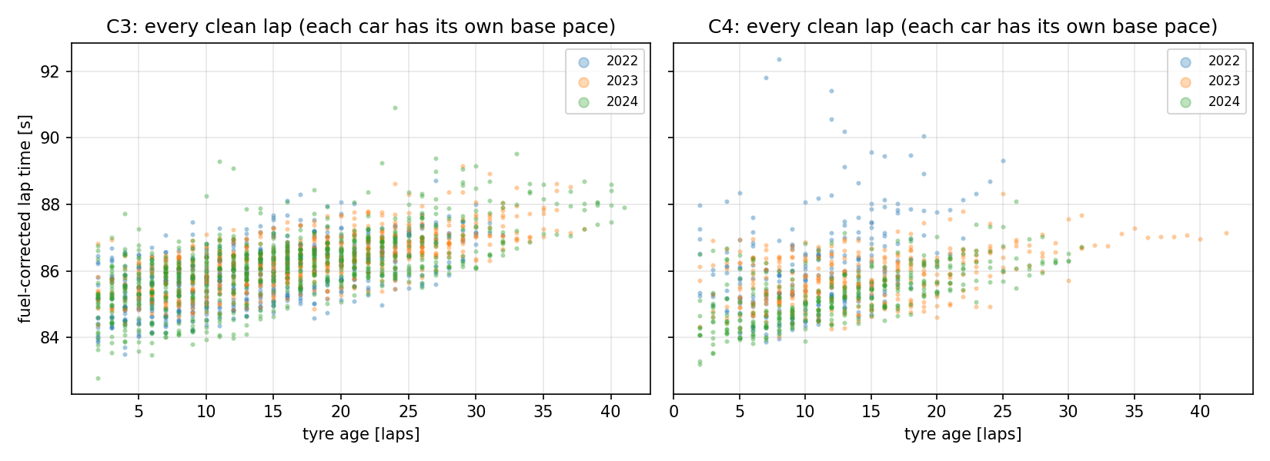 | 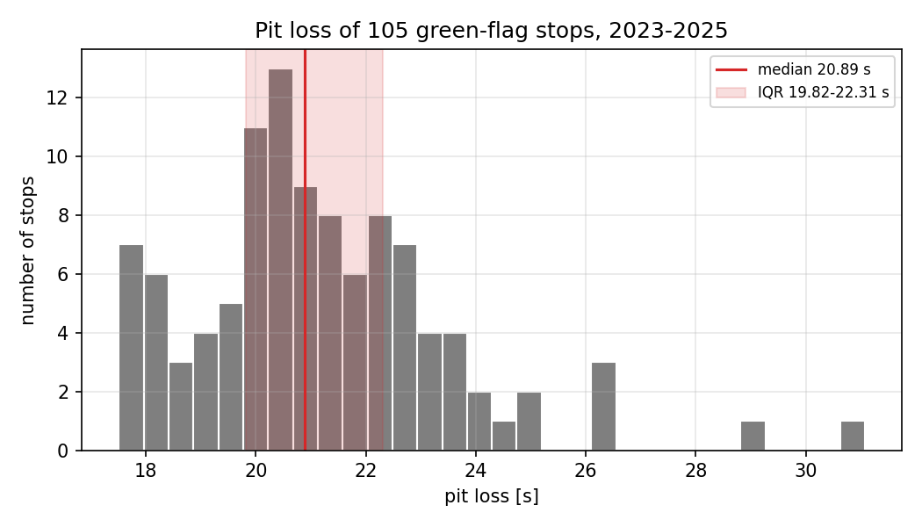
Figure 1. Left: every clean training lap, fuel-corrected lap time against tyre age (each car has its own level, which the per-stint offsets remove). Right: the measured pit losses, 2023–2025, with median and IQR.
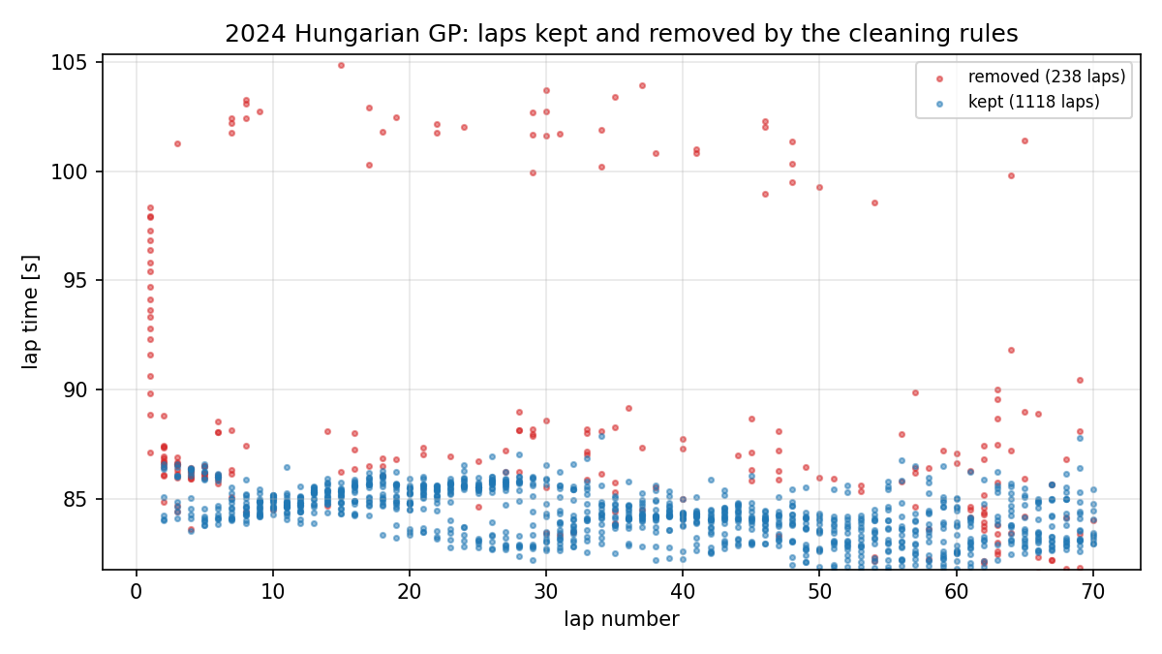 | 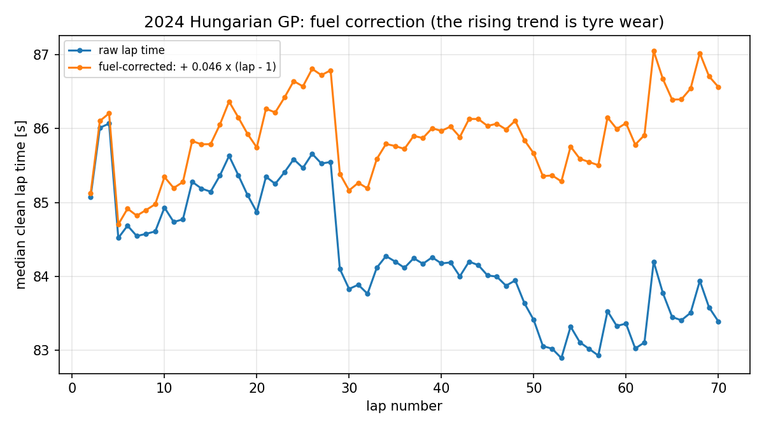
Figure 2. 2024 race: laps kept and removed by the cleaning rules (left); median lap time per lap before and after fuel correction (right). After correction the rising trend is tyre wear; the drops are the pit-stop waves.

3. Computational approach
Workflow. One command, scripts/run_pipeline.py, runs eight stages in order: the numerical-methods study → data loading, cleaning and fuel correction → cross-validation (or, after the test, verification of the frozen selection) → the single test evaluation → strategy optimisation → sensitivity analysis → the credibility audit → performance benchmarks. Every numerical choice lives in config.yaml and is validated on loading; every stage writes CSV tables and figures to reports/, and a manifest stores the SHA-256 hash of every result so that a re-run can prove it reproduced them. Each choice is logged with its options, evidence and validation in DECISIONS.md.

3.1 Numerical methods implemented from scratch
Table 4. From-scratch methods: how they work, where they are used and how each was verified.
Method | How it works | Used for / settings | Verification
Euler, Heun, RK4 | advance y with 1, 2 or 4 slope evaluations per step; global error O(h), O(h²), O(h⁴) | wear ODE in the model fit; RK4 with 1-lap steps | observed orders 1.00 / 2.00 / 4.00 (Fig. 2)
Dormand–Prince RK45 | 7-stage embedded pair; the 5th- minus 4th-order solution estimates the error; RMS norm scaled by atol + rtol·|y|; accept if ≤ 1; h_new = h·clip(0.9·err^(−1/5), 0.2, 10); last stage reused (FSAL) | accurate ODE reference; rtol 1e-3, atol 1e-6 | 25 f-evaluations vs SciPy’s 50 at rtol 1e-3, same accuracy
Bisection, secant, Newton | halve a sign-changing bracket (linear, guaranteed); secant line through the last two points (order ≈ 1.6); tangent line using f′ (order 2) | wear parameter b (root of dRSS/db), dT/dL = 0, break-even values; stop when step AND residual small, or |step| ≤ 4·eps·|x| | agree with each other and with SciPy; b found in 21 / 5 / 3 iterations
Finite differences | forward/backward error O(h), central O(h²); round-off grows as eps/h, so an optimal h exists | dRSS/db, dT/dL, sensitivities; h = eps^(1/2), eps^(1/3), eps^(1/4) × max(1, |x|) | default h sits at the measured error minimum (Fig. 2)
Gaussian elimination | LU factorisation with partial pivoting (largest pivot swapped up to avoid dividing by small numbers); 1-norm condition estimate | normal equations, (XᵀX)⁻¹ for standard errors; warn if cond > 1e12 | matches numpy.linalg.solve to 1e-12
Linear least squares | solve XᵀXβ = Xᵀy; cond(XᵀX) = cond(X)², so inputs are scaled to [−1, 1]; SE from σ²(XᵀX)⁻¹ | every model fit; QR as the alternative | matches lstsq; scaling cuts cond(X) from 1.6e10 to 94 (degree 6)
KNN regression | distance to every training point; average the k nearest (ties included), uniform or 1/distance weights | non-parametric degradation, k = 10–400 | identical to scikit-learn kd-tree

3.2 Degradation models
Every model has the form lap time = offset(stint) + d(tyre age) with d(0) = 0. The per-stint offset removes car, driver and compound base pace; it is eliminated before fitting by subtracting stint means (Frisch–Waugh–Lovell), so only the shape of d is estimated. Three families were compared with a no-degradation baseline: a polynomial of degree 1–3 without constant; a wear ODE dd/dn = a + b·d, whose b is found by a 21-point grid scan and bisection on dRSS/db (RK4 integration, checked against the exact solution a·expm1(bn)/b on every fit); and KNN on tyre age. Parameter uncertainty comes from a bootstrap that resamples whole stints (200 resamples, seed 42), because laps within a stint are correlated. On the training data the wear ODE gives a = 0.0693 s/lap and b = +0.0010 per lap, with a 95% interval for b that contains 0: there is no evidence of an accelerating ‘cliff’.

3.3 Race-time model and optimisation
For stints of n_i laps on compounds c_i, the race time is T = Σ_i [n_i·base(c_i) + Σ_{a=1..n_i} d_{c_i}(a)] + stops·pit loss − k_fuel·N(N − 1)/2 with N = 70 laps. A dry race must use two compounds, and no stint may exceed the largest tyre age observed with at least 5 laps (C3 40 laps, C4 35 laps), so the model is never extrapolated (D63). The strategy refits the selected model on 2023–2025 (D56) and uses an order-balanced C4−C3 pace delta of −0.080 s (D60). One-stop races are optimised by brute force (the reference) and by a continuous relaxation, where each stint’s sum is replaced by a midpoint integral and the root of dT/dL is found with secant and Newton (central-difference derivatives) and then rounded and checked. Two-stop races are enumerated exhaustively.
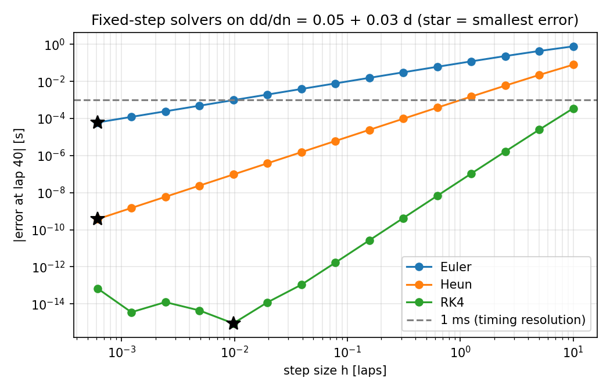 | 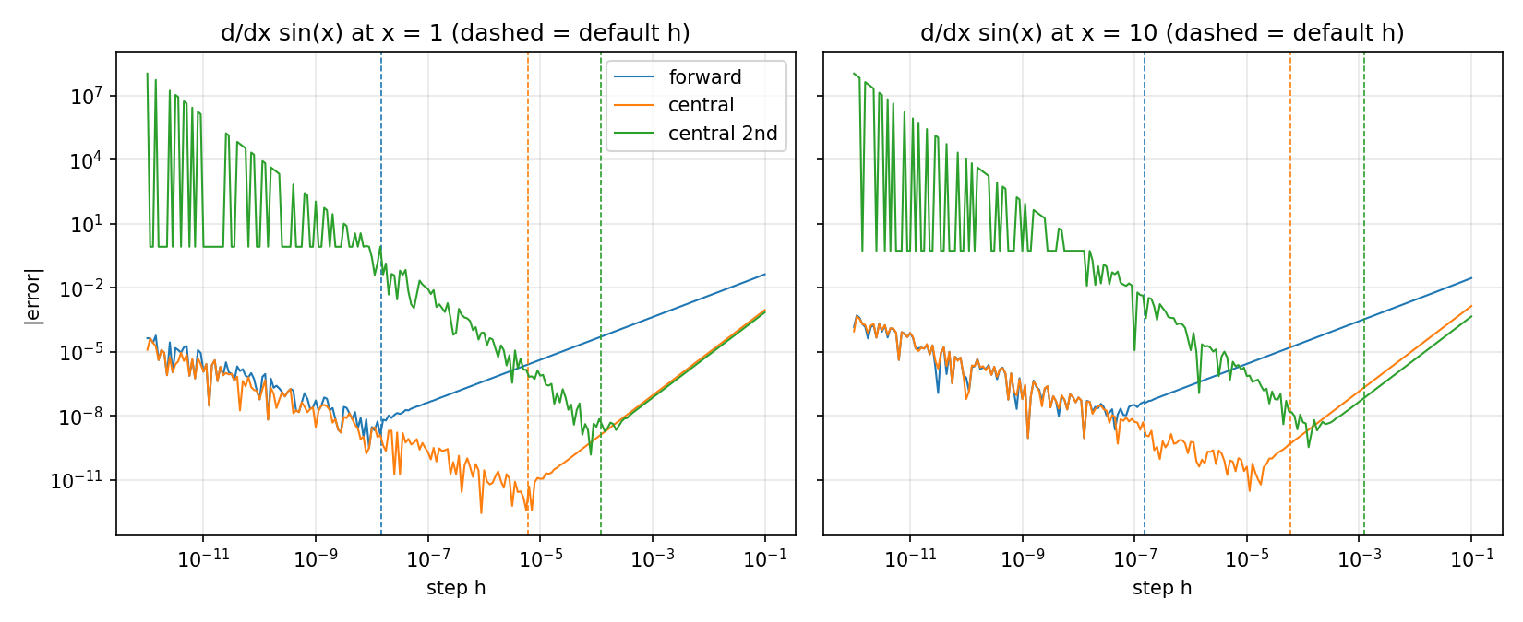
Figure 3. Verification of the numerical methods. Left: error of Euler, Heun and RK4 against step size on the wear ODE (slopes 1, 2, 4). Right: finite-difference error against step h; the dashed lines (default steps) sit at the minimum between truncation and round-off error, i.e. the optimal step.

4. Validation and verification
Code verification. 940 offline tests and doctests pass (pytest; HTML test report and 95% line coverage in the repository). Each from-scratch method is tested against an analytic solution or a trusted library, including its order of convergence. Tests use small synthetic tables and never download data.
Model selection: leave-one-race-out cross-validation on 2022–2024 (3 folds). Each held-out stint’s base pace is set by its first 3 laps, which are not scored; all other laps are predicted. RMSE is the primary metric. A candidate is accepted if it beats the no-degradation baseline in every fold, its mean bias is within ±0.10 s/lap, and its curve is non-negative and does not fall by more than 0.05 s between laps. The simplest accepted family winner within one standard error of the best RMSE is selected. The selection was frozen in model_selection.json (11:40:30 UTC) before the single test run (11:40:44 UTC); a code ‘firewall’ refuses to repeat the test or overwrite the selection.
Table 5. Cross-validation results (mean ± standard error over folds).
Model | C3 CV RMSE [s] | C3 bias [s/lap] | C4 CV RMSE [s] | C4 bias [s/lap] | Accepted?
Baseline (no degradation) | 1.168 | −0.866 | 1.132 | −0.634 | no (reference)
Polynomial degree 1 | 0.633 ± 0.091 | +0.040 | 0.851 ± 0.151 | +0.084 | yes – selected
Polynomial degree 2 | 0.633 | +0.035 | 0.849 | +0.134 | C3 yes, C4 bias fails
Wear ODE | 0.633 | +0.035 | 0.849 | +0.129 | C3 yes, C4 bias fails
KNN k = 100, uniform | 0.639 | −0.007 | 0.851 | −0.012 | yes

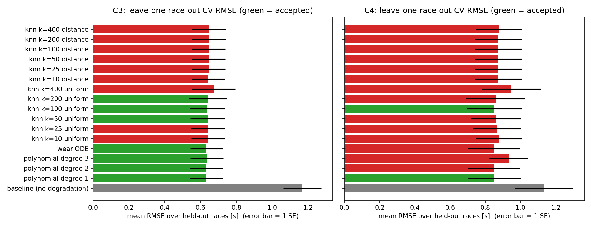
Figure 4. Cross-validated RMSE of all 17 candidates per compound. The flexible models do not beat a straight line, so the one-standard-error rule selects degree 1 for both compounds.
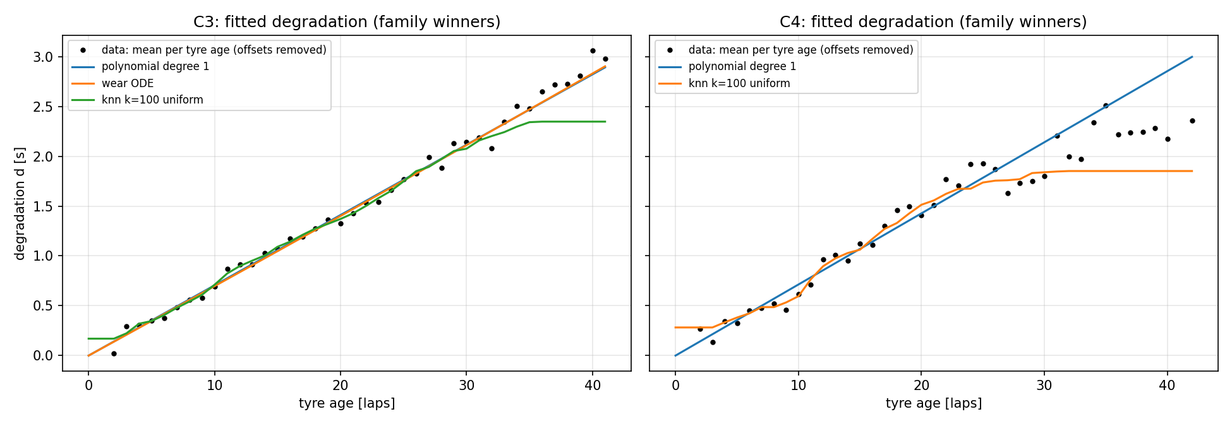
Figure 5. Tyre degradation fitted to the training races by the family winners (C3 left, C4 right; points = mean per tyre age after removing stint offsets): the straight line, the wear ODE and KNN (k = 100) coincide up to about 30 laps; beyond that KNN flattens because few laps remain to average.

4.1 Test on the withheld 2025 race and its diagnosis
On 2025 the selected lines had RMSE 0.942 s (C3) and 1.042 s (C4), better than the baseline (1.311 and 1.082 s), but a positive bias of +0.276 and +0.536 s/lap: they predicted more degradation than occurred, and the 0.10 s/lap criterion was not met. A post-test diagnosis that changes nothing (D89) splits the bias exactly into a wear-rate part and an anchor-lap part (Table 6). The 2025 wear rate was 30–36% lower than in 2022–24 (the 2025 C3 was softened and the median track temperature was 13–17 °C lower). For C4, the first laps of the 2025 stints were also about 0.2 s slow, which shifts every anchored prediction. Extrapolation beyond the training ages, the fuel correction (leftover effect −0.0027 s/lap, CI includes 0) and any single team (14 of 20 team groups biased positive) were ruled out.
Table 6. Exact decomposition of the 2025 test bias [s/lap].
Compound | Wear rate train → 2025 [s/lap] | Observed bias | Wear-rate part | Anchor-lap part | Bias within training ages
C3 | 0.0705 → 0.0451 | +0.276 | +0.416 | −0.140 | +0.268
C4 | 0.0713 → 0.0496 | +0.536 | +0.297 | +0.239 | +0.536

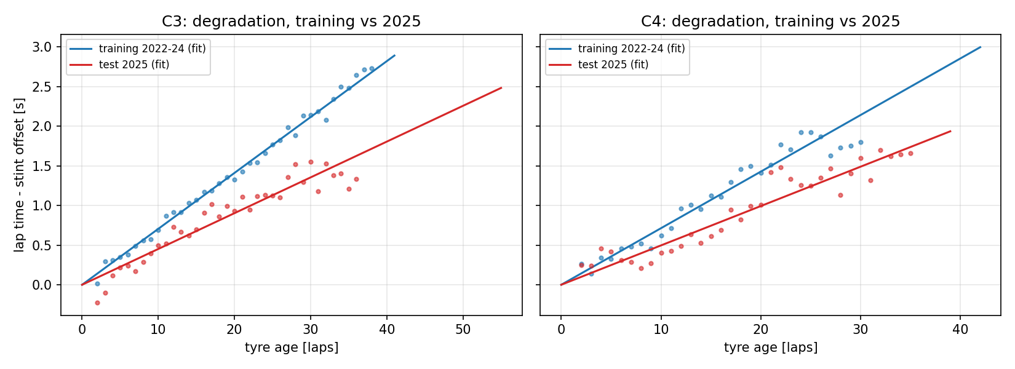
Figure 6. 2025 diagnosis: observed degradation (points, mean per tyre age after removing stint offsets) and fitted lines, training 2022–24 versus the 2025 test race. The 2025 slopes are 30–36% lower.
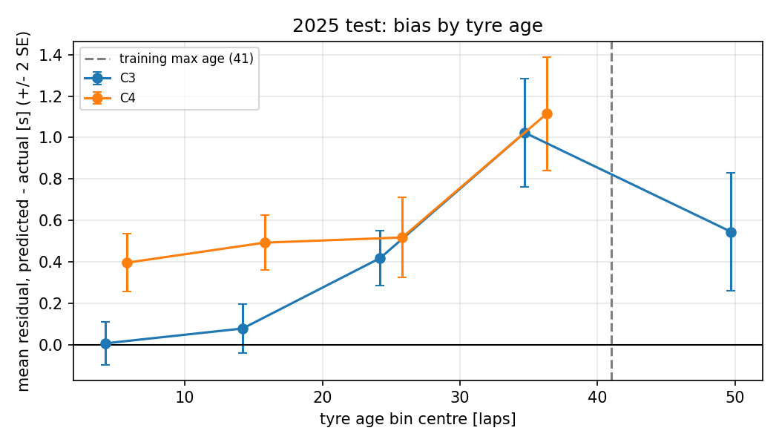
Figure 7. Mean 2025 test residual by tyre-age bin (±2 SE). C3 grows with age (slope too steep); C4 is already +0.4 s at young ages (anchor effect).

4.2 Leakage, constraint and reproducibility audit
An audit stage (D90) re-checks the real results on every pipeline run and stops the run if a check fails. All 14 checks pass: training and test races are disjoint; the selection was fitted without 2025 and frozen and committed before the test (git ancestry); each race is cleaned and fuel-corrected independently; anchor laps are never scored (1,730 scored, 261 anchor, overlap 0); the training races alone imply k_fuel = 0.0452 s/lap. For the strategy, every ranked strategy obeys the stint limits and the two-compound rule, its time matches an independent stint-by-stint sum within 1e-6 s, and an exhaustive search of every stint split confirms the best one-stop and two-stop and shows that the best three-stop race (5935.14 s) is slower. Two consecutive runs reproduce all 52 result files byte for byte, and so does a fresh clone from GitHub that downloads the data from scratch.

5. Alternative solutions and comparison
Table 7. Alternatives considered and the evidence behind each choice.
Decision | Alternatives compared | Evidence | Choice
Degradation model | baseline, polynomial 1–3, wear ODE, KNN (12 settings) | CV RMSE within 1 SE; bias; physical checks (Table 3) | polynomial degree 1: simplest, accepted
ODE solution in the fit | Euler, Heun, RK4, RK45, exact | cost to reach 1e-8 s: RK4 256, RK45 103 f-evals; exact 0.009 ms | RK4 (1-lap steps), verified against exact each fit
Least-squares solver | normal equations (mine), QR, SVD | degree 6 unscaled: 3.6e-9 / 5.1e-13 / 1.7e-10 rel. error; scaled: all ≤ 2.3e-13 | normal equations + input scaling
Root finder for b | bisection, secant, Newton | 21 / 5 / 3 iterations, identical a and b | bisection (guaranteed bracket)
One-stop optimiser | brute force, secant, Newton | 6 / 9 / 18 evaluations with limits; 69 / 12 / 21 without | brute force reference; secant 5.9× faster unconstrained
KNN search | brute force (mine) vs kd-tree | same predictions; time ∝ n^1.07 vs n^0.23; 270 MB vs 1.4 MB at n = 16,000 | brute force (exact, simple; data small)
Data source | F1 TV + FastF1 pre-release, free data | free sources reproducible by anyone | FastF1 mirror + OpenF1

6. Strategy results
With the 2023–2025 refit (C3 0.0597 s/lap, C4 0.0551 s/lap), the best strategy for the 70-lap race is two stops, C3 → C4 → C4 with stops after laps 21 and 45: 5926.50 s, 4.33 s faster than the best one-stop (pit lap 35, 5930.83 s). For the one-stop, the relaxed optimum dT/dL = 0 lies at lap 32.89, but the C4 stint limit (35 laps) moves the feasible optimum to lap 35: the data-coverage rule, not the physics, sets this pit lap (C5, C9). Brute force, secant and Newton agree. Several two-stop orders tie because the race-time curve is flat near the optimum (C6).
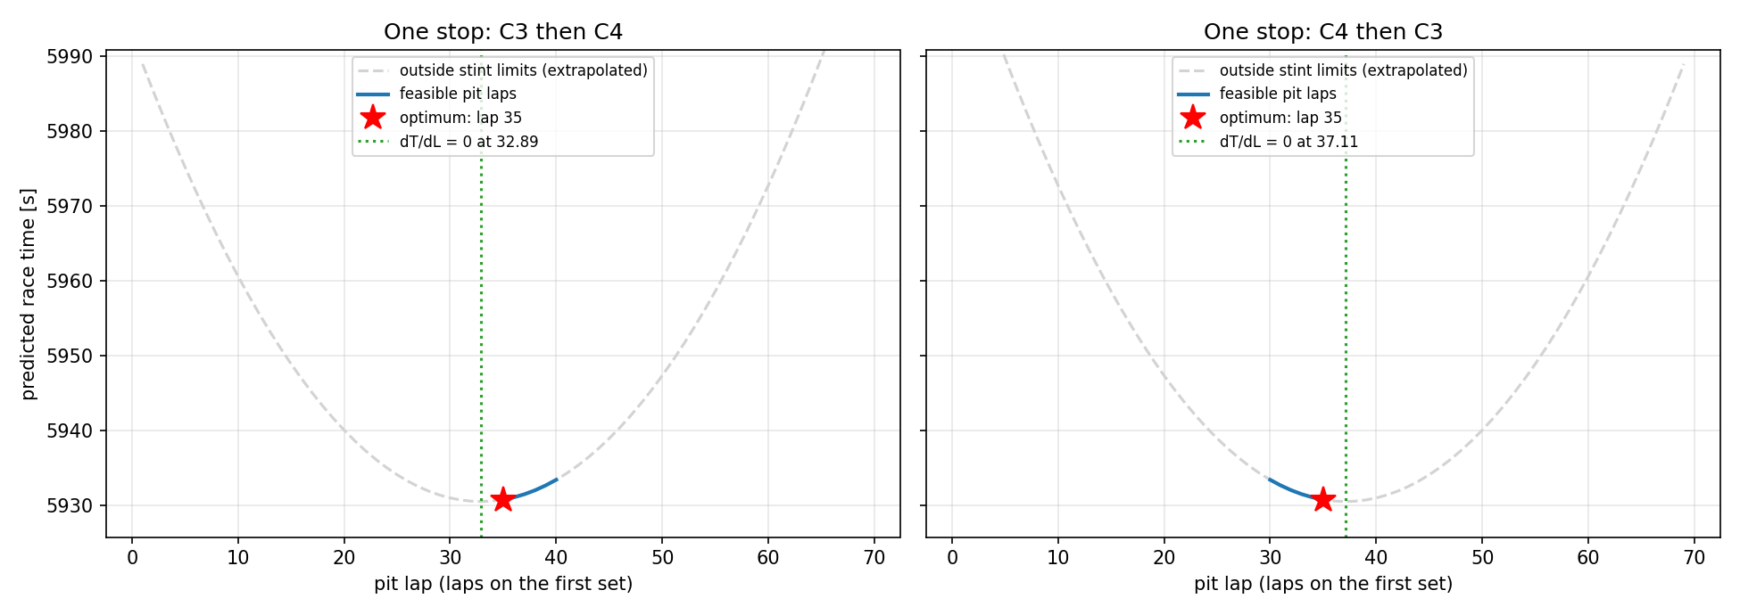
Figure 8. Predicted race time against pit lap for both one-stop orders: grey = outside the stint limits (extrapolated), star = optimum (lap 35), green = continuous root of dT/dL (lap 32.89).
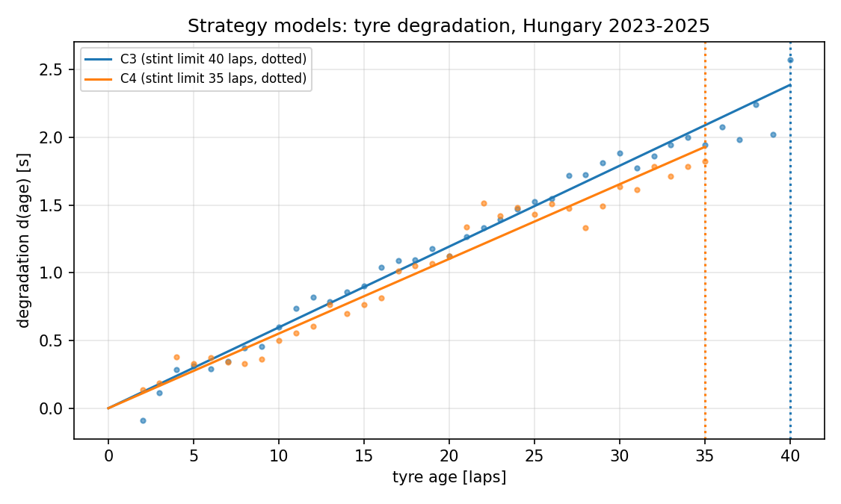 | 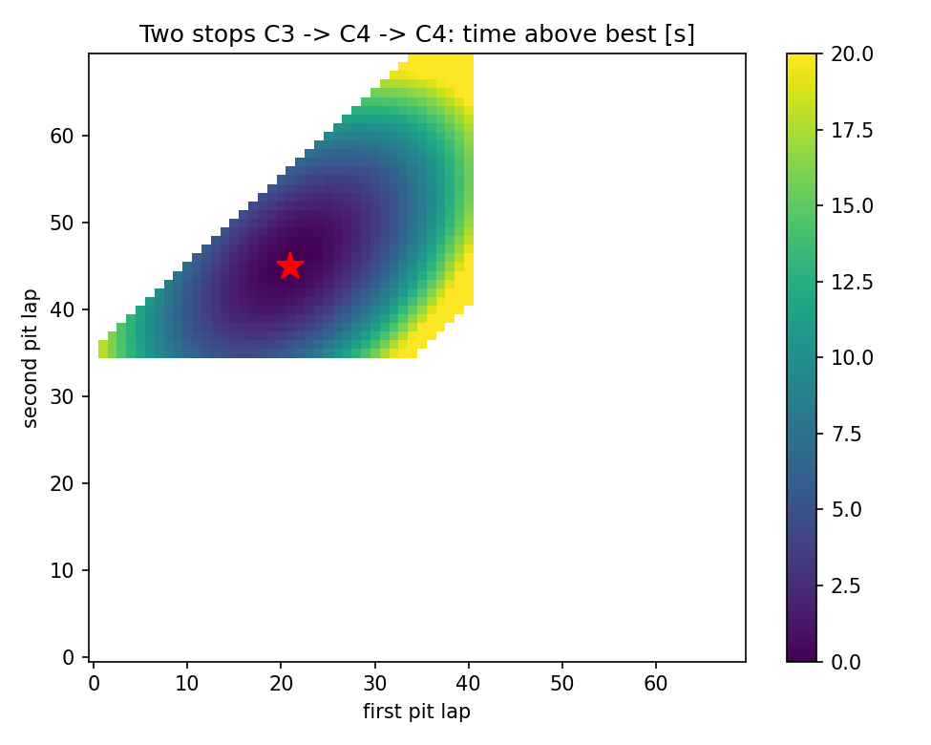
Figure 9. Left: the degradation models used by the strategy, with the observed data and the stint limits (dotted). Right: two-stop race C3 → C4 → C4, time above the best for every pair of pit laps; the star marks laps 21 and 45, white cells break a stint limit.

7. Sensitivity analysis
Each uncertain input was varied alone over a physically motivated range (D67), and local coefficients were computed with central differences at a 1% step, checked at 0.1% and 10% (D68). Exact checks confirm the method: d(one-stop time)/d(C3 rate) = 630 = 35·36/2 and d(margin)/d(pit loss) = −1. Bisection gives the break-even values where one and two stops are equal: pit loss 25.22 s (outside its IQR, so it cannot flip the decision) and k_fuel 0.0333 s/lap (inside its plausible range, so it can). Year-to-year wear also flips it: in a 2025-like low-wear year the one-stop wins by 1.27 s. Within a stint, lap number and tyre age rise together, so the fitted wear rate changes one-for-one with k_fuel (d rate/d k_fuel = 1): fuel and wear cannot be separated, and the k_fuel derivatives depend on the step size (1149 / 1158 / 745 s per unit at 0.1 / 1 / 10%), so they are reported as indicative only (C8).
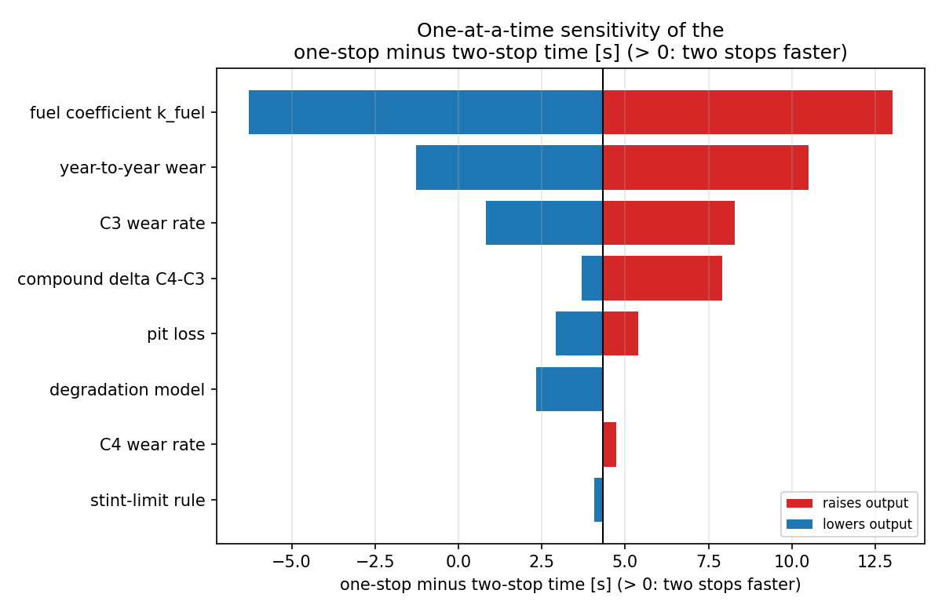 | 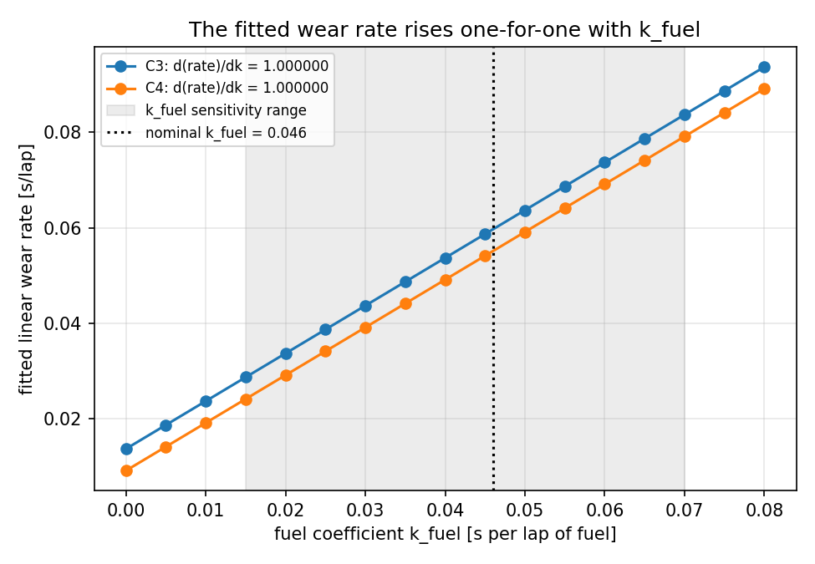
Figure 10. Left: tornado plot of the two-stop advantage (one-stop minus two-stop time, nominal +4.33 s); only the fuel coefficient and year-to-year wear can make it negative. Right: the fitted wear rate rises exactly one-for-one with the fuel coefficient, so fuel and wear cannot be separated.

8. Performance and optimisation
Timings use repeated runs whose repeat length is calibrated to at least 10 ms (7 repeats, minimum reported), memory uses tracemalloc, and FLOPs are counted per step: Euler f + 3, Heun 2f + 7, RK4 4f + 17 and one RK45 attempt 105 FLOPs for the wear ODE (f = 2). On the ODE benchmark RK4 reaches 1 ms-level accuracy with 16 f-evaluations, Euler needs 4096; RK45 reaches 1e-8 with 103. RK4 runs at only 1.35 MFLOP/s (4.6 µs per evaluation), so run time is dominated by Python overhead, not arithmetic, which is why the closed-form exact solution (0.009 ms) is used as the check. cProfile showed that the cross-validation’s prediction step took 67% of the compute time because it looped over every held-out stint. Vectorising it (one model call and numpy.bincount for the anchors) cut the pipeline from 2.16 ± 0.04 s to 1.75 ± 0.02 s (1.23×) with identical results (max difference 5.6e-16, tolerance 1e-12 s, enforced by a test). The profiler had suggested a larger gain because it adds overhead to every small call (C14).
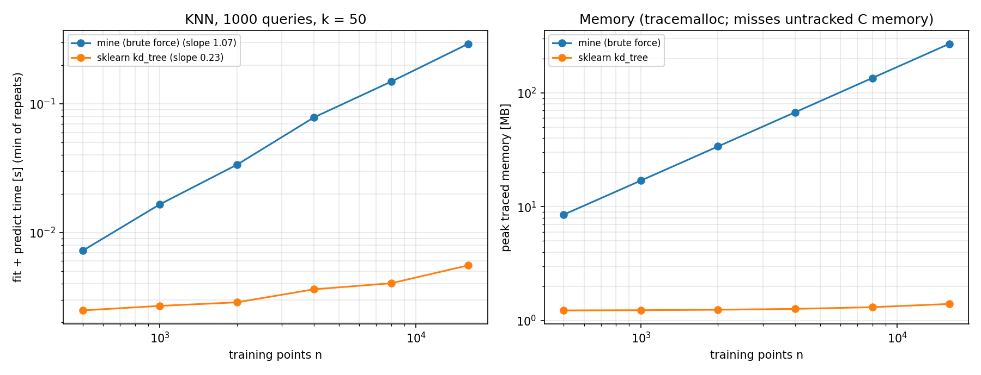
Figure 11. KNN scaling: run time and memory against training-set size; my brute-force search grows linearly (exponent 1.07), scikit-learn’s kd-tree sub-linearly (0.23), with identical predictions.
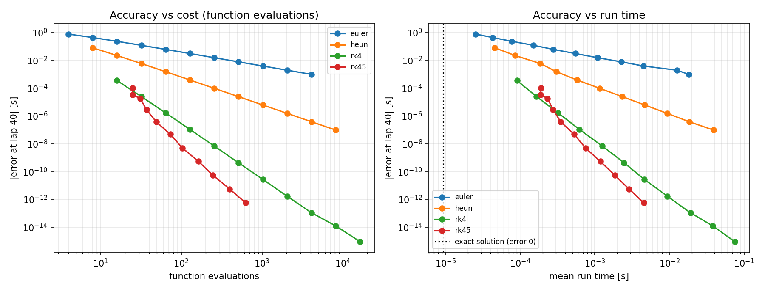
Figure 12. Accuracy against cost for the ODE solvers: error versus function evaluations (left) and versus run time (right).

9. Challenges and how they were resolved
Every problem was logged when it happened, with how it was detected, its root cause and its resolution (CHALLENGES.md; Phase 1–5 problems are recorded in DECISIONS.md). Table 8 lists all of them; the numbers in brackets are the log entries.
Table 8. All challenges met during the project, with root cause and resolution.
# | Challenge | Root cause | Resolution / lesson
1 | F1 timing archive locked (OI-1, D14) | from mid-October 2026 the archive requires an F1 TV login; FastF1’s free mirror has 2021–22 only | FastF1 2022 + OpenF1 2023–25 in one unified table; every response cached
2 | OpenF1 refused requests (D15) | HTTP 429 when too fast; HTTP 401 during live F1 sessions | 0.4 s delay, retries with back-off, clear error for live sessions, disk cache
3 | Scope changed three times (D4, D6, D52) | Bahrain had no Red Bull HARD laps (2022) and no MEDIUM laps (2023–24); one team gave too few stints | data surveys; select by Pirelli C-number; Hungary C3 (+ C4), all teams with per-stint offsets
4 | Fuzzy event matching (D7) | FastF1 silently returned the Australian GP for an invented event name | the loader compares the resolved name and raises RaceNotFoundError
5 | YAML read 1.0e10 as text (D38) | YAML needs a sign in the exponent | write 1.0e+10; config.py rejects text values
6 | Stopping rule never stopped (D30) | requiring step AND residual small fails when the floats nearest the root still give |f| > ftol | round-off safeguard |step| ≤ 4·eps·|x|; flat and steep cases tested
7 | Compound pace hidden (C1) | per-stint offsets absorb compound pace as well as car pace | estimate the compound delta separately
8 | Delta said C4 slower than C3 (C2) | 35 of 43 driver-races ran C4 first: stint order confounded with compound | order-balanced delta −0.080 s, range −0.32 to +0.15 s in the sensitivity
9 | Doctest placeholders (C3) | comment-only examples are not valid doctests | real examples; doctests run with every test suite
10 | Test fixture wrongly constrained (C4) | the test fixture’s stint limit, not the code, rejected the stints | fixture fixed; confirms the limit is enforced everywhere
11 | One-stop optimum pinned (C5, C9) | the C4 stint limit (35 laps) is below the relaxed optimum | report the active constraint; pit lap set by data coverage
12 | Flat curve, tied strategies (C6) | race time changes little near the optimum | ties reported as ties; margin compared with input uncertainty
13 | No feasible one-stop (C7) | with a ≥ 10-lap rule the limits sum to 67 < 70 laps | infeasible scenarios handled explicitly; a genuine finding
14 | Step-dependent derivatives (C8) | outputs pass through medians and an integer optimum (not smooth) | step-size check at 0.1/1/10 %; k_fuel derivatives marked indicative
15 | Figure title cut off; bad edit (C10) | long title; a shell edit inserted a literal newline | title shortened; no escape-interpreting edits
16 | Hand-counted FLOPs wrong (C11) | an expected doctest value was typed, not computed (104 vs 105) | only computed values are used as expected results
17 | Noisy timings (C12, C13) | 20–100 µs calls are at the scale of OS jitter | repeats calibrated to ≥ 10 ms; report the minimum; conclude only from ≥ 2× differences
18 | Profiler overstated gain (C14) | cProfile adds overhead to every small call | speed-up confirmed with plain timings (1.23×)
19 | Disk-cache effect on I/O timing (C15) | the operating system caches files after the first read | warm time reported; data loading excluded from the optimisation
20 | Frozen selection overwritten (C16) | a verification re-run of the CV stage rewrote model_selection.json after the test | restored from git; guard refuses a CV re-run after the test unless forced
21 | Local paths leaked (C17, C19, C20) | profiler, pdoc and pytest-html wrote absolute paths with the user name | relative paths, all artefacts scanned, git history rewritten (D92)
22 | Last-digit differences (C18) | vectorised sums in a different order change round-off (≤ 6.1e-16) | results regenerated; ‘same result’ always stated with a tolerance
23 | Cleaning report showed 0 laps (C21) | the ‘input’ row has removed = 0 by definition | laps loaded, removed per rule and kept, which now add up
24 | 126 incomplete docstrings (C22) | rule not checked automatically while coding | review script → 0 gaps; 18 functions given input checks with 49 tests
25 | Stale docstring (C23) | a Phase 2 note contradicted the later strategy decision D58 | corrected; audit check B9 explains why it is not leakage
26 | Reproducibility check skipped in a clone (C24) | git on Windows checks text files out with CRLF, changing the hashes | text hashes ignore line endings; fresh clone reproduces all 52 files
27 | 2025 test bias criterion failed (D89) | 2025 wear 30–36 % lower; slow anchor laps for C4 | exact bias decomposition; 2023–25 refit; year scenarios in the sensitivity

10. Limitations and lessons learned
- One circuit and two compounds. The parameters do not transfer to other tracks; four races give only three CV folds and one test race.
- Year-to-year change dominates. The test bias and the negative test R² (−0.04 C3, −0.47 C4) come from a season with 30–36% lower wear; cross-validation within past seasons cannot detect this, and the strategy decision can flip with the year.
- Fuel and wear are confounded. One k_fuel for all races, which also contains track evolution; the two-stop decision flips below 0.0333 s/lap.
- Not modelled: track temperature, weather, car set-up, driver, traffic and dirty air, tyre warm-up, safety cars, tyre-set availability and used tyres.
- Lessons: select data by the physical quantity, not the label; protect the test set in code; decompose a bias before explaining it; report active constraints with the optimum; check numerical derivatives for step-size dependence; never trust an expected value that was not computed; and check every generated file before publishing it.

11. AI-use reflection
Table 9. AI-use reflection (also in the repository README).
Item | Statement
Tool | Claude Code (Anthropic), VS Code extension, model Claude Opus 5.5, used for the whole project.
Contribution | The AI wrote essentially all of the code, the 940 tests and the first drafts of the documentation and this report, and ran every analysis. My contribution was the project specification and working rules, every Phase 1–5 decision, the questions that changed the analysis, and the review of each phase before it was committed.
Why and how | Writing every method from scratch with tests is a large amount of code. To keep control of the engineering, I required the AI to list every decision with options, a recommendation, evidence and a validation plan, and to stop until I approved or changed it (Phases 1–5). For Phases 6–9, I let it decide, with every such decision marked ‘to be reviewed by me’ in DECISIONS.md.
My decisions | Data surveys of every track and compound before choosing Hungary/C3 (later + C4); all teams instead of Red Bull; free data only; a step-size study for the optimal finite-difference step and comparisons of alternative methods; the 1e12 conditioning threshold; the Phase 2 cleaning options; approving the root-finder safeguard after my first choice failed; questions on track temperature and missing wear factors; how to respond to the failed test criterion; public repository with history rewrite.
Verification | Benchmarks against SciPy, scikit-learn and analytic solutions with orders of convergence; withheld-race test behind a code firewall; leakage and constraint audit with an independent exhaustive search; byte-for-byte reproduction from a fresh GitHub clone; I read each phase summary of assumptions and uncertainties before approving, and asked for explanations (e.g. the IQR, the purpose of a validation test).
AI errors | Unverified doctest values (C3, C11); a re-run that overwrote the frozen selection (C16); local paths leaked three times (C17, C19, C20); 126 incomplete docstrings against the project’s own rule (C22); a stale docstring (C23); a first stopping rule that could fail to stop (D30).
Effect on learning | The decision protocol made the AI explain options that I had to choose between, which is how I learned why central differences beat forward differences, why the normal equations lose accuracy with conditioning, and why within-season cross-validation cannot detect a season change. Its mistakes taught me that plausible output is not verified output.

12. Conclusion
Tyre degradation at the Hungaroring is well described by a straight line in tyre age once fuel, pit laps and non-green laps are removed and each stint has its own base pace: cross-validated RMSE 0.63 s (C3) and 0.85 s (C4), with no gain from polynomial, ODE or KNN models. On the withheld 2025 race the model still beat the baseline but over-predicted wear, which the audit traces to a 30–36% lower 2025 wear rate (and, for C4, slow first laps). The verified optimum for a typical car is a two-stop C3 → C4 → C4 race, 4.33 s faster than one stop, but this advantage reverses for a fuel coefficient below 0.0333 s/lap or in a low-wear season. The value of the work lies as much in the verified numerical toolkit, the honest test and the audit as in the strategy itself.

References
Dormand, J. R. and Prince, P. J. (1980). A family of embedded Runge–Kutta formulae. Journal of Computational and Applied Mathematics, 6(1), 19–26.
Efron, B. and Tibshirani, R. J. (1993). An Introduction to the Bootstrap. Chapman & Hall.
Sen, P. K. (1968). Estimates of the regression coefficient based on Kendall’s tau. Journal of the American Statistical Association, 63, 1379–1389.
FastF1 documentation. https://docs.fastf1.dev/ ; OpenF1 API. https://openf1.org/ (accessed October 2026).
Pirelli press: 2022 Hungarian Grand Prix preview, https://press.pirelli.com/2022-hungarian-grand-prix---preview/ ; Tyre news and nominations for Hungary and Belgium (2023), https://press.pirelli.com/tyre-news-and-nominations-for-hungary-and-belgium/
Formula1.com: What tyres will the teams and drivers have for the 2024 / 2025 Hungarian Grand Prix (URLs in reference/pirelli_allocation.csv).
SciPy, scikit-learn and NumPy documentation (used as benchmarks only).
Monash University. MMA3001 Numerical Methods and Machine Learning — Project Brief (2026).

Appendix A. Remaining figures
All 24 figures are regenerated by one run of scripts/run_pipeline.py; the figures not shown in the main text follow.
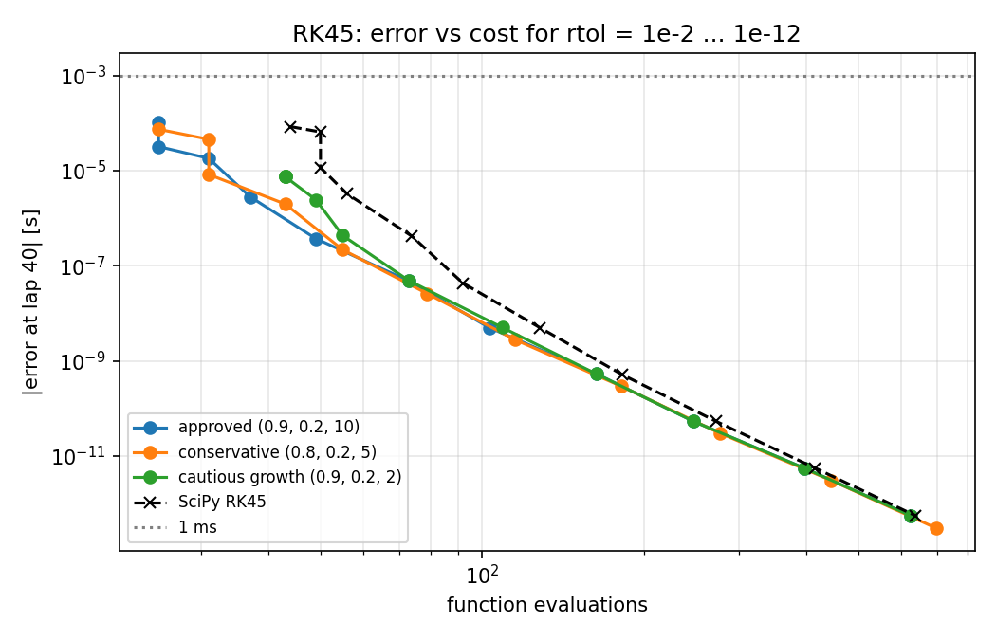 | 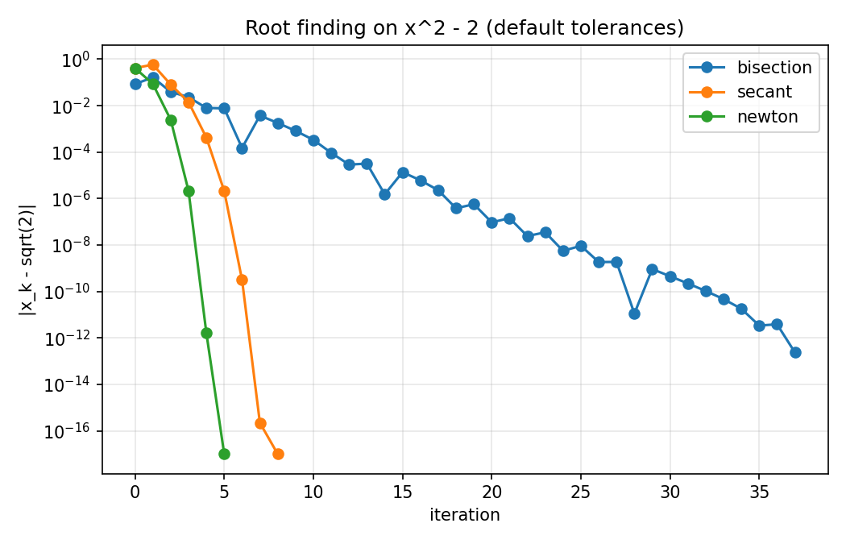
Figure 13. Left: my RK45 (three step-size controllers) against SciPy’s RK45, error against function evaluations for rtol 1e-2 to 1e-12. Right: bisection, secant and Newton on x² − 2 with the default tolerances, error against iteration (linear, super-linear and quadratic convergence).
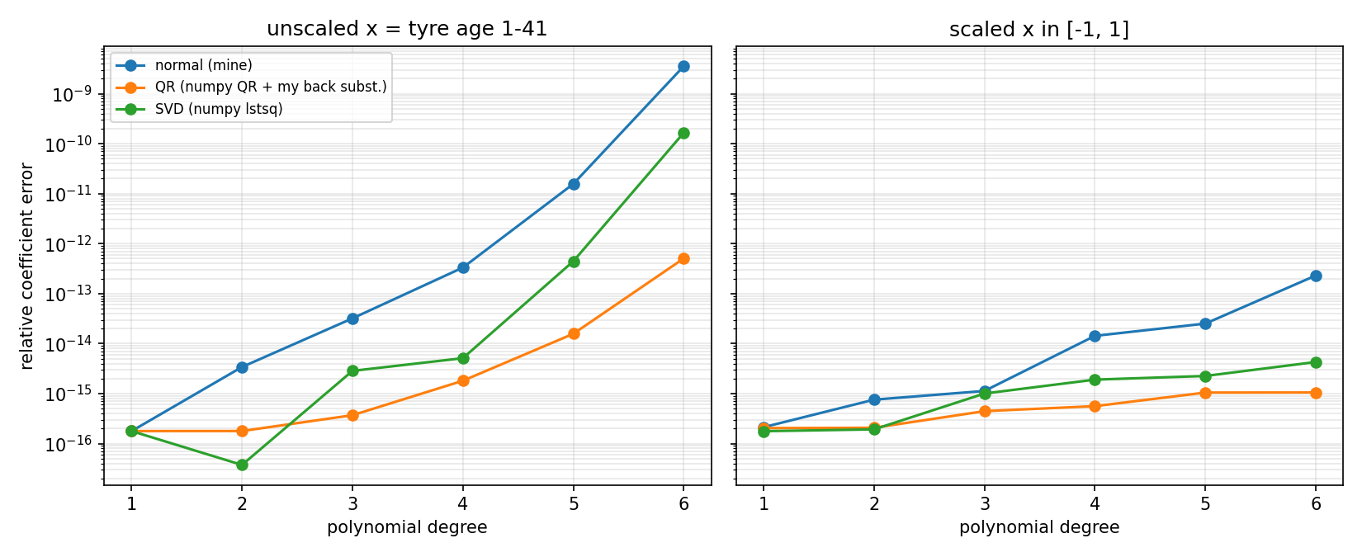
Figure 14. Least squares: relative coefficient error against polynomial degree for the normal equations, QR and SVD, with and without input scaling.
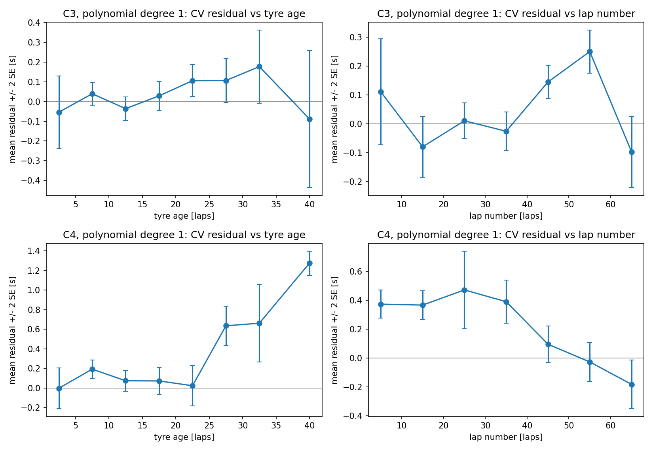
Figure 15. Cross-validation residuals by tyre age and lap number (leftover fuel effect check).
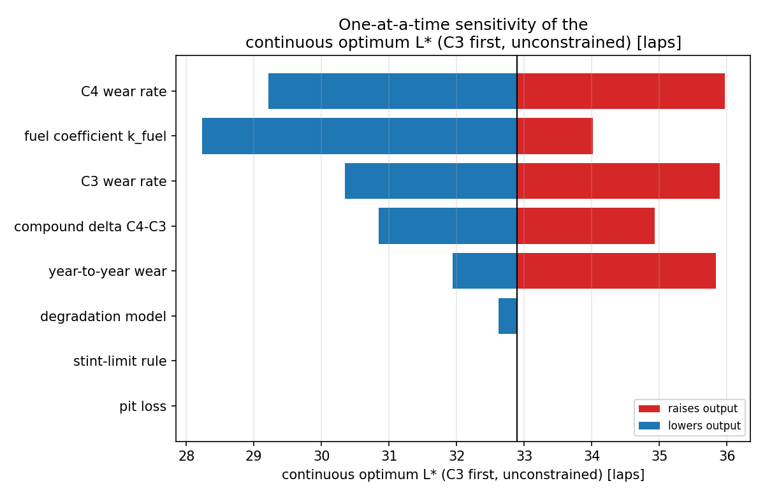 | 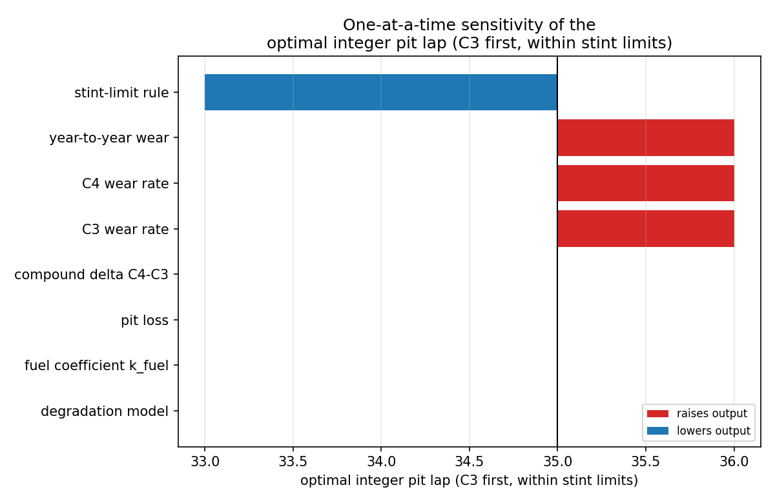
Figure 16. Tornado plots for the continuous optimum L* (left) and the integer pit lap (right), which the stint limit pins at 35–36.
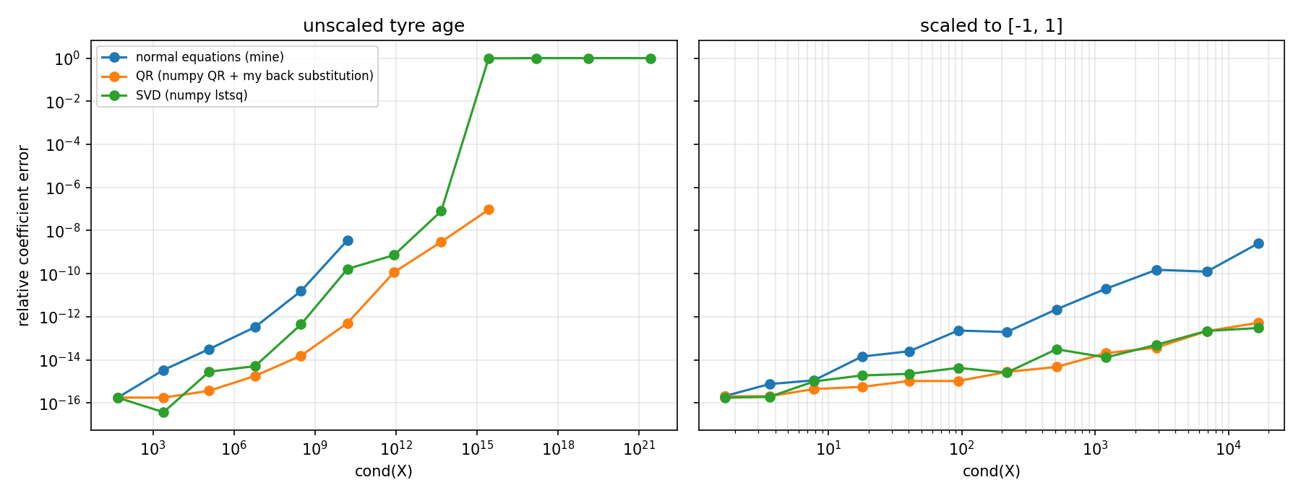
Figure 17. Least squares, degrees 1–12 on tyre ages 1–41 (Phase 8): relative coefficient error against cond(X). Unscaled (left), my normal equations refuse as singular from degree 7 and QR from degree 10, while SVD (lstsq) never refuses but is silently 98–100% wrong from degree 9. Scaled to [−1, 1] (right), every method stays accurate.

