# Process Mining

## Alpha Miner

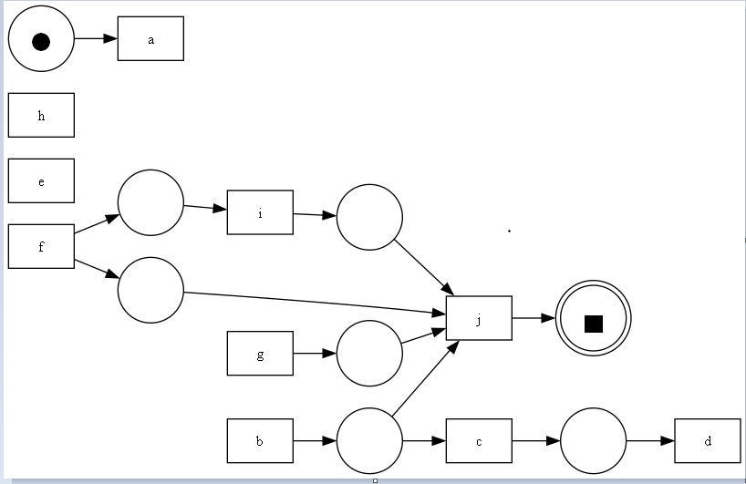

## Alpha Miner Petri Net

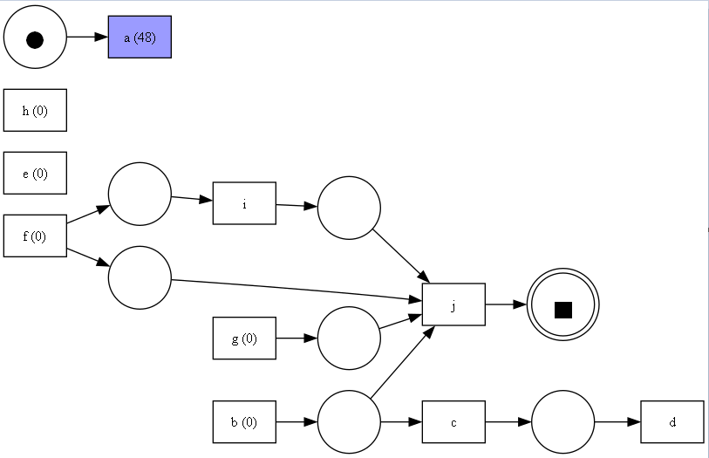

## Alpha Miner Discovery Graph on basis of Frequency

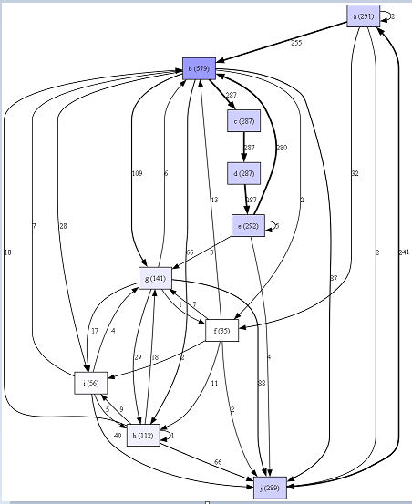

## Alpha Miner Discovery Graph on basis of Performance

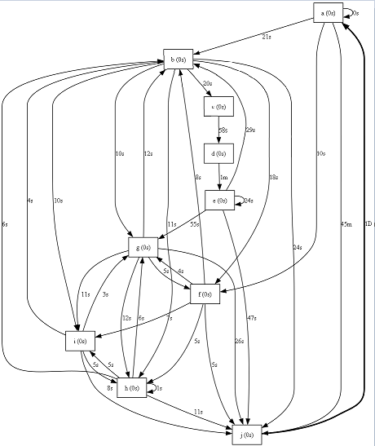

Heuristic Miner

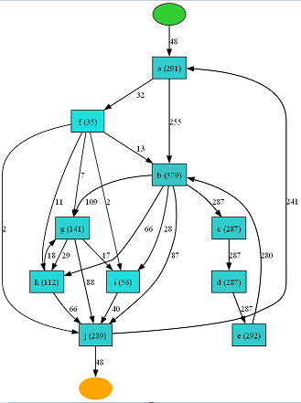

Heuristic Miner Petri Net

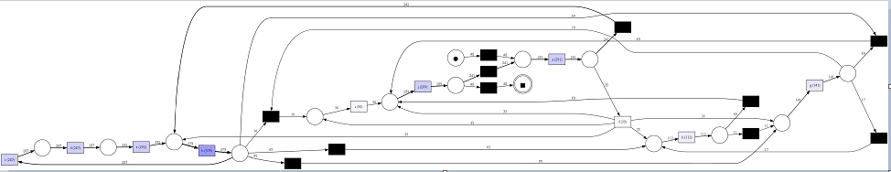

Inductive Miner

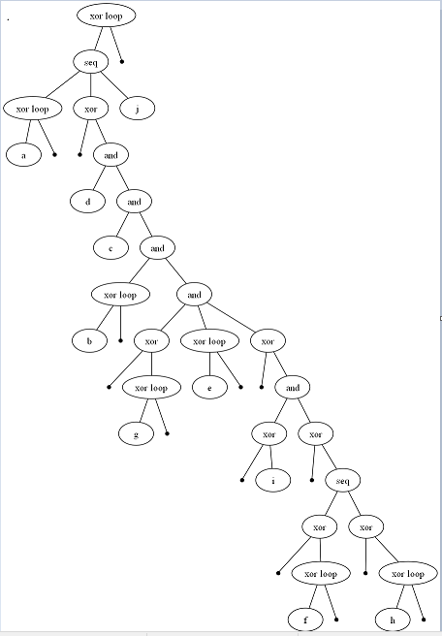

Inductive Miner Petri Net

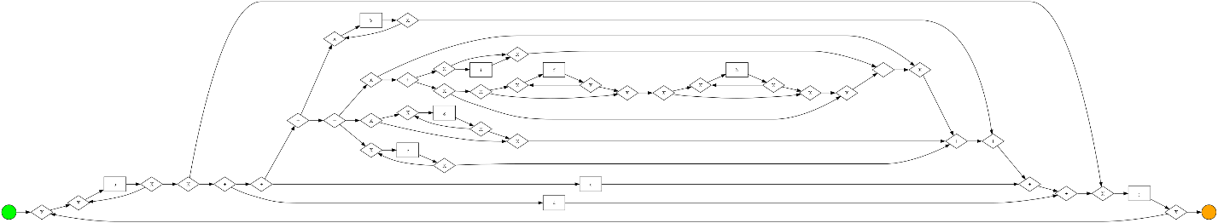

Inductive Miner BPMN Model

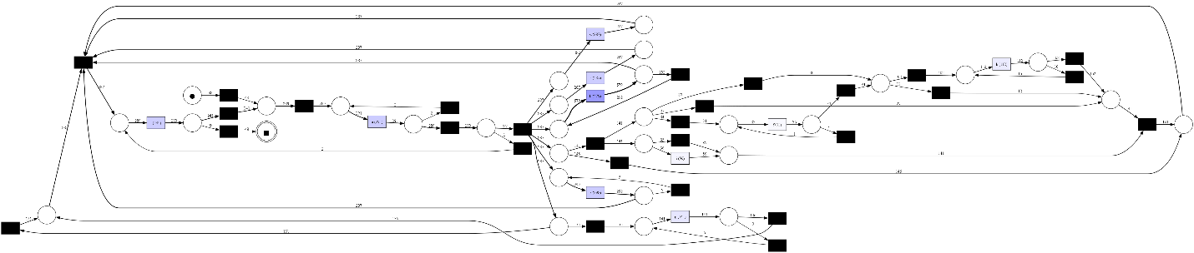

Network Analysis

