# Implementation of Generalized Sequence Pattern Algorithm

&

# Clustering and Analysis of Results

## Clusters of Students on basis of Sequence of Activities

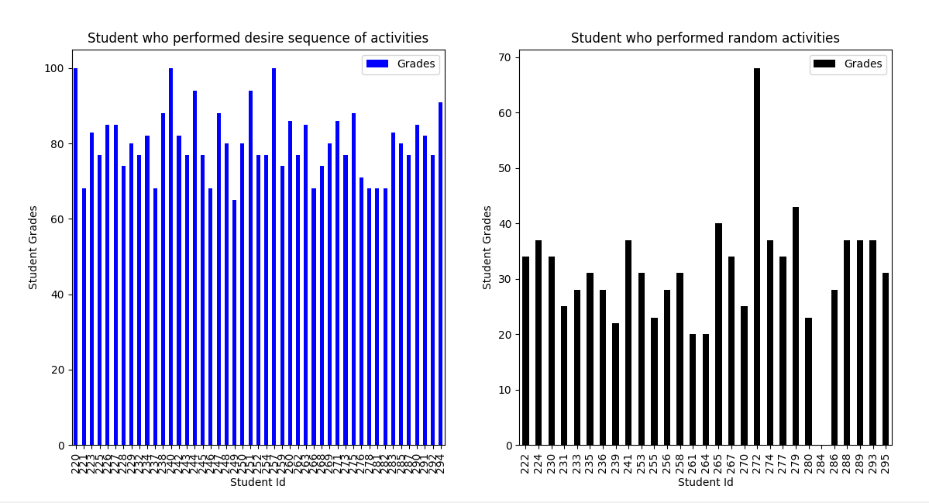

## Students Count in Each Cluster

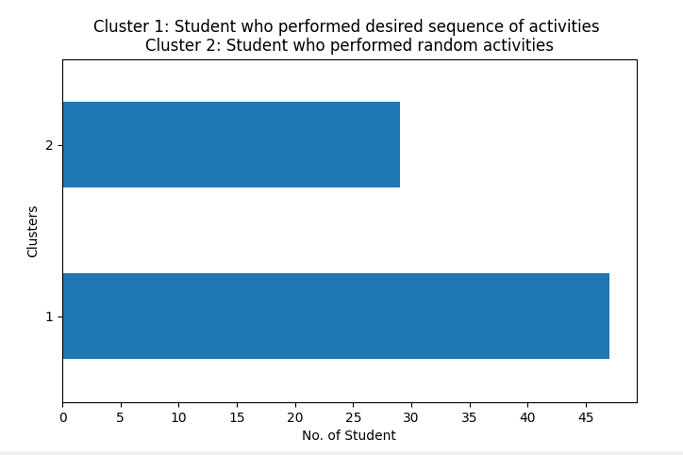

Comparison and Distribution of Students in both Clusters on basis of Sequence of Activities and Grades

