# Process Discovery – low performers

## Alpha Miner

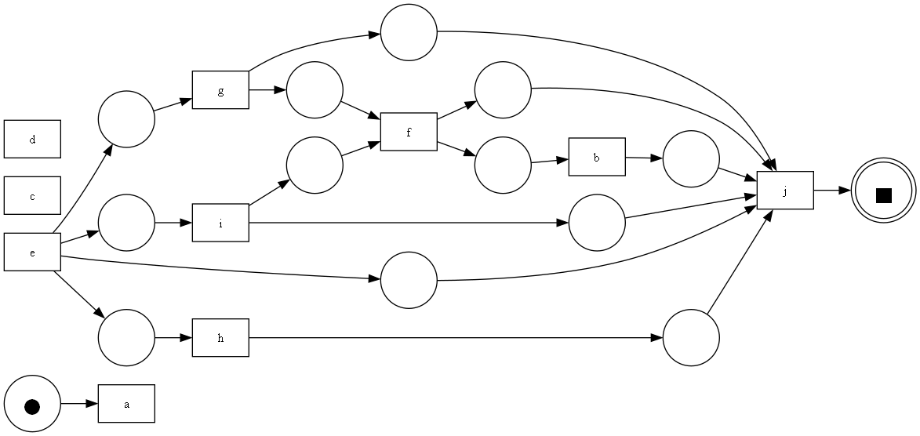

## Alpha Miner Petri Net

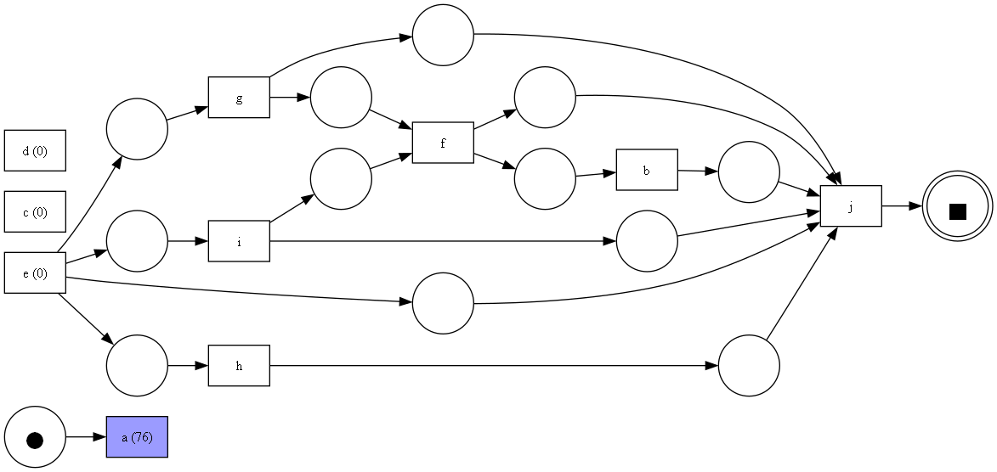

Inductive Miner

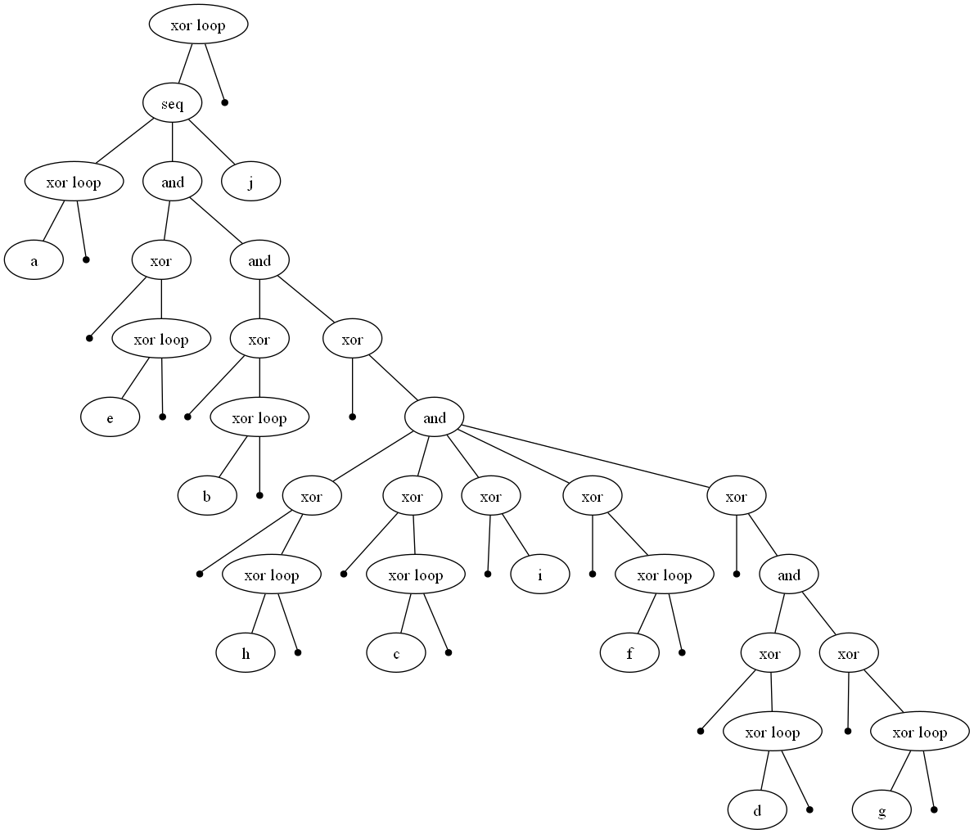

Inductive Miner Petri Net

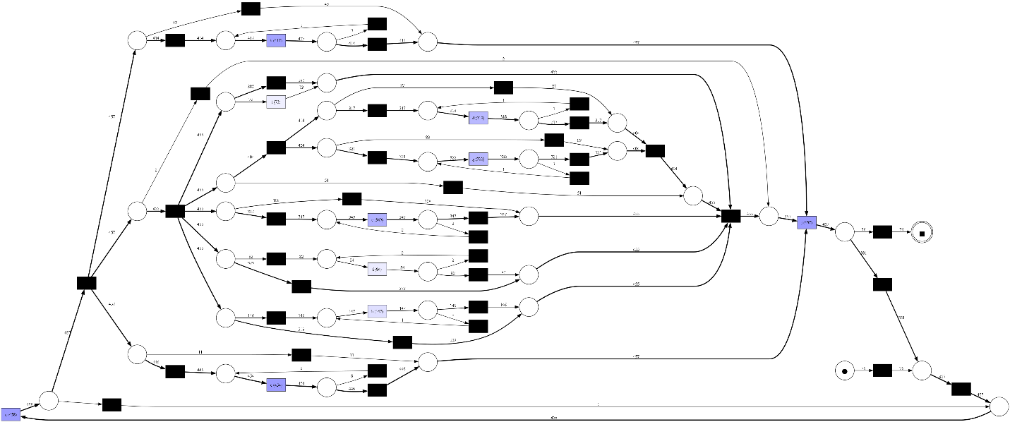

Heuristic Miner

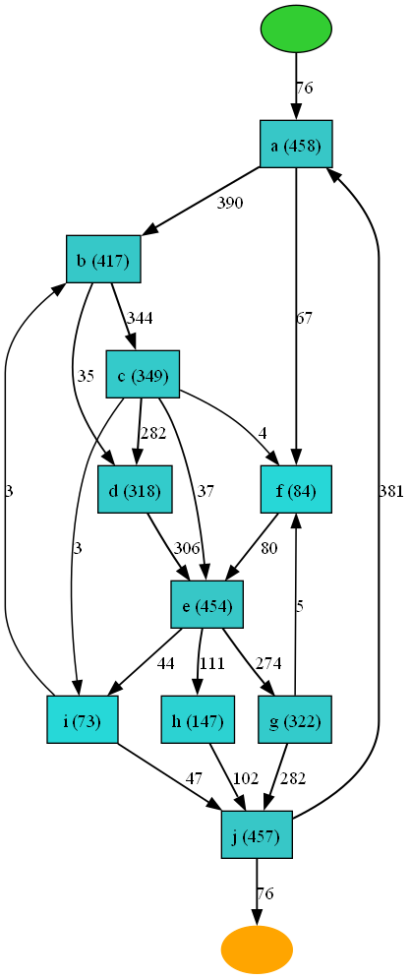

Heuristic Miner Petri Net

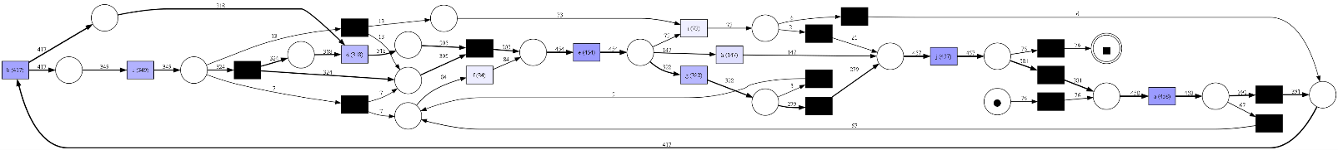

ILP Miner Petri Net

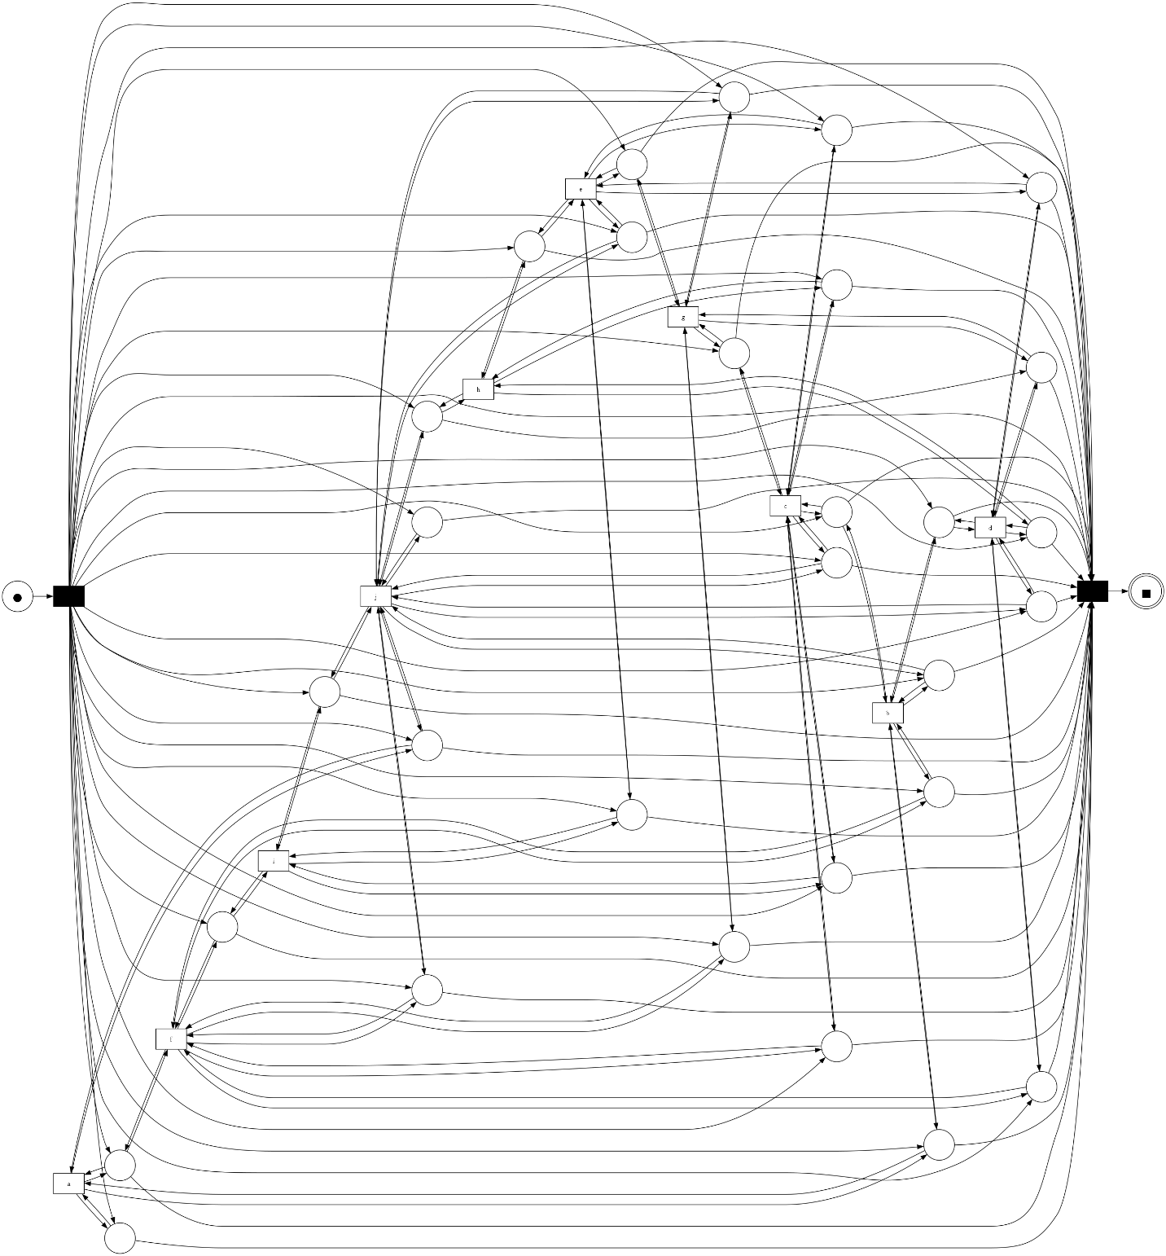

# Conformance Checking