

# Fortis Health Care.

**.**

Okhla Road,

New Delhi - 110 025 (INDIA)

Contact: +91-11-47135000

Fax: +91 11 2682 5013

.

[EMail-tactus.escorts@fortishealthcare.com](mailto:EMail-tactus.escorts@fortishealthcare.com)

# MEDICAL CERTIFICATE

|  |  |
| --- | --- |
| **Name Age/Sex Date**  **Reg. No.** | **: . Aakarsh Veer**  **: . 18/Male**  **: . 17/082023**  **: . 7622945** |

I, hereby certify that.

* That the patient was admitted in the hospital on my advice;
* That the patient has been under treatment in the Fortis Escorts Health

Care and that the

Under mentioned medicines are prescribed by me in the connection were essential for the

Recovery/prevention of the serious deterioration in the condition of the patient;

Name of medicines

* Chloramphenicol(Chloromycetin)
* Amoxicillin (Trimox, Anoxia, Biomox)
* Ciprofloxacin (Cipro)

1. That the injections administered were / were not for immunizing or prophylactic

Purposes;

1. That the patient is / was suffering from Typhoid and is / was under treatment

From 17/08/2023 to 09 / 09 / 2023

***Kindly correlate clinically***

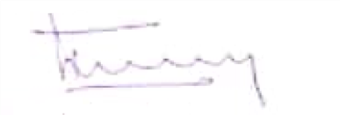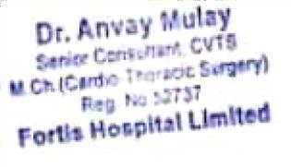

**Dr. Anvay Mulay**

**Senior Consultant-CVTS FORTIS HOSPITAL LIMITED**



**Reg. Office** OPD CITY CENTRE, SCD 11, Sector 11D, Chandigarh-160-011, INDIA **Ph.**

{0172}506122, 5055422