Preliminary analysis of worry about covid19

Reka Solymosi

03/06/2020

# Prevalence of worry

When asked the question “In the past 3 weeks, have you ever felt worried about getting COVID-19?”, 36% of people said that “No”, they had not felt worried about getting COVID-19 in the past 3 weeks.

Those who said “Yes” they experienced a specific instance of worry vary in the frequency and intensity of these events. 32% of these worried people only experienced worry “Once or twice” in the last 3 weeks, while 20 worried more than 10 times in this timeframe:

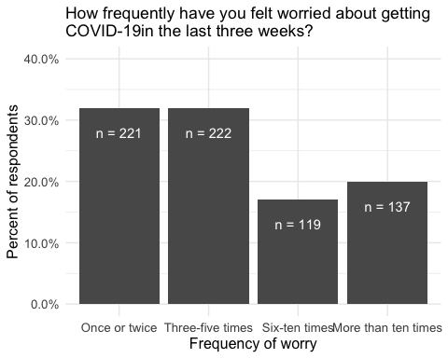

# Functional fear

Criminological work has found that, while some instances of worry can be destructive and paralysing, some people and some communities have the potential and the willingness to convert worry about crime into constructive action. In our study, the majority of people say ‘yes’ (91%) when we asked ‘do you take any precautions against getting Covid-19?’.

Based on their worries about catching the virus, as well as the self-reported effect of their worries, we can divide research participants into one of three groups:

* The ‘unworried’ group (36%): those who had not worried once about catching Covid-19 over the previous three weeks; precautions against the virus;
* The ‘worried but well-being unaffected’ group (32%): those who had worried, and quality of life was not affected; and,
* The ‘worried and well-being affected’ group (31%): those who had worried, took precautions, and quality of life was affected.

We can now use this classification to explore the effect of fear of COVID-19 on other behaviours and attitudes, while accounting for it’s more complex nature.

# Demographic variation in worry about covid19

## Race/gender

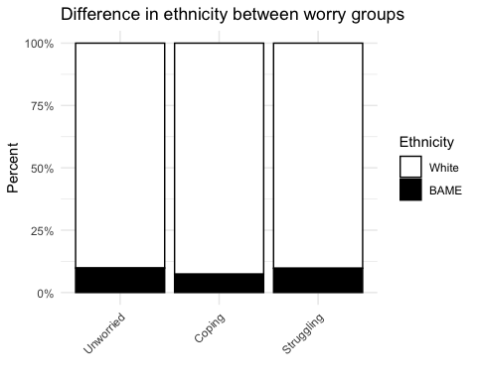

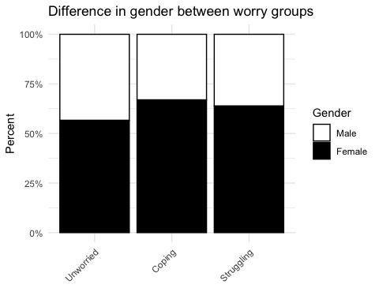

## Key workers

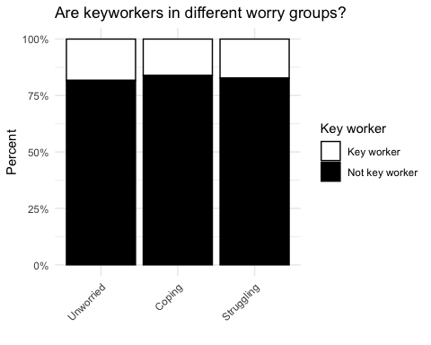

# Mental health outcomes between worry groups

## Thinking about how you felt yesterday, overall, how strongly did you feel the following emotions?

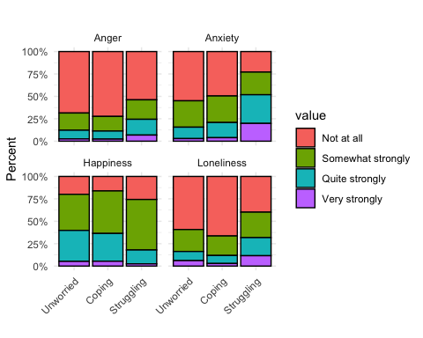

## Overall, how satisfied are you with your life nowadays?

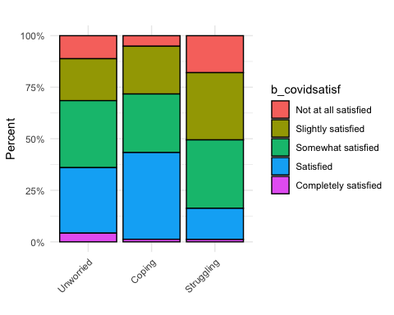

## Overall, to what extent do you feel that the things you do in your life are worthwhile?

