Blog Post

Reka Solymosi

23/05/2020

# Fear of COVID-19

Last week, [it was reported](https://www.thetimes.co.uk/article/coronavirus-boris-johnson-and-civil-service-chief-sir-mark-sedwill-clash-over-action-plan-g05tx5256) that Boris Johnson had made the quip: “I’ve learnt that it is much easier to take people’s freedoms away than give them back”. Much backlash has ensued, insinuating that the reason people are not returning to normal is [because they are cowing at home in terror](https://www.spiked-online.com/2020/05/20/the-lockdown-has-done-untold-damage-to-this-country/). Headlines broadcast that [Britons are more worried about COVID-19 than anyone else in the world](https://www.express.co.uk/news/uk/1278346/uk-coronavirus-news-cambridge-university-survey-covid-19-death-infection-rates) and that [people fear return to work will risk their family](https://www.theguardian.com/politics/2020/may/23/workers-fear-return-to-work-will-risk-their-family-gmb-survey-finds).

However “fear of” or “worry about” COVID-19 is not so one-dimensional as something which reduces people to shaky shut-ins who irrationally hide away from “taking back their freedoms”. Instead it can be understood as something which may motivate people to take reasonable measures that minimise the risks of the thing being feared.

We know from research on [fear of crime](https://www.tandfonline.com/doi/abs/10.1080/09627250802699673) that how people’s worry is definted and measured affects the types of conclusions that we may be able to draw about these constructs. In this post, we apply learnings from this vast body of knwledge around the fear of crime to better understand people’s fear of COVID-19. Specifically we aim to understand this as:

* something that people experience in certain situations and certain times, but not as an overwhelming characteristic
* something that may encourage people to act in ways that minimise their risk of exposure to COVID-19

# The study

Blabla

# Findings

## Overestimating worry with general questions

Worry about COVID-19 is likely to be a multifaceted experience that people have when they come accross something that evokes a specific feeling [1](https://onlinelibrary.wiley.com/doi/abs/10.1111/lcrp.12076). If we attempt to measure something like this with a general, catch-all type question, it is possible that we see misleading results. With fear of crime, when asked a question like “How worried are you about being burgled/mugged/raped/physically attacked by a stranger?” you tend to tap into people’s generalised anxieties, and overestimate the prevelance of fear [2](https://journals.sagepub.com/doi/pdf/10.1177/1477370808090834). On the other hand, if you ask more specific questions, which tap into the *frequency* and *intensity* with which these fear incidents are experienced, we might gain a more “true” insight into people’s experiences with fear of crime [2](https://journals.sagepub.com/doi/pdf/10.1177/1477370808090834).

We can see the same with asking people about their fear of COVID-19. When asked the question “In the past 3 weeks, have you ever felt worried about getting COVID-19?”, 36% of people said that “No”, they had not felt worried about getting COVID-19 in the past 3 weeks.

In contrast, when asked the more general question “How concerned are you about getting Covid-19?”, only 26% of them said they are “Not concerned at all” or “Not really concerned”. This leaves a difference of the 10%, which is 107 people who feel general concern/worry, but did not actually experience any incidences of worry in the past 3 weeks.

Even those who said “Yes” they experienced a specific instance of worry vary in the frequency and intensity of these events. 32% of these worried people only experienced worry “Once or twice” in this timeframe:

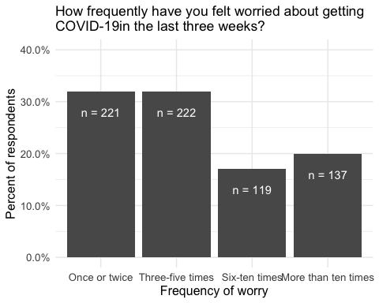

And the intensity of this worry varies as well. When asked: “On the last occasion, how worried did you feel?” 40% of people said they had felt only “A little bit worried”. (Also 4 people said they felt “Not worried at all” on their last occasion of worry, but I have no idea what to make of them…!)

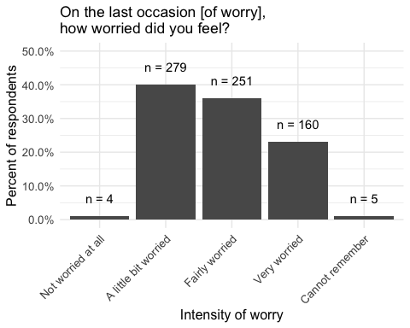

Evidently people experience worry about covid-19 differently, and summing them into one “worried” group masks a lot of variation in their experiences.

## Functional fear

The second point we make is that this fear does not necessarily have to be a paralizing force. Instead, it is possible that this fear serves a function in that it motivates vigilance and routine precautions.

In fact if we look at the relationship between experiencing worry in the last 3 weeks and taking precautions, we can see that those who said Yes to experiencing worry have 3 and a half times the odds of those who said no, that they will be taking precautions against Covid-19

## ### Cross-Tabulation, Row Proportions   
## #### b_foc_f * b_prec_f   
## **Data Frame:** data   
##   
## | | | | | |  
## |--------:|---------:|-------------:|-----------:|--------------:|  
## | | b_prec_f | Yes | No | Total |  
## | b_foc_f | | | | |  
## | Yes | | 665 (95.1%) | 34 ( 4.9%) | 699 (100.0%) |  
## | No | | 339 (84.5%) | 62 (15.5%) | 401 (100.0%) |  
## | Total | | 1004 (91.3%) | 96 ( 8.7%) | 1100 (100.0%) |

Of course for us to understand fear as functional, we must also consider whether it might impact on people’s quality of life. One of the main concerns about fear (whether of COVID-19 or crime) is that it can erode quality of life and well-being. If fear impacts on someone’s quality of life, it can no longer be considered functional[3](https://journals.sagepub.com/doi/full/10.1177/0004865820911994).

With this in mind, we can classify people into 4 groups:

**TO DO:** Name groups

* Group 1: Unworried (these people are not worried about covid-19)
* Group 2: Confusing people (Worried, don’t take precautions)
* Group 3: Functional worry (Worried, take precautions, quality of life is not affected)
* Group 4: Dysfunctional worry (Worried, take precautions, quality of life is affected)

In our sample we see there are

|  |  |  |
| --- | --- | --- |
| Worry Group | N | Percent |
| Group 1 | 312.16566 | 34 |
| Group 2 | 25.01059 | 3 |
| Group 3 | 316.68121 | 35 |
| Group 4 | 254.24473 | 28 |

We can now use this classification to explore the effect of fear of COVID-19 on other behaviours and attitudes, while accounting for it’s more complex nature.

For instance, we can take a look at the different types of precautions adopted by these different groups:

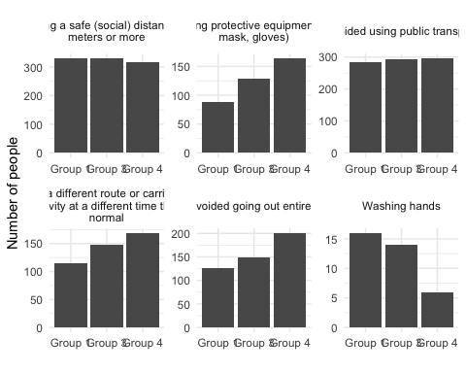

We see that while Group 1 are unworried, there are of course people in this group as well who take precautions.

The precautions recommended by government guidance, such as social distancing and avoiding transport are pretty uniform across groups, which makes sense as these are government recommended precautions.

However, the dysfunctional worry group take more precautions that go above and beyond these recommendations: wearing PPE, using a different route or travelling a different time, or avoiding going out entirely.

In some ways the easiest and least impactful precaution to take is to wash your hands. **NOTE: Annoyingly we didn’t actually ask this, but it came up in a free text other category, and this suggests that this is the one precaution that the other groups mention more, perhaps because the dysfunctional fear group do the other things so much more that this doesn’t feature. BUT I’m not sure we can actually use this, because it’s got a low n, because people had to be bothered to write it into the “other” category…**

We can also dig further and ask whether the precautions that people take have any further effect on reducing people’s quality of life. Comparing between groups we can see that the functionally worried group take precautions that reduce their quality of life a lot less, while the dysfunctionally worried group’s quality of life is reduced a lot more by the precautions they take, compared to the unworried group.

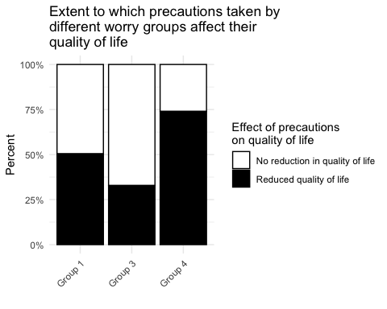

So even though all groups take precautions, they differ in the kinds of precautions taken, and functionally worried people are less affected by them than unworried people, while dysfunctionally worried people are more affected than unworried people by the precautions they take.

##   
## =============================================  
## Dependent variable:   
## ---------------------------  
## precqof_binary   
## ---------------------------------------------  
## foc19Group 3 0.481***   
## (0.176)   
##   
## foc19Group 4 2.793***   
## (0.193)   
##   
## Constant 1.017   
## (0.126)   
##   
## ---------------------------------------------  
## Observations 969   
## Log Likelihood -519.628   
## Akaike Inf. Crit. 1,045.256   
## =============================================  
## Note: *p<0.1; **p<0.05; ***p<0.01

Compared to the unworried group, the functionally worried group have about 40% the odds of the precautions they take reducing their quality of life. On the other hand, the disfuctionally worried group’s precautions have over twice the odds of the unworried group that their precautions reduce their quality of life.

# Worry and Compliance

So what does this mean for people’s worry as a force which makes them to comply with government regulations around restrictions to curb the spread of COVID-19? We can have a look at people’s compliance by calculating a score from the questions: “How often during the past week have you engaged in each of the following behaviours during the Covid-19 outbreak?” from Never (1) to Very often (5) (with Prefer not to say (7) excluded), the higher the score, the less compliance (the more they engage in non-compliant behaviours ie: Socialised in person with friends or relatives whom they don’t live with, Go out for a walk, run, or cycle and spend more than a few minutes sitting somewhere to relax, and/or Travelled for leisure (e.g. driven somewhere to go for a walk)).

**TODO:**  visualise these in blog-friendly way:

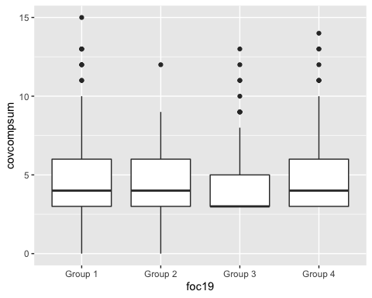

##   
## =============================================================  
## Dependent variable:   
## ---------------------------------------  
## covcompsum   
## (1) (2) (3) (4)   
## -------------------------------------------------------------  
## foc19Group 2 0.987 1.088 1.082 1.095   
## (0.097) (0.100) (0.101) (0.102)   
##   
## foc19Group 3 0.857*** 0.940 0.940 0.971   
## (0.039) (0.046) (0.046) (0.047)   
##   
## foc19Group 4 0.979 1.099* 1.098* 1.101*   
## (0.040) (0.051) (0.051) (0.052)   
##   
## b_covconc 0.934*** 0.935*** 0.948***   
## (0.019) (0.019) (0.020)   
##   
## b_covknow 0.987 0.999   
## (0.025) (0.025)   
##   
## age25-44 0.842***   
## (0.064)   
##   
## age45-64 0.793***   
## (0.072)   
##   
## age65+ 0.771**   
## (0.115)   
##   
## genderFemale 0.807***   
## (0.071)   
##   
## areaCardifff 0.790***   
## (0.070)   
##   
## areaEdinburgh 0.870**   
## (0.071)   
##   
## areaGlasgow 0.897   
## (0.069)   
##   
## areaLeeds 0.881*   
## (0.073)   
##   
## areaLiverpool 0.920   
## (0.072)   
##   
## areaLondon 0.928   
## (0.078)   
##   
## areaManchester 0.947   
## (0.071)   
##   
## areaNewcastle 0.906   
## (0.068)   
##   
## areaSheffield 0.921   
## (0.072)   
##   
## areaNone of these 0.890   
## (0.076)   
##   
## age25-44:genderFemale 1.125   
## (0.086)   
##   
## age45-64:genderFemale 1.084   
## (0.094)   
##   
## age65+:genderFemale 1.401**   
## (0.143)   
##   
## Constant 4.676*** 5.551*** 5.826*** 7.268***   
## (0.026) (0.054) (0.104) (0.122)   
##   
## -------------------------------------------------------------  
## Observations 1092 1092 1092 1092   
## Log Likelihood -1797.895 -1791.394 -1791.245 -1766.804  
## Akaike Inf. Crit. 3603.791 3592.788 3594.491 3579.607   
## =============================================================  
## Note: *p<0.1; **p<0.05; ***p<0.01

Overall there is no straightforward pattern to see between worry and compliance. In fact, it almost seems like the dysfunctionally worried people engage in slighlty more non-compliant activities compared with the unworried group.

When we consider social distancing specifically, we again see a positive relationship with being in the dysfunctionally worried group compared to the unworried group, in this case meaning they engage more in scial distancing. So the dysfunctionally worried go out more (**maybe this is why the worry has more impact on quality of life??**) but they also socially distance more.

The group who said they don’t take precautions (group 2) appear true to form here, as they are less likely to engage in social distancing than the unworried group.

**TO DO:** blog friendly presentation of results.

##   
## =================================================================  
## Dependent variable:   
## -------------------------------------------  
## sdcomplsum   
## (1) (2) (3) (4)   
## -----------------------------------------------------------------  
## foc19Group 2 0.664*** 0.625*** 0.637*** 0.606***   
## (0.086) (0.088) (0.088) (0.088)   
##   
## foc19Group 3 0.977 0.922** 0.923** 1.021   
## (0.027) (0.033) (0.033) (0.033)   
##   
## foc19Group 4 1.167*** 1.087** 1.092** 1.091**   
## (0.028) (0.036) (0.036) (0.036)   
##   
## b_covconc 1.044*** 1.039*** 1.115***   
## (0.014) (0.014) (0.014)   
##   
## b_covknow 1.057*** 1.113***   
## (0.018) (0.017)   
##   
## age25-44 0.797***   
## (0.040)   
##   
## age45-64 0.429***   
## (0.050)   
##   
## age65+ 0.185***   
## (0.116)   
##   
## genderFemale 0.465***   
## (0.049)   
##   
## areaCardifff 0.698***   
## (0.048)   
##   
## areaEdinburgh 0.626***   
## (0.053)   
##   
## areaGlasgow 0.557***   
## (0.054)   
##   
## areaLeeds 0.984   
## (0.048)   
##   
## areaLiverpool 0.897**   
## (0.048)   
##   
## areaLondon 0.958   
## (0.051)   
##   
## areaManchester 1.033   
## (0.045)   
##   
## areaNewcastle 0.824***   
## (0.046)   
##   
## areaSheffield 0.713***   
## (0.051)   
##   
## areaNone of these 0.634***   
## (0.056)   
##   
## age25-44:genderFemale 1.565***   
## (0.058)   
##   
## age45-64:genderFemale 2.094***   
## (0.068)   
##   
## age65+:genderFemale 0.896   
## (0.177)   
##   
## Constant 8.675*** 7.774*** 6.374*** 8.973***   
## (0.019) (0.040) (0.075) (0.085)   
##   
## -----------------------------------------------------------------  
## Observations 1092 1092 1092 1092   
## Log Likelihood -9989.076 -9984.102 -9979.126 -9138.313   
## theta 164349.800 164331.400 164903.000 118595.100  
## Akaike Inf. Crit. 19986.150 19978.200 19970.250 18322.630   
## =================================================================  
## Note: *p<0.1; **p<0.05; ***p<0.01

So it doesn’t seem from this data that fear of COVID-19 is in fact associated with changes in compliance with regulations, compared with those who do not experience this fear.

# Does wearing a mask mean people go out more?

Finally we wanted to see whether people might take some precautions to buy themselves credit in other areas. For example, it might be that when people wear a mask, they feel more protected, and therefore they decide to go out more frequently (engage in more non-compliant behaviour) or maybe get closer to people (engage in less social distancing).

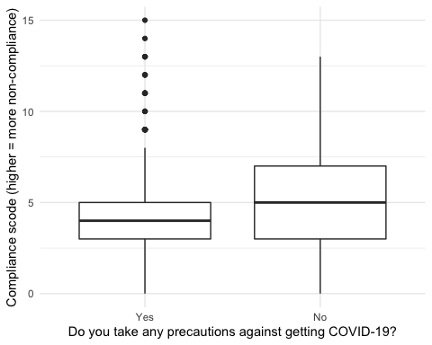

In fact, we see the opposite: generally it seems that people who take precautions engage in fewer non-compliant behaviours than people who do not take precautions. But what about differential effects of different types of precautions?

##   
## =============================================================  
## Dependent variable:   
## ---------------------------------------  
## covcompsum   
## (1) (2) (3) (4)   
## -------------------------------------------------------------  
## soc_dist 1.057 1.093 1.093 1.078   
## (0.068) (0.073) (0.073) (0.074)   
##   
## ppe 1.041 1.049 1.050 1.053   
## (0.035) (0.036) (0.036) (0.037)   
##   
## avoid_pt 0.931 0.935 0.937 0.916*   
## (0.052) (0.052) (0.052) (0.053)   
##   
## diff_rt_or_time 0.967 0.971 0.972 0.988   
## (0.035) (0.035) (0.035) (0.036)   
##   
## avoid_go_out 0.892*** 0.897*** 0.896*** 0.883***   
## (0.033) (0.034) (0.034) (0.035)   
##   
## wash_hands 0.907 0.944 0.945 0.974   
## (0.080) (0.080) (0.080) (0.082)   
##   
## foc19Group 2 1.073 1.067 1.054   
## (0.113) (0.113) (0.114)   
##   
## foc19Group 3 0.937 0.937 0.973   
## (0.048) (0.048) (0.049)   
##   
## foc19Group 4 1.112** 1.109* 1.121**   
## (0.053) (0.053) (0.054)   
##   
## b_covconc 0.939*** 0.940*** 0.956**   
## (0.019) (0.019) (0.020)   
##   
## b_covknow 0.982 0.997   
## (0.025) (0.025)   
##   
## age25-44 0.833***   
## (0.065)   
##   
## age45-64 0.772***   
## (0.073)   
##   
## age65+ 0.726***   
## (0.116)   
##   
## genderFemale 0.814***   
## (0.072)   
##   
## areaCardifff 0.782***   
## (0.071)   
##   
## areaEdinburgh 0.866**   
## (0.071)   
##   
## areaGlasgow 0.894   
## (0.070)   
##   
## areaLeeds 0.878*   
## (0.073)   
##   
## areaLiverpool 0.910   
## (0.073)   
##   
## areaLondon 0.930   
## (0.079)   
##   
## areaManchester 0.946   
## (0.071)   
##   
## areaNewcastle 0.912   
## (0.069)   
##   
## areaSheffield 0.925   
## (0.072)   
##   
## areaNone of these 0.897   
## (0.076)   
##   
## age25-44:genderFemale 1.134   
## (0.086)   
##   
## age45-64:genderFemale 1.088   
## (0.095)   
##   
## age65+:genderFemale 1.438**   
## (0.144)   
##   
## Constant 4.661*** 5.505*** 5.873*** 7.447***   
## (0.048) (0.072) (0.113) (0.131)   
##   
## -------------------------------------------------------------  
## Observations 1092 1092 1092 1092   
## Log Likelihood -1798.331 -1783.654 -1783.380 -1757.907  
## Akaike Inf. Crit. 3610.661 3589.308 3590.761 3573.813   
## =============================================================  
## Note: *p<0.1; **p<0.05; ***p<0.01

Not really, it seems like taking these precautions is not associated with any increase in non-compliance. Avoiding going out entirely means less engagement in non-compliant activities, which all involve going out, so that makes sense…!! Other than that it seems like people take precautions and adhere to government guidelines.

# Conclusions

Worry is complex and can be ‘functional’, functional worry helps people take precautions which do not reduce their quality of life (vs unworried people), but can still be in some cases dysfunctional, where if affects quality of life, as do the precautions people take to try to mitigate the worry.

No type of worry is associated with nonc-compliance when compared with unworried groups, and taking precautions also does not seem associated with engaging in more non-compliant activities.

# MORE STUFF:

# Who are these people?

## Boring stuff

How demographics vary across groups

## # weights: 36 (24 variable)  
## initial value 1247.806594   
## iter 10 value 1073.106245  
## iter 20 value 1034.920773  
## iter 30 value 1033.936385  
## iter 40 value 1033.864696  
## final value 1033.864546   
## converged

##   
## ============================================================  
## Dependent variable:   
## --------------------------------------  
## Group 2 Group 3 Group 4   
## (1) (2) (3)   
## ------------------------------------------------------------  
## age25-44 1.317 2.538** 1.584   
## (0.759) (0.408) (0.373)   
##   
## age45-64 0.877 5.378*** 2.652**   
## (0.987) (0.429) (0.406)   
##   
## age65+ 0.204** 5775465.000*** 2742899.000***  
## (0.731) (0.347) (0.347)   
##   
## genderFemale 0.466 4.190*** 3.356***   
## (1.212) (0.438) (0.397)   
##   
## age25-44:genderFemale 1.239 0.348** 0.393*   
## (1.369) (0.505) (0.477)   
##   
## age45-64:genderFemale 7.319 0.367* 0.367*   
## (1.486) (0.538) (0.525)   
##   
## age65+:genderFemale 8.579*** 0.00000*** 0.00000***   
## (0.731) (0.409) (0.412)   
##   
## Constant 0.069*** 0.251*** 0.358***   
## (0.624) (0.355) (0.310)   
##   
## ------------------------------------------------------------  
## Akaike Inf. Crit. 2115.729 2115.729 2115.729   
## ============================================================  
## Note: *p<0.1; **p<0.05; ***p<0.01

## Worry, knowledge, experience with covid19

## # weights: 36 (24 variable)  
## initial value 1247.806594   
## iter 10 value 838.223304  
## iter 20 value 812.598794  
## iter 30 value 812.374927  
## iter 40 value 812.364747  
## final value 812.364730   
## converged

## # weights: 56 (39 variable)  
## initial value 1247.806594   
## iter 10 value 863.408607  
## iter 20 value 811.802751  
## iter 30 value 803.070116  
## iter 40 value 802.499000  
## iter 50 value 802.479900  
## final value 802.476950   
## converged

##   
## =============================================================================  
## Dependent variable:   
## ---------------------------------------------------------  
## Group 2 Group 3 Group 4 Group 2 Group 3 Group 4   
## (1) (2) (3) (4) (5) (6)   
## -----------------------------------------------------------------------------  
## b_covconc 5.604*** 4.670*** 8.262*** 6.025*** 4.544*** 8.889***  
## (0.289) (0.115) (0.150) (0.297) (0.118) (0.157)   
##   
## b_covknow 0.419** 1.040 0.860 0.386*** 1.025 0.882   
## (0.343) (0.161) (0.180) (0.350) (0.163) (0.182)   
##   
## lost_job 1.056 1.825** 2.182*** 0.957 1.846** 2.007**   
## (0.651) (0.274) (0.302) (0.666) (0.282) (0.311)   
##   
## no_food 1.423 1.257 2.914*** 1.262 1.225 2.983***  
## (0.761) (0.364) (0.367) (0.768) (0.366) (0.369)   
##   
## someone_in_hospital 0.00001*** 0.401 1.436 0.00001*** 0.440 1.443   
## (0.00002) (0.655) (0.609) (0.00001) (0.663) (0.617)   
##   
## lost_someone 1.040 3.537* 3.468* 1.148 3.661* 3.529*   
## (1.964) (0.687) (0.712) (1.986) (0.699) (0.725)   
##   
## had_covYes 0.661 0.389*** 0.970 0.648 0.400*** 0.913   
## (0.615) (0.299) (0.296) (0.626) (0.303) (0.301)   
##   
## genderFemale 0.690 1.035 0.914   
## (0.450) (0.208) (0.234)   
##   
## age25-44 0.855 1.075 0.659   
## (0.661) (0.285) (0.309)   
##   
## age45-64 1.304 1.502 0.591   
## (0.690) (0.315) (0.350)   
##   
## age65+ 0.318 0.987 0.582   
## (1.216) (0.436) (0.477)   
##   
## race 1.487 1.024 1.026   
## (0.254) (0.040) (0.043)   
##   
## Constant 0.007*** 0.006*** 0.001*** 0.00004*** 0.004*** 0.001***  
## (1.578) (0.707) (0.847) (3.897) (0.891) (1.042)   
##   
## -----------------------------------------------------------------------------  
## Akaike Inf. Crit. 1672.729 1672.729 1672.729 1682.954 1682.954 1682.954  
## =============================================================================  
## Note: *p<0.1; **p<0.05; ***p<0.01

## Key workers?

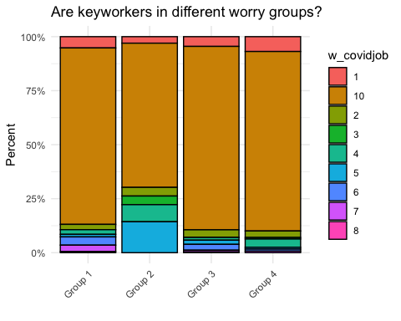

## Emotions

What Chris mentioned about the different groups and their will to live - this needs some psych context (pls help!)