Fear of Covid

Reka Solymosi

20/05/2020

## Descriptives of worry about covid 19

In total 64% of people said that they had felt worried about getting COVID-19 in the past 3 weeks.

Worry seems like a frequent occurrence rather than one-off incidences:

data %>%   
 filter(!is.na(b_focfr)) %>%   
 group_by(b_focfr) %>%   
 count() %>%   
 mutate(perc = round(n / sum(.$n)*100,0)) %>%   
 ggplot(., aes(x = b_focfr, y = perc/100)) +   
 geom_bar(stat = "identity") +   
 geom_text(aes(label=paste0("n = ", n)),vjust=3, col = "white") +  
 scale_y_continuous(labels = scales::percent, limits = c(0, 0.4)) +  
 xlab("Frequency of worry") +   
 ylab("Percent of respondents") +   
 labs(title = "How frequently have you felt worried about getting COVID-19\nin the last three weeks?") +  
 theme_minimal() +   
 theme(axis.title = element_text(size = 14),  
 axis.text = element_text(size = 12))

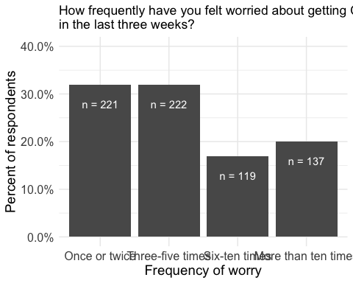

People also report high intensity of worry, almost a quarter of respondents (23%) were ‘very worried’:

data %>%   
 filter(!is.na(b_focwo)) %>%   
 group_by(b_focwo) %>%   
 count() %>%   
 mutate(perc = round(n / sum(.$n)*100,0)) %>%   
 ggplot(., aes(x = b_focwo, y = perc/100)) +   
 geom_bar(stat = "identity") +   
 geom_text(aes(label=paste0("n = ", n)),vjust=-1.5, col = "black") +  
 scale_y_continuous(labels = scales::percent, limits = c(0, 0.5)) +  
 xlab("Intensity of worry") +   
 ylab("Percent of respondents") +   
 labs(title = "On the last occasion [of worry], how worried did you feel?") +  
 theme_minimal() +   
 theme(axis.title = element_text(size = 14),  
 axis.text = element_text(size = 12),   
 axis.text.x = element_text(angle = 45, hjust = 1))

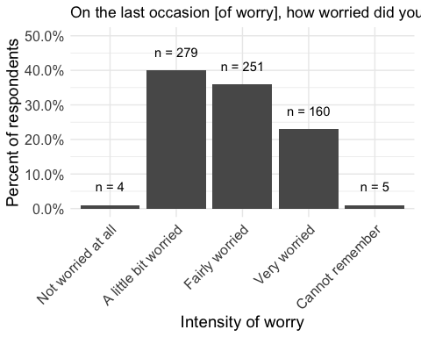

focqol <- data %>%   
 filter(!is.na(b_focqol)) %>%   
 group_by(b_focqol) %>%   
 count() %>%   
 mutate(perc = round(n / sum(.$n)*100,0))

In total half the people surveyed said their quality of life was affected by worry about COVID19 “Not at all” or “A little” (50%), while the other half said their quality of life was “Moderately”,“Quite a bit”, or “Very much” affected (50%).

ggplot(focqol, aes(x = b_focqol, y = perc/100)) +   
 geom_bar(stat = "identity") +   
 geom_text(aes(label=paste0("n = ", n)),vjust=-1.5, col = "black") +  
 scale_y_continuous(labels = scales::percent, limits = c(0, 0.5)) +  
 xlab("") +   
 ylab("Percent of respondents") +   
 labs(title = "To what extent was your quality of life reduced by your worry about COVID-19?") +  
 theme_minimal() +   
 theme(axis.title = element_text(size = 14),  
 axis.text = element_text(size = 12),   
 axis.text.x = element_text(angle = 45, hjust = 1))

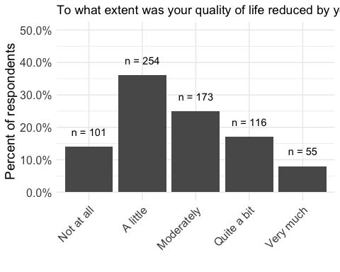

## Descriptives of precautions

Most people (91%) take some sort of precaution against COVID19. And for most of them,these precautions make them feel safer; 19% say that these precautions make them feel safer “Not at all” or “A little”, while the rest (81% ) say these precautions make them feel safer “Moderately”,“Quite a bit”, or “Very much”.

ggplot(precs_tab, aes(x = b_precs, y = perc/100)) +   
 geom_bar(stat = "identity") +   
 geom_text(aes(label=paste0("n = ", n)),vjust=-1.5, col = "black") +  
 scale_y_continuous(labels = scales::percent, limits = c(0, 0.5)) +  
 xlab("") +   
 ylab("Percent of respondents") +   
 labs(title = "To what extent do these precautions make you feel safer?") +  
 theme_minimal() +   
 theme(axis.title = element_text(size = 14),  
 axis.text = element_text(size = 12),   
 axis.text.x = element_text(angle = 45, hjust = 1))

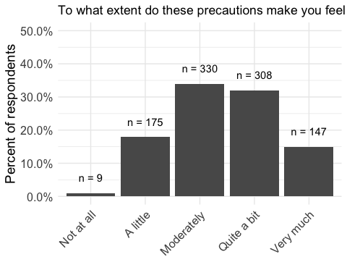

On the flip side, 45% of the people who take precatutions say that these precautions affect their quality of life “Not at all” or “A little”, while the rest (55% ) say their quality of life is affected “Moderately”,“Quite a bit”, or “Very much”.

ggplot(precqol_tab, aes(x = b_precqof, y = perc/100)) +   
 geom_bar(stat = "identity") +   
 geom_text(aes(label=paste0("n = ", n)),vjust=-1.5, col = "black") +  
 scale_y_continuous(labels = scales::percent, limits = c(0, 0.5)) +  
 xlab("") +   
 ylab("Percent of respondents") +   
 labs(title = "To what extent do these precautions reduce your quality of life?") +  
 theme_minimal() +   
 theme(axis.title = element_text(size = 14),  
 axis.text = element_text(size = 12),   
 axis.text.x = element_text(angle = 45, hjust = 1))

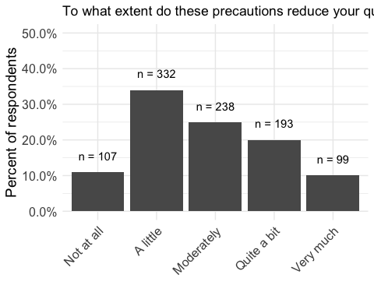

Finally, regarding the type of precautions people reported taking the following precautions (people could select more than one):

pivot_longer(data %>% select(starts_with("b_prectyp_")), cols = starts_with("b_prectyp_"), names_to = "prec_took") %>% group_by(value) %>% count() %>% filter(!is.na(value)) %>% mutate(w_value = str_wrap(value, 30)) %>%   
 ggplot(., aes(x = reorder(w_value, n), y = n)) +   
 geom_bar(stat = "identity") +   
 geom_text(aes(label=paste0("n = ", n)),hjust=-0.5, col = "black") +  
 ylim(c(0, 1200)) +  
 xlab("") +   
 ylab("Percent of respondents") +   
 labs(title = "Which of the following precautions do you take?\n(Mark all that apply)") +  
 theme_minimal() +   
 theme(axis.title.y = element_text(size = 10),  
 axis.title.x = element_text(size = 14),  
 axis.text = element_text(size = 12),   
 axis.text.x = element_text(angle = 45, hjust = 1)) +   
 coord_flip()

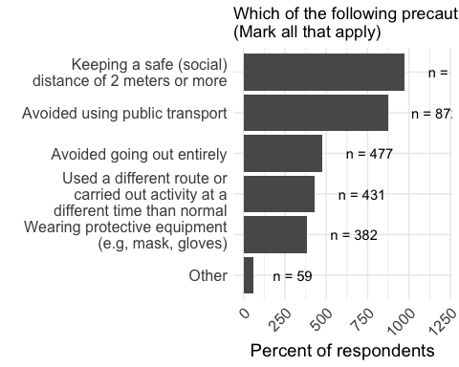

There was also a free text option for other types of precations people may take. 55 people filled out this free text option. 36 of these were about washing hands.

knitr::kable(data %>% filter(nchar(as.character(b_prectypo))>0) %>% select(b_prectypo) )

|  |
| --- |
| b_prectypo |
| Hand washing after being out &/or receiving deliveries |
| Hand washing for the recomended amount of time. |
| Increased handwashing (or use of alcohol based handgel when out) |
| Do not go out, with exception in to our garden and a dog walk down to the bottom of our street to the dog park |
| Working from home. Getting food and medicines delivered. |
| I wash my hands more often, I try to not touch my face. |
| washed hands after going out, binning tissues immediately even though i’m sure its hayfever giving me a runny nose and coldiness not Covid-19, used handsanitiser when out immediately after leaving public building i needed to visit. |
| Hand washing |
| Using First Defence on coming home from shopping, washing hands after opening post. |
| Vitamin D3 |
| Working from home |
| Carrying hand sanitiser when out |
| Shopping on-line as much as possible |
| washing hands after being outside |
| Following government guidelines, i.e. only going out once a day for exercise, and only shopping for food as infrequently as possible |
| Washing hands frequently |
| Working from home, getting all food and essentials delivered then washing all packaging, only going out for a walk max 2ice a week |
| washing hands very frequently |
| Basic hygiene practices (hand washing etc) |
| Worked from home & washed hands regularly, especially after going out. Went shopping for groceries less freq. Stopped touching face/phone outside of the house. Kept sanitizer in the car. Stayed home apart from exercise once per day. |
| took shallow breaths outside, avoided walking in other peoples spaces |
| Improving immune system |
| Washing hands more |
| Vitamin d |
| After I’ve been out, I get changed as soon as I get in and put my clothes in the wash. Then I wipe down all surfaces I’ve touched with my hands before taking my gloves off, then I wash my hands |
| Disinfecting shopping & parcels coming into my home. When going out, wash immediately all over, including hair & clothes after getting home. Regularly wiping down surfaces like door handles. |
| only went out for short walks and when nobody else around. washed hands often, did not see family or friends |
| Take daily vitamins to aid immune system |
| Hand sanatizing. |
| Washing hands very frequently |
| Extensive handwashing when possible and use of alcohol gel otherwise |
| washing hands as soon as I get inside |
| Taking care of health, only going out once in 2 weeks to get groceries |
| hand-washing and alcohol-based hand gels |
| washing hands more often |
| Regular hand washing/sanitizing. |
| Washing hands for 20 seconds or more with soap and water |
| wash my hands |
| Very frequent hand washing |
| washing hands, usng antibacterial gel, wiping shopping trolley handles |
| hand-washing more frequently |
| Wash my hands regulary |
| Extra hand washing; hand sanitiser |
| Washing hands frequently |
| change my clothing after being outside and washing my hands after being outside |
| Cleaning items that get delivered, washing my hands more often |
| Cleaning packaging of items bought from the shop ; Not kissing or snuggling my cat who goes outside |
| Use disinfectant on sufscrd and carry it with me to use on surfaced |
| Use hand sanitiser regularly at work |
| hand washing / hand gel |
| Wash hands much more |
| Using handsanitiser when out of the house. Washing hands for longer. Cleaning trolley or basket handles when going to shops and clean items bought from food shops before tidying away in cupboards |
| disinfecting or leaving cleaning packages/ deliveries untouched for a day or two before dealing with them |
| Quarantining any deliveries to my home, Washing hands and disinfecting any thing that comes into the house. |
| taking vitamin C and D supplements |