**Least safe place among Atlanta places rated by at least 25 Place Pulse users**

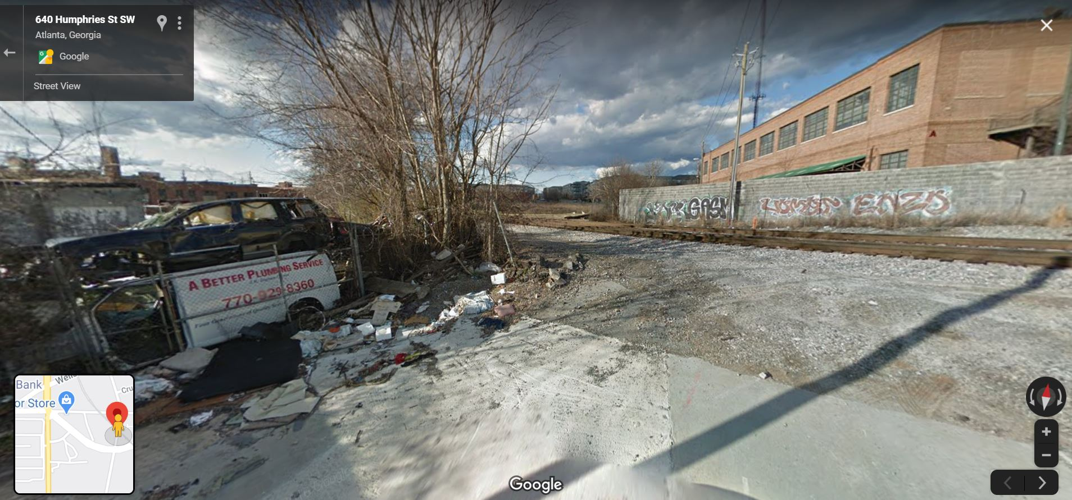

**Safest place among Atlanta places rated by at least 25 Place Pulse users**

