Changes in FoC

Reka Solymosi

10/06/2020

# Prevalence of worry

When asked the question in wave 2 “In the past 3 weeks, have you ever felt worried about getting COVID-19?”, 36% of people said that “No”, they had not felt worried about getting COVID-19 in the past 3 weeks. However, in wave three, 45% of people said that “No”, they had not felt worried about getting COVID-19 in the past 3 weeks. Appears worry is on the decrease… 133 people experienced worry in Wave 2, but not in Wave 3, while 55 people didn’t report experiencing any worry in W2 but did in W3. 492 reported that they experienced worry in both waves, while 310 worried in neither.

Based on their worries about catching the virus, as well as the self-reported effect of their worries, we can divide research participants into one of three groups:

# Functional Fear

## # A tibble: 10 x 2  
## whochangedff `round(sum(weight), 0)`  
## <chr> <dbl>  
## 1 Coping to Struggling 34  
## 2 Coping to Unworried 85  
## 3 Stayed Coping 183  
## 4 Stayed Struggling 128  
## 5 Stayed Unworried 250  
## 6 Struggling to Coping 86  
## 7 Struggling to Unworried 24  
## 8 Unworried to Coping 30  
## 9 Unworried to Struggling 7  
## 10 <NA> 80

# Is there association between change in circumstance and change in foc19 group?

## How covid19 has affected their lives

I created a score from summing up all the effects of covid (covidaffet_1 through 8) for wave 2 and for wave 3, then I subtracted the wave 3 score from the wave 2 score. So a higher score means that things have improved, while a lower score means that things have gotten worse between the two waves. This score seems to have no effect on the type of move between categories (ie I expected those who moved from unworried to struggling to have low score (things changed for the worse for them), and those who moved from struggling to unworried to have high score (things changed for the better for them), but did not see this at all):

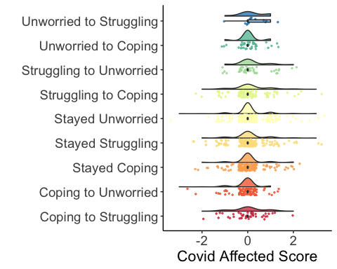

## Change in keyworker status

I could not find b_covidjob and c_covidjob in this dataset, only a_covidjob…!

## What about getting covid19 themselves?

I also looked at change in having Covid19 between the waves.

## # A tibble: 6 x 2  
## # Groups: covdiff [6]  
## covdiff n  
## <chr> <int>  
## 1 Didnt have cov19 either wave 804  
## 2 Had covid in W2, didn't answer W3 (possibly ded?) 17  
## 3 Had in both waves 139  
## 4 Had in W3 not W2 26  
## 5 Suspected in W2 but said didnt have in W3 17  
## 6 <NA> 97

The 26 people who got covid (or suspected) in the last 3 weeks have changed in their worry all over the place… Some got less worried (eg: 2 of them moved from struggling to unworried) while others got more worried (2 moved from coping to struggling, 1 from unworried to coping…)

## # A tibble: 8 x 2  
## # Groups: whochangedff [8]  
## whochangedff n  
## <chr> <int>  
## 1 Coping to Struggling 2  
## 2 Coping to Unworried 2  
## 3 Stayed Coping 4  
## 4 Stayed Struggling 5  
## 5 Stayed Unworried 6  
## 6 Struggling to Coping 4  
## 7 Struggling to Unworried 2  
## 8 Unworried to Coping 1

So not this either…

## Concern and change in worry group?

I also looked at convid concern between the waves:

## # A tibble: 5 x 2  
## # Groups: covconcdiff [5]  
## covconcdiff n  
## <chr> <int>  
## 1 Concerned in both waves 463  
## 2 Concerned in W2 no longer concerned in W3 121  
## 3 Not concerned in both waves 361  
## 4 Not concerned in W2 concerned in W3 46  
## 5 <NA> 109

So this one makes more sense, in that those who were not concerned in both are also those who stayed unworried, most of those that were concerned in w2 but not in w3 are in the coping to unworried or struggling to unworried move… But this isn’t really that exciting as these should really measure the same thing (ish), rather than one explaining the other…

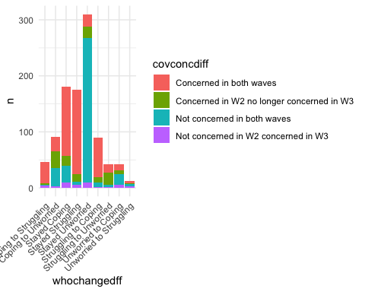

# Conclusions

Anyway, from this we can say nothing about why people move between categories, so I think at this point, the best thing to do is to just make a note at the end of the categories paper that people do move between the categories, we don’t know why, this is something we can explore later…