Crime Science Paper Analysis

Reka Solymosi

13/06/2020

# Sample

This data was collected as part of the ‘Policing the pandemic’ longitudinal study. We use data from the second and third waves collected between 11-14 May (wave 2) and XX - XX (wave 3) 2020. 1100 1100 people participated in wave 2 and 1019 in wave 3 of the study from nine metropolitan areas across the UK (Birmingham, Cardiff, Edinburgh, Glasgow, Leeds, Liverpool, Manchester, Newcastle, and Sheffield) and London. Quota weights were calculated making the sample largely representative of these cities and metropolitan areas. We use data from Wave 2 throughout, except for exploring the link between worry and risk perception (control, likelihood, consequence), which were asked in wave 3, and to assess any movement between groups between the two waves.

# Defining and measuring fear of COVID-19

It seems that people do experience worry about COVID-19. When asked the question “In the past 3 weeks, have you ever felt worried about getting COVID-19?” in wave 2, 34% of people said that “No”, they had not felt worried about getting COVID-19 in the past 3 weeks. From those who said “Yes”, the specific instance of worry varied in frequency and intensity. 35% of people who were worried only experienced this “Once or twice” in the last 3 weeks, while 21% worried more than 10 times in this timeframe.

Criminological work has found that, while some instances of worry can be destructive and paralysing, people and communities have the potential to convert worry about crime into constructive action [@jackson2010functional; @jackson2009untangling]. In our study, the majority of people said ‘yes’ (85%) when we asked ‘do you take any precautions against getting Covid-19?’. This implies that this fear can be considered functional, as it conceivably triggered self-protective behaviours against the virus.

Based on their worries about catching the virus, as well as the self-reported effect of their worries, we can divide research participants into one of three groups:

* The ‘unworried’ group (32%): those who had not worried once about catching Covid-19 over the previous three weeks;
* The ‘coping’ group (34%): those who had worried, but report that their quality of life was not affected by this worry; and,
* The ‘struggling’ group (27%): those who had worried, and reported that their quality of life was affected by this worry.

While all groups took precautions, there was a significant difference between whether or not these precautions had negative effect on people’s quality of life between the different worry groups (Fig 1, Table 1).

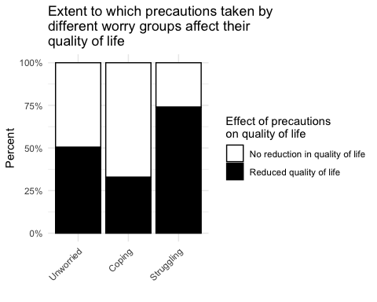

##   
## ==============================================  
## Dependent variable:   
## ---------------------------  
## precqof_binary   
## ----------------------------------------------  
## foc19_w2Coping 0.481***   
## (0.176)   
##   
## foc19_w2Struggling 2.793***   
## (0.193)   
##   
## Constant 1.017   
## (0.126)   
##   
## ----------------------------------------------  
## Observations 969   
## Log Likelihood -519.628   
## Akaike Inf. Crit. 1,045.256   
## ==============================================  
## Note: *p<0.1; **p<0.05; ***p<0.01

Compared to the unworried group, the functionally worried (Coping) group have about half the odds of their precautions reducing their quality of life. On the other hand, the dysfuctionally worried (Struggling) group’s precautions have well over twice the odds of the unworried group that their precautions reduce their quality of life.

Table 2 shows some descriptive statistics of these groups across demographic measures (gender, age, ethnicity), measures related to covid19 (key worker, affected by covid, had covid), mental health/emotions outcome measurses, and behavioural outcomes (takes precautions, and whether those precautions affect quality of life).

## Unworried Coping Struggling  
## perc_age_16_24 22 13 19  
## perc_age_25_44 50 39 42  
## perc_age_45_64 22 38 29  
## perc_age_65_over 6 10 9  
## perc_female 56 67 63  
## perc_BAME 10 7 9  
## perc_keyworker 18 16 17  
## perc_had_covid 16 9 19  
## w_mean_score_affected_by_covid 0.103 0.119 0.172  
## perc_worried 17 82 91  
## perc_felt_anxiety 45 50 77  
## perc_felt_anger 31 28 46  
## perc_felt_loneliness 41 34 60  
## perc_not_at_all_felt_happiness 20 16 26  
## perc_not_at_all_satisfied_w_life 11 5 18  
## perc_not_at_all_worthwhile 7 4 9

**NOTES:**

* Covid affected score is the sum of b_covidaffect 1 through 8, ie the more bad stuff happened, the higher the score
* Felt anxiety/anger/loneliness I am including anyone who didn’t answer “Not at all”
* Not at all felt happiness = only those who answered “not at all”
* I cannot find b_ and c_ covidjob in the dataset, so I used a_covidjob
* Worthwhile and Satisfied I just looked at “Not at all…” (can group with slightly also?)
* Percent worried include those who answered Concerned + Very concerned ( b_covconc> 3)

In wave 3 we also asked people about their perceived risk of covid-19. Specifically we asked people to estimate:

* Perceived Likelihood: “How likely do you think it is that, in the next 3 weeks, you will catch COVID-19?”
* Perceived Severity of Consequences: “If you contracted COVID-19, how severe do you expect its consequences to be on your health?”
* Perceived Control: “To what extent do you feel able to control whether or not, in the next 3 weeks, you will catch COVID-19?”

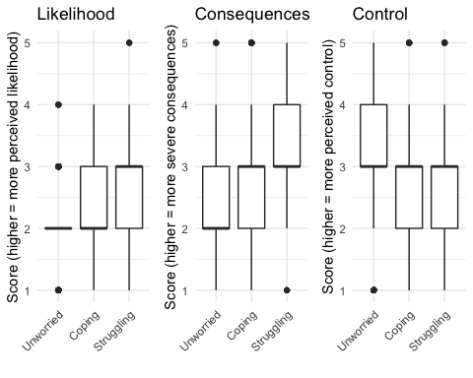

Unworried group have lower perceived likelihood and severity of consequences and higher perceived control, the Coping group are in the middle, and the Struggling group have the highest perceived likelihood and perceive most severe consequences! (Fig 2, Table 3).

##   
## ==============================================================  
## Dependent variable:   
## ------------------------------  
## c_riskln c_riskcn c_risksn   
## (1) (2) (3)   
## --------------------------------------------------------------  
## foc19_w3Coping 1.486*** 0.827*** 1.820***   
## (0.048) (0.060) (0.063)   
##   
## foc19_w3Struggling 2.148*** 0.824*** 2.785***   
## (0.057) (0.071) (0.075)   
##   
## Constant 7.236*** 22.499*** 11.329***   
## (0.032) (0.040) (0.043)   
##   
## --------------------------------------------------------------  
## Observations 1,018 1,018 1,018   
## R2 0.158 0.012 0.169   
## Adjusted R2 0.157 0.010 0.167   
## Residual Std. Error (df = 1015) 0.623 0.777 0.821   
## F Statistic (df = 2; 1015) 95.425*** 6.361*** 103.208***  
## ==============================================================  
## Note: *p<0.1; **p<0.05; ***p<0.01

# FOC19 and adherence with public health measures

## Lockdown compliance in Wave 2

Overall compliance score calculated from people’s answers to “How often during the past week have you engaged in each of the following behaviours during the Covid-19 outbreak?” from Never (1) to Very often (5) (with Prefer not to say (7) excluded), the higher the score, the less compliance (the more they engage in non-compliant behaviours ie: Socialised in person with friends or relatives whom they don’t live with, Go out for a walk, run, or cycle and spend more than a few minutes sitting somewhere to relax, and/or Travelled for leisure (e.g. driven somewhere to go for a walk)).

##   
## ==========================================================  
## Dependent variable:   
## ---------------------------------------  
## covcompsum   
## (1) (2) (3) (4)   
## ----------------------------------------------------------  
## foc19_w2Coping 0.861*** 0.947 0.947 0.954   
## (0.038) (0.047) (0.047) (0.046)   
##   
## foc19_w2Struggling 0.976 1.097* 1.095* 1.078   
## (0.039) (0.051) (0.051) (0.051)   
##   
## b_covconc 0.933*** 0.934*** 0.951**   
## (0.019) (0.019) (0.020)   
##   
## b_covknow 0.984 0.991   
## (0.025) (0.025)   
##   
## age25-44 0.899**   
## (0.043)   
##   
## age45-64 0.830***   
## (0.049)   
##   
## age65+ 0.947   
## (0.068)   
##   
## genderFemale 0.888***   
## (0.033)   
##   
## race_codedBAME 1.059   
## (0.055)   
##   
## Constant 4.681*** 5.566*** 5.892*** 6.402***   
## (0.027) (0.054) (0.104) (0.108)   
##   
## ----------------------------------------------------------  
## Observations 1067 1067 1067 1067   
## Log Likelihood -1775.538 -1769.045 -1768.840 -1753.464  
## Akaike Inf. Crit. 3557.076 3546.090 3547.679 3526.928   
## ==========================================================  
## Note: *p<0.1; **p<0.05; ***p<0.01

Group 3 (the functionally worried people), are more compliant (less non-compliant) compared with the unworried group as reference. On the other hand once more control variables in the model, dysfunctionally worried people seem to engage in these behaviours more? Maybe they really enjoy these things, and so when they restrict it affects their quality of life a lot more??

On the other hand, when asking specifically for social distancing, it changes, and it is actually the dysfunctionally worried group who seem to engage in more social distancing than the unworried group, while group 2 (worried, no precautions) engage less in social distancing. Social distancing score: higher score means they engaged *more* in social distancing.

Group 2 (worried, no precautions) less likely to socialy distance, group 4 (dysfunctional) more likely than unworried group (reference) to socially distance:

##   
## =============================================================  
## Dependent variable:   
## ------------------------------------------  
## sdcomplsum   
## (1) (2) (3) (4)   
## -------------------------------------------------------------  
## foc19_w2Coping 0.954* 0.909*** 0.910*** 0.952   
## (0.027) (0.033) (0.033) (0.033)   
##   
## foc19_w2Struggling 1.136*** 1.071* 1.079** 1.033   
## (0.028) (0.036) (0.036) (0.036)   
##   
## b_covconc 1.037*** 1.031** 1.127***   
## (0.014) (0.014) (0.014)   
##   
## b_covknow 1.063*** 1.106***   
## (0.018) (0.017)   
##   
## age25-44 1.004   
## (0.029)   
##   
## age45-64 0.650***   
## (0.035)   
##   
## age65+ 0.181***   
## (0.088)   
##   
## genderFemale 0.703***   
## (0.023)   
##   
## race_codedBAME 1.462***   
## (0.033)   
##   
## Constant 8.719*** 7.959*** 6.397*** 5.699***   
## (0.020) (0.040) (0.075) (0.076)   
##   
## -------------------------------------------------------------  
## Observations 1067 1067 1067 1067   
## Log Likelihood -9878.955 -9875.549 -9869.484 -9211.977  
## theta 163149.900 162828.300 163363.500 95907.770  
## Akaike Inf. Crit. 19763.910 19759.100 19748.970 18443.950  
## =============================================================  
## Note: *p<0.1; **p<0.05; ***p<0.01

## Willingness to track, trace and isolate

This is now data from Wave 3 (both track trace and worry grouping based on w3 answers)

What’s the relationship between foc19 and willingness to cooperate with these specific health measures? No realationship apparently:

##   
## ==========================================================  
## Dependent variable:   
## ---------------------------------------  
## tracktracesum   
## (1) (2) (3) (4)   
## ----------------------------------------------------------  
## foc19_w3Coping 1.090*** 1.004 1.005 1.001   
## (0.022) (0.026) (0.026) (0.026)   
##   
## foc19_w3Struggling 1.059** 0.952 0.952 0.951   
## (0.026) (0.031) (0.031) (0.032)   
##   
## c_covconc 1.067*** 1.066*** 1.065***   
## (0.011) (0.011) (0.012)   
##   
## c_covknow 1.013 1.014   
## (0.015) (0.015)   
##   
## age25-44 0.992   
## (0.028)   
##   
## age45-64 0.978   
## (0.030)   
##   
## age65+ 0.990   
## (0.042)   
##   
## genderFemale 1.062***   
## (0.021)   
##   
## race_codedBAME 0.976   
## (0.035)   
##   
## Constant 12.244*** 10.363*** 9.879*** 9.674***   
## (0.015) (0.032) (0.064) (0.068)   
##   
## ----------------------------------------------------------  
## Observations 989 989 989 989   
## Log Likelihood -2105.902 -2087.830 -2087.462 -2082.549  
## Akaike Inf. Crit. 4217.804 4183.661 4184.925 4185.098   
## ==========================================================  
## Note: *p<0.1; **p<0.05; ***p<0.01

## Willingness to re-engage with the world as lockdown is eased

What’s the relationship between foc19 and attitudes towards the easing of the lockdown? Coping and Struggling both more likely to think government is easing lockdown at right speed vs unworried people (answered “Yes” to “At the moment, the Government is attempting to reopen the economy while at the same time keeping the rate of infection down. Do you think the lockdown is being eased at the right speed?”), with Coping x1.5 and Struggling over x2 than Unworried. Once adding control variables, this only holds for “Struggling” group.

##   
## ==========================================================  
## Dependent variable:   
## ---------------------------------------  
## c_lockeas   
## (1) (2) (3) (4)   
## ----------------------------------------------------------  
## foc19_w3Coping 0.649** 0.720 0.720 0.749   
## (0.170) (0.200) (0.200) (0.203)   
##   
## foc19_w3Struggling 0.452*** 0.517** 0.517** 0.592**   
## (0.218) (0.258) (0.258) (0.265)   
##   
## c_covconc 0.922 0.927 0.854*   
## (0.083) (0.084) (0.089)   
##   
## c_covknow 0.918 0.927   
## (0.122) (0.123)   
##   
## age25-44 1.221   
## (0.232)   
##   
## age45-64 1.481   
## (0.248)   
##   
## age65+ 2.350**   
## (0.332)   
##   
## genderFemale 1.128   
## (0.162)   
##   
## race_codedBAME 0.990   
## (0.283)   
##   
## Constant 0.569*** 0.699 0.954 0.801   
## (0.110) (0.237) (0.500) (0.534)   
##   
## ----------------------------------------------------------  
## Observations 989 989 989 989   
## Log Likelihood -515.697 -514.860 -514.942 -510.693   
## Akaike Inf. Crit. 1,037.395 1,037.719 1,039.883 1,041.387  
## ==========================================================  
## Note: *p<0.1; **p<0.05; ***p<0.01

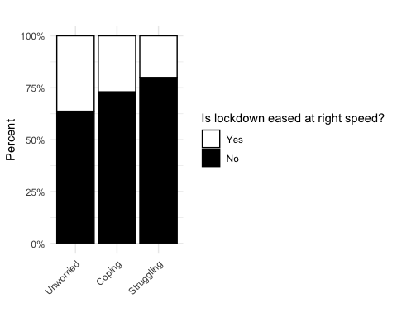

So the ones that do not agree with the speed, is there difference between worry groups in whether they think it’s being eased too quickly (vs too slowly)? Recoded “Is the Government easing the lockdown…” “Far too quickly” and “A little too quickly” to “Quickly” and “A little too slowly” and “Far too slowly” to Slowly. “Slowly” is the reference category. SO, Coping group have higher odds (by a lot!) to want quicker easing of lockdown than Unworried group.

##   
## ============================================================  
## Dependent variable:   
## -----------------------------------------  
## as_factor(ease_bi)   
## (1) (2) (3) (4)   
## ------------------------------------------------------------  
## foc19_w3Coping 12.871*** 4.553* 4.699* 4.667*   
## (0.822) (0.868) (0.874) (0.880)   
##   
## foc19_w3Struggling 6.130** 1.473 1.593 1.691   
## (0.735) (0.830) (0.835) (0.851)   
##   
## c_covconc 2.399*** 2.309*** 2.252***   
## (0.252) (0.248) (0.253)   
##   
## c_covknow 0.605 0.623   
## (0.329) (0.330)   
##   
## age25-44 0.202*   
## (0.862)   
##   
## age45-64 0.209*   
## (0.919)   
##   
## age65+ 1,293,851.000  
## (1,402.343)   
##   
## genderFemale 1.494   
## (0.462)   
##   
## race_codedBAME 1.395   
## (1.045)   
##   
## Constant 10.517*** 1.464 11.284* 31.504**   
## (0.235) (0.554) (1.467) (1.702)   
##   
## ------------------------------------------------------------  
## Observations 695 695 695 695   
## Log Likelihood -88.625 -82.169 -80.861 -77.756   
## Akaike Inf. Crit. 183.250 172.337 171.723 175.511   
## ============================================================  
## Note: *p<0.1; **p<0.05; ***p<0.01

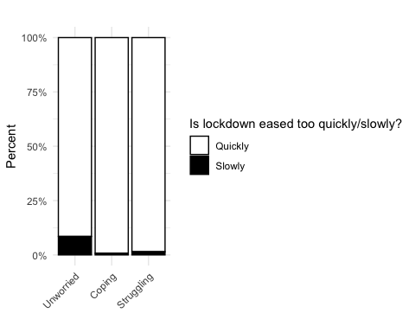

# FOC19 and rule and political cynicism

Would it be interesting to see if people who are unworried are more likely to believe that it’s ok to bend the rules and that elites bend the rules anyway? - Seems like none of these have come out exciting…

## Legal cynicism

Sum of:

* People who always follow the law are fools
* People in power use the law to try to control people like me
* People with money and power can get away with anything

Strongly disagree (1) – strongly agree (5)

##   
## ==========================================================  
## Dependent variable:   
## ---------------------------------------  
## legcyn   
## (1) (2) (3) (4)   
## ----------------------------------------------------------  
## foc19_w2Coping 0.911** 0.968 0.968 0.971   
## (0.037) (0.032) (0.032) (0.032)   
##   
## foc19_w2Struggling 0.942 1.019 1.017 0.998   
## (0.039) (0.036) (0.036) (0.036)   
##   
## c_covconc 0.967*** 0.969** 0.990   
## (0.013) (0.013) (0.013)   
##   
## c_covknow 0.965* 0.960**   
## (0.018) (0.018)   
##   
## age25-44 0.937**   
## (0.032)   
##   
## age45-64 0.898***   
## (0.035)   
##   
## age65+ 0.706***   
## (0.054)   
##   
## genderFemale 0.972   
## (0.024)   
##   
## race_codedBAME 1.090**   
## (0.039)   
##   
## Constant 8.883*** 10.359*** 11.779*** 12.438***  
## (0.026) (0.036) (0.075) (0.078)   
##   
## ----------------------------------------------------------  
## Observations 1067 965 965 965   
## Log Likelihood -2538.732 -1941.162 -1939.268 -1910.585  
## Akaike Inf. Crit. 5083.464 3890.324 3888.536 3841.171   
## ==========================================================  
## Note: *p<0.1; **p<0.05; ***p<0.01

## Life cynicism

Sum of:

* It’s okay to do anything you want as long as you don’t hurt anyone.
* To make money, there are no right or wrong ways anymore, only easy ways and hard ways
* Nowadays a person has to live pretty much for today and let tomorrow take care of itself

Strongly disagree (1) – strongly agree (5)

##   
## ==========================================================  
## Dependent variable:   
## ---------------------------------------  
## lifecyn   
## (1) (2) (3) (4)   
## ----------------------------------------------------------  
## foc19_w2Coping 0.917** 0.949 0.948 0.954   
## (0.040) (0.036) (0.036) (0.036)   
##   
## foc19_w2Struggling 0.949 0.990 0.988 0.970   
## (0.043) (0.041) (0.041) (0.041)   
##   
## c_covconc 0.988 0.990 1.013   
## (0.014) (0.015) (0.015)   
##   
## c_covknow 0.969 0.964*   
## (0.021) (0.021)   
##   
## age25-44 0.943   
## (0.037)   
##   
## age45-64 0.874***   
## (0.040)   
##   
## age65+ 0.741***   
## (0.060)   
##   
## genderFemale 0.955*   
## (0.027)   
##   
## race_codedBAME 1.088*   
## (0.044)   
##   
## Constant 6.880*** 7.622*** 8.555*** 9.039***   
## (0.029) (0.041) (0.085) (0.089)   
##   
## ----------------------------------------------------------  
## Observations 1067 965 965 965   
## Log Likelihood -2351.801 -1896.844 -1895.653 -1875.226  
## Akaike Inf. Crit. 4709.602 3801.689 3801.305 3770.453   
## ==========================================================  
## Note: *p<0.1; **p<0.05; ***p<0.01

## Rule cynicism

Sum of:

* It is OK to bend the rules when I need to
* People in my local community bend the rules when they need to
* People in power bend the rules when they need to

Strongly disagree (1) – strongly agree (5)

##   
## ==========================================================  
## Dependent variable:   
## ---------------------------------------  
## rulecyn   
## (1) (2) (3) (4)   
## ----------------------------------------------------------  
## foc19_w2Coping 0.925** 1.005 1.004 1.002   
## (0.034) (0.030) (0.030) (0.031)   
##   
## foc19_w2Struggling 0.946 1.053 1.052 1.041   
## (0.036) (0.035) (0.035) (0.035)   
##   
## c_covconc 0.951*** 0.952*** 0.963***   
## (0.012) (0.012) (0.013)   
##   
## c_covknow 0.986 0.983   
## (0.018) (0.018)   
##   
## age25-44 1.004   
## (0.032)   
##   
## age45-64 0.956   
## (0.035)   
##   
## age65+ 0.838***   
## (0.050)   
##   
## genderFemale 1.016   
## (0.023)   
##   
## race_codedBAME 0.957   
## (0.040)   
##   
## Constant 9.544*** 11.576*** 12.195*** 12.147***  
## (0.024) (0.034) (0.072) (0.076)   
##   
## ----------------------------------------------------------  
## Observations 1067 965 965 965   
## Log Likelihood -2565.242 -1886.078 -1885.742 -1876.365  
## Akaike Inf. Crit. 5136.484 3780.156 3781.484 3772.730   
## ==========================================================  
## Note: *p<0.1; **p<0.05; ***p<0.01

# A note on the fluidity of these groups

Finally we want to note that these categories are not deterministic, in that people may move about between them.

While most people have stayed in the same group between the two waves (68%), almost a third (32%) moved between categories (Table x, Figure x).

## # A tibble: 9 x 2  
## # Groups: whochangedff [9]  
## whochangedff n  
## <chr> <int>  
## 1 Coping to Struggling 46  
## 2 Coping to Unworried 91  
## 3 Stayed Coping 180  
## 4 Stayed Struggling 175  
## 5 Stayed Unworried 310  
## 6 Struggling to Coping 90  
## 7 Struggling to Unworried 42  
## 8 Unworried to Coping 42  
## 9 Unworried to Struggling 13

Nicer visual: