Willingness to engage angle

Reka Solymosi

16/06/2020

Asked whether or not people engaged in the following behaviours in wave 2 and wave 3:

* Socialised in person with friends or relatives whom you don’t live with
* Went out for a walk, run, or cycle and spent more than a few minutes sitting somewhere to relax
* Travelled for leisure (e.g. driven somewhere to go for a walk)

In wave 2 these were breaking the regulations, but in wave 3 they were allowed to do these. So we can say if the score goes up, they re-engaged, whereas if it stays the same or goes down (weird) then they are not re-engaging.

Coded as: calculated a re-engagement score, which is the score for the compliance items in wave 2 subtracted from the sum of the compliace items in wave 3. This means higher score means more re-engagement (0 is same engagement, negative is more engagement in wave 2 than wave 3 (shouldnt be a lot of this in theory??) and positive is more activity in wave 3 than wave 2)

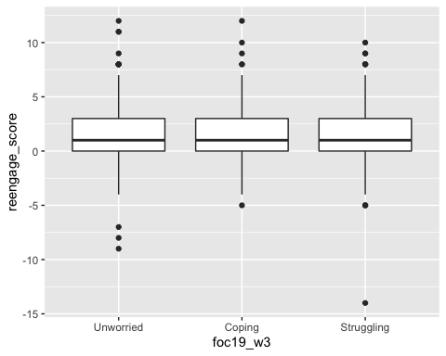

##   
## ===============================================  
## Dependent variable:   
## ----------------------------  
## reengaged_yn   
## (1) (2)   
## -----------------------------------------------  
## c_covconc 0.834*** 0.763***   
## (0.062) (0.079)   
##   
## foc19_w3Coping 1.431*   
## (0.187)   
##   
## foc19_w3Struggling 1.386   
## (0.226)   
##   
## Constant 2.648*** 2.932***   
## (0.221) (0.231)   
##   
## -----------------------------------------------  
## Observations 1,021 1,019   
## Log Likelihood -595.696 -592.691   
## Akaike Inf. Crit. 1,195.392 1,193.381   
## ===============================================  
## Note: *p<0.1; **p<0.05; ***p<0.01

No doesn’t look like there’s a difference in reengaging unless we separate out the different activities, in that case for socialising there is a difference, but not for the other two:

##   
## ===============================================  
## Dependent variable:   
## ----------------------------  
## more_socialising   
## (1) (2)   
## -----------------------------------------------  
## c_covconc 0.921 0.829**   
## (0.062) (0.081)   
##   
## foc19_w3Coping 1.725***   
## (0.194)   
##   
## foc19_w3Struggling 1.257   
## (0.238)   
##   
## Constant 0.797 0.886   
## (0.219) (0.229)   
##   
## -----------------------------------------------  
## Observations 986 984   
## Log Likelihood -564.880 -558.537   
## Akaike Inf. Crit. 1,133.761 1,125.074   
## ===============================================  
## Note: *p<0.1; **p<0.05; ***p<0.01

##   
## ===============================================  
## Dependent variable:   
## ----------------------------  
## more_relaxing_out   
## (1) (2)   
## -----------------------------------------------  
## c_covconc 0.826*** 0.771***   
## (0.062) (0.080)   
##   
## foc19_w3Coping 1.226   
## (0.192)   
##   
## foc19_w3Struggling 1.379   
## (0.234)   
##   
## Constant 1.244 1.357   
## (0.217) (0.227)   
##   
## -----------------------------------------------  
## Observations 988 986   
## Log Likelihood -567.300 -565.228   
## Akaike Inf. Crit. 1,138.600 1,138.455   
## ===============================================  
## Note: *p<0.1; **p<0.05; ***p<0.01

##   
## ===============================================  
## Dependent variable:   
## ----------------------------  
## more_leisure_travel   
## (1) (2)   
## -----------------------------------------------  
## c_covconc 0.803*** 0.795***   
## (0.069) (0.088)   
##   
## foc19_w3Coping 0.943   
## (0.216)   
##   
## foc19_w3Struggling 1.141   
## (0.260)   
##   
## Constant 0.703 0.722   
## (0.235) (0.245)   
##   
## -----------------------------------------------  
## Observations 988 986   
## Log Likelihood -482.649 -482.140   
## Akaike Inf. Crit. 969.297 972.280   
## ===============================================  
## Note: *p<0.1; **p<0.05; ***p<0.01