Exploratory of Wave 3 worry

Reka Solymosi

10/06/2020

# Descriptives

Overall the wave 3 descriptives show less worry, less frequently…

## Prevalence of worry

When asked the question “In the past 3 weeks, have you ever felt worried about getting COVID-19?”, 43% of people said that “No”, they had not felt worried about getting COVID-19 in the past 3 weeks.

From those who said “Yes”, the specific instance of worry varied in frequency and intensity. 36% of people who were worried only experienced this “Once or twice” in the last 3 weeks, while 15% worried more than 10 times in this timeframe:

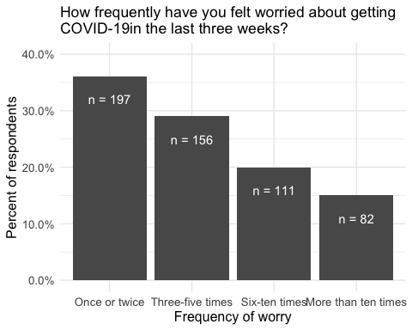

## Functional fear

* The ‘unworried’ group (40%): those who had not worried once about catching Covid-19 over the previous three weeks; precautions against the virus;
* The ‘coping’ group (33%): those who had worried, but report that their quality of life was not affected by this worry; and,
* The ‘struggling’ group (19%): those who had worried, and reported that their quality of life was affected by this worry.

## Precautions

Coping and struggling take similar amount of precautions, unworried slightly less.

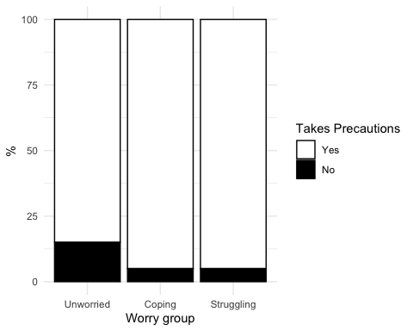

Do these precautions affect QoL? Least so for the ‘Coping’ group (less than Unworried!) and most for those Struggling:

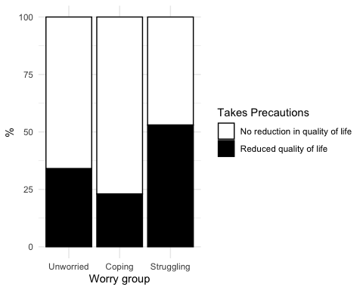

What precautions do they take?

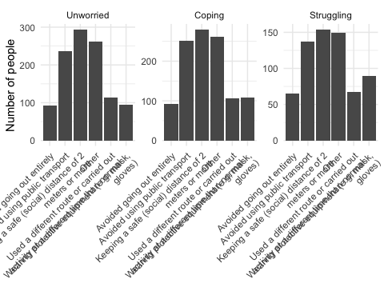

## Places of worry

## # A tibble: 8 x 2  
## # Groups: Location [8]  
## Location N  
## <fct> <int>  
## 1 At home 299  
## 2 Out shopping or running errands 166  
## 3 At work (not at home) 31  
## 4 Engaging in a leisure activity away from home (including exercise) 21  
## 5 Walking or cycling (as part of your daily commute/running errands) 15  
## 6 Cannot remember 7  
## 7 Taking public transporation 6  
## 8 Taking private transportation (e.g. car, taxi, Uber) 1

## Focloc by type of worry

Not super intersting at the moment, seems like there isn’t much travel, maybe later as more people start travelling it will be better. I think the strength of this is will be looking at how it might change over time,

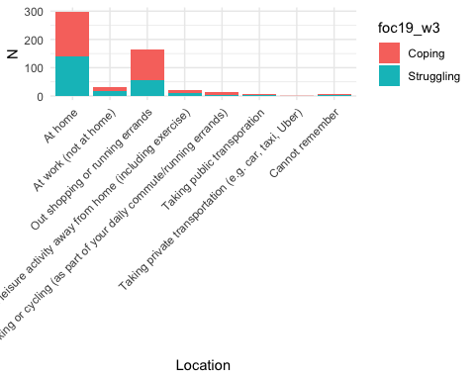

# Demographic variation in worry about covid19

## Race/gender

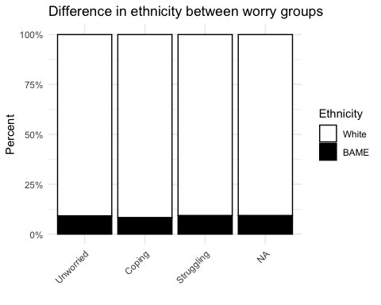

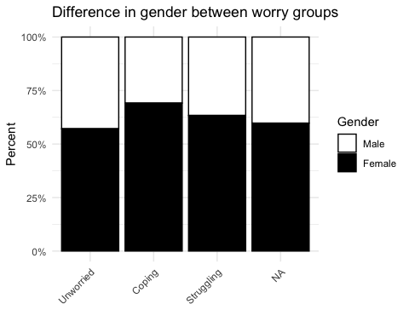

## Key workers

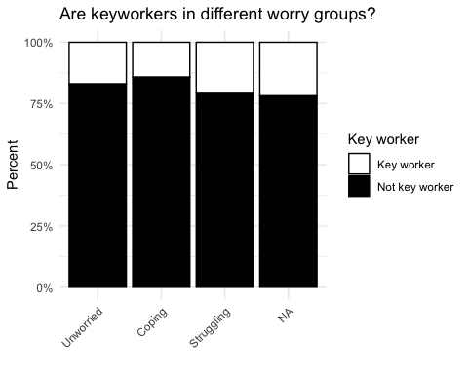

# Mental health outcomes between worry groups

## Thinking about how you felt yesterday, overall, how strongly did you feel the following emotions?

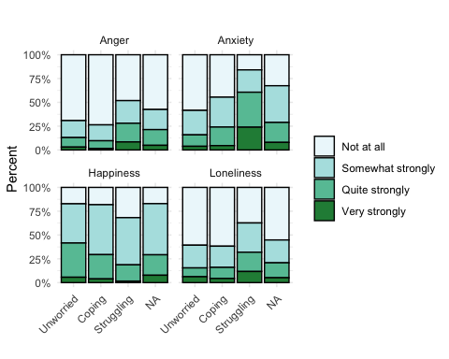

## Overall, how satisfied are you with your life nowadays?

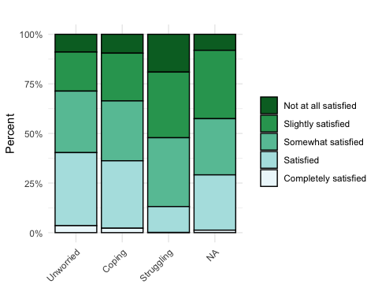

## Overall, to what extent do you feel that the things you do in your life are worthwhile?

