Missing paper

Nadia Kennar, Reka Solymosi

04/02/2022

# Results

In total 1749123 calls were made to the police force between 2015 - 2020. Of these, 42547 were about missing incidents. 528 of these calls were made from LSOAs which were outside the study area, so they were excluded.

The total sample was therefore 42019 calls about missing incidents across 652 LSOAs within the force in our study made between 2015-01-01 and 2020-12-31.

Of these, the majority (81.1%, n = 34090) came through public non emergency reports (e.g. calling 101), 13.2%, n = 5548) through 999 calls, and 2.1% (n = 871) from other emergency or police themselves (in 3.6% (n = 1510) of calls origin was not recorded).

## Spatial distribution

If distributed equally throughout all neighbourhoods, we would expect to see 64 incidents per LSOA. However we know that many incidents are due to repeat missing episodes of the same individuals. While we do not have individual level data here, we can consider concentration within neighbourhoods. One approach is to use Lorenz curves.

One way to measure inequality in the distribution of missing incidents is to use Lorenz curve, and associated Gini coefficient. The Lorenz curve is a probability plot (a P–P plot) comparing the distribution of a variable against a hypothetical uniform distribution of that variable. It can usually be represented by a function $L(F)$, where $F$, the cumulative portion of the population, is represented by the horizontal axis, and $L$, the cumulative portion of the variable of interest (e.g. missing incidents), is represented by the vertical axis. While Lorenz curves are used typically to graph inequality of distribution of wealth they can be applied in this case to explore unequal distribution of crimes between micro-places. A perfectly equal distribution would be depicted by the straight line $y=x$. [ @lorenz1905methods, @zeileis2012package]. The corresponding Gini coefficient represents the ratio of the area between the line of perfect equality and the observed Lorenz curve to the area between the line of perfect equality and the line of perfect inequality [@gastwirth1972estimation]. The closer the coefficient is to 1, the more unequal the distribution is [@zeileis2012package].

Figure REF shows a generalized Lorenz curve ( $=\text{ordinary Lorenz curve}*mean(x)$). The result can be interpreted like this: $p*100$ percent account for $L(p)*100$ percent of $x$.

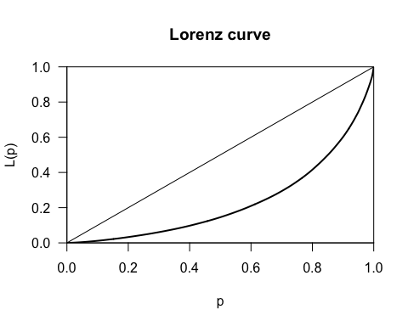

Upon seeing this, we can consider that many of the LSOAs in our study area contribute very little to overall calls for missing persons, and it is instead the top few which contribute most of the calls. We can quantify this further using the Gini coefficient.

## [1] 0.5379101

This score of 53.8% is considerable - for context with respect to income, the United Nations suggests that a national Gini coefficient larger than 0.40 is considered high [@catalano2009measuring].