**Module 1:**

Android OS Architecture: Application Layer, Framework Layer, Libraries and Runtime, Hardware Abstraction Layer, and Kernel

**Task**: Select any two Mobile Apps used in your mobile phone and note the various functionalities and their corresponding layers

**Android OS Architecture:**

Android operating system is a stack of software components which is roughly divided into five sections and four main layers as shown below in the architecture diagram.

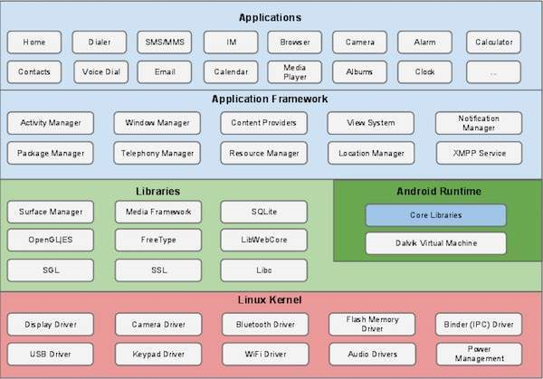

## Linux kernel

At the bottom of the layers is Linux - Linux 3.6 with approximately 115 patches. This provides a level of abstraction between the device hardware and it contains all the essential hardware drivers like camera, keypad, display etc. Also, the kernel handles all the things that Linux is really good at such as networking and a vast array of device drivers, which take the pain out of interfacing to peripheral hardware.

## Libraries

On top of Linux kernel there is a set of libraries including open-source Web browser engine WebKit, well known library libc, SQLite database which is a useful repository for storage and sharing of application data, libraries to play and record audio and video, SSL libraries responsible for Internet security etc.

## Android Libraries

This category encompasses those Java-based libraries that are specific to Android development. Examples of libraries in this category include the application framework libraries in addition to those that facilitate user interface building, graphics drawing and database access. A summary of some key core Android libraries available to the Android developer is as follows −

* **android.app** − Provides access to the application model and is the cornerstone of all Android applications.
* **android.content** − Facilitates content access, publishing and messaging between applications and application components.
* **android.database** − Used to access data published by content providers and includes SQLite database management classes.
* **android.opengl** − A Java interface to the OpenGL ES 3D graphics rendering API.
* **android.os** − Provides applications with access to standard operating system services including messages, system services and inter-process communication.
* **android.text** − Used to render and manipulate text on a device display.
* **android.view** − The fundamental building blocks of application user interfaces.
* **android.widget** − A rich collection of pre-built user interface components such as buttons, labels, list views, layout managers, radio buttons etc.
* **android.webkit** − A set of classes intended to allow web-browsing capabilities to be built into applications.

Having covered the Java-based core libraries in the Android runtime, it is now time to turn our attention to the C/C++ based libraries contained in this layer of the Android software stack.

## Android Runtime

This is the third section of the architecture and available on the second layer from the bottom. This section provides a key component called **Dalvik Virtual Machine** which is a kind of Java Virtual Machine specially designed and optimized for Android.

The Dalvik VM makes use of Linux core features like memory management and multi-threading, which is intrinsic in the Java language. The Dalvik VM enables every Android application to run in its own process, with its own instance of the Dalvik virtual machine.

The Android runtime also provides a set of core libraries which enable Android application developers to write Android applications using standard Java programming language.

## Application Framework

The Application Framework layer provides many higher-level services to applications in the form of Java classes. Application developers are allowed to make use of these services in their applications.

The Android framework includes the following key services −

* **Activity Manager** − Controls all aspects of the application lifecycle and activity stack.
* **Content Providers** − Allows applications to publish and share data with other applications.
* **Resource Manager** − Provides access to non-code embedded resources such as strings, color settings and user interface layouts.
* **Notifications Manager** − Allows applications to display alerts and notifications to the user.
* **View System** − An extensible set of views used to create application user interfaces.

## Applications

You will find all the Android application at the top layer. You will write your application to be installed on this layer only. Examples of such applications are Contacts Books, Browser, Games etc.

**Task**: Select any two Mobile Apps used in your mobile phone and note the various functionalities and their corresponding layers

**Face book functionalities:**

* **Timeline.** User profiles and updates are shown on what it known as the Timeline. Timeline is the successor to the Facebook wall, which was the original home for user profiles and updates. The user timeline includes posts, status updates, friend listings, photos, videos and user activity information.
* **Friends.** A primary feature of Facebook is the ability to search for and connect with friends and family. The search interface helps users quickly find acquaintances and also suggests potential connections.
* **News Feed.** News Feed enables users to view news from the connections and groups that they follow. Users can like a given post or comment on it.
* **Pages.** Pages are the profile and content pages for businesses on Facebook. Pages provide the ability for businesses to share information and communicate with customers.
* **Games.** Facebook provides an integrated capability enabling users to play games on their own or together with friends. Among the early successes of games on Facebook was Zynga's FarmVille.
* **Groups.** Communities of interest can organize themselves with the Facebook group feature. This enables the sharing of information, images and active discussions.
* **Events.** This feature enables users and groups to organize events that their followers can attend. It enables users to send out invites and help manage an attendee list.
* **Marketplace.** This is an online yard sale, where users can buy and sell goods and services with other Facebook members.
* **Messenger.** This is an instant messenger that enables friends to communicate in real time via webchat or a mobile app.
* **Video.** [Facebook Live](https://www.techtarget.com/whatis/definition/Facebook-Live) is a feature that enables individuals and businesses to stream live video to friends, family and followers.

**What’s app functionality:**

### **1. Same WhatsApp, Multiple devices**

After years of waiting, WhatsApp finally gave us the ability to use our same WhatsApp account on multiple devices. So, the feature basically works like how you use WhatsApp Web. All you need to do is — suppose you want to run WhatsApp on a different phone. Simply, download WhatsApp on the new device, and while you’re on the screen that says enter your phone number, simply tap the three dots in the top-right and select Link to existing account. After that, scan the QR code from your primary phone, and voila, you can now run the same WhatsApp account on two smartphones. And you can simultaneously do this on 4 different devices, which is pretty cool and handy.

### **2. Chat lock**

Chat Lock is another cool feature that has been a long time coming. Up until now, to hide chats, either you could archive them or lock WhatsApp altogether. But now, you can specifically lock WhatsApp chats. To do this, simply head over to the profile info screen of any chat contact that you’d like to lock. Then, scroll down to find the ‘Chat lock’ option. On the next screen, enable "Lock this chat with fingerprint", authenticate and you are done.

### **3. Edit messages**

### Similar to Telegram, you can now edit sent WhatsApp messages, basically to rectify any mistake or edit your message. To do this, tap and hold on to the message you wish to edit. Now select the ‘Edit’ option from the three-dots menu in the top-right. Make the changes to the text and hit the ‘tick’ option to finalise the changes. Note, you can only edit texts within the first 15 minutes, and there’s going to be an edited tag below the edited message.

### **4. Share high-quality photos**

Up until now, if you had to share a high-quality photo with someone on WhatsApp, you had to rely on sending a photo as a document. Well, not anymore. Simply, go to WhatsApp Settings, look for Storage and Data, and within Media Upload Quality, choose “Best quality” for Photo Upload quality. This way, you can send your photos in the best possible quality on WhatsApp without relying on the “sending photo as document” feature.

### **5. Dedicated video recording mode**

Previously, to directly record a video from WhatsApp, users had to press and hold the shutter button in the camera section of WhatsApp. But now, with the dedicated video recording mode, there’s a separate button altogether that lets you record videos.

### **6. Voice status**

We all know how to send voice messages on WhatsApp. But did you know you can now set voice messages as your status updates? Very simple. Head over to the ‘Status’ tab on WhatsApp and select the ‘pencil’ icon at the bottom. On the next screen, tap the ‘microphone’ icon and start recording your voice message for up to 30 seconds.

### **7. Status link previews**

When posting a link as your status, WhatsApp can now automatically add a preview image by fetching the thumbnail or the featured image from the URL. Basically, with this feature, the person hitting your link will have context by seeing the thumbnail, like what the link is actually talking about.

**Instagram**

Instagram is one of the biggest social media platforms nowadays. It’s almost impossible to have a successful social media marketing campaign without Instagram. As a social network built around photos and videos, Instagram made its way to popularity thanks to its simple filter feature that can make any photo look high-quality with little effort. But if the platform only had one feature, it wouldn’t be where it is right now.

There are tons of Instagram features that are being updated constantly. In fact, it can be quite overwhelming trying to keep up with all of them. But if you want to make the most out of your Instagram, there’s a few that you should focus on. So we’re discussing the 10 most important Instagram features that you should be utilizing in your Instagram marketing strategy.

## 1. Instagram Live Video

#### **What Is Live Video?**

Live Video is a feature that enables Instagram users to stream video in real-time. Users can directly communicate with their followers and engage by comments and reactions.

While users broadcast a live [video on their Instagram](https://blog.kicksta.co/instagram-videos-people-will-share/) account, the profile photo, which is in the story section, has a light ring that notifies their followers to join the live broadcast.

#### **Instagram Live Features**

[Instagram Live Video](https://blog.kicksta.co/instagram-live-beat-algorithm/) includes quite a lot of useful features that enable users to engage with followers. The noteworthy ones are:

* Broadcast video in real-time
* Save your live video to replay in Instagram Stories
* Followers can comment and react
* Pin comments to the top of the video
* Invite a friend who is watching the live video to stream together
* View engagement numbers after broadcasting

**Module 2:**

Android Studio: Install Android Studio, SDK Manager, Configure Plugins, Android Virtual Device(AVD) Emulators

Task: Install Android Studio and Configure Latest Android SDKs and Android Virtual Devices

# **Install Android Studio**

Set up Android Studio in just a few clicks. First, check the system requirements. Then [download the latest version of Android Studio](https://developer.android.com/studio).

## Windows

**Note:** Windows machines with ARM-based CPUs aren't currently supported.

Here are the system requirements for Windows:

|  |  |  |
| --- | --- | --- |
| **Requirement** | **Minimum** | **Recommended** |
| OS | 64-bit Microsoft Windows 8 | Latest 64-bit version of Windows |
| RAM | 8 GB RAM | 16 GB RAM or more |
| CPU | x86_64 CPU architecture; 2nd generation Intel Core or newer, or AMD CPU with support for a Windows [Hypervisor Framework](https://developer.android.com/studio/run/emulator-acceleration#vm-windows). | Latest Intel Core processor |
| Disk space | 8 GB (IDE and Android SDK and Emulator) | Solid state drive with 16 GB or more |
| Screen resolution | 1280 x 800 | 1920 x 1080 |

To install Android Studio on Windows, follow these steps:

* If you downloaded an .exe file (recommended), double-click to launch it.
* If you downloaded a .zip file:
  1. Unpack the .zip.
  2. Copy the **android-studio** folder into your **Program Files** folder.
  3. Open the **android-studio > bin** folder.
  4. Launch studio64.exe (for 64-bit machines) or studio.exe (for 32-bit machines).
  5. Follow the **Setup Wizard** in Android Studio and install any recommended SDK packages.

The following video shows each step of the setup procedure for the recommended .exe download:

As new tools and other APIs become available, Android Studio notifies you with a pop-up. To manually check for updates, click **Help > Check for Update**.

## Mac

Here are the system requirements for Mac:

|  |  |  |
| --- | --- | --- |
| **Requirement** | **Minimum** | **Recommended** |
| OS | MacOS 10.14 (Mojave) | Latest version of MacOS |
| RAM | 8 GB RAM | 16 GB RAM or more |
| CPU | Apple M1 chip, or 2nd generation Intel Core or newer with support for [Hypervisor Framework](https://developer.android.com/studio/run/emulator-acceleration#vm-windows). | Latest Apple Silicon chip |
| Disk space | 8 GB (IDE and Android SDK and Emulator) | Solid state drive with 16 GB or more |
| Screen resolution | 1280 x 800 | 1920 x 1080 |

To install Android Studio on your Mac, follow these steps:

1. Launch the Android Studio DMG file.
2. Drag and drop Android Studio into the Applications folder, then launch Android Studio.
3. Choose whether to import previous Android Studio settings, then click **OK**.
4. Complete the Android Studio **Setup Wizard**, which includes downloading the Android SDK components that are required for development.

As new tools and other APIs become available, Android Studio notifies you with a pop-up. To manually check for updates, click **Android Studio > Check for Updates**.

## Linux

**Note:** Linux machines with ARM-based CPUs aren't currently supported.

Here are the system requirements for Linux:

|  |  |  |
| --- | --- | --- |
| **Requirement** | **Minimum** | **Recommended** |
| OS | Any 64-bit Linux distribution that supports Gnome, KDE, or Unity DE; GNU C Library (glibc) 2.31 or later. | Latest 64-bit version of Linux |
| RAM | 8 GB RAM | 16 GB RAM or more |
| CPU | x86_64 CPU architecture; 2nd generation Intel Core or newer, or AMD processor with support for AMD Virtualization (AMD-V) and SSSE3. | Latest Intel Core processor |
| Disk space | 8 GB (IDE and Android SDK and Emulator) | Solid state drive with 16 GB or more |
| Screen resolution | 1280 x 800 | 1920 x 1080 |

To install Android Studio on Linux, follow these steps:

1. Unpack the .zip file you downloaded to an appropriate location for your applications, such as within /usr/local/ for your user profile or /opt/ for shared users.

For a 64-bit version of Linux, first install the [required libraries for 64-bit machines](https://developer.android.com/studio/install#64bit-libs).

1. To launch Android Studio, open a terminal, navigate to the android-studio/bin/ directory, and execute studio.sh.
2. Select whether you want to import previous Android Studio settings, then click **OK**.
3. Complete the Android Studio **Setup Wizard**, which includes downloading the Android SDK components that are required for development.

**Task: Install Android Studio and Configure Latest Android SDKs and Android Virtual Devices**

## System Requirements

Before downloading and installing Android Studio, the following requirements are essential.

* Operating System Version - Microsoft Windows 7/8/10 (32-bit or 64-bit).
* Random Access Memory (RAM) - Minimum 4 GB RAM and 8 GB RAM recommended.
* Free Disk Space - Minimum 2 GB and 4 GB recommended.
* Minimum Required JDK Version - Java Development Kit (JDK) 8.
* Minimum Screen Resolution - 1280 * 800.resolution

## Download and Install Android Studio

**Step 1**

 To download the Android Studio, visit the official [Android Studio](https://developer.android.com/studio/) website in your web browser.

**Step 2**

 Click on the "Download Android Studio" option.

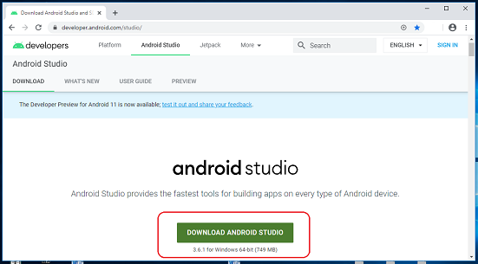

**Step 3**

 Double click on the downloaded "Android Studio-ide.exe" file.

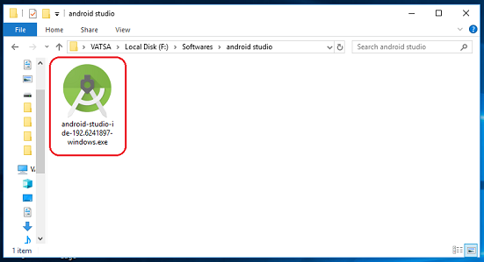

**Step 4**

 "Android Studio Setup" will appear on the screen and click "Next" to proceed.

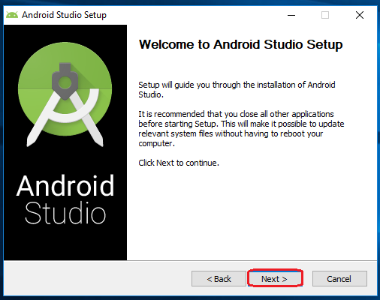

**Step 5**

 Select the components that you want to install and click on the "Next" button.

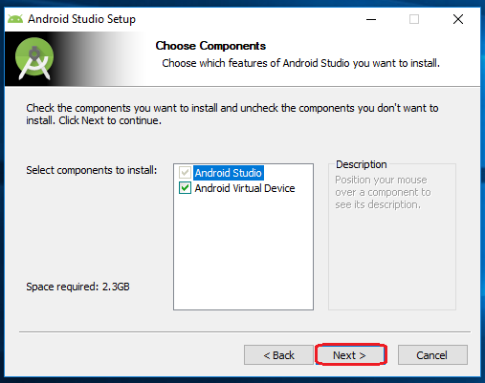

**Step 6**

 Now, browse the location where you want to install the Android Studio and click "Next" to proceed.

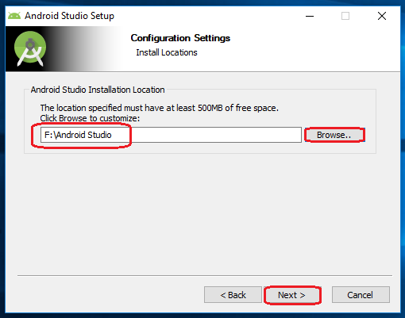

**Step 7**

 Choose a start menu folder for the "Android Studio" shortcut and click the "Install" button to proceed.

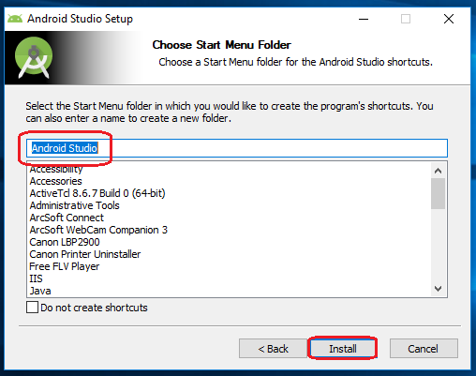

**Step 8**

 After the successful completion of the installation, click on the "Next" button.

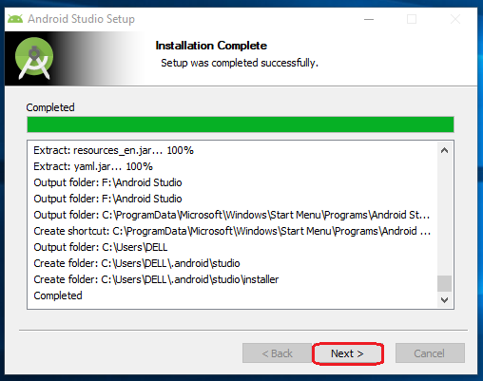

**Step 9**

 Click on the "Finish" button to proceed.

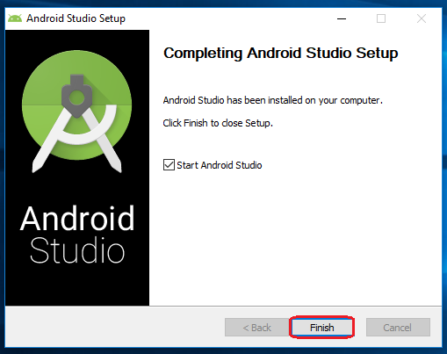

 Now, your Android studio welcome screen will appear on the screen.

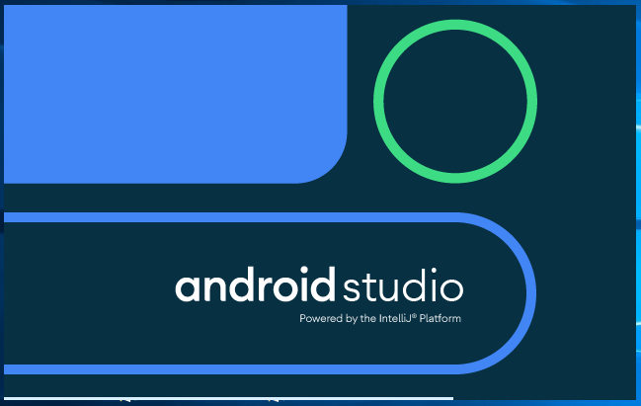

## Android Studio Setup Configuration

**Step 10**

 "Android Studio Setup Wizard" will appear on the screen with the welcome wizard. Click on the "Next" button.

**Step 11**

 Select (check) the "Standard" option if you are a beginner and do not have any idea about Android Studio. It will install the most common settings and options for you. Click "Next" to proceed.

**Step 12**

 Now, select the user interface theme as you want. (I prefer Dark theme (Dracula) that is most liked by the coders). Then, click on the "Next" button.

**Step 13**

 Now, click on the "Finish" button to download all the SDK components.

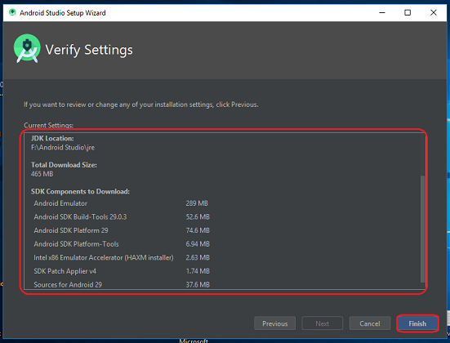

And, the downloading and installation process of components gets started.

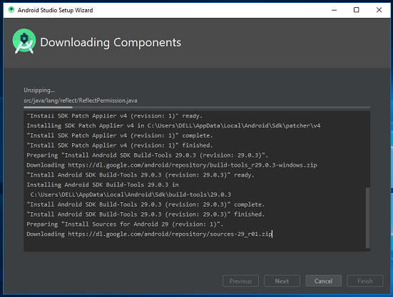

**Step 14**

 After downloading all the necessary components, click on the "Finish" button.

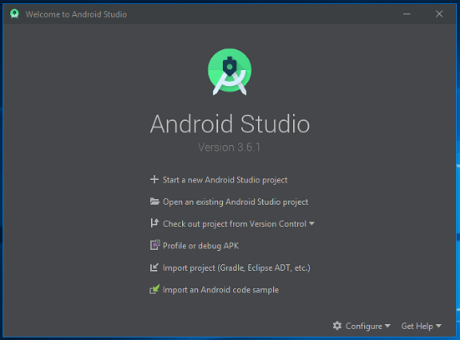

 Congrats, your Android Studio has been successfully installed in your system and you can start a new Android studio project.

**Module 3:**

Building your First Application: Understanding Activities and Intents, Activity Lifecycle and Managing State, Activities and Implicit Intents

Task: Build and Run Hello World Application on the virtual Device and also test the app on your mobile phone.

## About activities

An activity represents a single screen in your app with an interface the user can interact with. For example, an email app might have one activity that shows a list of new emails, another activity to compose an email, and another activity for reading individual messages. Your app is a collection of activities that you either create yourself, or that you reuse from other apps.

Although the activities in your app work together to form a cohesive user experience in your app, each one is independent of the others. This enables your app to start activities in other apps, and other apps can start your activities (if your app allows it). For example, a messaging app you write could start an activity in a camera app to take a picture, and then start the activity in an email app to let the user share that picture in email.

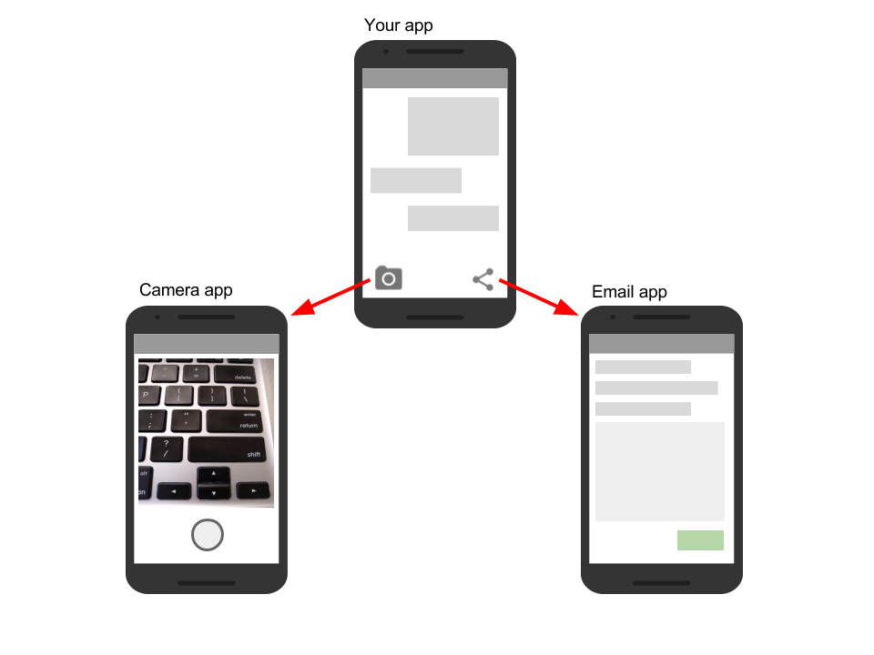

Typically, one activity in an app is specified as the "main" activity, which is presented to the user when launching the application for the first time. Each activity can then start other activities in order to perform different actions.

# **Android Intent**

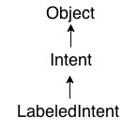

**Android Intent** is the message that is passed between components such as activities, content providers, broadcast receivers, services etc.

It is generally used with startActivity() method to invoke activity, broadcast receivers etc.

The **dictionary meaning** of intent is intention or purpose. So, it can be described as the intention to do action.

The LabeledIntent is the subclass of android.content.Intent class.

Android intents are mainly used to:

* Start the service
* Launch an activity
* Display a web page
* Display a list of contacts
* Broadcast a message
* Dial a phone call etc.

## Types of Android Intents

There are two types of intents in android: implicit and explicit.

### **1) Implicit Intent**

**Implicit Intent** doesn't specifiy the component. In such case, intent provides information of available components provided by the system that is to be invoked.

For example, you may write the following code to view the webpage.

1. Intent intent=**new** Intent(Intent.ACTION_VIEW);
2. intent.setData(Uri.parse("http://www.javatpoint.com"));
3. startActivity(intent);

### **2) Explicit Intent**

**Explicit Intent** specifies the component. In such case, intent provides the external class to be invoked.

1. Intent i = **new** Intent(getApplicationContext(), ActivityTwo.**class**);
2. startActivity(i);

To get the full code of explicit intent, visit the next page.

**Task:Build and Run Hello World Application on the virtual Device and also test the app on your mobile phone.**

**Step-1:Visit the site** [**https://www.mobiroller.com/en/**](https://www.mobiroller.com/en/)

**Step-2:Select “*Try it for free*” button**

**Step**-**3**: **Select “*Crate an account*” Button**

* 1. **Enter E-Mail Address**
  2. **Enter full name**
  3. **Enter Password**

**After entering the above details Press “*Create New Account*”.**

**Step-4: Login the page**

**Step-5: Select “+ Create New App”**

**Step-6: Enter App Name**

**Step-7: Select Any “*Template*”.**

**Step-8: Press the button “*Go to Control Panel*“**

**After Entering Control Panel, we will observe our app**

**completed 80% will Displayed.**

***(if you want to Change Template, change it)***

**Step-9:Select *Content* Button.**

**Select Modules (if Any) (I am Selected *Website* Module)**

**Enter** *Title* **and** *Websites* **link.**

**Select Save Option Button.**

**Step-10: Select “Add Module Button”.**

**Select Modules (if Any) (I am Selected *Standard Content* Module)**

**Enter Title Name**

**Enter Context name**

**(if you want to add any image , add it)**

**Select Save Option Button.**

**Step-11: Select “*Appearance* “Button**

**Go to General settings & if you want to change font color, Animation**

**Select Save Option Button.**

**Step-12: Press “*Generate APK*” button**

**Press “Yes” button**

**Press “generate APK”**

**After generating Apk link we will receive a mail.**

**Finally, copy the link and install it in your mobile phone.**