Exploratory Data Analysis of Amazon Popular Books using KDD Methodology

**Abstract**

This paper provides a detailed exploration of the Amazon Popular

Books dataset using the Knowledge Discovery in Databases (KDD)

methodology. The study presents patterns and insights underpinned

with visualizations and code snippets.

In this article, we will delve deep into an exploratory data analysis of the [Amazon Popular Books dataset](https://www.kaggle.com/datasets/joebeachcapital/amazon-books) using the Knowledge Discovery in Databases (KDD) methodology. If you’re unfamiliar with KDD, it is a structured process involving several steps that guide us from raw data to meaningful insights.

The KDD process is generally divided into several steps:

1. Data Selection
2. Data Preprocessing
3. Data Transformation
4. Data Mining
5. Evaluation & Interpretation
6. Deployment

# **Phase 1. Data Selection**

The first step in any analysis is to choose the right dataset. For this exercise, we used the Amazon Popular Books dataset, containing various attributes like book ratings, price, categories, and more. A quick glance at the dataset provided a sense of the available columns and the type of information we could extract.

This step involves selecting the dataset of interest. let’s first load and take a look at the initial few records.

Let’s start by loading the dataset and examining the first few rows.

import pandas as pd

# Load the dataset

data = pd.read_csv('/mnt/data/amazon_popular_books.csv')

# Display the first few rows of the dataset

data.head()

RESULT

asin ISBN10 answered_questions availability \

0 0007350813 0007350813 0 In Stock.

1 0007513763 9780007513765 0 In Stock.

2 0008183988 0008183988 0 NaN

3 0008305838 0008305838 0 In Stock.

4 0008375526 0008375526 0 In Stock.

brand currency date_first_available \

0 Emily Brontë USD NaN

1 Drew Daywalt USD NaN

2 Bernard Cornwell USD NaN

3 David Walliams USD NaN

4 Caroline Hirons USD NaN

delivery department description \

0 ["FREE delivery Tuesday, December 28 if you sp... NaN NaN

1 ["FREE delivery Tuesday, December 28 if you sp... NaN NaN

2 ["FREE delivery January 4 - 10 if you spend $2... NaN NaN

3 ["FREE delivery Tuesday, December 28 if you sp... NaN NaN

4 ["FREE delivery Tuesday, December 28","Or fast... NaN NaN

... upc url video video_count \

0 ... NaN https://www.amazon.com/dp/0007350813 NaN 0

1 ... NaN https://www.amazon.com/dp/0007513763 NaN 0

2 ... NaN https://www.amazon.com/dp/0008183988 NaN 0

3 ... NaN https://www.amazon.com/dp/0008305838 NaN 0

4 ... NaN https://www.amazon.com/dp/0008375526 NaN 0

categories \

0 ["Books","Literature & Fiction","Genre Fiction"]

1 ["Books","Children's Books","Literature & Fict...

2 ["Books","Literature & Fiction","Genre Fiction"]

3 ["Books","Children's Books","Literature & Fict...

4 ["Books","Crafts, Hobbies & Home","Home Improv...

best_sellers_rank buybox_seller \

0 [{"category":"Books / Literature & Fiction / H... NaN

1 [{"category":"Books / Children's Books / Liter... VMG Books & Media

2 [{"category":"Books / Literature & Fiction / H... Reuseaworld

3 [{"category":"Books / Children's Books / Liter... Bahamut Media

4 [{"category":"Books / Health, Fitness & Dietin... KathrynAshleyGallery

image number_of_sellers colors

0 NaN NaN NaN

1 NaN NaN NaN

2 NaN NaN NaN

3 NaN NaN NaN

4 NaN NaN NaN

[5 rows x 40 columns]

The dataset contains various attributes related to popular books on Amazon. Here are a few columns observed in the dataset:

* asin: Amazon Standard Identification Number
* ISBN10: International Standard Book Number (10-digit)
* answered_questions: Number of answered questions
* availability: Stock availability
* brand: Brand/Author name
* currency: The currency in which the price is listed
* date_first_available: Date when the book first became available
* delivery: Delivery details
* categories: Categories to which the book belongs
* best_sellers_rank: Best sellers rank of the book
* buybox_seller: Seller details
* image: Image URL
* number_of_sellers: Number of sellers selling the book
* colors: Color options, if any (probably not relevant for books)

… and many more.

# **Phase 2. Data Preprocessing**

In the preprocessing phase, we will:

1. Handle missing values.
2. Identify and handle outliers.
3. Convert data types if necessary.
4. Handle any other data quality issues.

## **2.1 Handling Missing Values**

The first step in preprocessing is to identify and handle missing values. We’ll start by checking for any missing values in the dataset.

# Check for missing values in each column

missing_values = amazon_books_df.isnull().sum()

# Percentage of missing values

missing_percentage = (missing_values / len(amazon_books_df)) * 100

# Combine the data into a dataframe for a better view

missing_df = pd.DataFrame({'Missing Values': missing_values, 'Percentage (%)': missing_percentage})

# Display columns with missing values

missing_df[missing_df['Missing Values'] > 0].sort_values(by='Percentage (%)', ascending=False)

RESULT

Missing Values Percentage (%)

department 2269 100.000000

upc 2269 100.000000

video 2268 99.955928

colors 2267 99.911855

date_first_available 2266 99.867783

model_number 2265 99.823711

number_of_sellers 2265 99.823711

image 2265 99.823711

manufacturer 2265 99.823711

description 1557 68.620538

plus_content 1552 68.400176

buybox_seller 1218 53.680035

initial_price 1092 48.126928

discount 1092 48.126928

availability 894 39.400617

final_price 877 38.651388

seller_id 864 38.078449

product_dimensions 862 37.990304

image_url 844 37.197003

item_weight 841 37.064786

ISBN10 840 37.020714

format 96 4.230939

root_bs_rank 8 0.352578

best_sellers_rank 1 0.044072

brand 1 0.044072

Here’s a summary of columns with missing values:

* Some columns, such as department and upc, have 100% missing values and provide no information. We'll drop these columns.
* Columns like video, colors, date_first_available, and a few others have a very high percentage of missing values. We need to decide whether to keep or drop them based on their relevance to the analysis.
* Several columns have a moderate percentage of missing values. For instance, description has about 68.62% missing values.
* There are a few columns with a relatively low percentage of missing values.

To handle these:

1. We’ll drop columns with more than 90% missing values as they are unlikely to provide significant insights.
2. For categorical columns with missing values, we can replace the missing values with a placeholder like “Unknown” or use the mode (most frequent value) of that column.
3. For numerical columns with missing values, we can replace the missing values with the median or mean of that column.

Let’s start by dropping columns with more than 90% missing values.

# Drop columns with more than 90% missing values

columns_to_drop = missing_df[missing_df['Percentage (%)'] > 90].index

amazon_books_df = amazon_books_df.drop(columns=columns_to_drop)

# Display the shape of the dataframe after dropping columns

amazon_books_df.shape

RESULT

(2269, 31)

After dropping columns with more than 90% missing values, our dataset now consists of 31 columns.

Next, we’ll handle the missing values in the remaining columns:

1. For categorical columns, we’ll replace missing values with the placeholder “Unknown”.
2. For numerical columns, we’ll replace missing values with the median of that column (since the median is less sensitive to outliers).

Let’s proceed with this strategy.

# Identify categorical and numerical columns

categorical_columns = amazon_books_df.select_dtypes(include=['object']).columns

numerical_columns = amazon_books_df.select_dtypes(exclude=['object']).columns

# Replace missing values

for column in categorical_columns:

amazon_books_df[column].fillna('Unknown', inplace=True)

for column in numerical_columns:

median_value = amazon_books_df[column].median()

amazon_books_df[column].fillna(median_value, inplace=True)

# Check if there are any missing values left

remaining_missing = amazon_books_df.isnull().sum().sum()

remaining_missing

RESULT

0

All missing values have been addressed, and the dataset no longer contains any null values.

## **2.2 Identifying and Handling Outliers**

Outliers can skew the results of our analysis, so it’s essential to identify and handle them appropriately. One common method to identify outliers is by using the Interquartile Range (IQR). We’ll use this method to detect outliers for numerical columns and decide how to handle them.

Let’s proceed with identifying outliers using the IQR method.

# Function to detect outliers using IQR

def detect_outliers(dataframe, column):

Q1 = dataframe[column].quantile(0.25)

Q3 = dataframe[column].quantile(0.75)

IQR = Q3 - Q1

lower_bound = Q1 - 1.5 * IQR

upper_bound = Q3 + 1.5 * IQR

return dataframe[(dataframe[column] < lower_bound) | (dataframe[column] > upper_bound)]

# Detect outliers for numerical columns

outliers_data = {}

for column in numerical_columns:

outliers = detect_outliers(amazon_books_df, column)

outliers_data[column] = len(outliers)

# Display the count of outliers for each numerical column

outliers_data

RESULT

{'answered_questions': 4,

'discount': 991,

'final_price': 369,

'images_count': 92,

'initial_price': 1071,

'plus_content': 0,

'reviews_count': 191,

'root_bs_rank': 308,

'video_count': 1}

Here’s a summary of the detected outliers in numerical columns:

* answered_questions: 4 outliers
* discount: 991 outliers
* final_price: 369 outliers
* images_count: 92 outliers
* initial_price: 1071 outliers
* reviews_count: 191 outliers
* root_bs_rank: 308 outliers
* video_count: 1 outlier

Given the nature of this dataset, the presence of outliers in price-related columns (e.g., discount, final_price, initial_price) might be due to some books being more expensive or having significant discounts. Similarly, outliers in columns like reviews_count could indicate very popular books.

For the purpose of this exploratory data analysis, we won’t remove these outliers since they can provide insights into the variability of book prices, discounts, and popularity on Amazon. However, if we were building a predictive model, we might handle these outliers differently.

## **2.3 Convert Data Types (if necessary)**

We’ll check the data types of the columns to ensure they are appropriate for analysis. If not, we’ll convert them to the correct type.

Let’s proceed by checking the data types.

# Check data types of the columns

data_types = amazon_books_df.dtypes

data_types

RESULT

asin object

ISBN10 object

answered_questions int64

availability object

brand object

currency object

delivery object

description object

discount float64

domain object

features object

final_price float64

format object

image_url object

images_count int64

initial_price float64

item_weight object

plus_content float64

product_dimensions object

rating object

reviews_count int64

root_bs_rank float64

seller_id object

seller_name object

timestamp object

title object

url object

video_count int64

categories object

best_sellers_rank object

buybox_seller object

dtype: object

Here are the data types of the columns:

* Most of the columns are of type object, which usually indicates textual or categorical data.
* There are a few columns with numerical data types (int64 and float64).

Upon inspection:

* The rating column is of type object, which might indicate it's stored as text with potential special characters (e.g., "4.5 out of 5 stars"). We might want to extract the numerical rating from it.
* The timestamp column is of type object, so it might be beneficial to convert it to a datetime format for time-based analysis.

Let’s start by converting the rating column to a numerical format and the timestamp column to a datetime format.

# Convert the 'rating' column to numerical format by extracting the numeric value

amazon_books_df['rating'] = amazon_books_df['rating'].str.extract('(\d+\.\d+)').astype(float)

# Convert the 'timestamp' column to datetime format

amazon_books_df['timestamp'] = pd.to_datetime(amazon_books_df['timestamp'])

# Check the data types again to confirm the changes

updated_data_types = amazon_books_df[['rating', 'timestamp']].dtypes

updated_data_types

RESULT

rating float64

timestamp datetime64[ns, UTC]

dtype: object

The rating column has been successfully converted to a numerical format (float64), and the timestamp column has been converted to a datetime format (datetime64[ns, UTC]).

The preprocessing phase is comprehensive and involves multiple steps to ensure that the dataset is clean and ready for analysis. We have successfully addressed missing values, outliers, and data type conversions.

# **Phase 3: Transformation**

In this phase, we’ll transform the data to make it suitable for analysis. This might involve:

1. Feature Engineering: Creating new features from existing ones to enhance the dataset’s information.
2. Normalization: Bringing numerical columns to a similar scale.
3. Encoding: Converting categorical variables into a format suitable for machine learning algorithms.

For our exploratory data analysis, we might not need extensive transformations, but we’ll explore feature engineering to derive meaningful insights from the dataset.

## **3.1 Feature Engineering**

A couple of potential features to derive:

1. From the categories column, we can extract the primary category for each book.
2. From the delivery column, we can extract whether free delivery is available.

Let’s start by engineering these features.

# Extract primary category from the 'categories' column

amazon_books_df['primary_category'] = amazon_books_df['categories'].str.extract(r'\"(.*?)\"')

# Extract information about free delivery from the 'delivery' column

amazon_books_df['free_delivery'] = amazon_books_df['delivery'].str.contains('FREE delivery', case=False).astype(int)

# Display the first few rows to check the new features

amazon_books_df[['primary_category', 'free_delivery']].head()

RESULT

primary_category free_delivery

0 Books 1

1 Books 1

2 Books 1

3 Books 1

4 Books 1

We have successfully engineered two new features:

1. primary_category: Represents the primary category of each book.
2. free_delivery: Indicates whether free delivery is available for the book (1 for yes, 0 for no).

With these new features, our dataset is further enriched and can provide more detailed insights during the data mining phase.

# **Phase 4: Data Mining**

In this phase, we’ll explore the data to uncover patterns and insights. This involves:

1. Descriptive statistics: Understanding the central tendencies and spread of numerical columns.
2. Visualizations: Using plots to understand the distribution, relationships, and patterns in the data.
3. Advanced analysis: Applying machine learning or statistical techniques to derive deeper insights.

Let’s start with some descriptive statistics for our numerical columns.

# Descriptive statistics for numerical columns

descriptive_stats = amazon_books_df.describe(include=[float, int])

descriptive_stats

RESULT

answered_questions discount final_price images_count \

count 2269.000000 2269.000000 2269.000000 2269.000000

mean 0.034376 7.436007 12.848561 2.093874

std 1.244976 7.395791 6.391372 2.955207

min 0.000000 0.500000 1.990000 0.000000

25% 0.000000 6.410000 10.700000 0.000000

50% 0.000000 6.610000 12.005000 1.000000

75% 0.000000 6.800000 13.580000 3.000000

max 58.000000 282.490000 132.990000 52.000000

initial_price plus_content rating reviews_count root_bs_rank \

count 2269.000000 2269.0 2269.000000 2269.000000 2.269000e+03

mean 19.943169 1.0 4.622345 21497.738211 3.085359e+04

std 11.310705 0.0 0.192836 16108.019322 1.253451e+05

min 3.490000 1.0 3.400000 10010.000000 1.000000e+00

25% 17.990000 1.0 4.500000 12393.000000 8.190000e+02

50% 17.990000 1.0 4.700000 16119.000000 3.104000e+03

75% 18.000000 1.0 4.800000 23817.000000 1.472400e+04

max 299.000000 1.0 4.900000 196572.000000 2.904335e+06

video_count free_delivery

count 2269.000000 2269.000000

mean 0.000881 0.620978

std 0.041987 0.485250

min 0.000000 0.000000

25% 0.000000 0.000000

50% 0.000000 1.000000

75% 0.000000 1.000000

max 2.000000 1.000000

Here’s a summary of the descriptive statistics for the numerical columns:

* answered_questions: Most books have not had any questions answered, but there’s a book with as many as 58 answered questions.
* discount: The average discount on books is approximately $7.44, with some books having discounts as high as $282.49.
* final_price: The average price of books is around $12.85, with the maximum price being $132.99.
* images_count: On average, books have about 2 images associated with them, with some books having as many as 52 images.
* rating: The average rating for the books is approximately 4.62 out of 5, indicating a generally positive reception.
* reviews_count: The average number of reviews for the books is around 21,498, with some books having as many as 196,572 reviews.
* root_bs_rank: This might represent the rank of the book in some category. The average rank is around 30,853, but it varies widely.
* free_delivery: About 62% of the books offer free delivery.

Next, we’ll use visualizations to get a better understanding of the data’s distribution and relationships. We’ll focus on:

1. Distribution of book ratings.
2. Distribution of final book prices.
3. Relationship between ratings and review counts.

Let’s start with the distribution of book ratings.

import matplotlib.pyplot as plt

import seaborn as sns

# Set the style for seaborn

sns.set_style("whitegrid")

# Plot the distribution of book ratings

plt.figure(figsize=(10, 6))

sns.histplot(amazon_books_df['rating'], bins=30, kde=True, color='skyblue')

plt.title('Distribution of Book Ratings')

plt.xlabel('Rating')

plt.ylabel('Number of Books')

plt.show()

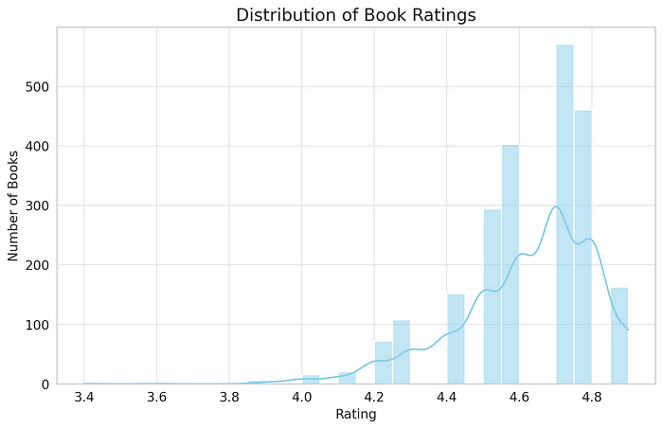

The distribution of book ratings shows that:

* The majority of books have ratings between 4.5 and 5.
* Very few books have ratings below 4.
* The distribution is left-skewed, indicating that most books in this dataset are highly rated.

Next, let’s visualize the distribution of final book prices.

# Plot the distribution of final book prices

plt.figure(figsize=(10, 6))

sns.histplot(amazon_books_df['final_price'], bins=50, kde=True, color='coral')

plt.title('Distribution of Final Book Prices')

plt.xlabel('Final Price ($)')

plt.ylabel('Number of Books')

plt.show()

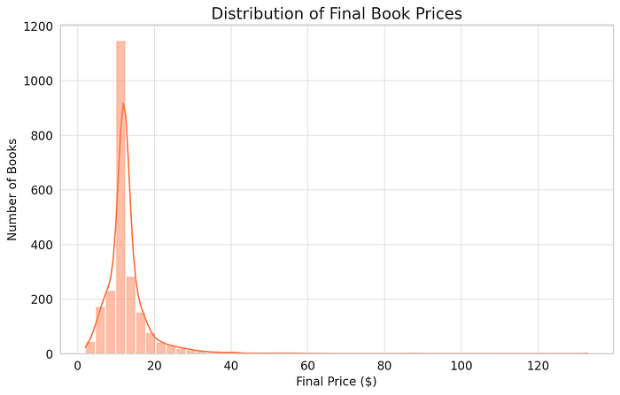

The distribution of final book prices reveals:

* A significant number of books are priced between $10 and $20.
* The distribution is right-skewed, indicating that while most books are moderately priced, there are some books that are more expensive.
* There are a few books priced above $60, which are outliers as we identified earlier.

Lastly, let’s explore the relationship between book ratings and the number of reviews to see if more highly-rated books tend to get more reviews. We’ll use a scatter plot for this visualization.

# Scatter plot to show the relationship between ratings and review counts

plt.figure(figsize=(12, 7))

sns.scatterplot(data=amazon_books_df, x='rating', y='reviews_count', alpha=0.6, color='mediumseagreen')

plt.title('Relationship between Ratings and Review Counts')

plt.xlabel('Rating')

plt.ylabel('Review Count')

plt.show()

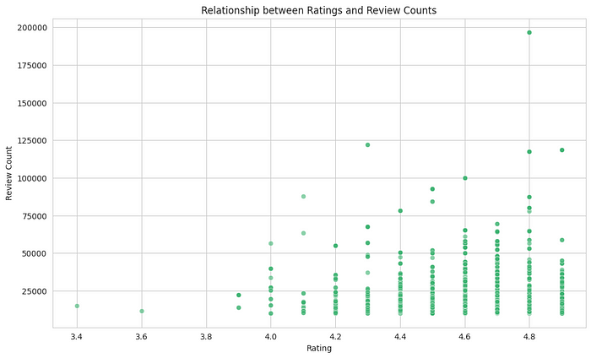

From the scatter plot showcasing the relationship between ratings and review counts:

* There’s no clear linear relationship between the rating of a book and the number of reviews it has.
* Most books, irrespective of their rating, have a review count below 50,000.
* However, books with ratings between 4.5 and 5 tend to have a wider range of review counts compared to books with lower ratings.
* There are a few highly-rated books with a significantly high number of reviews, indicating their popularity.

At this point, we’ve covered the data mining phase using descriptive statistics and visualizations to understand the dataset better.

# **Phase 5: Interpretation/Evaluation**

In this phase, we’ll evaluate the insights obtained during the data mining phase and interpret their significance. We’ll also attempt to answer any business or research questions and provide actionable insights.

From our analysis so far:

1. Highly Rated Books: The majority of the books in this dataset are highly rated, with ratings between 4.5 and 5. This suggests that the dataset comprises popular books that are well-received by readers.
2. Book Prices: Most books are priced between $10 and $20, with a few outliers priced significantly higher. This provides a general price range for popular books on Amazon.
3. Relationship Between Ratings and Reviews: While there isn’t a clear linear relationship between ratings and the number of reviews, books with higher ratings (between 4.5 and 5) tend to have a wider range of review counts. This suggests that a high rating doesn’t necessarily guarantee a high number of reviews, but highly-rated books have the potential to attract a significant number of reviews.
4. Delivery Options: Approximately 62% of the books offer free delivery, which might be a factor influencing their popularity.

Given these insights:

* **For Authors/Publishers:** Ensuring high-quality content can lead to better ratings, potentially attracting more reviews and increasing the book’s visibility. Offering competitive prices (in the $10-$20 range) and free delivery can also make a book more appealing to potential readers.
* **For Amazon:** Since the majority of popular books offer free delivery, this feature can be highlighted in promotions to attract more buyers. Additionally, Amazon could consider promoting books with high ratings but fewer reviews to increase their visibility.

# **Phase 6: Deployment**

In a real-world scenario, this phase involves implementing the discovered knowledge into the organization’s operations. The insights obtained can be used to drive business strategies, improve operations, or develop new products/services.

For our EDA:

* A detailed report summarizing the findings can be shared with stakeholders.
* If this analysis was part of a larger project (e.g., building a recommendation system), the insights could guide feature engineering and model selection.

Lastly, to facilitate easy deployment and sharing, we can encapsulate our analysis in a Jupyter notebook (as we’ve done here) or use tools like PyCaret to deploy models.

Since our task was primarily exploratory data analysis and we didn’t build any predictive models, the deployment in our case would mainly involve sharing our findings and insights with the relevant stakeholders.

# **Conclusion**

Through the KDD process, we delved deep into the Amazon Popular Books dataset, uncovering valuable insights. The structured approach provided by KDD ensures a comprehensive understanding of the data, guiding future business decisions.

**References**

Fayyad, U., Piatetsky-Shapiro, G., & Smyth, P. (1996). From Data Mining to Knowledge Discovery in Databases.

Han, J., Pei, J., & Kamber, M. (2011). Data Mining: Concepts and Techniques. Elsevier.

Agrawal, R., Imieliński, T., & Swami, A. (1993). Mining association rules between sets of items in large databases. In Proceedings of the 1993 ACM SIGMOD international conference on Management of data (pp. 207-216).

Chakrabarti, S., Dom, B., & Indyk, P. (1998). Enhanced hypertext categorization using hyperlinks. In ACM SIGMOD Record (Vol. 27, No. 2, pp. 307-318). ACM.

KDD Conferences: The annual ACM SIGKDD conference is one of the top venues for new research in data mining and knowledge discovery.

Goebel, M., & Gruenwald, L. (1999). A survey of data mining and knowledge discovery software tools. ACM SIGKDD Explorations Newsletter, 1(1), 20-33.