PHASE 6 – PROJECT TESTING
AI StudyBuddy

INTRODUCTION:
TEAM ID: SWTID-2026-9277
TEAM LEADER : MADHAN KUMAR D
MAID ID: mad0214han @gmail.com

TEAM MEMBERS:
NAME | MAIL ID
KATHIR KUMARAN S | Kathirkumaran2006@gmail.com
MAHESH L | Mahesh.l20155@gmail.com
KRISHNA RAJ | krishnabhavanrj @gmail.com

1. Testing Objective
Testing verifies that authentication, study-material handling, AI features, database operations and protected APIs work as intended.

2. API Test Cases
Test | Observed Result
Dependency installation | Successful
MongoDB connection | Successful
Server startup | Successful – port 5000
Student registration | 201 Created
Student login | 200 OK
Material upload | 201 Created
Summary | 200 OK
Flashcards | 200 OK
Quiz | 200 OK
Study plan | 200 OK
Administrator registration | 201 Created

3. Testing Tools
- Postman or Thunder Client
- MongoDB/Mongoose database verification
- Server console/log inspection

4. Bug Tracking
Record each issue found during testing, its cause, correction and retest result in the project folder.

5. Evidence to Upload
- API request/response screenshots
- Successful and failed test screenshots
- Database evidence where applicable
- Bug-fix evidence
- Final test-results table
Important: The status fields above are intentionally left for the actual execution results; they should not be marked Pass/Fail until the corresponding test is performed.
6.Material and AI Tests:

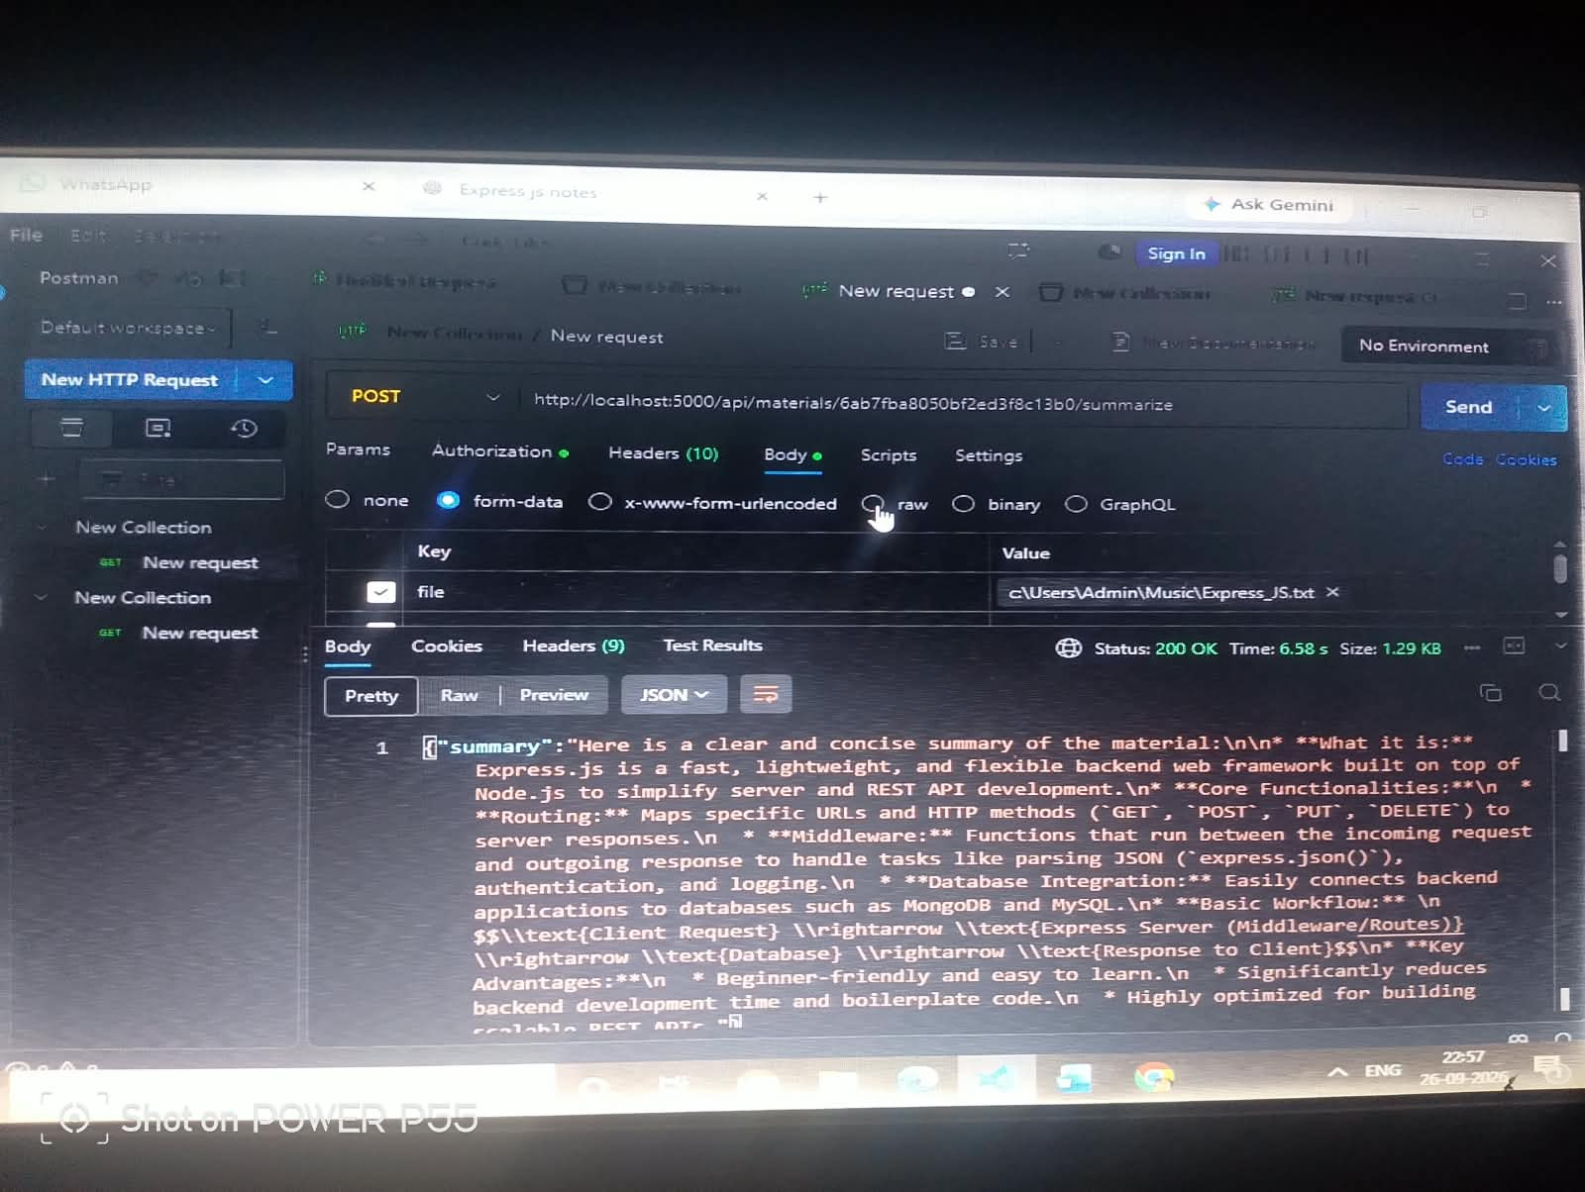

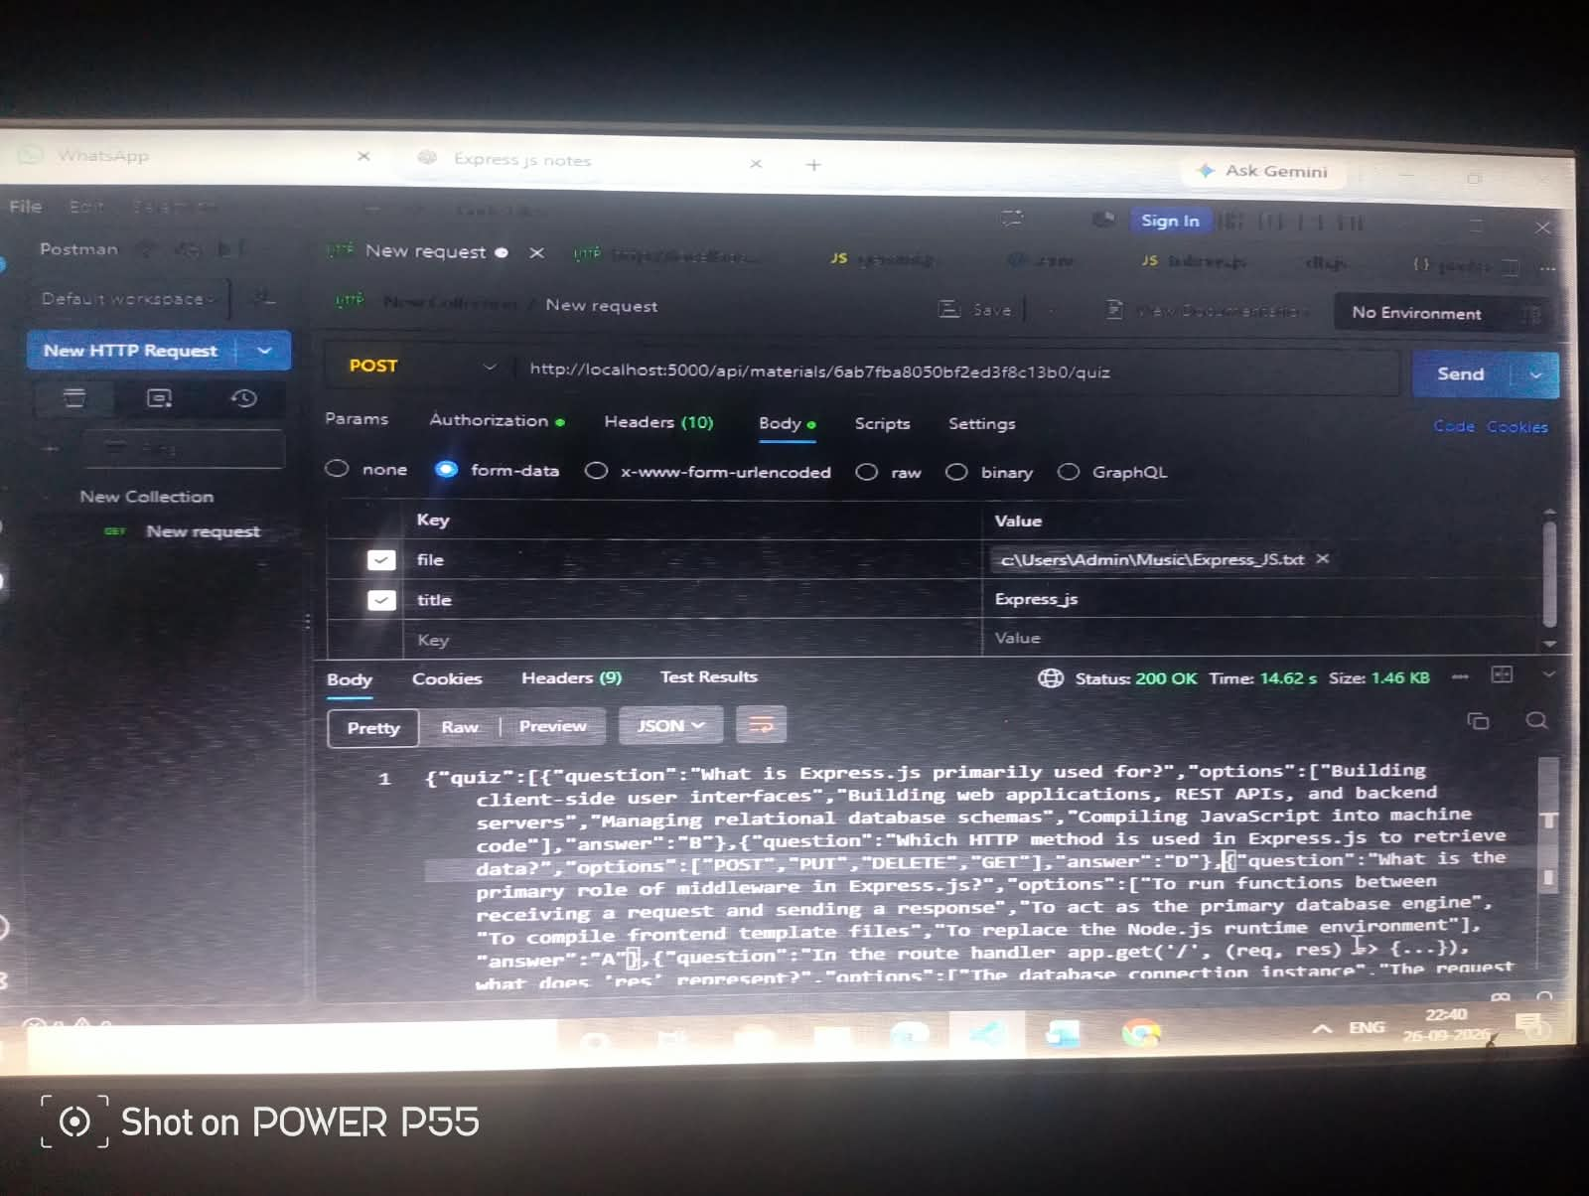

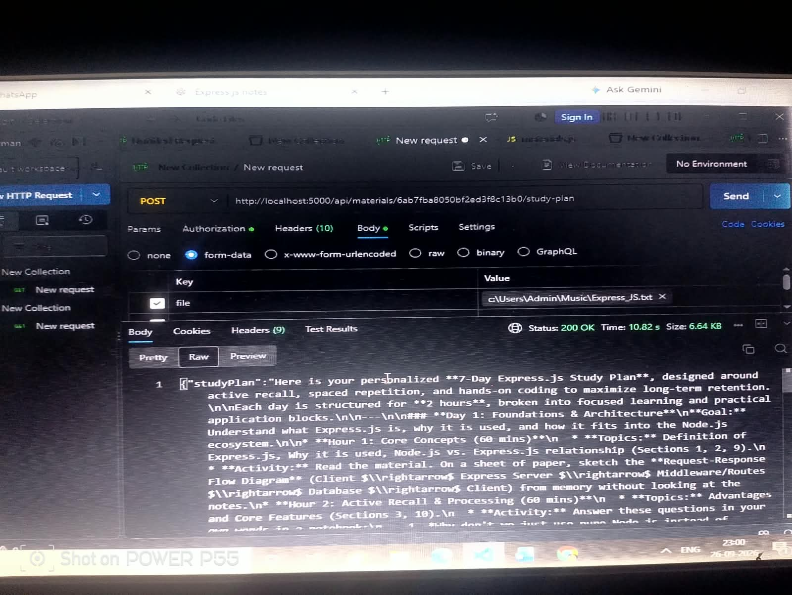

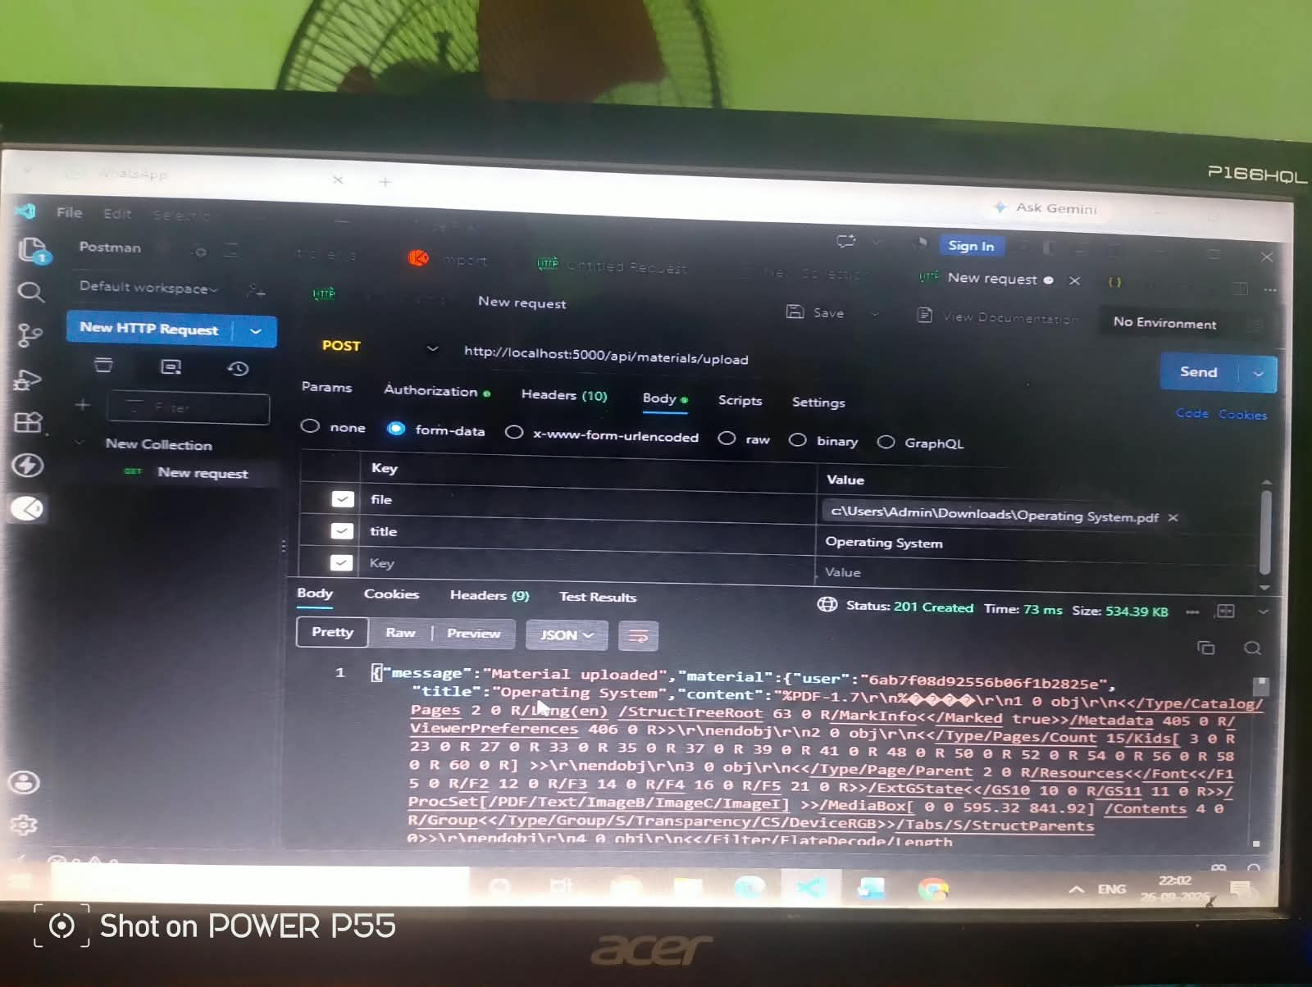

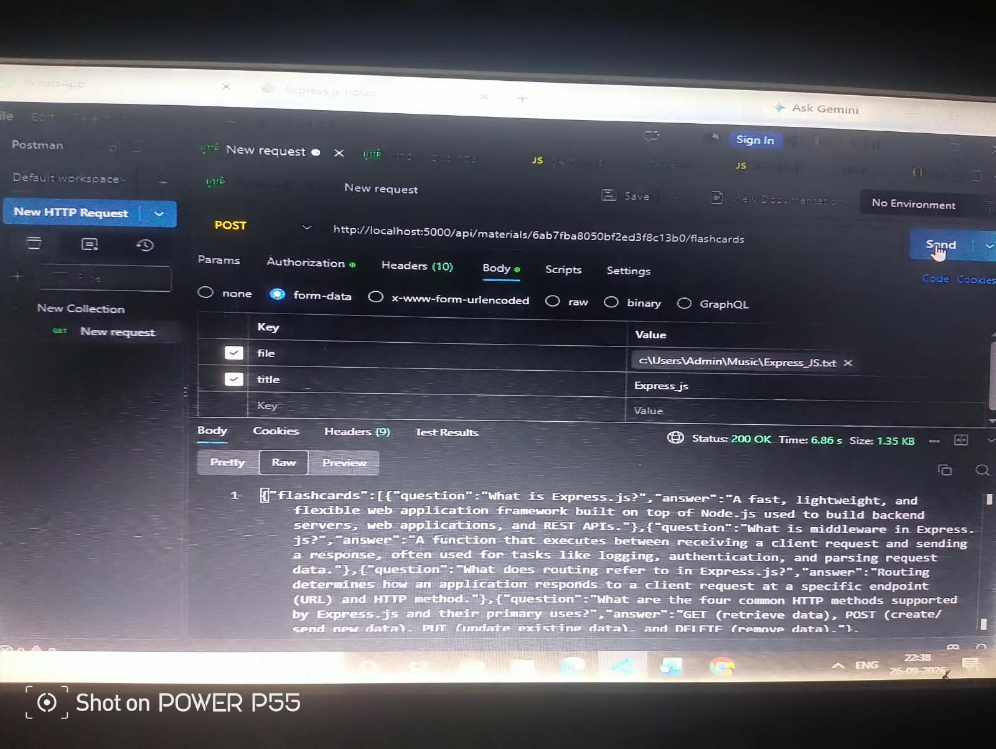

Environment :
