PHASE 8 – PROJECT DEMONSTRATION
AI StudyBuddy

INTRODUCTION:
TEAM ID: SWTID-2026-9277
TEAM LEADER : MADHAN KUMAR D
MAID ID: mad0214han @gmail.com

TEAM MEMBERS:
NAME | MAIL ID
KATHIR KUMARAN S | Kathirkumaran2006@gmail.com
MAHESH L | Mahesh.l20155@gmail.com
KRISHNA RAJ | krishnabhavanrj @gmail.com

1. Demonstration Objective
The final demonstration should show the project running, explain its purpose and benefits, demonstrate the working process, and present the final output.

2. Demo Introduction Script
Project Name: LearnMate – AI StudyBuddy. It is an AI-powered learning assistance platform designed to help students manage study materials and generate summaries, flashcards, quizzes and personalized study plans.

3. Demo Sequence
1. Show the project title and briefly explain the problem faced by students.
2. Explain the proposed solution and major benefits.
3. Show the project/source structure.
4. Start the backend and show the server running.
5. Show MongoDB connection/data where appropriate.
6. Demonstrate user registration and login.
7. Show authentication/protected API usage.
8. Upload or provide study material.
9. Generate and display an AI summary.
10. Generate and display flashcards.
11. Generate and display a quiz.
12. Generate and display a personalized study plan.
13. Show the final output and explain how it helps the student.

4. Required Demo Elements
- Screen sharing
- Voice-over/explanation
- Project name
- Purpose of the project
- Use and benefits
- Project execution/working process
- Actual project execution
- Final output

5. Video Submission
Upload the demo video to Google Drive and set sharing to “Anyone with the link → Viewer”. Submit the Google Drive link according to the SmartBridge instructions.

6. Demo Checklist
☐ Screen sharing ready
☐ Voice-over ready
☐ Backend runs successfully
☐ MongoDB is available
☐ API testing tool ready
☐ AI feature responses ready
☐ Final output shown
☐ Google Drive sharing verified

7.Demonstrated Outputs:

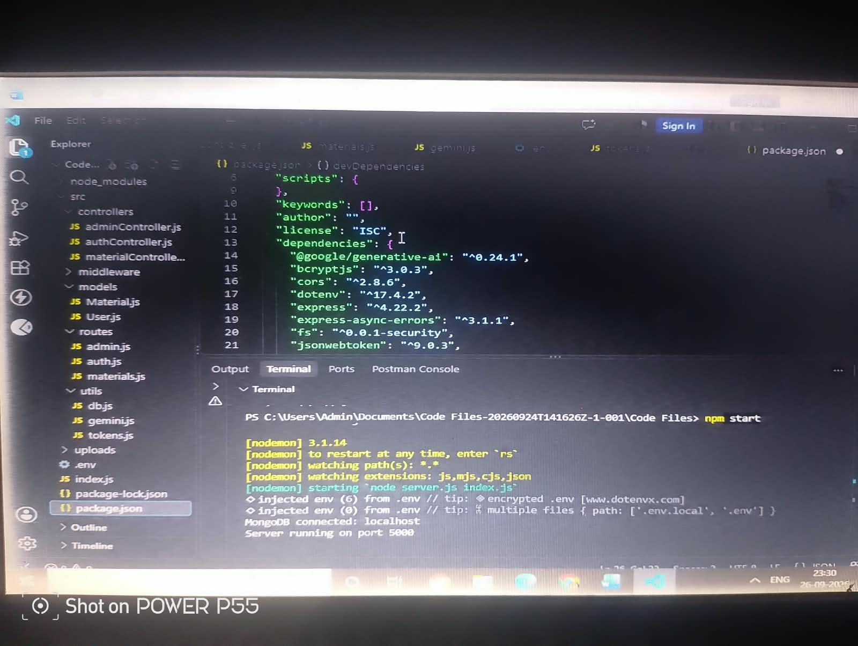

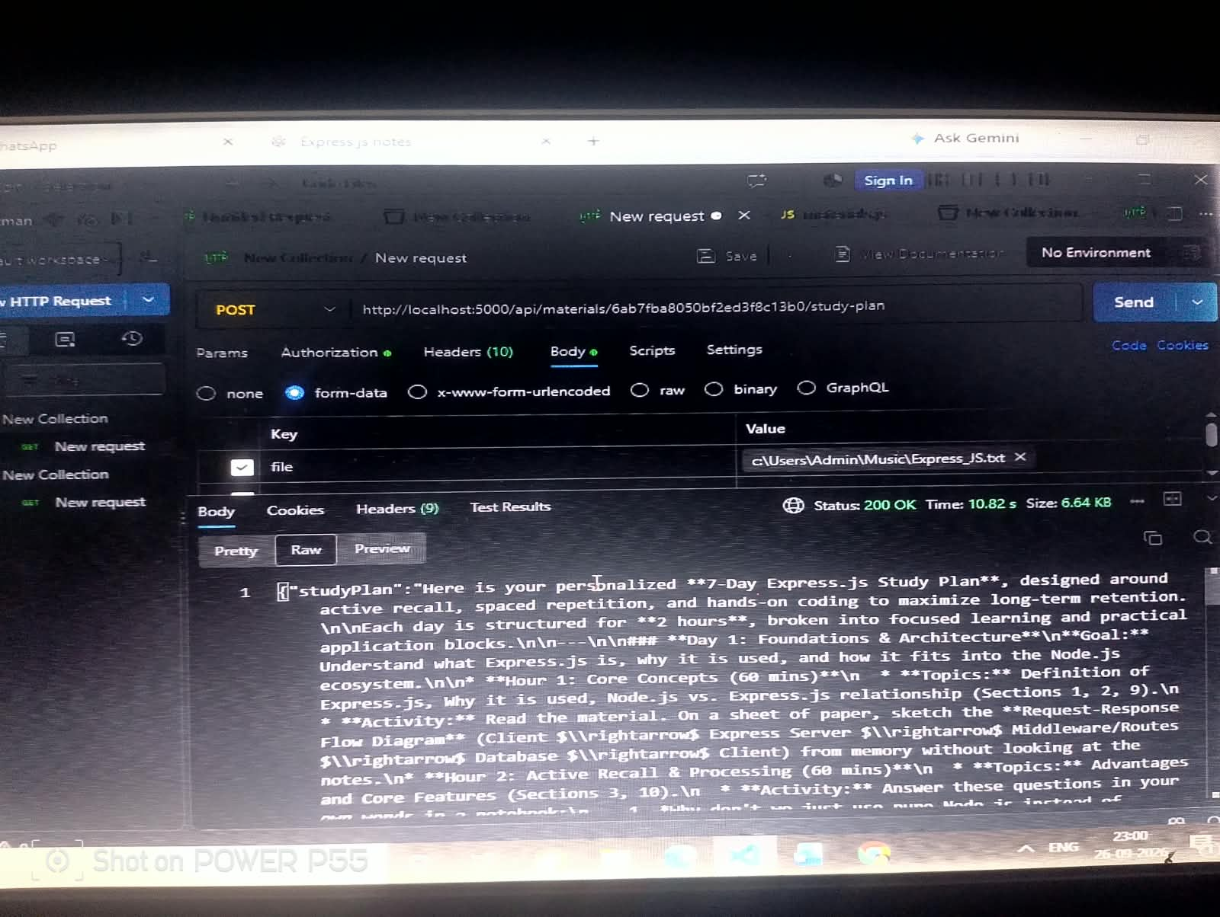

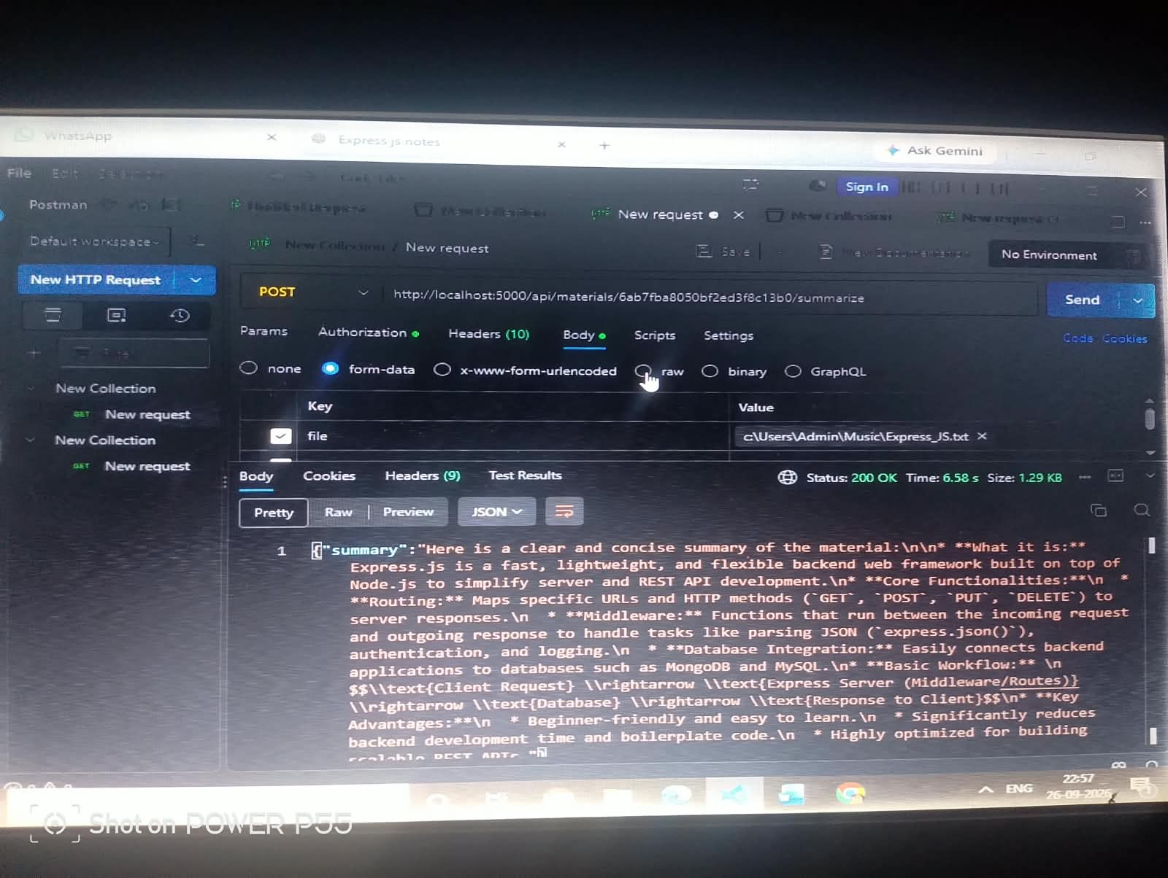

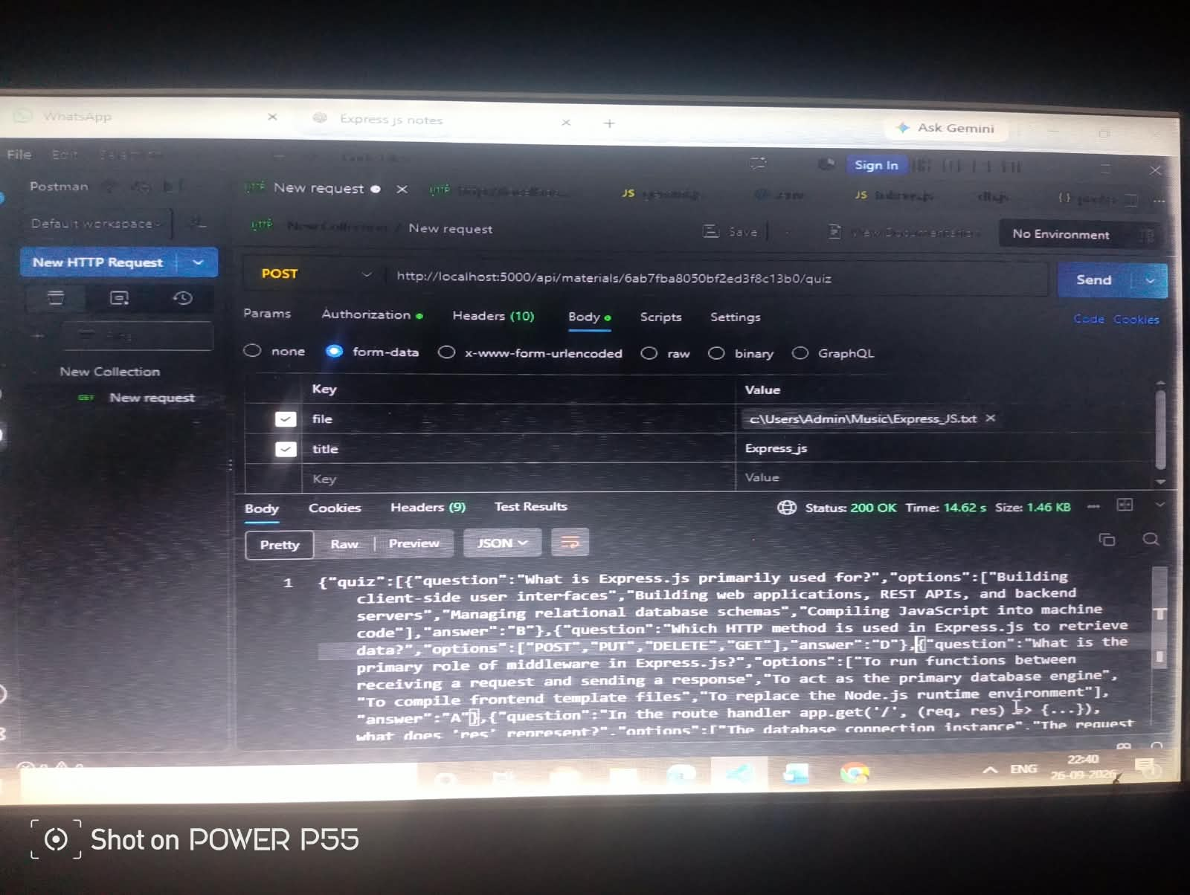

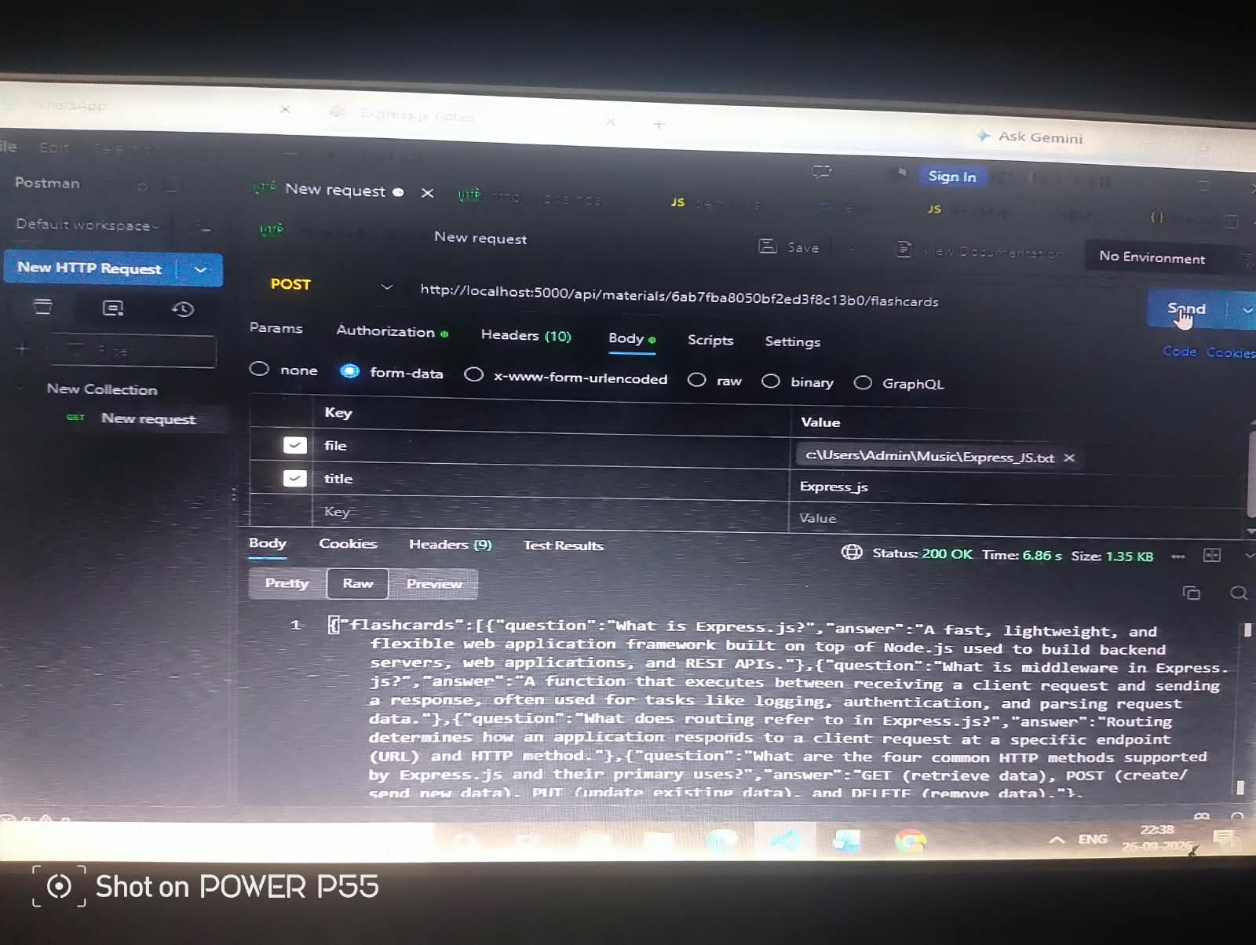

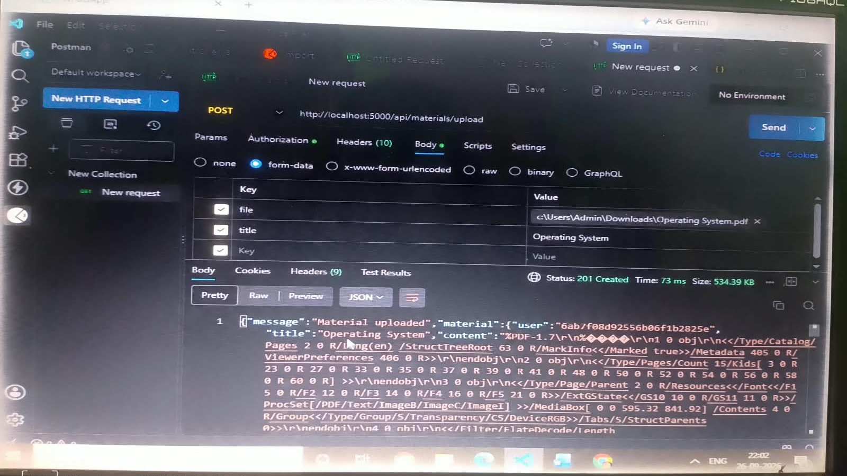

8. Conclusion
The demonstration presents the complete working flow of LearnMate – AI StudyBuddy from authentication and study-material input to AI-generated learning resources and final output.

